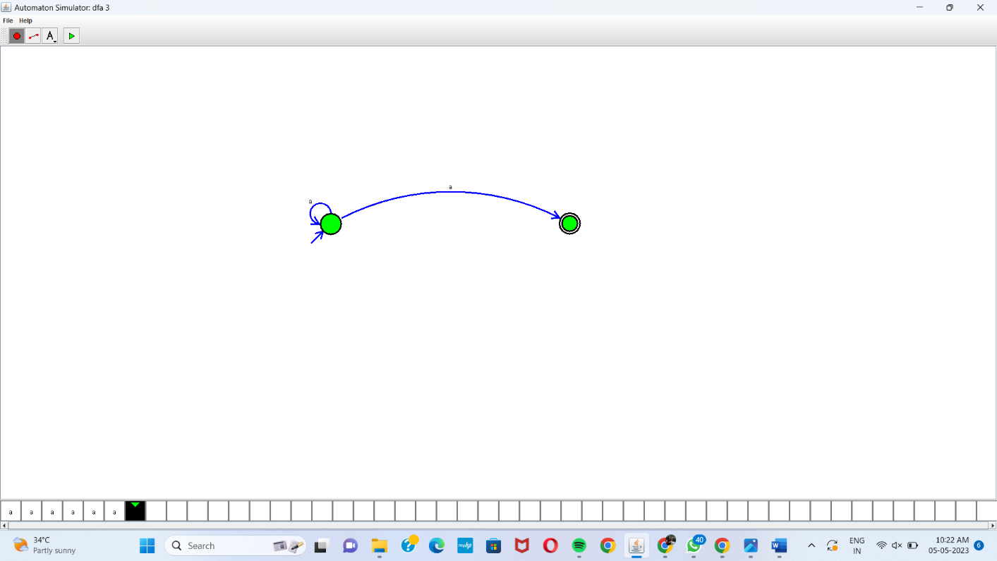

Automaton Simulator, v1.0

nfa {

alphabet {abcd\*@}

state {

initial {yes}

coord {636 342}

}

state {

final {yes}

coord {1096 341}

}

edge 0 0 {

transits {a}

offset {2.356194490192345}

}

edge 0 1 {

transits {a}

offset {0.5235987755982988}

}

}