WEBTESTING SE1LENIUM

CC1

SHRUTHIKA

727721EUAI053

1)

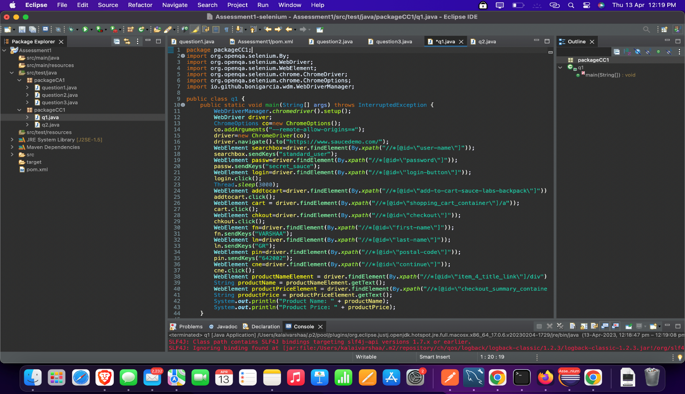

OUTPUT:

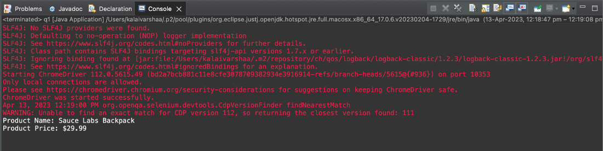

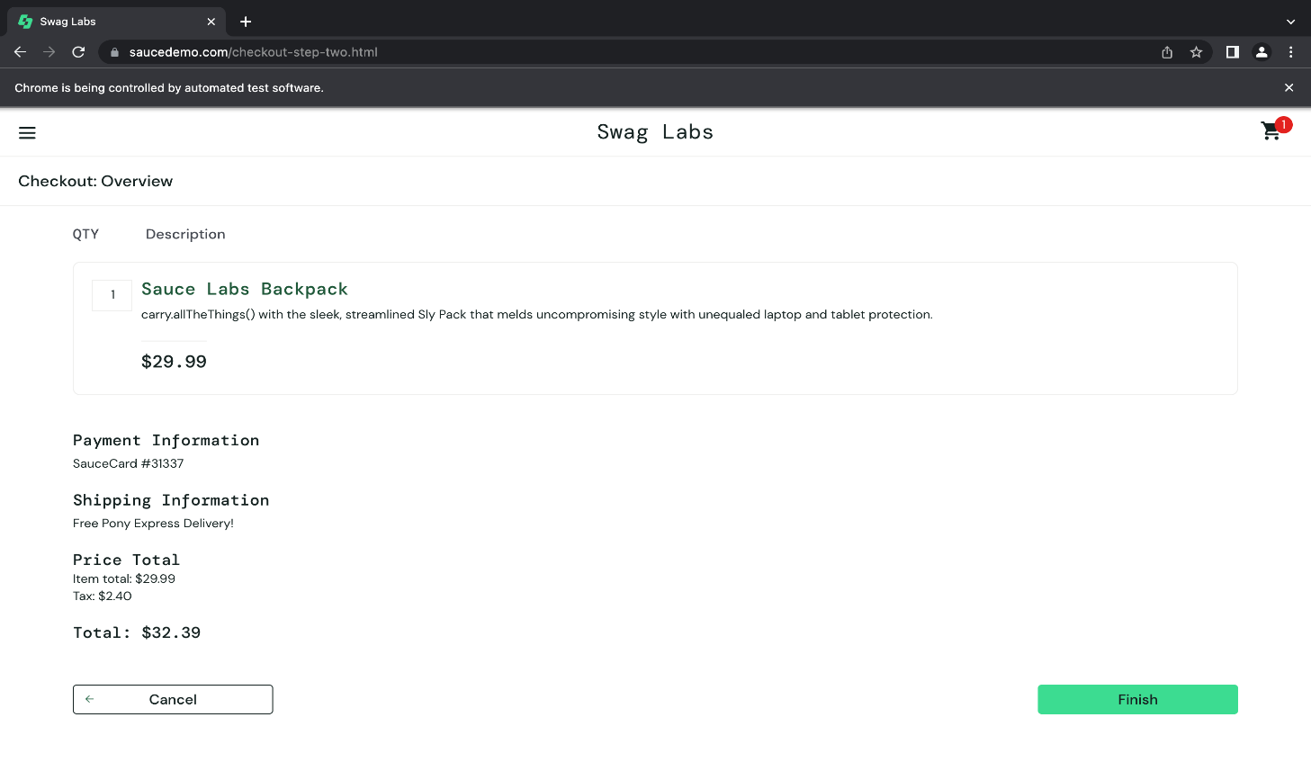

2)

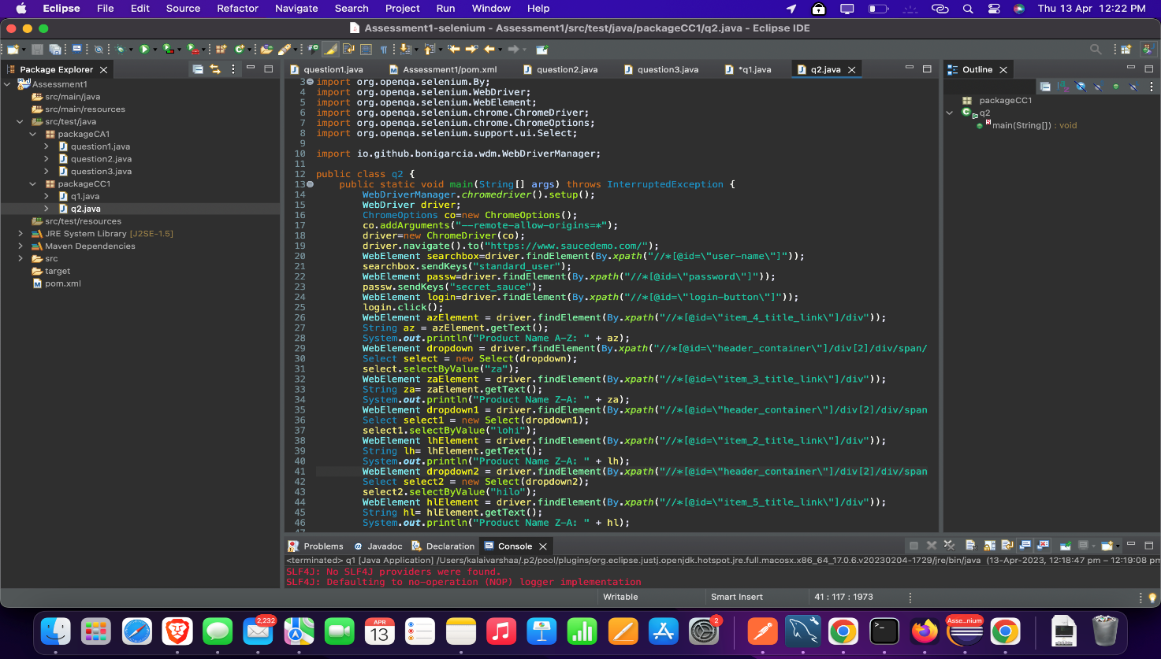

OUTPUT:

