Name: Shruti Santaji shevale

Roll no: 222

Batch: B3

Sudo apt Install git & Sudo apt update

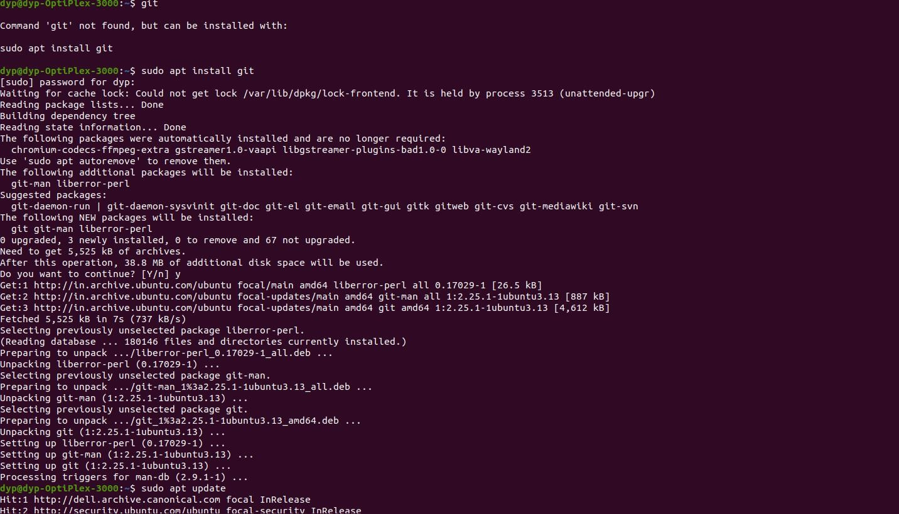

Git congfig -- global User.name (your name )

Git congfig -- global User.email (your email)

Git congfig --list

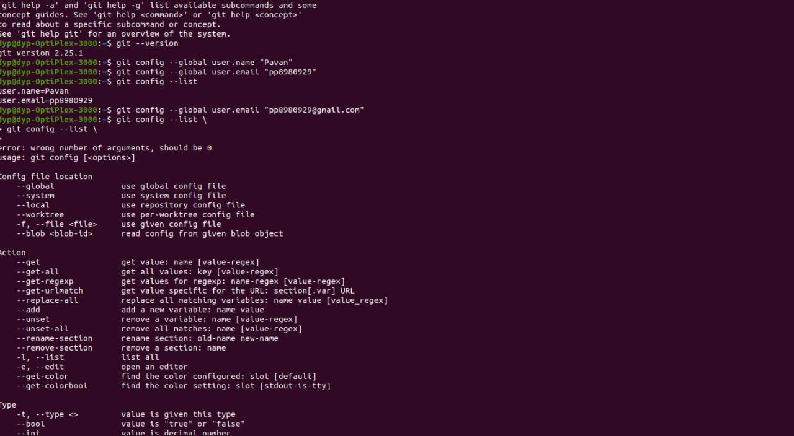

# Create new repository

(git clon https:/github.com/usename/repository name/file name {path} )



Cd repository name

Is

Cat README.md

Touch file_name

Is

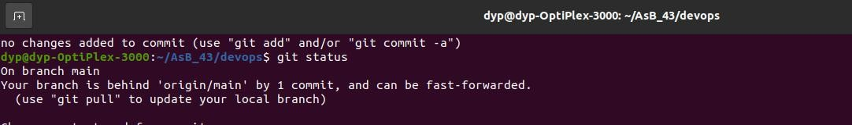Gedit python

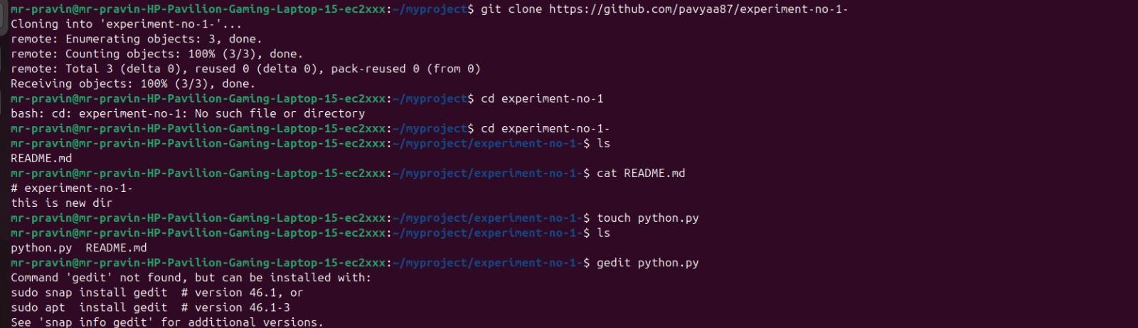

Create a new branch Git Branch

Git branch (branch name )

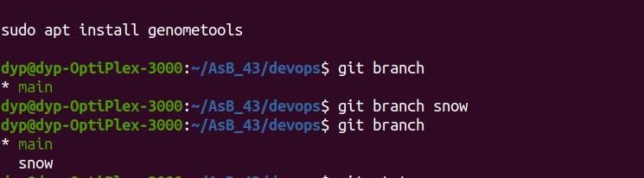

Git Status

Git Add

Git Commit -m

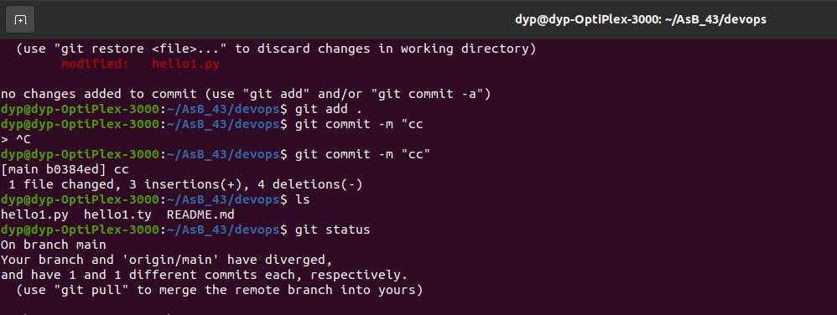

Git push origin main

Git checkout

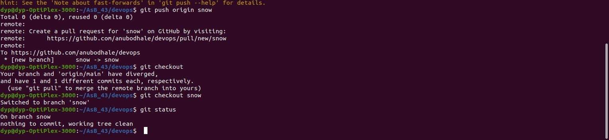

Create new code or file

Git add

Git commit -m “added a file”

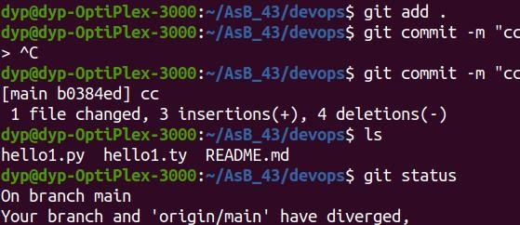

Git pull origin main

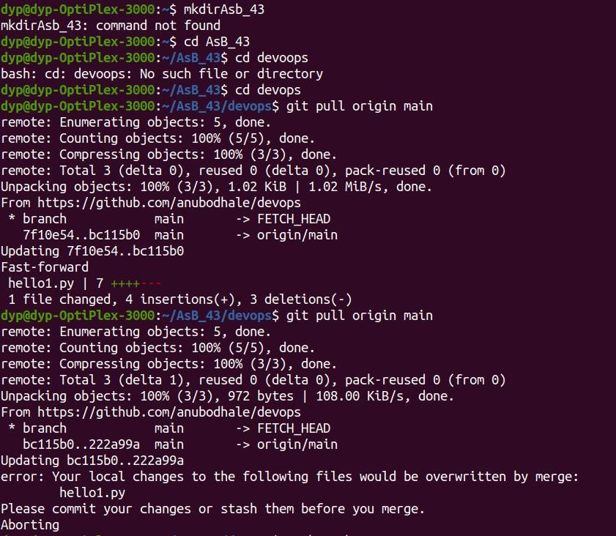

Git push origin snow

Git checkout b branch name

