**Practical 1:**

**Creating Your First Android App: Set up Android Studio and create a basic "Hello World" app.**

**Code:**

**MainActivity.java**

package com.example.helloworld;

import android.os.Bundle;

import androidx.activity.EdgeToEdge;

import androidx.appcompat.app.AppCompatActivity;

public class MainActivity extends AppCompatActivity {

@Override

protected void onCreate(Bundle savedInstanceState) {

super.onCreate(savedInstanceState);

EdgeToEdge.enable(this);

setContentView(R.layout.activity_main);

}

}

**activity_main.xml**

<?xml version="1.0" encoding="utf-8"?>

<androidx.constraintlayout.widget.ConstraintLayout xmlns:android="http://schemas.android.com/apk/res/android"

xmlns:app="http://schemas.android.com/apk/res-auto"

xmlns:tools="http://schemas.android.com/tools"

android:id="@+id/main"

android:layout_width="match_parent"

android:layout_height="match_parent"

tools:context=".MainActivity">

<TextView

android:layout_width="201dp"

android:layout_height="51dp"

android:layout_centerInParent="true"

android:text="Hello World!"

android:textAlignment="center"

android:textAllCaps="false"

android:textAppearance="@style/TextAppearance.AppCompat.Display3"

android:textColor="#9C27B0"

android:textSize="30sp"

android:textStyle="bold|italic"

app:layout_constraintBottom_toBottomOf="parent"

app:layout_constraintEnd_toEndOf="parent"

app:layout_constraintStart_toStartOf="parent"

app:layout_constraintTop_toTopOf="parent"

tools:ignore="MissingConstraints" />

</androidx.constraintlayout.widget.ConstraintLayout>

**Output:**

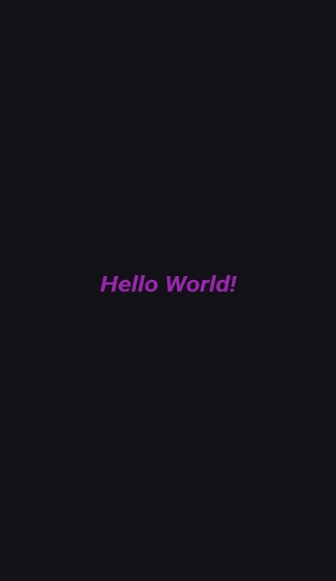

**Practical 2:**

**Creating Android App to implement basic activity and design layout using xml. (3 buttons Send, Receive, Delete & Toast a message when click on button).**

**Code:**

**MainActivity.java**

package com.example.practical2;

import android.os.Bundle;

import android.view.View;

import android.widget.Button;

import android.widget.Toast;

import androidx.activity.EdgeToEdge;

import androidx.appcompat.app.AppCompatActivity;

public class MainActivity extends AppCompatActivity implements View.OnClickListener {

private Button Send,Receive,Delete;

@Override

protected void onCreate(Bundle savedInstanceState) {

super.onCreate(savedInstanceState);

EdgeToEdge.enable(this);

setContentView(R.layout.activity_main);

Send = findViewById(R.id.SendBtn);

Receive = findViewById(R.id.ReceiveBtn);

Delete = findViewById(R.id.deleteBtn);

Send.setOnClickListener(this);

Receive.setOnClickListener(this);

Delete.setOnClickListener(this);

}

@Override

public void onClick(View view) {

if (view.getId() == R.id.SendBtn) {

showToast("Message Sent Successfully!");

} else if (view.getId() == R.id.ReceiveBtn) {

showToast("New Message Received!");

} else if (view.getId() == R.id.deleteBtn) {

showToast("Message Deleted!");

}

}

private void showToast(String message) {

Toast.makeText(this, message, Toast.LENGTH_SHORT).show();

}

}

**activity_main.xml**

<?xml version="1.0" encoding="utf-8"?>

<androidx.constraintlayout.widget.ConstraintLayout xmlns:android="http://schemas.android.com/apk/res/android"

xmlns:app="http://schemas.android.com/apk/res-auto"

xmlns:tools="http://schemas.android.com/tools"

android:id="@+id/main"

android:layout_width="match_parent"

android:layout_height="match_parent"

tools:context=".MainActivity">

<Button

android:id="@+id/SendBtn"

android:layout_width="134dp"

android:layout_height="56dp"

android:layout_marginTop="92dp"

android:text="Send"

android:textColor="#00BCD4"

android:textSize="28sp"

app:layout_constraintBottom_toTopOf="@+id/ReceiveBtn"

app:layout_constraintEnd_toEndOf="parent"

app:layout_constraintStart_toStartOf="parent"

app:layout_constraintTop_toTopOf="parent"

app:layout_constraintVertical_bias="0.201"

tools:ignore="MissingConstraints" />

<Button

android:id="@+id/ReceiveBtn"

android:layout_width="158dp"

android:layout_height="58dp"

android:text="Receive"

android:textColor="#00BCD4"

android:textSize="28sp"

app:layout_constraintBottom_toBottomOf="parent"

app:layout_constraintEnd_toEndOf="parent"

app:layout_constraintHorizontal_bias="0.498"

app:layout_constraintStart_toStartOf="parent"

app:layout_constraintTop_toTopOf="parent"

tools:ignore="MissingConstraints" />

<Button

android:id="@+id/deleteBtn"

android:layout_width="150dp"

android:layout_height="56dp"

android:layout_marginBottom="4dp"

android:text="Delete"

android:textColor="#00BCD4"

android:textSize="28sp"

app:layout_constraintBottom_toBottomOf="parent"

app:layout_constraintEnd_toEndOf="parent"

app:layout_constraintStart_toStartOf="parent"

app:layout_constraintTop_toBottomOf="@+id/ReceiveBtn"

tools:ignore="MissingConstraints" />

</androidx.constraintlayout.widget.ConstraintLayout>

**Output:**

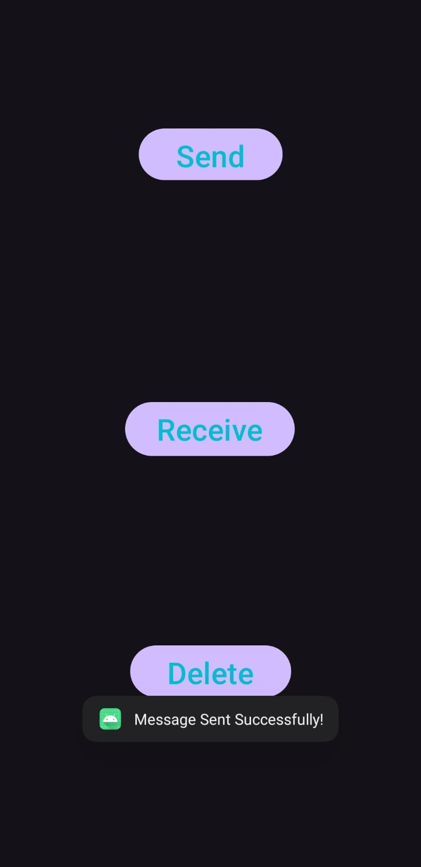 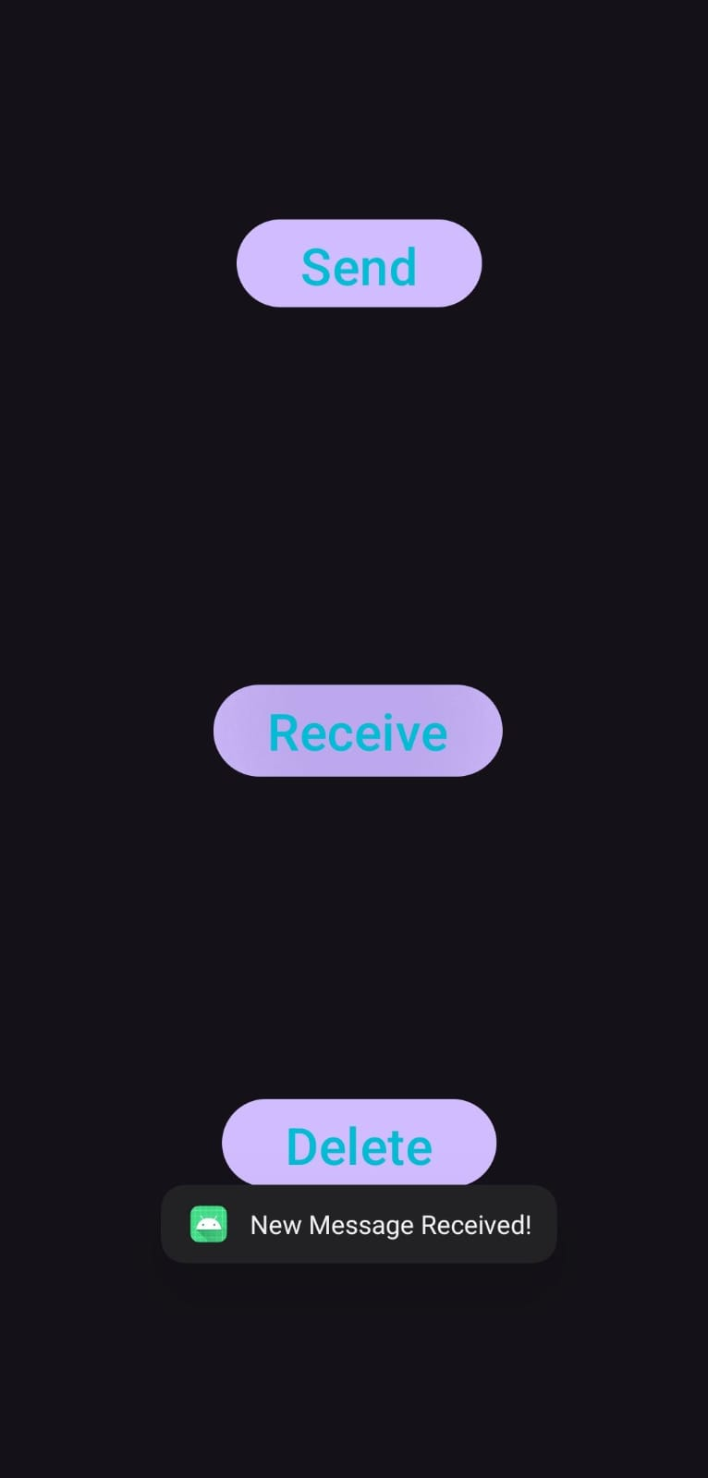 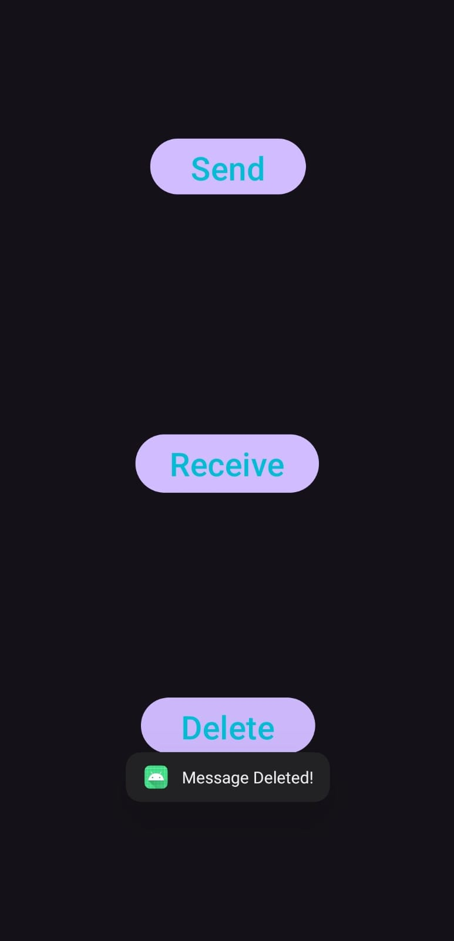

**Practical 3:**

**Working with Views and ViewGroups. (3 layout, FYIT, SYIT and TYIT. Use Color.xml, String.xml)**

**Code:**

**colors.xml**

<?xml version="1.0" encoding="utf-8"?>

<resources>

<color name="fy_background">#E6F3FF</color>

<color name="sy_background">#FFE6E6</color>

<color name="ty_background">#E6FFE6</color>

<color name="tyit_color">#D72B2B</color>

<color name="syit_color">#8BC34A</color>

<color name="fyit_color">#03A9F4</color>

<color name="white">#FFFFFF</color>

<color name="black">#000000</color>

</resources>

**strings.xml**

<?xml version="1.0" encoding="utf-8"?>

<resources>

<string name="app_name">Pratical3</string>

<string name="fy_title">First Year IT</string>

<string name="sy_title">Second Year IT</string>

<string name="ty_title">Third Year IT</string>

<string name="welcome_msg">Welcome to</string>

<string name="department">Information Technology</string>

</resources>

**layout_fyit.xml**

<?xml version="1.0" encoding="utf-8"?>

<LinearLayout xmlns:android="http://schemas.android.com/apk/res/android"

android:layout_width="match_parent"

android:layout_height="match_parent"

android:background="@color/fy_background"

android:orientation="vertical"

android:padding="16dp">

<TextView

android:layout_width="453dp"

android:layout_height="wrap_content"

android:padding="16sp"

android:text="@string/welcome_msg"

android:textAlignment="gravity"

android:textColor="@color/fyit_color"

android:textSize="34sp" />

<TextView

android:layout_width="456dp"

android:layout_height="wrap_content"

android:layout_marginTop="16dp"

android:padding="16dp"

android:text="@string/fy_title"

android:textAlignment="gravity"

android:textColor="@color/fyit_color"

android:textSize="34sp"

android:textStyle="bold" />

</LinearLayout>

**layout_syit.xml**

<?xml version="1.0" encoding="utf-8"?>

<LinearLayout xmlns:android="http://schemas.android.com/apk/res/android"

android:layout_width="match_parent"

android:layout_height="match_parent"

android:background="@color/sy_background"

android:orientation="vertical"

android:padding="16dp">

<TextView

android:layout_width="wrap_content"

android:layout_height="wrap_content"

android:text="@string/welcome_msg"

android:textSize="24sp"

android:textColor="@color/syit_color"/>

<TextView

android:layout_width="wrap_content"

android:layout_height="wrap_content"

android:text="@string/sy_title"

android:textSize="32sp"

android:textStyle="bold"

android:layout_marginTop="16dp"

android:textColor="@color/syit_color"/>

</LinearLayout>

**layout_tyit.xml**

<?xml version="1.0" encoding="utf-8"?>

<LinearLayout xmlns:android="http://schemas.android.com/apk/res/android"

android:layout_width="match_parent"

android:layout_height="match_parent"

android:background="@color/ty_background"

android:orientation="vertical"

android:padding="16dp">

<TextView

android:layout_width="wrap_content"

android:layout_height="wrap_content"

android:text="@string/welcome_msg"

android:textColor="@color/tyit_color"

android:textSize="34sp" />

<TextView

android:layout_width="wrap_content"

android:layout_height="wrap_content"

android:layout_marginTop="16dp"

android:text="@string/ty_title"

android:textColor="@color/tyit_color"

android:textSize="34sp"

android:textStyle="bold" />

</LinearLayout>

**Output:**

 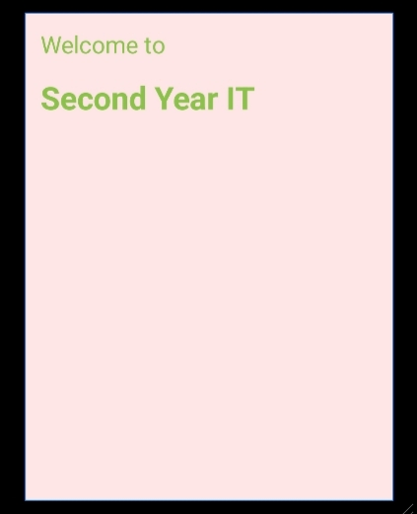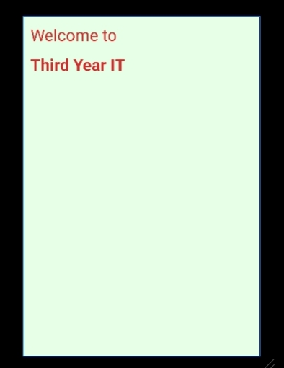

**Practical 4:**

**Introduction to Fragments: Implement fragments within activities to create Dynamic UI.**