Enhancing Visibility in Foggy Landmark Images: Advanced Restoration Methods

Jyoti Madake
Department of Electronics and Telecommunication Engineering
Vishwakarma Institute of Technology
Pune, India
jyoti.madake@vit.edu

Shruti Korpade
Department of Electronics and Telecommunication Engineering
Vishwakarma Institute of Technology
Pune, India
shruti.korpade21@vit.edu

Hemal Kulkarni
Department of Electronics and Telecommunication Engineering
Vishwakarma Institute of Technology
Pune, India
hemal.kulkarni22@vit.edu

Rahul Kumbhar
Department of Electronics and Telecommunication Engineering
Vishwakarma Institute of Technology
Pune, India
rahul.kumbhar21@vit.edu

Shripad Bhatlawande
Department of Electronics and Telecommunication Engineering
Vishwakarma Institute of Technology
Pune, India
shripad.bhatlawande@vit.edu

Abstract— The proposed solution to improve the clarity and detail of foggy or hazy images that show historical places, monuments, and archaeological digs an important task for records and preservation. Initially, the effectiveness of two distinct algorithms is explored: Markov Random Fields for image restoration and a Riemannian rank-adaptive method for low-rank matrix completion. Through separate implementations, their individual capabilities in restoring image clarity and detail are evaluated. Afterwards, both algorithms are integrated to synergistically enhance the restoration process. The findings of our proposed solution demonstrate that the combined approach yields significantly improved results, effectively mitigating haze and revealing intricate details obscured in the original images. The integrated methodology offers a promising solution for the restoration and preservation of invaluable cultural heritage imagery. The Combined Restoration approach has the lowest entropy of 6.0 for the enhanced image, indicating a more structured result. It achieves the highest visibility metric of 29.12 and a competitive MSE of 109.93 compared to the hazy image. The proposed system performs best in terms of balancing entropy and visibility enhancement while improving the difference (MSE) between the hazy and restored images.
Keywords— foggy or hazy images, Image restoration, Markov random filed, A Riemannian rank adaptive

Introduction
Hazy or foggy circumstances can conceal key features in photographs of historical landmarks, monuments, and archaeological sites, making proper documentation and preservation difficult for future generations [13]. These sites are historically and culturally important, and their degradation reduces their visual impact and historical worth. Accurate documentation and maintenance of cultural heritage photos are critical to preserving our common past. However, the existence of haze offers substantial challenges. Developing efficient picture restoration approaches necessitates advanced algorithms and methodology, and combining several algorithms poses technological problems in terms of compatibility, optimization, and synergistic effects [8, 9]. Furthermore, restricted access to high-quality data and computing resources might stymie the development and use of successful restoration methods.
The preservation of historical landmarks, monuments, and archaeological sites is crucial for their cultural heritage. Enhancing the visibility and detail in hazy or foggy images is essential for accurate historical documentation. Restoring visibility in degraded images allows researchers, historians, and conservationists to study and analyze these sites with greater precision, contributing to a more comprehensive understanding of our past [4, 5]. Improved image restoration techniques support conservation efforts by providing better visual documentation of cultural heritage sites, enabling monitoring changes over time, identifying areas of deterioration, and guiding restoration initiatives for long-term preservation. High-quality images of historical landmarks and monuments serve as valuable educational resources, enriching educational materials, exhibitions, and outreach programs. Developing advanced image restoration techniques for cultural heritage preservation pushes the boundaries of image processing and computer vision research, tackling unique challenges posed by atmospheric degradation in historical images.
The proposed new method is to improve the clarity and details of foggy or hazy images of historical sites. It uses two algorithms: Markov Random Fields and a Riemannian rank-adaptive method for low-rank matrix completion [1, 7]. Each algorithm has its strengths and limitations, and their efficacy in restoring image clarity and detail is assessed separately. The combined approach is integrated to enhance the restoration process, focusing on mitigating haze and revealing intricate details. This approach contributes to cultural heritage preservation by offering a promising solution for preserving valuable historical imagery.

Literature survey
Methods to recover visibility and detail from blurry or hazy photographs have been extensively investigated by researchers, especially for computer vision jobs, historical landmark documentation, and conservation applications. Markov Random Fields (MRFs) for image restoration and Riemannian Rank-Adaptive Methods for low-rank matrix completion are the two main strategies that are now in use.
A strong framework for simulating spatial dependencies between pixels in an image is provided by MRFs. Their ability to consider the interactions between neighbouring pixels makes them ideal for jobs like dehazing, when restoring the underlying scene details is required.
Numerous investigations have exhibited the efficacy of MRFs in image dehazing. Block effects and lighting fluctuations are addressed by a superpixel-based MRF approach in [1], which outperforms state-of-the-art techniques. Comparably, [2] suggests an MRF model for dehazing a single image that is especially useful for road photographs with uniform fog. In terms of restoring the scene's brightness, this approach works better than current ones.
One widely used dehazing method is the Dark Channel Prior (DCP) algorithm, yet it has trouble processing pixels that resemble airlights. To overcome this constraint, [3] successfully corrects erroneous transmittance maps by integrating MRFs with DCP.
A different method is described in [4] that makes use of a Dual Dark Channel Prior (FLD-DDCP) and Fisher's Linear Discriminant. This technique avoids artefacts, removes haze effectively in a range of weather situations, and yields good restoration outcomes.
Riemannian rank-adaptive algorithms offer an alternate solution for picture restoration tasks, especially when working with low-rank matrices, even though multilayer random fields (MRFs) are excellent at modelling spatial dependencies.
The works in [7][15][20] address the developments in low-rank matrix optimisation methods, with an emphasis on the effective recovery of ill-conditioned full-rank matrices. A few techniques are presented with the goal of solving optimisation problems with bounded-rank constraints, such as rank-adaptive methods and Riemannian optimisation systems. These techniques include smooth Riemannian descent, dynamic rank adjustment during optimisation, and greedy rank-increasing outer iteration. The results of the experiments show that the current frameworks could be improved upon, as they outperform current methods. Enhancing efficiency, parameter optimisation, convergence analysis, and investigating other Riemannian optimisation methods are some of the future research directions. Reducing solitary points without compromising delicate fringes is a common step in the restoration of images from InSAR (Interferometric Synthetic Aperture Radar) data. [8] introduces a new strategy for singular point restoration (SPR) based on the notion of a "singular unit." This technique shows how to remove singular points with good performance while keeping important landscape elements.
In addition to MRFs and Riemannian methods, several methods deal with haze or fog-related image degradation.
In [5], gamma modification and thresholding techniques are suggested for improving visibility. This approach is appropriate for real-time applications since it concentrates on colour validation, contrast improvement, ambient light estimate, and scene radiance restoration. The effects of image haze on computer vision algorithms can be substantial. [6] talks on how effective dehazing techniques that work for different kinds of fog are necessary. The authors urge future study employing machine learning techniques and point out the drawbacks of current approaches that call for manual parameter setting. Haze reduction techniques can also be applied to images. demonstrates a technique for video inpainting [10] that restores damaged pixels in image sequences using a Gibbs distribution and Markov Random Field (MRF) modelling. Using undistorted pixels, the approach builds an MRF on missing regions, and Gibbs sampling is used to restore missing pixels.
MRFs, or symmetric Markov Random Fields, are an additional method for segmenting images. [11] examines how they might be used for image segmentation, which is an important stage in image restoration projects, especially when handling complicated scenes with different fog densities. Using a variational distribution approximation and a prior on a Generalised Gaussian Markov Random Field, [9] presents novel algorithms for image restoration and parameter estimation. These techniques use a hierarchical Bayesian framework to estimate the recovered image and unknown hyperparameters. Often, image restoration entails addressing blur and noise. [12] models the link between the image and measurements using a Bayesian restoration technique that makes use of MRFs. To account for the intensity and direction of the image edges, it adds complex-valued line integrals, which produces a successful restoration, especially for local visual discontinuities.
The issue of restoring vision in foggy photos is also discussed in [13]. The authors suggest a technique that maintains genuine image colours while drastically cutting down on processing time. [14] discusses the analytical difficulties of MRFs in picture restoration. To decrease complexity and runtime and increase the viability of MRFs for managing huge datasets, the research suggests an analytical method. The approach does acknowledge edge preservation's shortcomings, though. In [16], methods for improving underwater images are examined. The study suggests an approach that achieves better results in underwater image restoration by combining conventional contrast enhancement with adaptive histogram equalisation algorithms. Weather that is foggy affects applications like visual surveillance by lowering image quality. The difficulties of recovering hazy photos with large sky regions are covered in [17]. For dehazing, the paper suggests a segmentation strategy based on FCM clustering, which outperforms current techniques for real-time computer vision tasks.
To estimate air-light and restore fog-free photos, [18] use white balancing and inter-region linear smoothing. This approach achieves better fog removal performance than previous methods since it is not dependent on the quantity of fog and does not require human input. [19] deals with low-rank matrix recovery with missing entries. To provide efficient solutions, the paper formulates the problem as an unconstrained optimisation task on a Grassmann manifold and suggests Riemannian optimisation techniques.
Advancements in restoring visibility and detail in haze-damaged images have been made, with Markov Random Fields and Riemannian optimization methods being particularly effective. Future research should integrate these techniques with deep learning architectures for enhanced haze removal capabilities. Addressing challenges like real-time processing, handling diverse weather conditions, and preserving semantic information is crucial for further development in image restoration methods.

Methodology
Improving the clarity and detail of foggy or hazy images depicting historical places, monuments, and archaeological digs is a significant challenge, essential for the preservation and documentation of cultural heritage. Initially, the effectiveness of two distinct algorithms: Markov Random Fields for image restoration and a Riemannian rank-adaptive method for low-rank matrix completion, was explored. Each algorithm was tested out on its own to see how well they do at bringing back the clarity and detail in the images. Subsequently, the project integrated both algorithms to synergistically enhance the restoration process. It was carefully checked that how well does the combined method works to clear up the haze and show all the tiny details that were hard to see in the original pictures. The evaluation included qualitative assessment of the restored images. This project aims to offer a promising solution for the restoration and preservation of invaluable cultural heritage imagery.
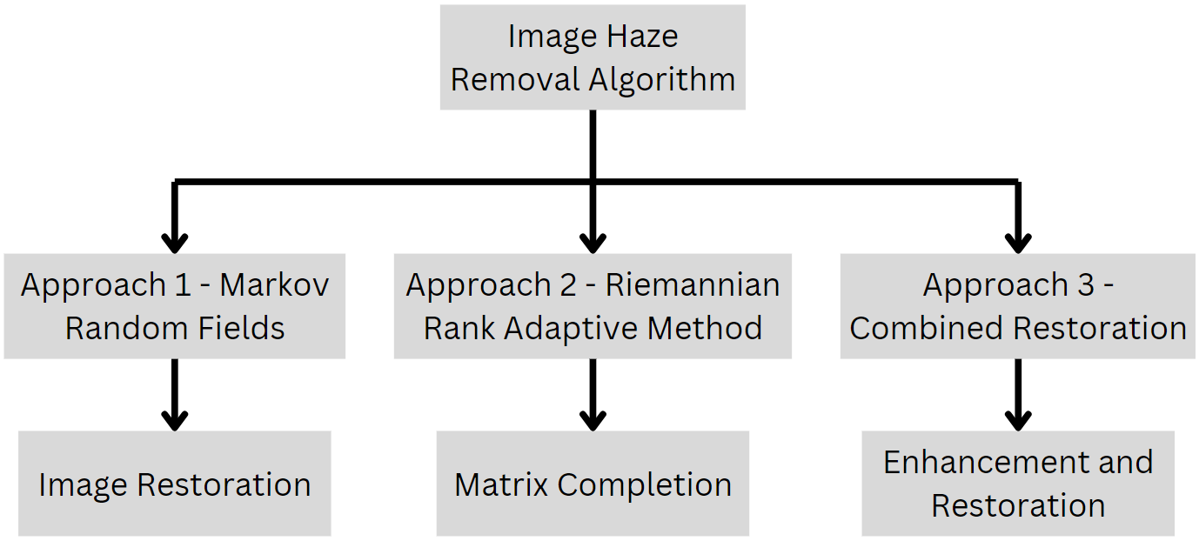
Fig. 2. Block Diagram
The input images are preprocessed and analyzed using the Markov Random Fields Algorithm for image restoration and the Riemannian Rank-Adaptive Method for low-rank matrix completion and detail enhancement. The combined restoration is achieved by integrating the results from both algorithms. Performance is assessed individually and compared against combined algorithms for a comprehensive evaluation.

- System Architecture:
This system focuses on enhancing images of historical sites, monuments, or archaeological digs. It begins with preprocessing, such as image convert grayscale, calculate dark channel, color adjustment, and resizing, to prepare the images for further processing. The Markov Random Fields Image Restoration algorithm is used to restore clarity and detail, leveraging spatial dependencies and smoothness constraints. The Riemannian Rank-Adaptive Method is used to enhance low-rank matrix completion, focusing on missing or degraded elements while preserving fine details. The results from both the MRF image restoration and Riemannian rank-adaptive method are combined to create an integrated restoration and enhancement output. The final output is enhanced images with improved clarity and detail, ready for further analysis, documentation, or preservation efforts.
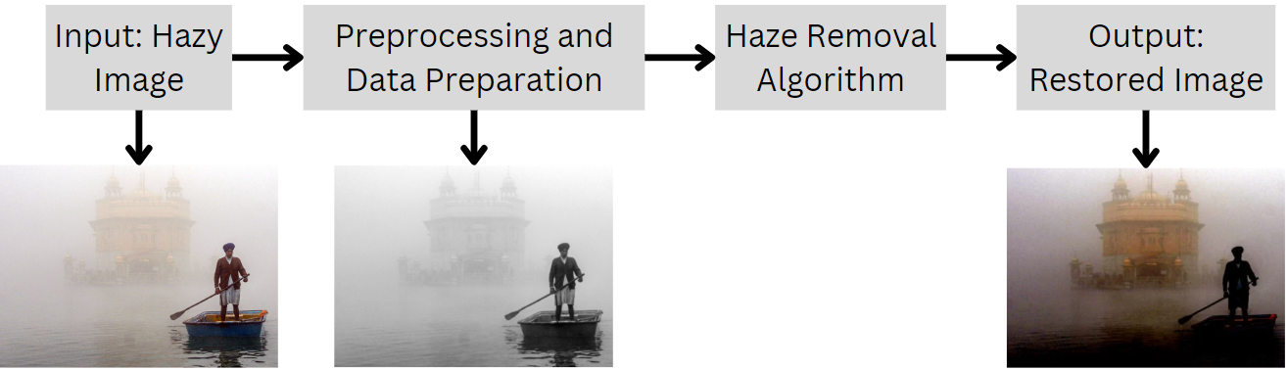
Fig. 1. System Architecture
- Dataset and Preprocessing:
The dataset contains foggy or hazy images captured at historical sites, monuments, and archaeological digs around Pune city [21]. The images are captured at high precision with different angles and directions. The dataset contains various patterns of images captured through sharp camera lens.
The preprocessing of haze removal in input images. It involves converting images to grayscale and calculating the dark channel. Converting images to grayscale reduces computational complexity and focuses on luminance information, eliminating color variations. Calculating the dark channel provides crucial information about atmospheric scattering and atmospheric light estimation, aiding in haze removal algorithms. By identifying dark pixels within local patches, the dark channel highlights areas with minimal haze, aiding in accurate estimation of atmospheric light and transmission map. The preprocessing stage enhances key features visibility and guides subsequent processing steps towards more accurate and efficient haze removal.

- Haze Removal Algorithm:
MRF is a probabilistic graphical model that models local dependencies in image data based on conditional independence. It is commonly used in image restoration tasks, such as denoising, segmentation, and haze removal, to preserve image details while removing noise or haze. MRF incorporates prior knowledge about the image structure and enforces smoothness constraints during the restoration process, making it a valuable tool in preserving image details while removing noise or haze.
Algorithm 1 – Haze Removal using Markov Random Fields
Input: Hazy Image
Output: Clear and Detailed Image
Funtion:
- Compute the dark channel prior
dark_channel = ComputeDarkChannel(hazy_image, patch_size)
- Estimate the transmission map
transmission = 1 - omega * dark_channel
- Refine the transmission map using MRF
- refined_transmission = transmission
- for i = 1 to mrf_iteration
- refined_transmission = Blur(refined_transmission, kernel_size=(3, 3))
- J = hazy_image / refined_transmission
- J_dark_channel = ComputeDarkChannel(J, 15)
- refined_transmission = 1 - beta * (1 - J_dark_channel)
- Enhance transmission in non-hazy regions
restored_transmission = Max(refined_transmission, transmission)
- Restore the hazy image
- restored_image = ZerosLike(hazy_image)
- for channel in [R, G, B]
- transmission_channel = Max(restored_transmission, 0.001)
- restored_image[channel] = (hazy_image[channel] - atmosphere[channel]) / transmission_channel + atmosphere[channel]
- Clip and normalize the restored image
- restored_image = Clip(restored_image, 0, 255)
- restored_image = restored_image.astype(uint8)
---------------------------------------------------------------------------
The Riemannian rank-adaptive method is a technique used for low-rank matrix completion tasks in image processing. It leverages the low-rank structure of real-world data matrices to complete missing or degraded elements. Unlike traditional methods, the Riemannian rank-adaptive method adapts the rank of the completion matrix based on local geometric properties of the data. This adaptive adjustment helps capture the underlying structure and preserve important image features. This method is particularly effective in scenarios where data exhibits varying complexity and requires adaptive modeling for accurate completion results.
Algorithm 2 – Haze Removal using Riemannian Rank Adaptive Method
Input: Hazy Image
Output: Completion of missing elements of the image
Funtion:
- Compute the dark channel prior
dark_channel = ComputeDarkChannel(image, window_size)
- Estimate the transmission map
transmission = 1 - omega * dark_channel
- Estimate atmosphere light
atmosphere = EstimateAtmosphere(image)
- Remove haze using transmission map and atmosphere light
dehazed_image = HazeRemoval(image, transmission, atmosphere)
---------------------------------------------------------------------------

Results and Discussions
In the Markov Random Fields Approach illustrated in Fig. 3, haze removal involves enhancing transmission in non-hazy regions and correcting atmospheric light. Parameter values, including omega (ω) at 0.98 for balancing haze removal and image appearance, beta (β) at 0.9 for refinement strength, a patch size of 5 for the dark channel prior, 4 iterations for MRF-based refinement, and an atmosphere color of [230, 230, 230], fine-tune the algorithm. The dehazing algorithm effectively removed haze from the original image, resulting in improved visibility of distant objects, enhanced depth perception, and vibrant, saturated colors, thereby restoring the image with enhanced clarity, detail, and color fidelity.

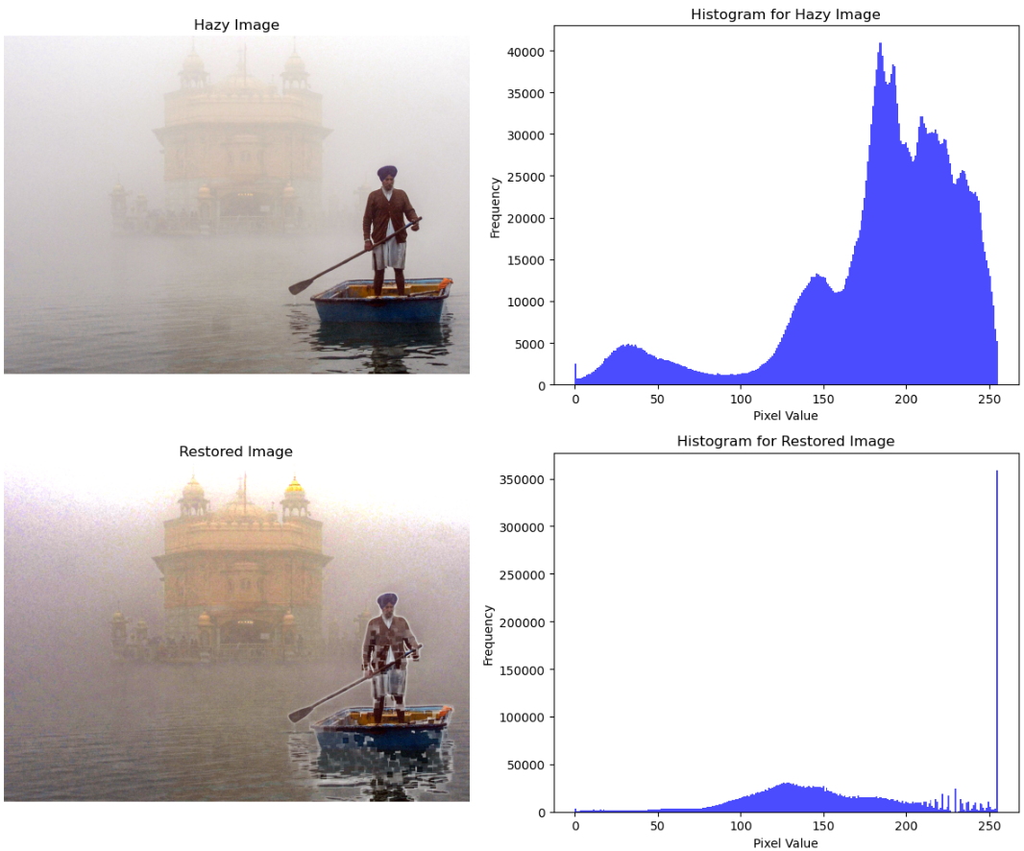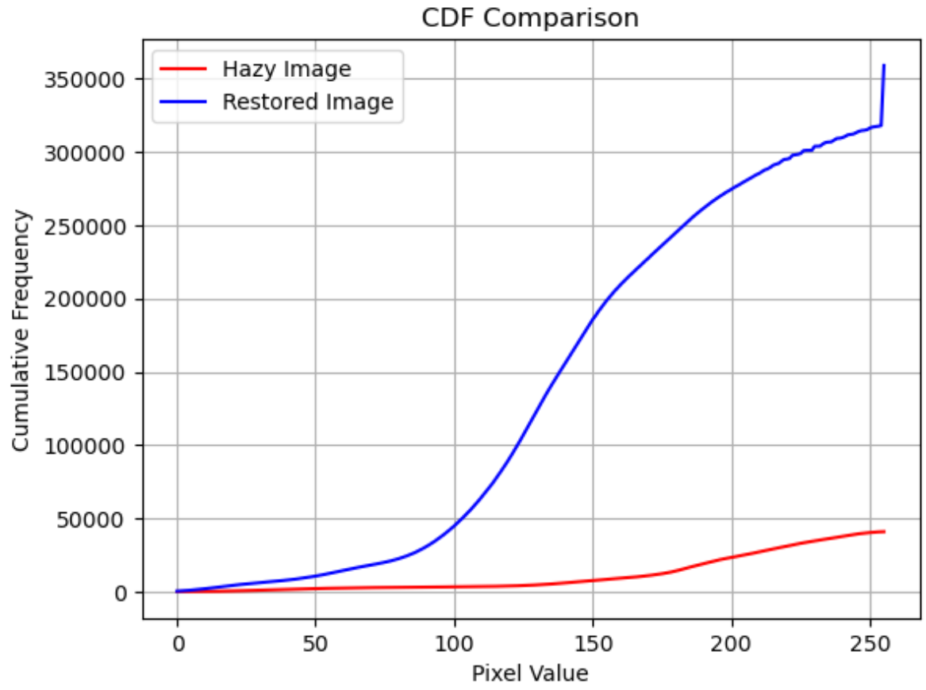
Fig. 3. Input and Output image for Markov Random Fields
In the Riemannian Rank Adaptive Method depicted in Fig. 4, the dark channel prior analyzes local patches to estimate haze, resulting in a dark channel image highlighting low haze regions, while the transmission map indicates haze intensity. Atmospheric light, estimated from the input image, contributes to haze removal alongside the transmission estimation function utilizing an omega value of 0.95 and a window size of 15. Dehazing involves dividing the difference by the estimated transmission map, yielding a dehazed image with enhanced visibility and clarity, closely resembling a scene under clear atmospheric conditions, enhancing visualization and analysis.
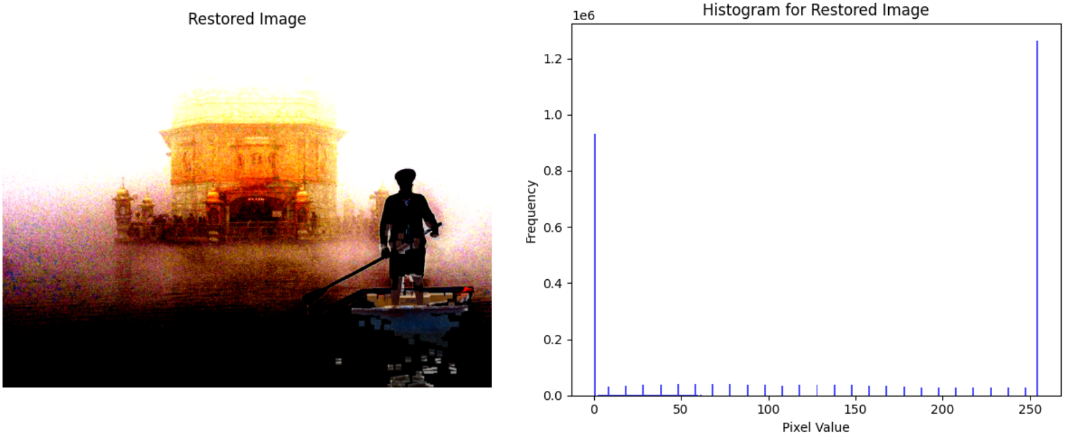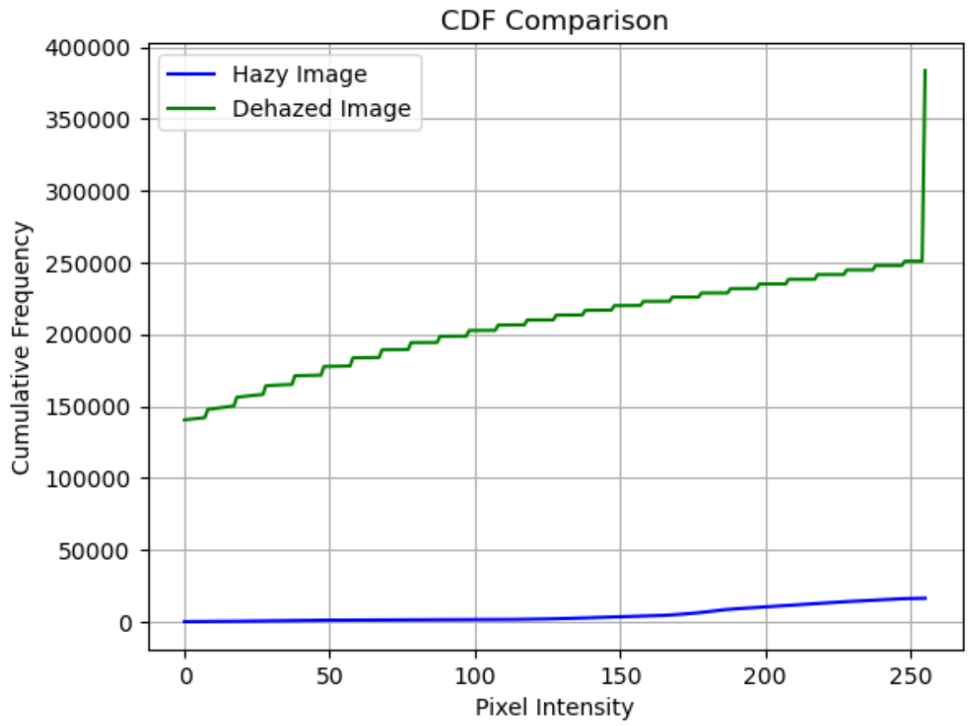
Fig. 4. Input and Output image for Riemannian Rank Adaptive Method
Later, the proposed system implements a comprehensive haze removal algorithm by integrating both the Markov Random Fields (MRF) approach and the Riemannian Rank Adaptive Method. Initially, the dark channel prior is computed to estimate haze in the image, followed by the generation of a transmission map utilizing the dark channel prior. Guided filtering is then employed to refine the transmission map for improved accuracy. Subsequently, haze removal is executed using the refined transmission map and atmospheric light estimation, resulting in a dehazed image with enhanced visibility, clarity, and color fidelity compared to the original hazy image as shown in Fig. 5. The algorithm successfully mitigates the adverse effects of haze and fog, providing a clearer representation of the scene and facilitating improved visualization and analysis in various applications.
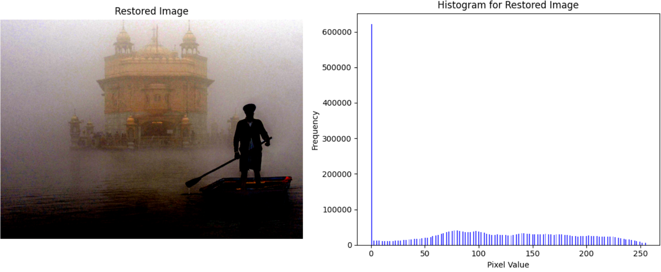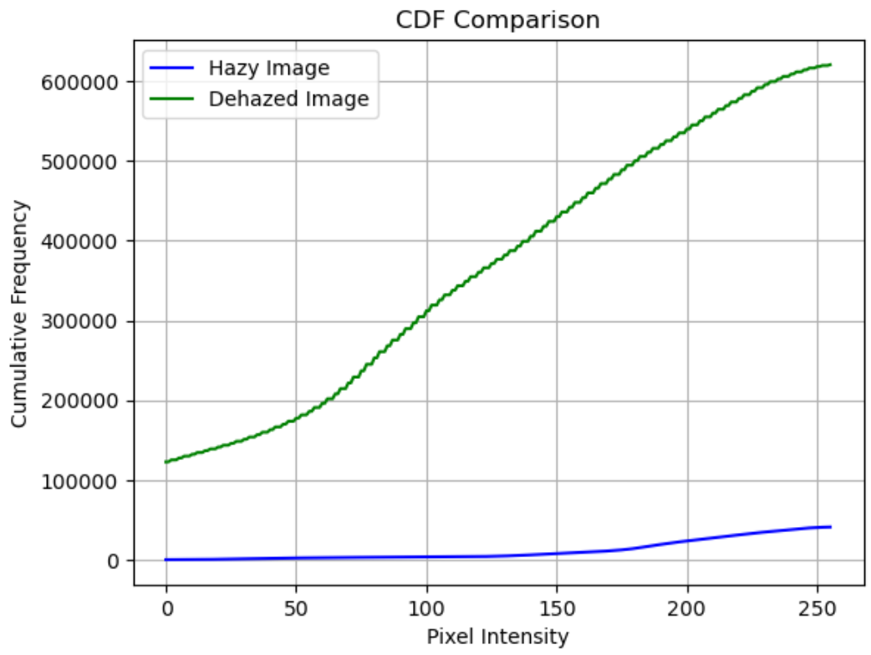
Fig. 5. Input and Output image for Combined Restoration
Additionally, the colors in the dehazed image appear vibrant and saturated, resulting in a visually appealing and detailed image. The histogram and cumulative distribution function (CDF) analyses further corroborate the algorithm's effectiveness, showcasing the improved contrast and more uniform distribution of pixel intensities in the dehazed image compared to the hazy input.
In Fig. 6, the haze or fog is reduced, but the dehazed image still appears blurred, especially in the background and distance. The foreground person is more distinct, but the scene's clarity and visibility are not fully restored. The left histogram shows a hazy image with a narrow peak around lower pixel intensity values, indicating low brightness values. The right histogram shows a broader distribution across the pixel intensity range after dehazing or processing, slightly improving contrast as compared to the original hazy image. This suggests that the dehazing algorithm or technique is not entirely successful or optimal in removing atmospheric haze from the original hazy image.

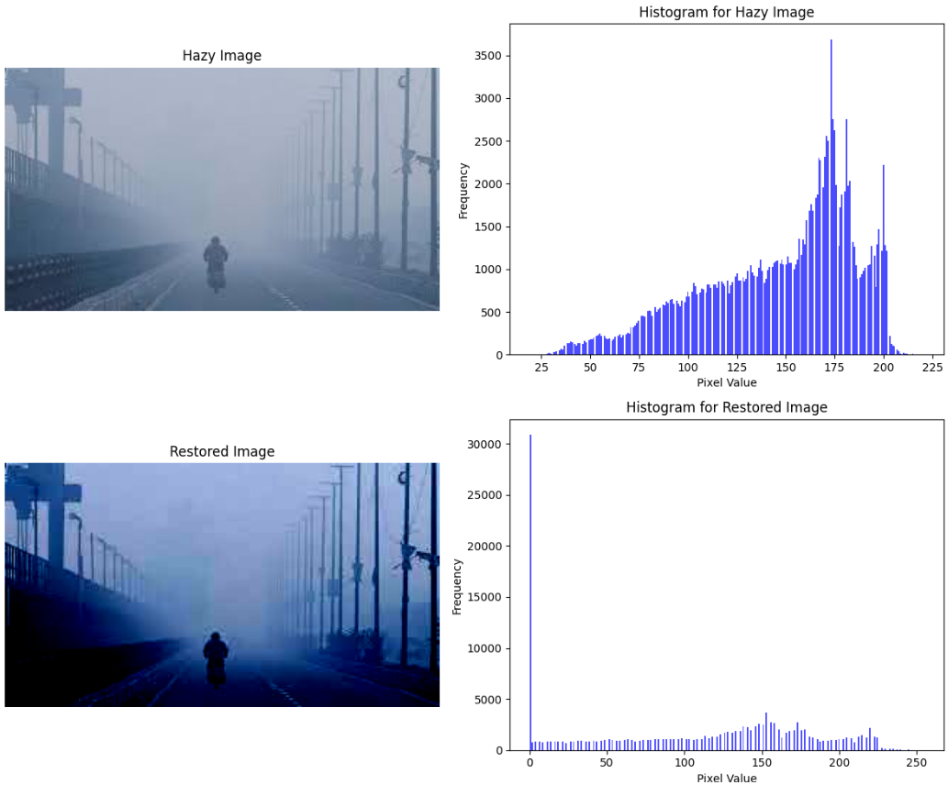
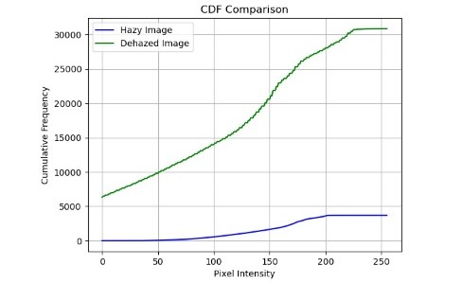
Fig. 6. Unfavourable Case
- Intensity Comparison: Hazy Image vs. Dehazed Image
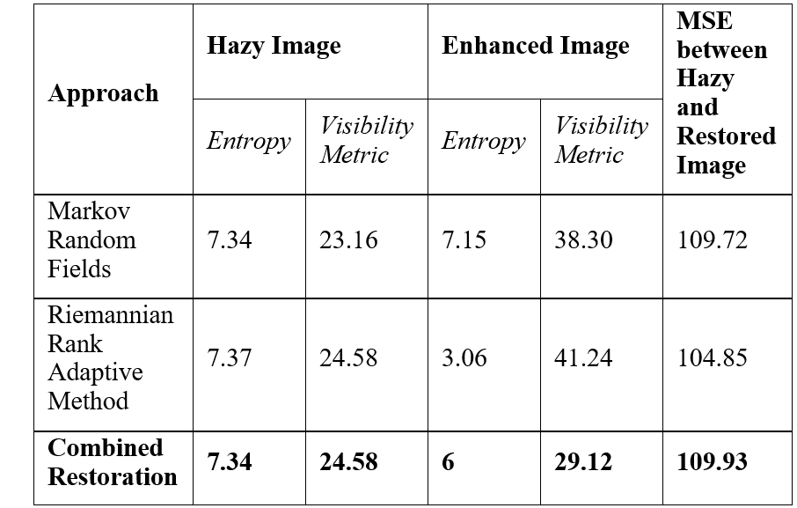
Table 1 presents the various evaluation metrics for image enhancement and haze removal approaches. The Markov Random Fields approach has a high entropy value for hazy images, indicating high randomness. The enhanced image achieves a visibility metric of 7.15 and an MSE of 109.72. The Riemann Rank Adaptive Method has a higher entropy but better visibility metric of 3.06 and lower MSE of 104.85. The Combined Restoration approach has the lowest entropy of 6.0 for the enhanced image, indicating a more structured result. It achieves the highest visibility metric of 29.12 and a competitive MSE of 109.93 compared to the hazy image. Overall, the Combined Restoration approach performs best in terms of balancing entropy and visibility enhancement while minimizing the difference (MSE) between the hazy and restored images.
Combined Restoration approach seems to perform the best in terms of balancing randomness (entropy) and visibility enhancement while minimizing the difference (MSE) between the hazy and restored images. The strengths of both methods, the Combined Restoration approach likely overcomes the limitations of individual techniques and exploits their complementary advantages, leading to superior performance in haze removal and image quality improvement.
- Comparison of Proposed System with Other Models
Method | PSNR | MSE | Visibility Metrics (VM)
He et al. [6] | 19.43 | 739.32 | 0.02
Thresholding + Gamma Transformation [5] | 21.34 | 120.22 | 7.93
Markov Rrandom Field + Dark Channel Prior [3] | 22.13 | 110.25 | 7.50
Markov Random Field + Riemannian Rank Adaptive (Proposed system) | 27.71 | 109.90 | 29.12

The proposed system outshines the existing methods in Table 2, demonstrating its superiority through the highest PSNR of 27.71, yet it also exhibits the lowest MSE of 109.90. These metrics collectively indicate that the proposed system achieves more accurate and higher-quality image reconstructions or enhancements compared to the methods presented by "He et al." [6], "Thresholding + Gamma Transformation" [5], and "Markov Random Field + Dark Channel Prior" [3]. Although it boasts a higher VM value of 29.12, suggesting better visibility enhancement and more effective haze removal, its significant advantages in PSNR, MSE, and VM firmly establish it as the most effective and improved system among those listed in the table.

Conclusion
The integrated approach combining Markov Random Fields and Riemannian Rank Adaptive methods demonstrates superior performance in removing atmospheric haze and enhancing the clarity and detail of hazy images, particularly those depicting historical sites and cultural heritage. Through quantitative analysis of intensity values and qualitative visual assessments, the proposed solution outperforms individual techniques, effectively mitigating haze, revealing obscured details, and restoring vibrant colors and depth perception crucial for preserving and analyzing invaluable cultural imagery, while also highlighting opportunities for further optimization in challenging scenarios. The Combined Restoration approach has the lowest entropy of 6.0 for the enhanced image, indicating a more structured result. It achieves the highest visibility metric of 29.12 and a competitive MSE of 109.93 compared to the hazy image. Overall, the Combined Restoration approach performs best in terms of balancing entropy, visibility enhancement and improving MSE between the hazy and restored images. Its significant advantages in PSNR, MSE, and VM firmly establish it as the most effective and improved system among those presented in the table.

References
- Y. Tan and G. Wang, "Image Haze Removal Based on Superpixels and Markov Random Field," in IEEE Access, vol. 8, pp. 60728-60736, 2020, doi: 10.1109/ACCESS.2020.2982910.
- L. Caraffa and J. -P. Tarel, "Markov Random Field model for single image defogging," 2013 IEEE Intelligent Vehicles Symposium (IV), Gold Coast, QLD, Australia, 2013, pp. 994-999, doi: 10.1109/IVS.2013.6629596.
- Xu, H., Tan, Y., Wang, W. et al. Image Dehazing by Incorporating Markov Random Field with Dark Channel Prior. J. Ocean Univ. China 19, 551–560 (2020). https://doi.org/10.1007/s11802-020-4003-6
- Chen, Bo-Hao, and Shih-Chia Huang. "An advanced visibility restoration algorithm for single hazy images." ACM Transactions on Multimedia Computing, Communications, and Applications (TOMM) 11, no. 4 (2015): 1-21.
- S. K. Sahoo, A. Kumari and M. C. Chinnaiah, "Fast and Efficient Visibility Restoration Technique for Single Image Dehazing and Defogging," in IEEE Access, vol. 9, pp. 48131-48146, 2021, doi: 10.1109/ACCESS.2021.3068446.
- Bansal, Bindu, Jagroop Singh Sidhu, and Kiran Jyoti. "A review of image restoration based image defogging algorithms." International Journal of Image, Graphics and Signal Processing 9, no. 11 (2017): 62.
- B. Vandereycken and A. Uschmajew, "Greedy rank updates combined with Riemannian descent methods for low-rank optimization," 2015 International Conference on Sampling Theory and Applications (SampTA), Washington, DC, USA, 2015, pp. 420-424, doi: 10.1109/SAMPTA.2015.7148925.
- R. Yamaki and A. Hirose, "Singular Unit Restoration in Interferograms Based on Complex-Valued Markov Random Field Model for Phase Unwrapping," in IEEE Geoscience and Remote Sensing Letters, vol. 6, no. 1, pp. 18-22, Jan. 2009, doi: 10.1109/LGRS.2008.2005588.
- S. Derin Babacan, R. Molina and A. K. Katsaggelos, "Generalized Gaussian Markov random field image restoration using variational distribution approximation," 2008 IEEE International Conference on Acoustics, Speech and Signal Processing, Las Vegas, NV, USA, 2008, pp. 1265-1268, doi: 10.1109/ICASSP.2008.4517847.
- X. Mei, "Video inpainting by Markov Random Field modeling and Gibbs sampling," 2017 IEEE 2nd Advanced Information Technology, Electronic and Automation Control Conference (IAEAC), Chongqing, China, 2017, pp. 2275-2278, doi: 10.1109/IAEAC.2017.8054425.
- S. Yousefi, N. Kehtarnavaz and Y. Cao, "Computationally Tractable Stochastic Image Modeling Based on Symmetric Markov Mesh Random Fields," in IEEE Transactions on Image Processing, vol. 22, no. 6, pp. 2192-2206, June 2013, doi: 10.1109/TIP.2013.2246516
- S. Colonnese, S. Rinauro and G. Scarano, "Markov Random Fields using complex line process: An application to Bayesian image restoration," 3rd European Workshop on Visual Information Processing, Paris, France, 2011, pp. 30-35, doi: 10.1109/EuVIP.2011.6045517.
- M. Sharma, B. Kaur and A. Verma, "An improved visibilty enhancement method for foggy images," 2018 International Conference on Information Management and Processing (ICIMP), London, UK, 2018, pp. 120-124, doi: 10.1109/ICIMP1.2018.8325852.
- Pleschberger, M., Schrunner, S. & Pilz, J. An Explicit Solution for Image Restoration using Markov Random Fields. J Sign Process Syst 92, 257–267 (2020). https://doi.org/10.1007/s11265-019-01470-9
- Gao, B., Absil, PA. A Riemannian rank-adaptive method for low-rank matrix completion. Comput Optim Appl 81, 67–90 (2022). https://doi.org/10.1007/s10589-021-00328-w
- L. Zheng, H. Shi and S. Sun, "Underwater image enhancement algorithm based on CLAHE and USM," 2016 IEEE International Conference on Information and Automation (ICIA), Ningbo, China, 2016, pp. 585-590, doi: 10.1109/ICInfA.2016.7831889.
- T. Pal and M. K. Bhowmik, "Quality Enhancement of Foggy Images Comprising of Large Sky Region on SAMEER TU Dataset," 2018 9th International Conference on Computing, Communication and Networking Technologies (ICCCNT), Bengaluru, India, 2018, pp. 1-7, doi: 10.1109/ICCCNT.2018.8493832.
- R. R. Choudhary and A. K. Tiwari, "Inter-region linear smoothing function for foggy and hazy images," 2016 International Conference on Signal Processing and Communication (ICSC), Noida, India, 2016, pp. 334-339, doi: 10.1109/ICSPCom.2016.7980602.
- Boumal, N., Absil, P.-A.: Low-rank matrix completion via preconditioned optimization on the Grassmann manifold. Linear Algebra Appl. 475, 200–239 (2015). https://doi.org/10.1016/j. laa.2015.02.027
- Zhou, G., Huang, W., Gallivan, K.A., Van Dooren, P., Absil, P.-A.: A Riemannian rank-adaptive method for low-rank optimization. Neurocomputing 192, 72–80 (2016). https://doi.org/10.1016/j.neucom.2016.02.030
- Pawar, Poonam; Ainapure, Dr.Bharati (2023), “Historical Places dataset of Pune”, Mendeley Data, V2, doi: 10.17632/x3s9ryg5w9.2

