GIT HANDSON

shrut@SHRUTI MINGW64 ~ (master)
$ git version
git version 2.43.0.windows.1

shrut@SHRUTI MINGW64 ~ (master)
$ git config --global user.name "Shruti"

shrut@SHRUTI MINGW64 ~ (master)
$ git config --global user.email "shruti.sundar0405@gmail.com"

shrut@SHRUTI MINGW64 ~ (master)
$ git config --global --list
user.email=shruti.sundar0405@gmail.com
user.name=shruti-s0405
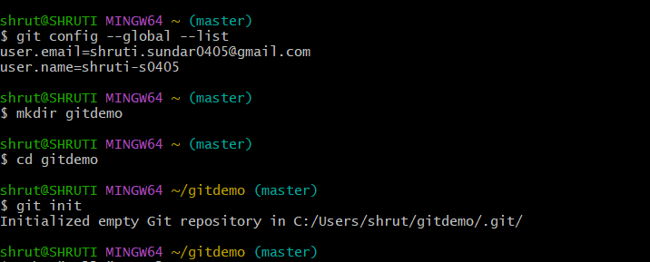

shrut@SHRUTI MINGW64 ~/gitdemo(main)
$ mkdir gitdemo1

shrut@SHRUTI MINGW64 ~/gitdemo(main)
$ cd gitdemo1

shrut@SHRUTI MINGW64 ~/gitdemo(main)
$ git init
Initialized empty Git repository in C:/Users/HP/gitdemo1/.git/

shrut@SHRUTI MINGW64 ~/gitdemo(main)
$ echo "Hello from gitdemo" >welcome.txt

shrut@SHRUTI MINGW64 ~/gitdemo(main)
$ cat welcome.txt
Hello from gitdemo

shrut@SHRUTI MINGW64 ~/gitdemo(main)
$ git add welcome.txt
warning: in the working copy of 'welcome.txt', LF will be replaced by CRLF the next time Git touches it

shrut@SHRUTI MINGW64 ~/gitdemo(main)
$ git remote add origin https://github.com/Shruti-S0405/gitdemo.git

shrut@SHRUTI MINGW64 ~/gitdemo(main)
$ git push -u origin main
Enumerating objects: 4, done.
Counting objects: 100% (4/4), done.
Delta compression using up to 4 threads
Compressing objects: 100% (2/2), done.
Writing objects: 100% (3/3), 311 bytes | 155.00 KiB/s, done.
Total 3 (delta 0), reused 0 (delta 0), pack-reused 0 (from 0)
To https://github.com/Shruti-S0405/gitdemo.git
5a6a88a..c50a175 main -> main
branch 'main' set up to track 'origin/main'.

