Market analysis

Industry Overview

- India is the 2nd largest two-wheeler market in the world.
- It stands next only to China and Japan in terms of the number of two- wheelers produced and the sales of two-wheeler respectively.
- In 2013, the Indian two-wheeler market accounted for 14.38 million units
- CAGR (compound annual growth rate) (last three decade’s) is10.03%
- Average two-wheelers per 1000 people in India are 31
- The urban market for two-wheelers is largely penetrated with nearly 57 of every 100 youths that earn an income to support the ownership of a two-wheeler
- More than 15 industry players in existence.

Sale of geared and non-geared two-wheeler
Segment | FY 2019-20 | FY 2018-19 | Growth
Motorcycles | 1,12,14,640 | 1,35,98,190 | -17.5%
Scooters | 55,66,036 | 67,01,430 | -16.9%
Mopeds | 6,36,940 | 8,80,227 | -27.6%
Total | 1,74,17,616 | 2,11,79,847 | -17.8%

Two-wheeler domestic sales in India from financial year 2013-2021

F Y | Two wheelers sold  (in million units)
2021 | 15.12
2020 | 17.42
2019 | 21.18
2018 | 20.2
2017 | 17.6
2016 | 16.5
2015 | 16
2014 | 14.8
2013 | 13.8

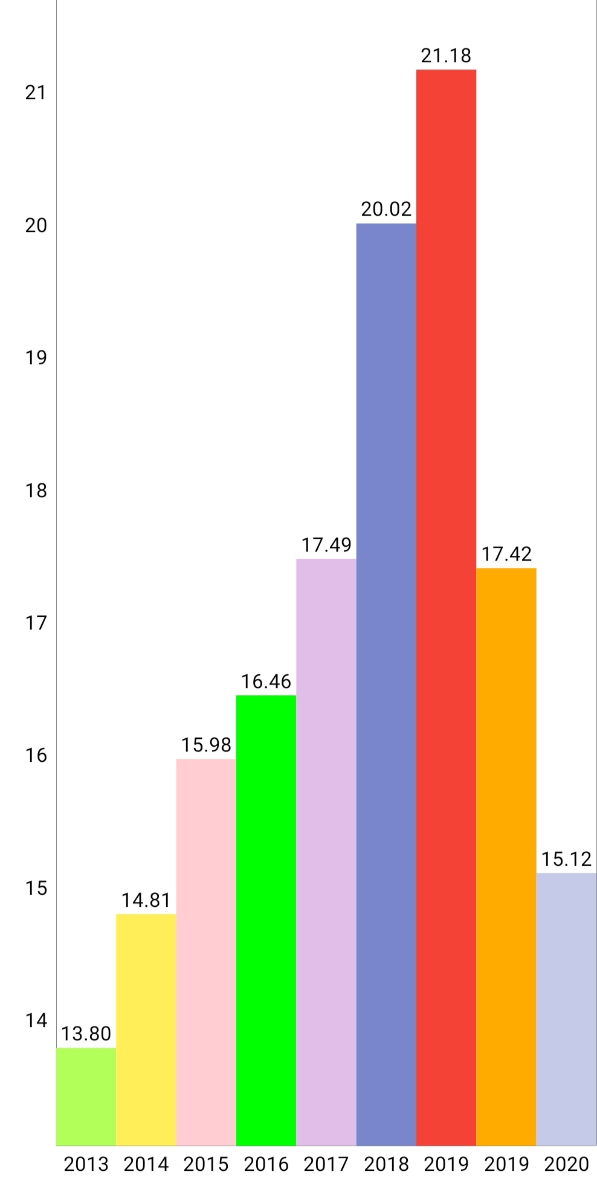
State wise domestic sale of two wheelers

SI.NO | State | Jun’19 | Jun’18 | May’19 | YOY % diff | MOM% diff
1 | U. Pradesh | 2,55,812 | 2,58,410 | 2,36,731 | -1.01% | 8.06%
2 | Tamil Nadu | 1,24,535 | 1,43,793 | 1,31,093 | -13.39% | -5.00%
3 | Maharashtra | 1,18,453 | 1,44,012 | 1,51,264 | -17.75% | -21.69%
4 | Bihar | 1,14,959 | 87,728 | 1,16,032 | 31.04% | -0.93%
5 | Karnataka | 1,00,087 | 1,10,988 | 1,07,564 | -9.82% | -6.95%
6 | Rajasthan | 79,896 | 78,629 | 95,968 | 1.61% | -16.75%
7 | Gujarat | 76,175 | 1,04,750 | 92,729 | -27.22% | -17.85%
8 | West Bengal | 70,033 | 1,01,750 | 66,900 | -31.17% | 4.68%
9 | Kerala | 55,824 | 0 | 55,736 | N/A | 0.16%
10 | Odisha | 54,357 | 62,897 | 56,527 | -13.58% | -3.84%
11 | Punjab | 41,834 | 56,052 | 43,613 | -25.37% | -4.08%
12 | Haryana | 41,006 | 43,200 | 39,706 | -5.08% | 3.27%
13 | Jharkhand | 39,393 | 42,091 | 45,605 | -6.41% | -13.62%
14 | Chhatisgarh | 38,241 | 38,933 | 44,327 | -1.78% | -13.73%
15 | Assam | 33,568 | 30,696 | 37,380 | 9.65% | -9.96%
16 | Delhi | 32,561 | 37,903 | 38,007 | -14.09% | -14.33%
17 | Uttarakhand | 13,709 | 15,668 | 17,265 | -12.50% | -20.60%
18 | J & k | 8,197 | 9,581 | 9,671 | -14.45% | -15.24%
19 | Himachal P | 5,173 | 5,860 | 5,290 | -11.72% | -2.21%
20 | Pondicherry | 4,240 | 5,184 | 4,438 | -18.21% | -4.46%
21 | Goa | 2,799 | 3,553 | 3,732 | -21.22% | -25.00%
22 | Tripura | 2,757 | 4,075 | 3,837 | -32.34% | -28.15%
23 | Manipur | 2,712 | 1,619 | 1,803 | 67.51% | 50.42%
24 | Mizoram | 2,039 | 1,445 | 2,130 | 41.11% | -4.27%
25 | Chandigarh | 1,787 | 2,213 | 2,110 | -19.25% | -15.31%
26 | Meghalaya | 1,619 | 1,434 | 1,687 | 12.90% | -4.03%
27 | Arunachal | 1,387 | 761 | 1,545 | 82.26% | -10.23%
28 | D & N | 509 | 617 | 497 | -17.50% | 2.41%
29 | D & D | 364 | 521 | 342 | -30.13% | 6.43%
30 | Sikkim | 358 | 191 | 274 | 87.43% | 30.66%
31 | Nagaland | 349 | 302 | 433 | 15.56% | -19.40%
 | Total | 13,24,823 | 13,94,770 | 14,14,236 | -5.01 | -6.32

