
PROJECT REPORT
VOICE GUARD
INDIC FAKE VOICE DETECTION
A technical project report submitted in partial fulfilment of the requirements for the award of the degree
MASTER OF SCIENCE IN DATA SCIENCE
Submitted by | [STUDENT NAME]
Register number | [REGISTER NUMBER]
Project guide | [PROJECT GUIDE]
Academic year | [ACADEMIC YEAR]

DEPARTMENT OF DATA SCIENCE
CHRIST (DEEMED TO BE UNIVERSITY), BENGALURU

CERTIFICATE
This is to certify that the project report entitled “VOICE GUARD: INDIC FAKE VOICE DETECTION” is a bona fide record of the work carried out by [STUDENT NAME], Register Number [REGISTER NUMBER], under my supervision and guidance, in partial fulfilment of the requirements for the award of the degree of Master of Science in Data Science at CHRIST (Deemed to be University).
The work described in this report has been reviewed as a technical project draft. Final institutional approval, student particulars, guide particulars, signatures, dates, and seals must be completed before submission.

Project Guide | Head of Department
[PROJECT GUIDE]  [GUIDE DESIGNATION]  Signature: __________________ | Name: __________________  Signature: __________________  Date: __________________

Internal Examiner | External Examiner
Name: __________________  Signature: __________________ | Name: __________________  Signature: __________________

DECLARATION
I, [STUDENT NAME], Register Number [REGISTER NUMBER], hereby declare that the project report entitled “VOICE GUARD: INDIC FAKE VOICE DETECTION” is an original record of work carried out by me under the guidance of [PROJECT GUIDE]. The report has not been submitted, in whole or in part, for the award of any other degree, diploma, fellowship, or similar title.
Where external research, software libraries, datasets, pretrained models, and public documentation have been used, they are acknowledged in the references. Historical model metrics are explicitly distinguished from the new v2 evaluation protocol; no unexecuted v2 result is represented as measured evidence.

Place: Bengaluru
Date: __________________
Signature of Student: __________________

ACKNOWLEDGEMENT
I express my sincere gratitude to CHRIST (Deemed to be University), the Department of Data Science, and the project guide for the opportunity and guidance provided during this work. I also acknowledge the researchers and maintainers behind XLS-R, AASIST, PyTorch, Hugging Face Datasets, Streamlit, and the public speech anti-spoofing literature that informed the implementation and evaluation discipline of this project.
Special thanks are due to peers and reviewers who helped identify issues in split integrity, threshold orientation, input validation, robustness interpretation, and user-interface communication. These reviews led to a safer upload policy, a clearer three-way result, a reproducible Kaggle workflow, and a prompt-group-disjoint v2 experimental protocol.
Finally, I thank my family and friends for their continued encouragement throughout the project.
[STUDENT NAME]

ABSTRACT
Synthetic speech is increasingly accessible across languages and delivery channels, creating a need for practical tools that can flag potentially generated audio without presenting a machine score as proof. Voice Guard is a research and demonstration system for analysing uploaded speech across sixteen Indian languages. It combines a frozen 300-million-parameter XLS-R speech representation frontend with a trainable, AASIST-inspired graph-attention classifier head. A professional Streamlit interface validates audio before inference, binds results to the selected file hash, returns cautious three-way wording, and produces a one-page evidence report.
A repository review found that the historical v1 benchmark—98.39% accuracy and 1.03% equal error rate—was affected by extensive ID-family proxy overlap across split boundaries and had already been observed during development. The result is therefore retained only as a regression baseline. This report documents a v2 protocol that exports metadata without audio, constructs language-scoped prompt groups, creates a deterministic group-disjoint split, binds the audit to the exact split using SHA-256, rebuilds feature caches, compares candidate heads on validation only, and gates final test evaluation until one checkpoint is locked. The upstream metadata does not expose speaker or generator lineage, so the present v2 claim is limited to prompt-disjoint evaluation. No v2 accuracy is reported until the full Kaggle GPU run is completed.
Keywords: audio deepfake detection, Indic speech, XLS-R, graph attention, EER, Streamlit, leakage-resistant evaluation

TABLE OF CONTENTS
Section | Title | Page
1 | Introduction | 1
2 | System Analysis | 3
3 | System Design | 6
4 | Implementation | 10
5 | Testing and Results | 15
6 | Conclusion and Future Work | 21
Appendix A | Kaggle Demo Quick Start | 22
Appendix B | V2 Training Runbook | 23
Appendix C | Acceptance and Traceability Checklist | 24
 | References | 25
Page numbers refer to the Arabic numbering that begins with Chapter 1.

LISTS AND ABBREVIATIONS

LIST OF TABLES
No. | Title | Page
2.1 | Functional and non-functional requirements | 4
2.2 | Threats, controls, and residual risks | 5
3.1 | Decision policy and public wording | 8
4.1 | Repository module responsibilities | 10
5.1 | Historical v1 benchmark | 16
5.2 | V2 experiment status | 19

LIST OF FIGURES
No. | Title | Page
2.1 | V2 prompt-group-disjoint protocol | 5
3.1 | Voice Guard inference pipeline | 6
3.2 | Professional UI workflow and safety controls | 9
5.1 | Historical v1 confusion matrix | 16
5.2 | Historical v1 robustness evidence | 18

ABBREVIATIONS
Term | Meaning
AASIST | Audio Anti-Spoofing using Integrated Spectro-Temporal Graph Attention Networks
ECE | Expected Calibration Error
EER | Equal Error Rate
GAT | Graph Attention Network
HF | Hugging Face
TTS | Text-to-Speech
UI | User Interface
XLS-R | Cross-lingual Speech Representation model

CHAPTER 1

INTRODUCTION

1.1 BACKGROUND
Text-to-speech and voice-conversion systems can now create convincing speech with little specialised equipment. The same technology enables accessibility, dubbing, education, and creative production, but it can also be used in impersonation, misinformation, and social-engineering attacks. Detection is especially difficult when audio is short, compressed, noisy, replayed through a loudspeaker, or produced by a generator that was absent from training.
Voice Guard addresses this problem as a multilingual research prototype for sixteen Indian languages: Assamese, Bengali, Bodo, Dogri, English, Gujarati, Hindi, Kannada, Malayalam, Manipuri, Marathi, Nepali, Odia, Sanskrit, Tamil, and Telugu. The system analyses acoustic representations rather than the semantic truth of an utterance. Its result therefore indicates model evidence about synthetic-speech characteristics; it does not prove identity, intent, deception, or legal authenticity.

1.2 MOTIVATION
Many public demos optimise for a single confident label. Voice Guard instead treats communication and evaluation discipline as part of model safety. Uploads are validated before inference, uncertain scores receive an inconclusive state, technical evidence remains available without dominating the interface, and the historical benchmark is clearly separated from the proposed v2 experiment.

1.3 OBJECTIVES
- Build an end-to-end upload, validation, inference, and evidence-report workflow.
- Support sixteen target languages without claiming automatic language identification.
- Combine a multilingual frontend with a compact trainable anti-spoofing head.
- Make split lineage, model selection, final testing, and Kaggle execution auditable.

1.4 LITERATURE AND TECHNOLOGY CONTEXT
XLS-R extends self-supervised wav2vec 2.0 pretraining to 128 languages and hundreds of thousands of hours of public speech, providing a strong cross-lingual representation for downstream tasks [1]. Voice Guard uses the 300M checkpoint as a frozen feature extractor. Freezing reduces trainable memory and enables feature caching, but it also prevents the frontend from adapting to anti-spoofing artefacts unless a future experiment selectively fine-tunes it.
AASIST models spoofing cues in spectral and temporal graphs with specialised heterogeneous attention [2]. The classifier in this repository is intentionally described as AASIST-inspired: it applies graph attention over XLS-R frame features, but it is not a reproduction of the full RawNet2 encoder, heterogeneous spectral/temporal graph construction, max graph operation, or original readout. This distinction is important for scientific clarity.
ASVspoof research evaluates logical-access, physical-access, and deepfake scenarios, demonstrating the importance of codec, channel, and replay conditions [3]. Calibration literature also shows that high classification accuracy does not guarantee reliable confidence values; temperature scaling is a simple post-processing method, but its success must be measured rather than assumed [4]. These findings motivate Voice Guard's use of EER, robustness slices, ECE, and cautious result wording.

1.5 SCOPE AND BOUNDARIES
In scope | Out of scope
Uploaded speech files from supported formats | Continuous microphone surveillance
Binary real/synthetic model score plus an inconclusive band | Speaker identity or forensic proof
Prompt-disjoint v2 evaluation with current metadata | Unseen-speaker/generator claims without lineage fields
Local and Kaggle-hosted Streamlit demonstration | Production SLA, legal certification, or autonomous enforcement

CHAPTER 2

SYSTEM ANALYSIS

2.1 PROBLEM STATEMENT
The core problem is not merely to obtain a high score on a random clip split. A trustworthy detector must resist leakage between related samples, preserve an untouched final test set, identify failure under channel changes, and communicate uncertainty to non-specialist users. The project review found weaknesses in each of these areas in the historical workflow: source-family proxies crossed all split boundaries, the v1 test set had already influenced discussion, robustness thresholds had been oriented incorrectly in some artifacts, and the earlier UI could present results with more certainty than the evidence justified.

2.2 EXISTING AND PROPOSED SYSTEM
Area | Historical state | Implemented direction
Data split | Exact IDs disjoint; family overlap extensive | Prompt-group-disjoint v2 split plus signed audit
Selection | Observed v1 test discussed during iteration | Validation-only ablation ranking; gated test
Inference | Binary-looking result and weak input checks | Validated input and three-way decision
Language | Unreliable automatic identification path | No inferred language; no effect on verdict
UI | Generic layout and ambiguous score | Polished evidence workspace with model-score caveat
Deployment | Notebook-specific tunnel failure | Secret-based token, health check, cleanup, random URL

2.3 STAKEHOLDERS
- End user: uploads an audio sample and needs a cautious, readable result.
- Researcher: needs exact split, checkpoint, configuration, and metric provenance.
- Project reviewer: needs honest distinctions between measured v1 evidence and pending v2 evidence.
- Operator: needs a repeatable Kaggle launch path without exposing ngrok credentials.

2.4 FUNCTIONAL AND NON-FUNCTIONAL REQUIREMENTS
ID | Requirement | Verification
FR-01 | Accept WAV, MP3, FLAC, OGG, and M4A uploads | UI and input-policy tests
FR-02 | Reject empty, oversized, silent, too-short, too-long, or non-finite audio | Unit tests and browser smoke test
FR-03 | Return likely genuine, inconclusive, or likely synthetic | Decision-policy tests
FR-04 | Bind every result and PDF to the selected audio SHA-256 | State and report tests
FR-05 | Export metadata and construct deterministic prompt groups | Protocol unit tests
FR-06 | Refuse v2 training/evaluation when audit does not match split | Tamper test
NFR-01 | Do not expose secrets in source or notebook output | Repository scan and secret lookup
NFR-02 | Keep demo readable on desktop and narrow screens | Browser layout inspection
NFR-03 | Record exact Git revision used by Kaggle | Resolved SHA output
NFR-04 | Avoid unqualified production or forensic claims | Copy and report review

2.5 DATA LINEAGE AND SPLIT INTEGRITY
The official dataset card currently exposes transcript text, clip ID, language, TTS label, and audio [5]. It does not expose stable speaker, session, recording-source, or generator identifiers. The new exporter streams metadata with the audio column removed, rejects unsupported or hidden labels, requires the expected full row count, normalises Unicode and whitespace, and hashes each language-plus-transcript combination into a prompt group.
When several trustworthy grouping columns are present, the split builder treats them as OR constraints. Records that share a speaker, source, session, generator, or prompt are joined through connected components and assigned together. The companion audit records the strategy, source metadata SHA-256, exact split SHA-256, ratios, seed, distribution, missing strata, and group overlap count. Training and evaluation verify the audit before using any alternate split.
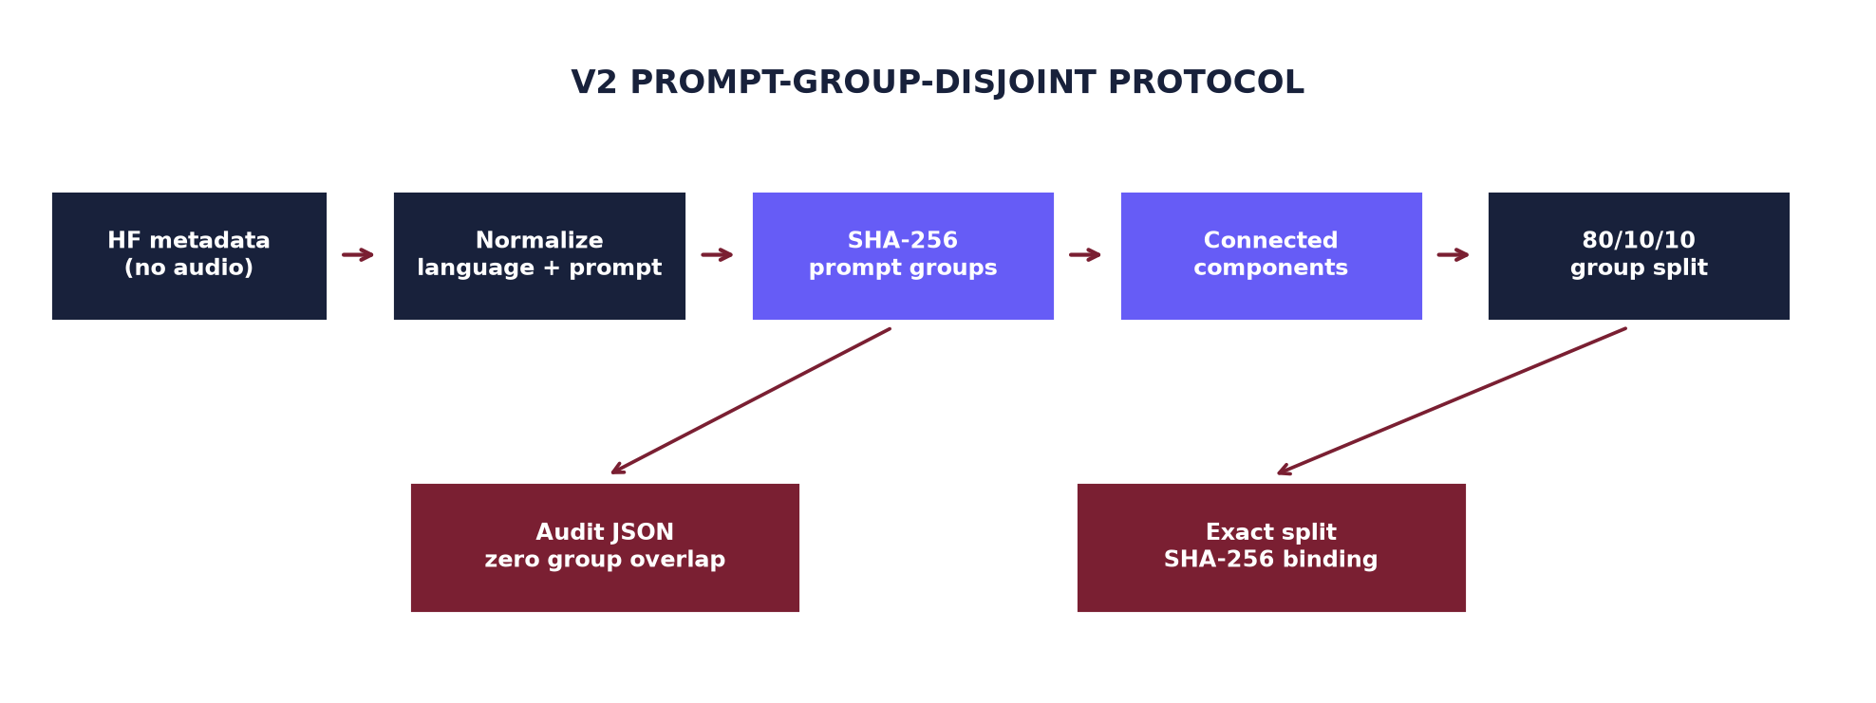
Figure 2.1 V2 prompt-group-disjoint protocol. The current claim is prompt-disjoint only.

2.6 THREATS AND RESIDUAL RISKS
Threat | Implemented control | Residual risk
Prompt leakage | Group prompt hashes before assignment | Equivalent paraphrases may not hash together
Speaker/source leakage | Builder supports lineage columns | Fields unavailable upstream
Split tampering | Audit SHA bound to exact bytes | Does not certify metadata truth
Test-set tuning | Explicit one-time notebook gate | Still relies on operator discipline

CHAPTER 3

SYSTEM DESIGN

3.1 OVERALL ARCHITECTURE
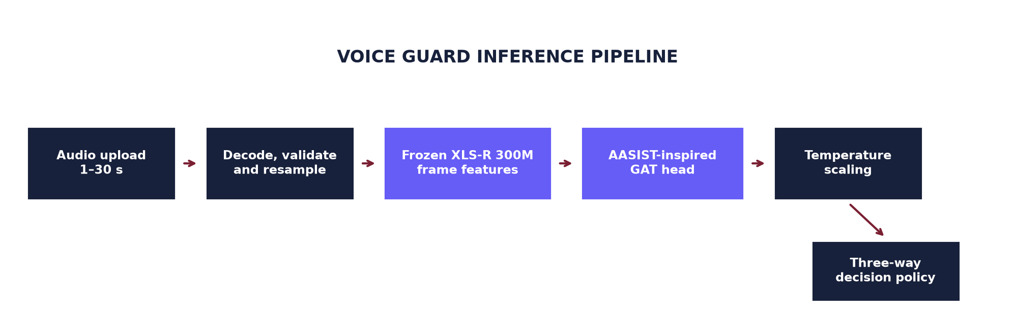
Figure 3.1 Voice Guard inference pipeline.
The deployment path separates inexpensive safety checks from expensive neural inference. Encoded size is checked before decoding. The decoded waveform is converted to mono floating point, screened for duration, finiteness, energy, and audibility, then resampled to 16 kHz. The frozen frontend produces a sequence of 1,024-dimensional frame embeddings. A compact classifier head returns one fake logit, temperature scaling adjusts the logit, and a policy converts the resulting score into public wording.

3.2 COMPONENT BOUNDARIES
- `voice_guard_core.py` contains dependency-light audio and decision policies.
- `model_pipeline.py` contains decoding, XLS-R, classifier heads, caching, training, calibration, and evaluation.
- `app.py`, `ui_kit.py`, and `i18n.py` implement the interaction and presentation layer.
- `evidence_report.py` creates a file-bound automated analysis PDF.
- `data_pipeline/` implements export, group-safe splitting, protocol verification, and leakage audit.

3.3 AUDIO VALIDATION AND PREPROCESSING DESIGN
Public uploads are limited to 25 MB and 1–30 seconds. Duration capping is both a product choice and a resource-safety requirement because the current graph attention layer has quadratic sequence complexity. The policy rejects zero-length arrays, non-finite values, near-silent signals, and clips without sufficient audible content. These controls prevent a digital-silence warm-up sample from receiving a misleading verdict and reduce accidental GPU or memory abuse.
1. Read encoded bytes and reject empty or oversized payloads before model imports perform heavy work.
2. Decode through torchaudio with a controlled fallback for common compressed formats.
3. Mix channels to mono, validate numerical values, and measure duration and signal energy.
4. Resample to 16 kHz, the rate expected by the XLS-R model card [6].
5. Hash the exact selected bytes and clear any previous result whenever the selection changes.

3.4 FEATURE REPRESENTATION AND MASKING
The frontend is kept in evaluation mode with gradients disabled. Batched extraction supplies an attention mask so padding is not interpreted as speech. Cached features are sharded to avoid holding the full corpus in memory. Cache manifests record target clip fingerprints, data type, completeness, failed clips, and configuration. Adopting v2 therefore requires a new cache directory; reusing v1 features would break split provenance even when the tensors themselves are numerically valid.
Stage | Input | Output | Primary guard
Decode | Encoded bytes | Waveform + source rate | Format/size checks
Normalise | Waveform | Mono 16 kHz float | Duration/energy/finiteness
XLS-R | Padded waveform batch | Frame embeddings | Attention mask
Cache | Per-clip embeddings | Sharded tensors | Manifest and SHA fingerprint

3.5 CLASSIFIER, CALIBRATION, AND DECISION POLICY
The default head projects XLS-R frames, applies graph attention, and combines attentive and maximum temporal summaries before binary classification. Two simpler baselines—attention pooling and mean pooling—are included because architectural complexity must earn its place on validation. A fourth candidate uses the graph head with feature noise, time masking, and channel dropout to target the historical weakness under noisy conditions.
Equal error rate is computed from bona fide and spoof score distributions. Accuracy, precision, recall, F1, and the confusion matrix use an explicitly named fake-probability threshold. This separation prevents the sign error that previously affected robustness threshold artifacts. Temperature is fitted on validation logits only. Its ECE before and after calibration is recorded; a worse ECE is not presented as improved confidence.
Score range | Public verdict | Interpretation
Below lower policy threshold | Likely genuine | Model evidence leans toward genuine speech
Between policy thresholds | Inconclusive | Evidence is too close for a directional statement
Above upper policy threshold | Likely synthetic | Model evidence leans toward generated speech
Table 3.1 Decision policy and public wording. The score is not forensic proof.

3.6 RESULT INTEGRITY
Each analysis result carries the exact SHA-256 of the selected encoded file. Application state stores the result hash separately from the current selection hash. If the user replaces the upload, the verdict, error, filename, and report state are cleared before rendering. The downloadable PDF repeats the same hash, making stale-result substitution observable.

3.7 PROFESSIONAL USER-INTERFACE DESIGN
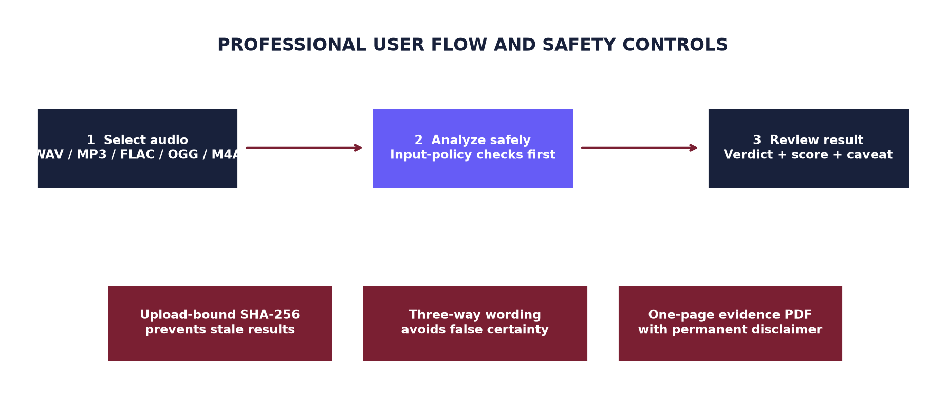
Figure 3.2 Professional UI workflow and safety controls.
The refreshed interface uses a calm dark hero, violet and blue accents, generous spacing, a dedicated upload workspace, a three-step process card, and result panels that expose details progressively. The earlier “pay” wording was removed because the application has no payment workflow. The visible score is labelled AI-likelihood model score, not confidence or proof. A permanent disclaimer and suggested safety action remain visible after every result.
- Desktop-first wide layout with responsive Streamlit columns.
- Clear empty state, selected filename and size, audio preview, and disabled analysis button before upload.
- Distinct genuine, inconclusive, and synthetic visual states without alarmist language.
- Technical details remain available in an expander for reviewers.
- The interface language selector changes presentation text only; it never changes the model score.

CHAPTER 4

IMPLEMENTATION

4.1 REPOSITORY MODULES
File or area | Responsibility
app.py | Streamlit state, upload flow, result rendering, report download
ui_kit.py / i18n.py | Visual system and interface copy
voice_guard_core.py | Input and decision policies without Torch/Streamlit dependencies
model_pipeline.py | Model, cache, training, calibration, inference, metrics
evidence_report.py | One-page automated analysis PDF
data_pipeline/export_hf_metadata.py | Streaming, no-audio metadata export and prompt hashes
data_pipeline/build_group_safe_split.py | Connected-component group split and audit generation
data_pipeline/split_protocol.py | Runtime verification of protocol and SHA-bound audit
run_validation_ablations.py | Validation-only candidate comparison
kaggle/*.ipynb | Direct demo hosting and v2 GPU workflow

4.2 IMPLEMENTATION PRINCIPLES
- Fail closed when split provenance, labels, cache coverage, or audio validity is ambiguous.
- Keep thresholds and score orientation explicit at API boundaries.
- Make generated artifacts atomic where partial files could be mistaken for complete output.
- Record exact Git and SHA-256 identities at data, split, result, and notebook boundaries.
- Keep model claims narrower than the available metadata and evidence.

4.3 METADATA EXPORT AND DETERMINISTIC SPLITTING
The exporter removes the audio column before streaming records, so split planning does not download or decode audio. Unicode NFKC normalisation, case folding, trimming, and whitespace collapse make prompt hashing deterministic across cosmetic text differences. Language is included in the hash to avoid grouping unrelated translations merely because their normalised strings happen to match.
For multiple grouping fields, union-find constructs connected components. This is stricter than concatenating fields into a composite key: a shared speaker still joins two rows even when their sources or prompts differ. Group components are ordered deterministically, then greedily assigned to minimise per-language/per-label and overall size error against 80/10/10 targets. The builder refuses empty splits, group overlap, or missing language/label strata unless an explicitly non-reportable exploratory override is supplied.
python data_pipeline/export_hf_metadata.py \
--output data_pipeline/metadata_v2.jsonl
python data_pipeline/build_group_safe_split.py \
data_pipeline/metadata_v2.jsonl --group-columns prompt_id \
--output data_pipeline/split_ids_v2.json
python data_pipeline/leakage_audit.py \
--split-file data_pipeline/split_ids_v2.json

4.4 PROTOCOL VERIFICATION
The verifier requires protocol version `v2-group-disjoint`, an exact split-file digest match, zero audited overlap, complete strata, a positive clip count, a declared grouping strategy, and a source metadata digest. Alternate split training and evaluation call this verifier. The historical default remains intentionally blocked because its overlap is a documented property, not an approved exception.

4.5 TRAINING AND VALIDATION ABLATIONS
Feature caching separates the expensive frozen frontend pass from repeated classifier-head experiments. The runner evaluates five declared candidates with the same v2 split and cache lineage. It stores configuration, validation EER, ECE before and after scaling, checkpoint directory, and split SHA. Its output explicitly records `selection_scope: validation_only` and `test_split_touched: false`.
Candidate | Purpose
gat | Default graph-attention head without feature augmentation
gat_separate_norms | GAT variant with separate layer normalisation
attention_pool | Simpler learned temporal pooling baseline
mean_pool | Low-complexity averaging baseline
gat_feature_robust | GAT plus cached-feature noise, time masking, and channel dropout

4.6 MODEL SELECTION
The notebook initially ranks candidates by validation EER, but the final choice must also consider calibration and robustness. A small clean-EER gain does not justify a large codec or noise regression. The chosen checkpoint path is copied into an explicit environment variable only after review. The final-test cell checks full-run mode, the enable flag, and the locked checkpoint before calling the evaluator.
Repeated seeds and bootstrap confidence intervals are recommended before publication-quality claims. They are not silently simulated by the current notebook. The default smoke mode exists only to verify execution and is capped at 400 clips per split and two epochs.

4.7 KAGGLE DEMO AND NGROK LIFECYCLE
The demo notebook defaults to the `main` Git reference for convenience and immediately resolves and prints the exact commit SHA. A frozen demo can set a 40-character SHA instead. Dependencies are installed once, Streamlit is launched as a subprocess, and the notebook polls `/_stcore/health` before opening a tunnel. The hosting cell remains alive so the public URL continues to work.
The ngrok credential is read from a Kaggle Secret named `NGROK_AUTHTOKEN`. The token is never printed or written to the repository. Before connecting, local tunnels are closed. A random public endpoint avoids accidental reuse of a still-active reserved endpoint. On stop, interrupt, or error, the notebook closes the tunnel and terminates Streamlit in `finally`.
Kaggle → Add-ons → Secrets
Name: NGROK_AUTHTOKEN
Value: <paste token in Kaggle only>
Enable internet + GPU → Run all → Open printed HTTPS URL

4.8 OPERATIONAL DIAGNOSTICS
curl -fsS http://127.0.0.1:8501/_stcore/health
tail -n 100 /kaggle/working/voice_guard_streamlit.log

4.9 SECURITY, PRIVACY, AND FAILURE HANDLING
The local Streamlit process handles uploaded bytes in the active session and does not implement a payment, account, or permanent upload store. Public copy describes this limited behavior without promising properties that external hosting layers cannot guarantee. Detailed stack traces remain in server logs, while the UI shows a safe generic failure message for internal errors.
Control | Implementation | Reason
Credential isolation | Kaggle Secret lookup | Prevents token commits and notebook leakage
Upload limits | Encoded size and decoded duration caps | Reduces misuse and resource exhaustion
Safe errors | Public generic message; server logging | Avoids leaking internals
State binding | SHA-256 selection/result equality | Prevents stale verdict/report display
No auto language claim | Optional declared metadata only | Avoids unsupported inference
Cautious verdict | Three-way score policy | Avoids presenting uncertain evidence as fact

4.10 DEPLOYMENT LIMITATIONS
The Kaggle/ngrok setup is suitable for a demonstration, not a production service. Runtime availability depends on Kaggle session limits, internet access, external model download, and ngrok availability. The 300M frontend is slow on CPU. Production deployment would require authenticated access, rate limiting, observability, explicit retention policy, model/version registry, secure secrets management, capacity planning, and a documented incident process.

CHAPTER 5

TESTING AND RESULTS

5.1 VERIFICATION STRATEGY
Testing is layered so that lightweight policy and provenance checks run without loading the 300M model. Unit tests cover encoded and decoded audio validation, stable decision thresholds, file-bound result state, report generation, prompt normalisation, label rejection, multi-field connected components, and split-audit tampering. Python compilation and a focused Ruff pass catch syntax, undefined-name, and high-severity style errors. Notebook JSON is parsed separately.
Layer | Examples | Expected evidence
Unit | Input policy, decisions, split protocol | Deterministic pass/fail
Static | Python compile, Ruff F/E9, diff check | No syntax or obvious correctness errors
Notebook | Valid JSON and required gates/secrets | Top-to-bottom executable structure
Browser | Local Streamlit desktop/narrow layout | Visible controls and polished hierarchy
Document | DOCX render and page inspection | No clipping, overlap, or stale template pages
Model | Validation EER/ECE/robustness | Pending full v2 Kaggle run

5.2 LEAKAGE AUDIT BEHAVIOR
The default v1 leakage audit is expected to fail. This is a successful safety outcome because it prevents the historical split from being reused for a new reportable run. A v2 split is accepted only when its companion audit verifies against the exact bytes. Synthetic tests demonstrate that one shared value in any selected grouping field keeps records in the same connected component.

5.3 HISTORICAL V1 BENCHMARK
The recorded historical test result evaluated 3,111 clips and reported 1.03% EER, 98.39% accuracy, 99.67% precision, 97.10% recall, and 0.9837 F1 with fake as the positive class. At P(fake) > 0.5, the confusion matrix contained 1,553 true negatives, 5 false positives, 45 false negatives, and 1,508 true positives. All requested clips were evaluated.
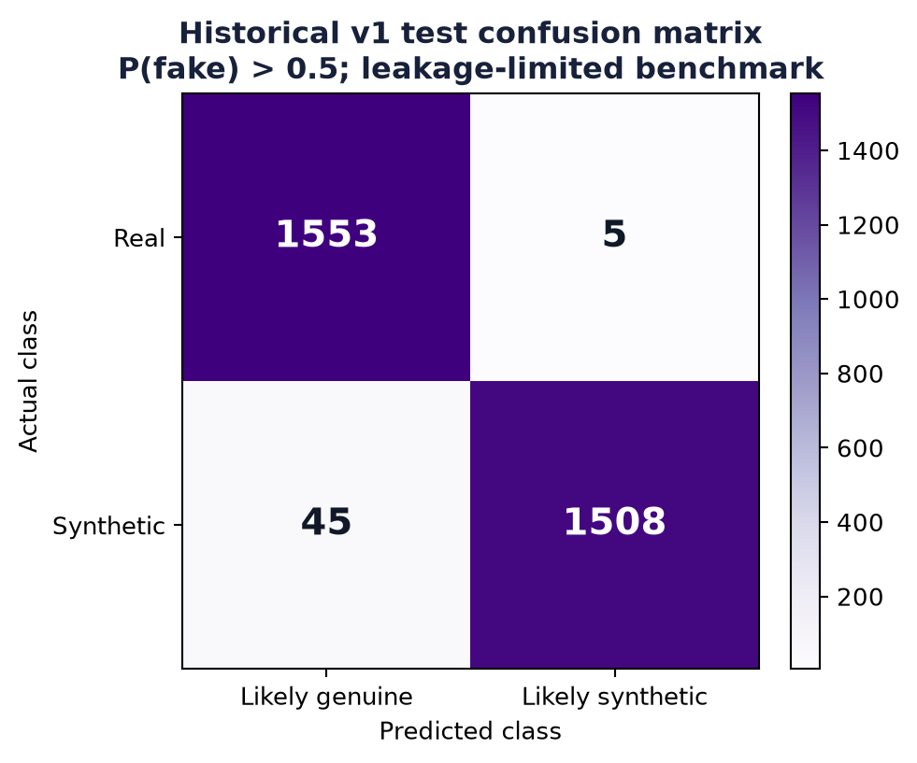
Figure 5.1 Historical v1 confusion matrix at P(fake) > 0.5.
Metric | Historical value | Interpretation
EER | 1.03% | Threshold-independent separation on observed v1 test
Accuracy | 98.39% | At P(fake) > 0.5
Precision | 99.67% | Fake is positive class
Recall | 97.10% | 45 fake clips missed
F1 | 0.9837 | Balance of precision and recall

5.4 WHY THE HISTORICAL RESULT IS NOT THE CURRENT ACCURACY CLAIM
Although exact clip IDs were disjoint, the repaired audit found that approximately 98–99% of clips belonged to ID-family proxies represented across split boundaries: 24,396 of 24,881 train clips and 3,090 of 3,111 test clips were in families visible on both sides. The proxy is imperfect, but overlap at this scale makes the clean v1 result optimistic for source or speaker generalisation. The test set has also been observed and must not be used to select the next architecture, augmentation, or threshold.
The historical checkpoint remains useful for regression testing, UI operation, and identifying robustness priorities. It is not discarded, but its role changes from headline evidence to baseline evidence. A future report revision should replace this page's headline with the locked v2 result while retaining v1 in an appendix for lineage.

5.5 PER-LANGUAGE EVIDENCE
Historical per-language EER ranged from 0% for several language buckets to 2.50% for Nepali, with Odia at 2.20%, Manipuri at 1.00%, and Malayalam at 0.50%. These buckets are aggregate benchmark slices, not an individual upload's confidence. Small group sizes, shared source families, and absent speaker/generator metadata limit generalisation claims.
Language | N | Historical EER
Malayalam | 201 | 0.50%
Manipuri | 200 | 1.00%
Odia | 182 | 2.20%
Nepali | 200 | 2.50%
Other 12 language buckets | 156–201 each | 0.00%

5.6 HISTORICAL ROBUSTNESS EVIDENCE
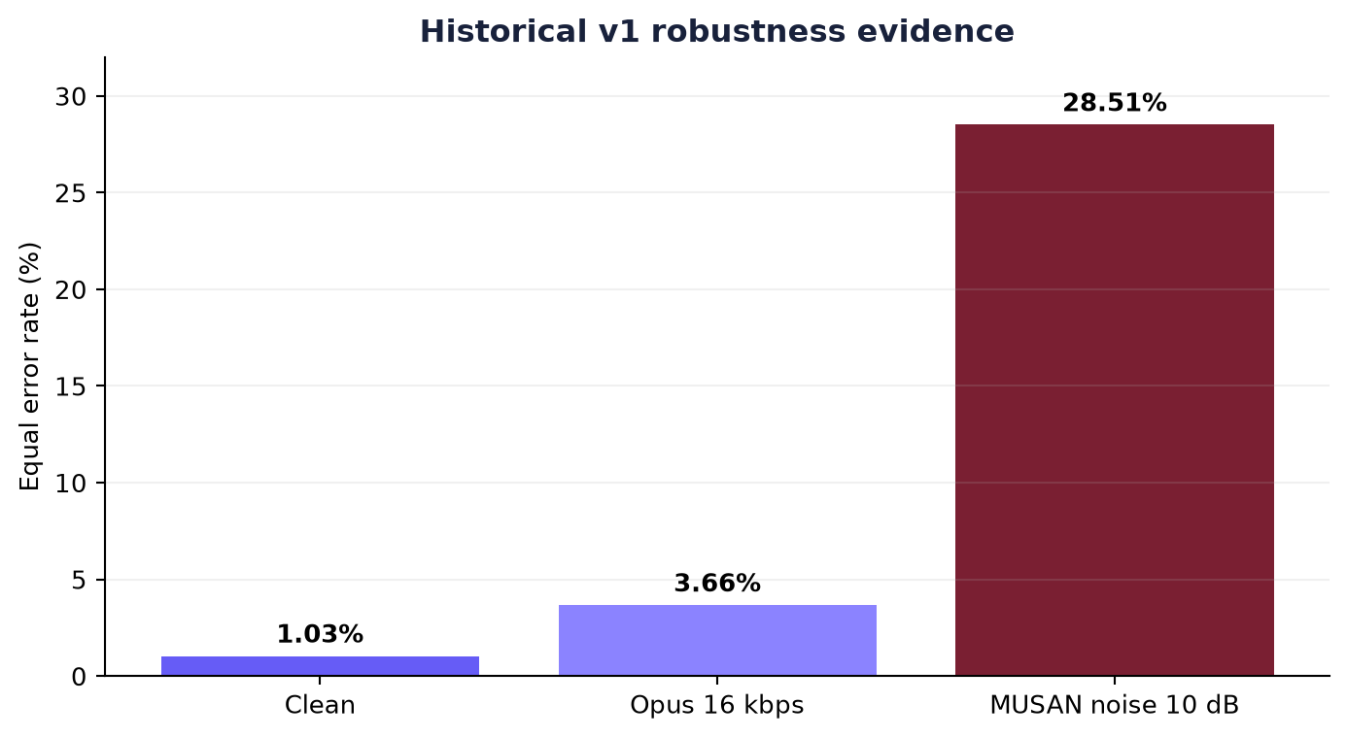
Figure 5.2 Historical v1 EER under clean, Opus, and MUSAN-noise conditions.
Opus compression at 16 kbps increased EER to 3.66%, while 10 dB MUSAN noise increased EER to 28.51%. The noise condition is the clearest observed weakness and motivates the feature-robust candidate. Some old robustness classification artifacts applied a saved bona fide threshold with the wrong sign in fake-logit space; EER remains threshold independent, but accuracy-style numbers from those artifacts must be regenerated for v2.
A reportable v2 robustness matrix should include clean audio, multiple codec bitrates, noise types and SNRs, replay or channel simulation, unseen generators, and real controls. The same locked candidate must be used across conditions, and confidence intervals should be reported for material comparisons.

5.7 CALIBRATION
The historical checkpoint stored a temperature of 1.2600, but the recorded ECE did not establish a meaningful improvement. Therefore the UI labels the output as a model score, not a calibrated real-world probability. V2 selection records ECE before and after scaling and should retain temperature scaling only when it improves validation calibration without test-set fitting.

5.8 V2 EXPERIMENT STATUS
Item | Status | Meaning
Metadata exporter | Implemented and unit tested | No-audio export; prompt hashes; label/row checks
Group-safe builder | Implemented and unit tested | OR-connected components; deterministic split
SHA-bound audit | Implemented and unit tested | Training/evaluation reject mismatches
Fresh v2 cache path | Configured in notebook | No v1 cache reuse
Validation ablations | Configured in notebook | Five candidates; validation-only summary
Full GPU training | Pending Kaggle execution | No new checkpoint or v2 accuracy yet
One-time v2 test | Locked behind explicit gate | Must run after candidate selection
Table 5.2 V2 experiment status at the time of report generation.

5.9 ACCEPTANCE CRITERIA FOR AN IMPROVED MODEL
- The full metadata export contains 31,102 rows with both labels and all sixteen languages.
- The split audit reports zero prompt-group overlap and every language/label stratum in every split.
- The candidate was selected using validation only; the test-touched flag remains false until lock.
- Validation EER and calibration are at least competitive with simpler pooling baselines.
- Noise and codec robustness do not regress materially; 10 dB noise is a primary decision slice.
- The one-time test run records exact Git, metadata, split, checkpoint, and configuration identities.
Until these criteria are met, the model is operational for demonstration but not proven better. The repository changes improve evaluation quality and make genuine model improvement possible; they do not by themselves change the checkpoint's learned weights.

5.10 LIMITATIONS, ETHICS, AND RESPONSIBLE USE
Audio deepfake detection is an adversarial and shifting problem. New synthesis systems can remove artefacts learned from older generators, while compression, denoising, microphones, room acoustics, accents, emotion, and health conditions can alter genuine speech. A single model score should therefore support human review rather than trigger punishment, account suspension, or public accusation.
- False positives may cause reputational harm; confirm with provenance, context, and expert analysis.
- False negatives may create false reassurance; absence of detected artefacts is not proof of authenticity.
- Language coverage is a dataset property, not a guarantee of equal performance for dialects or communities.
- The current split cannot prove unseen-speaker or unseen-generator generalisation.
- Public demos should not retain audio or scores beyond the stated operational need.
- Model/version changes should be auditable and accompanied by a model card and change log.

5.11 RECOMMENDED HUMAN WORKFLOW
1. Treat the result as a screening signal, not a verdict about a person.
2. Preserve the original file and its cryptographic hash.
3. Check recording provenance, metadata, surrounding conversation, and known source channel.
4. Repeat analysis with a higher-quality source when compression or noise is severe.
5. Escalate high-impact decisions to qualified human review and document uncertainty.

CHAPTER 6

CONCLUSION AND FUTURE WORK

6.1 CONCLUSION
Voice Guard now has a coherent research-to-demo path. The model pipeline uses a frozen multilingual frontend, an explicitly AASIST-inspired head, corrected score orientation, validation calibration, and file-bound inference. The interface has been rebuilt as a professional evidence workspace with strong upload controls, cautious three-way wording, clear technical details, and a matching downloadable report. Kaggle deployment now uses a secret-based ngrok token, health checking, exact revision logging, and reliable cleanup.
The largest scientific improvement is procedural: the project no longer treats the historical v1 number as sufficient proof. A metadata exporter, connected-component group splitter, SHA-bound audit, fresh-cache workflow, validation-only ablation runner, and final-test gate provide a defensible v2 experiment. Because upstream lineage metadata is incomplete and the full GPU run has not yet been executed, this report does not claim a better accuracy number.

6.2 PRIORITISED FUTURE WORK
1. Acquire trustworthy speaker, source, session, device, and generator identifiers for a lineage-disjoint split.
2. Run full v2 Kaggle training with repeated seeds; lock a candidate using validation EER, calibration, and robustness.
3. Add codec, noise, reverberation, and replay augmentation; compare selective XLS-R adaptation.
4. Evaluate unseen generators and independent real controls with confidence intervals and subgroup analysis.

6.3 EXPECTED OUTCOME
The next milestone is not simply a higher clean accuracy. It is a locked v2 checkpoint whose performance remains credible after prompt separation, noise and codec stress, repeated runs, and an untouched final test. That outcome can then replace the historical checkpoint in the demo through a separate reviewed commit.

APPENDIX A — KAGGLE DEMO QUICK START
1. Push the reviewed commit containing the demo notebook and checkpoint to the Git repository.
2. Open `kaggle/voice_guard_demo.ipynb` in Kaggle.
3. Create the Kaggle Secret `NGROK_AUTHTOKEN`, paste the token value, and grant notebook access.
4. Enable internet access and a GPU accelerator.
5. Leave `VOICE_GUARD_REF=main` for the newest approved branch state, or replace it with a 40-character commit SHA for a frozen demo.
6. Run all cells. Confirm that the setup cell prints the expected resolved SHA.
7. Wait for `Streamlit health check passed`, then open the printed HTTPS ngrok URL.
8. Keep the hosting cell running. Stop it to close the tunnel and Streamlit process.

A.1 UI ACCEPTANCE CHECK
- The page shows Voice Guard branding, the upload workspace, and no payment wording.
- A missing upload keeps the analysis button disabled.
- Replacing the selected file clears the old result and PDF.
- Invalid, silent, under-one-second, over-thirty-second, and oversized samples are rejected.
- A valid file shows cautious three-way wording and an AI-likelihood model score.
- The downloaded PDF contains the same SHA-256 shown in technical details.

APPENDIX B — V2 TRAINING RUNBOOK
1. Open `kaggle/voice_guard_v2_training.ipynb`; enable GPU and internet.
2. Run default smoke mode and verify metadata export, split audit, cache construction, training, and validation outputs.
3. Inspect `split_ids_v2.audit.json`: protocol version, split SHA, zero overlap, all strata, and row count must pass.
4. Set `VOICE_GUARD_TRAIN_MODE=full`, restart the session, and run from the top with fresh paths.
5. Review all candidate validation summaries and robustness evidence. Do not inspect v2 test scores.
6. Set `VOICE_GUARD_LOCKED_CHECKPOINT` to exactly one final candidate.
7. Set `VOICE_GUARD_RUN_FINAL_TEST=1` and execute the final-test cell once.
8. Archive the commit SHA, metadata summary, split and audit, ablation summary, checkpoint, and final metrics.
VOICE_GUARD_TRAIN_MODE=smoke # pipeline verification only
VOICE_GUARD_TRAIN_MODE=full # reportable training run
VOICE_GUARD_LOCKED_CHECKPOINT=/kaggle/working/.../best_model.pt
VOICE_GUARD_RUN_FINAL_TEST=1 # enable only after lock
Promotion to `checkpoints/best_model.pt` is a separate decision. Re-run repository tests and a local UI smoke test after replacing the checkpoint and matching summary.

APPENDIX C — ACCEPTANCE AND TRACEABILITY CHECKLIST
Artifact or check | Required record
Source control | Git commit SHA and clean working tree
Metadata | Dataset revision/name, 31,102 rows, metadata SHA-256
Split | Split JSON, audit JSON, exact split SHA-256, grouping scope
Features | Fresh v2 cache manifests and failed-clip log
Training | Candidate configs, seeds, epochs, hardware, validation summaries
Selection | Written rationale using validation and robustness only
Test | One-time run record, final metrics, confidence intervals when available
Demo | Checkpoint SHA/summary, local UI check, Kaggle resolved SHA
Report | Rendered DOCX inspection and original-template checksum

C.1 KNOWN PLACEHOLDERS BEFORE SUBMISSION
- Replace [STUDENT NAME], [REGISTER NUMBER], [PROJECT GUIDE], and [GUIDE DESIGNATION].
- Confirm programme, department, campus, academic year, and institutional wording.
- Add signatures, dates, and seals required by the department.
- After the full v2 run, update the results chapter without removing the historical limitations.

C.2 TEMPLATE PRESERVATION
The supplied file `project report documentation template.docx` remains unchanged. Its recorded SHA-256 is `4b711593d42a731a6d408d3b3274ba4877f761af7e31e026f565b0fe99e7d713`. This report is generated as a separate clean artifact because the source template contains instructional/sample pages and malformed XML values that should not be propagated into a final submission file.

REFERENCES
[1] A. Babu et al., “XLS-R: Self-supervised Cross-lingual Speech Representation Learning at Scale,” arXiv:2111.09296, 2021. https://arxiv.org/abs/2111.09296
[2] J.-w. Jung et al., “AASIST: Audio Anti-Spoofing using Integrated Spectro-Temporal Graph Attention Networks,” arXiv:2110.01200, 2021. https://arxiv.org/abs/2110.01200
[3] J. Yamagishi et al., “ASVspoof 2021: Accelerating Progress in Spoofed and Deepfake Speech Detection,” Proc. ASVspoof 2021, pp. 47–54, 2021. https://www.isca-archive.org/asvspoof_2021/yamagishi21_asvspoof.html
[4] C. Guo, G. Pleiss, Y. Sun, and K. Q. Weinberger, “On Calibration of Modern Neural Networks,” Proc. ICML, vol. 70, pp. 1321–1330, 2017. https://proceedings.mlr.press/v70/guo17a.html
[5] SherryT997, “IndicTTS-Deepfake-Challenge-Data,” Hugging Face Datasets. https://huggingface.co/datasets/SherryT997/IndicTTS-Deepfake-Challenge-Data
[6] Meta AI, “facebook/wav2vec2-xls-r-300m,” Hugging Face model card. https://huggingface.co/facebook/wav2vec2-xls-r-300m
[7] Voice Guard repository, `README.md`, `model_pipeline.py`, `voice_guard_core.py`, and `docs/TEST_SET_RESULTS.md`, local project sources, reviewed 23 August 2026.
[8] Streamlit, “Streamlit documentation.” https://docs.streamlit.io/
[9] ngrok, “Python SDK and tunnel documentation.” https://ngrok.com/docs/using-ngrok-with/python/

DOCUMENT STATUS
Submission-ready technical draft generated from the protected institutional template. Personal fields and the pending full v2 experimental results must be completed before formal submission.

