Optimizers
They try to make loss function to come at its lowest.
Gradient Descent-
The weight is only updated once after scanning entire dataset.
For every epoch:
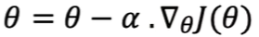
Stochastic Gradient Descent
The weights are updated after every datapoint and not after entire dataset.
For every epoch,
For every sample:
Mini-Batch Gradient descent
The weights get updated after every N samples.
For every epoch,
For every N sample:
SDG + Momentum
The dataset follows a specific pattern then some data is passed on while testing which causes loss and this is the reason for inclusion of acceleration term.
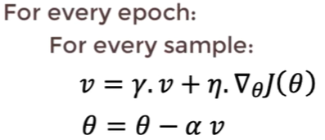
SDG + Momentum + Acceleration
The data with slightly different output is discarded.
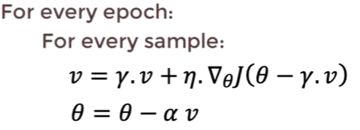
Adam:
The prediction rate goes on increasing with every data.
