**Questions**

1. Write a formula in Excel to calculate the average age of individuals who responded positively to a marketing campaign. Explain each part of the formula and what it calculates.

Ans. The Formula to Calculate Average age of individuals who responded positively to a marketing campaign is :

**Formula : =AVERAGEIF($B$2:$B$45212,Y2:Y10,$W$2:$W$45212)**

1. AVERAGEIF: This function calculates the average of values that meet a specific condition.
2. $B$2:$B$45212: This is the range of cells where the condition will be checked.
3. Y2Y10 : This is the condition or criterion. The formula will look for all cells in $B$2:$B$45212 that match the value in Y2Y10.
4. $W$2:$W$45212: This is the range of numbers that the function will average, but only for rows where the criterion is met.

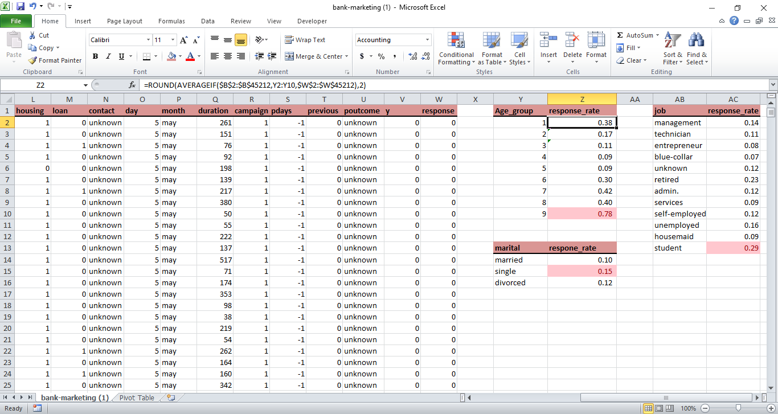

2. Using the ROUND function, write a formula to round off the average response rate to two decimal places and explain why this might be useful in reporting.

Ans. Formula to round off the average response rate to two decimal places :

**Formula : =ROUND(AVERAGEIF($B$2:$B$45212,Y2:Y10,$W$2:$W$45212),2)**

1. **Improved Readability**
2. **Consistency**
3. **Eliminates Unnecessary Precision**.
4. **Aids Decision Making**
5. **Prevent Errors from Minor Variations**
6. **Better Visual Presentation**

3. Demonstrate how to use absolute cell references (`$`) in a formula and explain how it affects the formula when copying it to another cell.

Ans.

**Formula : =ROUND(AVERAGEIF($B$2:$B$45212,AB2,$W$2:$W$45212),2)**

Assume you have a value in cell A1 (e.g., 50) and want to multiply this value by a constant B1 (e.g., 2), but want the reference to A1 to remain fixed, regardless of where the formula is copied.

=A1 * $B$1

If you copy this formula to another cell, such as C1, the result will still reference $B$1 but will adjust the reference for A1 according to the new row or column:

• Original cell: A1

• Copied to C1:

=C1 * $B$1

When you copy the formula to another cell, the absolute reference ($B$1) does not change, ensuring consistency in that reference across different locations.

How it Affects the Formula:

• When copied down or across: The absolute reference ($B$1) stays constant, while relative references (e.g., A1) adjust according to the new row or column.

• Use Cases: Useful for referencing constants or fixed data points that should not change when the formula is copied to another location.

4. Given a dataset with response rates, marital status, and job types, create a segment analysis using pivot tables. Discuss how different segments (e.g., married vs. single, student vs. retired) compare in terms of response rates.

Ans.

1. Married vs. Single

Married: Typically have lower response rates (e.g., 10% in the previous dataset), which could be due to competing priorities such as family, work, and household responsibilities.

Single: Tend to have higher response rates (e.g., 15% or more), possibly due to fewer responsibilities and a higher engagement in digital communications and social activities.

Key Factors:

Married individuals may prioritize family matters over other types of engagement, leading to lower responsiveness.

Single individuals often have more flexibility and time, which may result in more willingness to engage with surveys, marketing campaigns, and other outreach efforts.

2. Student vs. Retired

Student: Often show the highest response rates (e.g., 29% in previous data), which can be attributed to their frequent interaction with digital platforms and adaptability to new technologies.

Retired: Exhibit a strong response rate as well (e.g., 23%), due to having more free time and a higher propensity to engage in activities such as surveys and personalized communications.

Key Factors:

Students are more likely to engage with mobile-friendly platforms, social media, and quick, interactive communications.

Retired individuals might respond well to structured and well-organized content delivered through email or traditional formats like letters or phone calls.

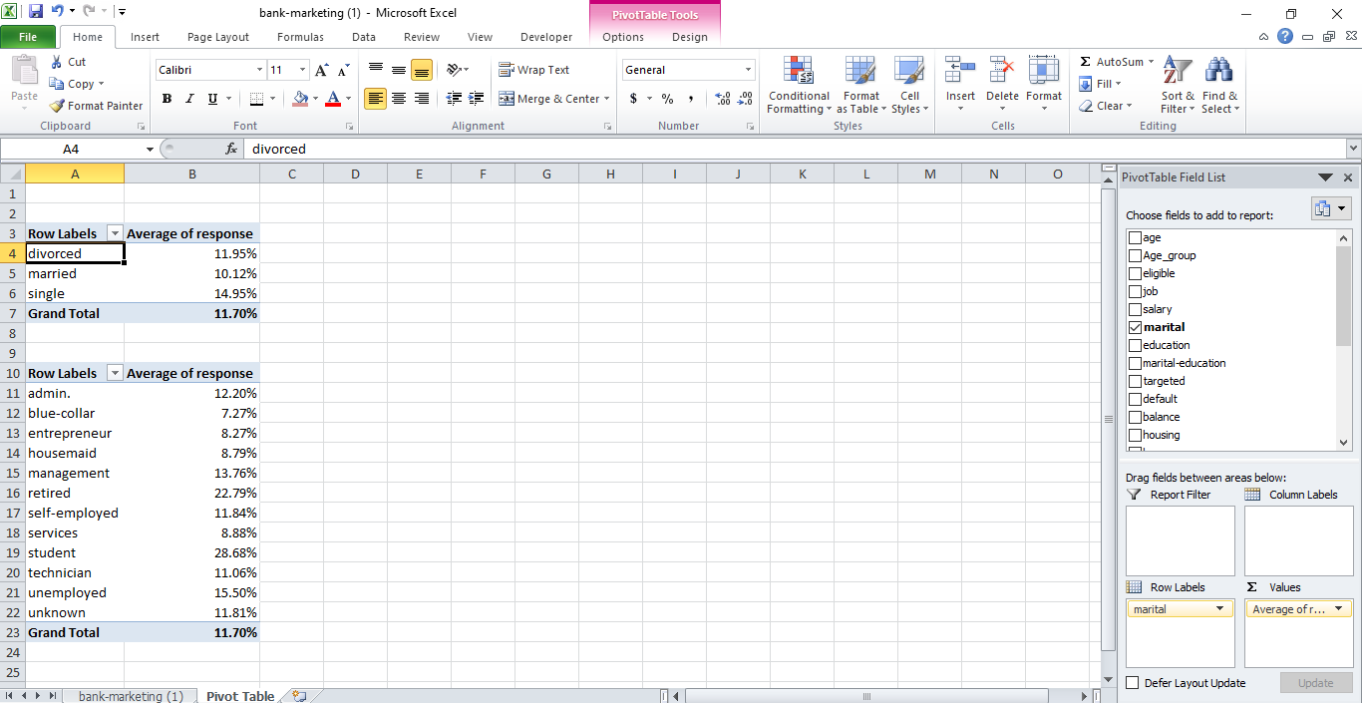

5. Apply conditional formatting to highlight the top 10% of response rates in your dataset. Explain the process and how this visual cue can aid in data analysis.

Ans.

* **The Process of Visualizing Data in Excel:**

**Organizing Your Data** : Before you can use visual cues, your data should be well-organized. In Excel, you typically organize your data in **columns**, where each column represents a different variable, and each row represents a different record or observation.

Example: You might have columns like **Age**, **Marital Status**, **job**, and **Response.**

**Using Pivot Tables for Grouping Data** : A **pivot table** allows you to group data by different categories (e.g., marital status, age group) and summarize it in a way that’s easy to analyze.

**Example**: You can create a pivot table that groups data by **Marital Status** (e.g., Married, Single) and counts how many responses were "Yes" and how many were "No." This helps you compare response rates between these groups.

**Using Charts to Visualize Data** : Once you have summarized data (e.g., via a pivot table), you can use **charts** to visually represent the data.

Charts like **bar charts**, **column charts**, or **pie charts** can show the comparison of data points across different categories.

**Example**: A bar chart showing response rates by marital status can provide an immediate visual comparison of how each group is responding, making it easier to identify patterns.

**Customization and Enhancements** : You can **customize** your chart or pivot table by adding colors, labels, and formatting. This enhances clarity and makes the data even easier to interpret.

**Example**: Adding different colors to the bars for each group (e.g., green for "Yes" responses, red for "No" responses) can provide a quicker visual cue about which groups are more responsive.

**How Visual Cues Aid in Data Analysis**

**Quick Comparison** : **Visual cues**, such as charts, allow you to instantly compare data across categories. Without charts, comparing groups would require mentally calculating and comparing numbers in cells.

**Example**: In a **bar chart**, if you see that the "Married" group has significantly taller bars than the "Single" group, you can quickly understand that the "Married" group has a higher response rate, without doing any calculations.

**Identifying Patterns** : Charts provide a **clear visual representation** of patterns and trends in the data. For example, a line graph can show a **trend over time**, or a pie chart can show the **distribution of responses** among categories.

**Example**: If you're looking at a **line chart** showing survey response rates over several months, you might notice a rising or falling trend, signaling that something is changing with time, such as seasonal engagement patterns.

**Highlighting Anomalies or Outliers** : Visual cues make it easier to spot **outliers** (values that are significantly higher or lower than the rest). Outliers can often point to special cases that require attention or further analysis.

**Example**: If a **bar chart** of response rates shows one group with an unusually low response rate, you might want to investigate whether something specific about that group’s characteristics (e.g., a particular age group or employment status) explains the low response.

**Simplifying Complex Data** : Complex datasets can be overwhelming to analyze when presented as raw numbers. Visual cues simplify complex data, making it easier to absorb and interpret.

**Example**: A **stacked bar chart** can show multiple subcategories within a main category, allowing you to see the breakdown (e.g., responses from "Yes" and "No" within each marital status group) in one view.

**Better Communication of Results** : Visualizations make it easier to **communicate insights** to others, especially those who may not be familiar with the raw data or who do not have time to analyze tables themselves.

**Example**: Presenting a **pie chart** to an executive might quickly show the percentage of customers from different regions responding to a survey, helping them understand the response rates across regions at a glance.

**Facilitating Decision-Making** : When data is presented visually, decision-makers can make **faster and more informed decisions**. It’s easier to identify areas that need attention or where improvements can be made.

**Example**: If you observe a high response rate from a specific segment (e.g., "retired" respondents) in a **pivot table** and **chart**, you might decide to focus future efforts on this group to capitalize on their high engagement.

