Incident 934378

Supplier invoice version 2 with error -

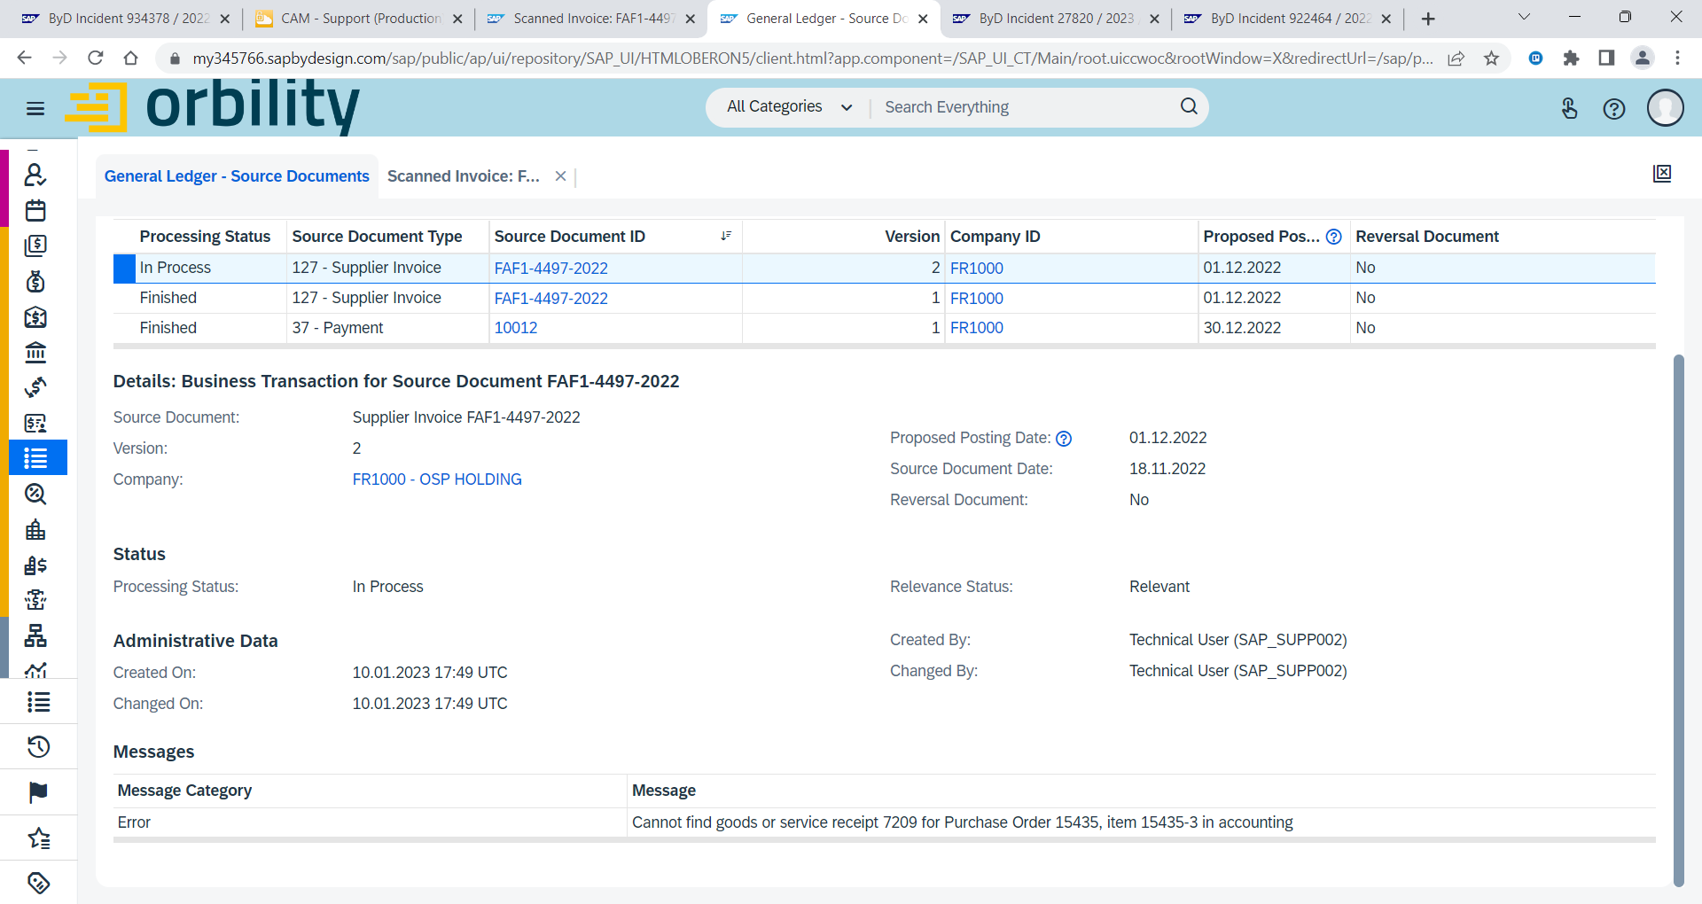

Item 3 - Cost distribution has a missing reference item

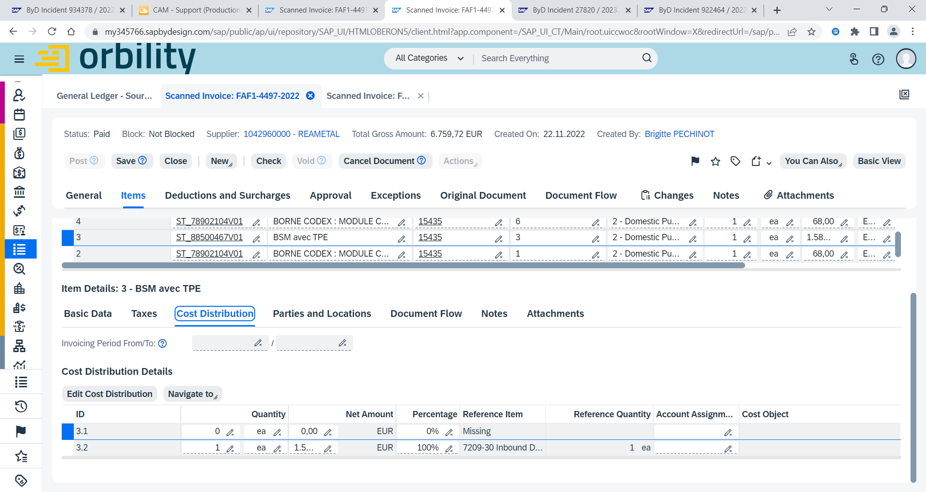

No item coding block in test shell

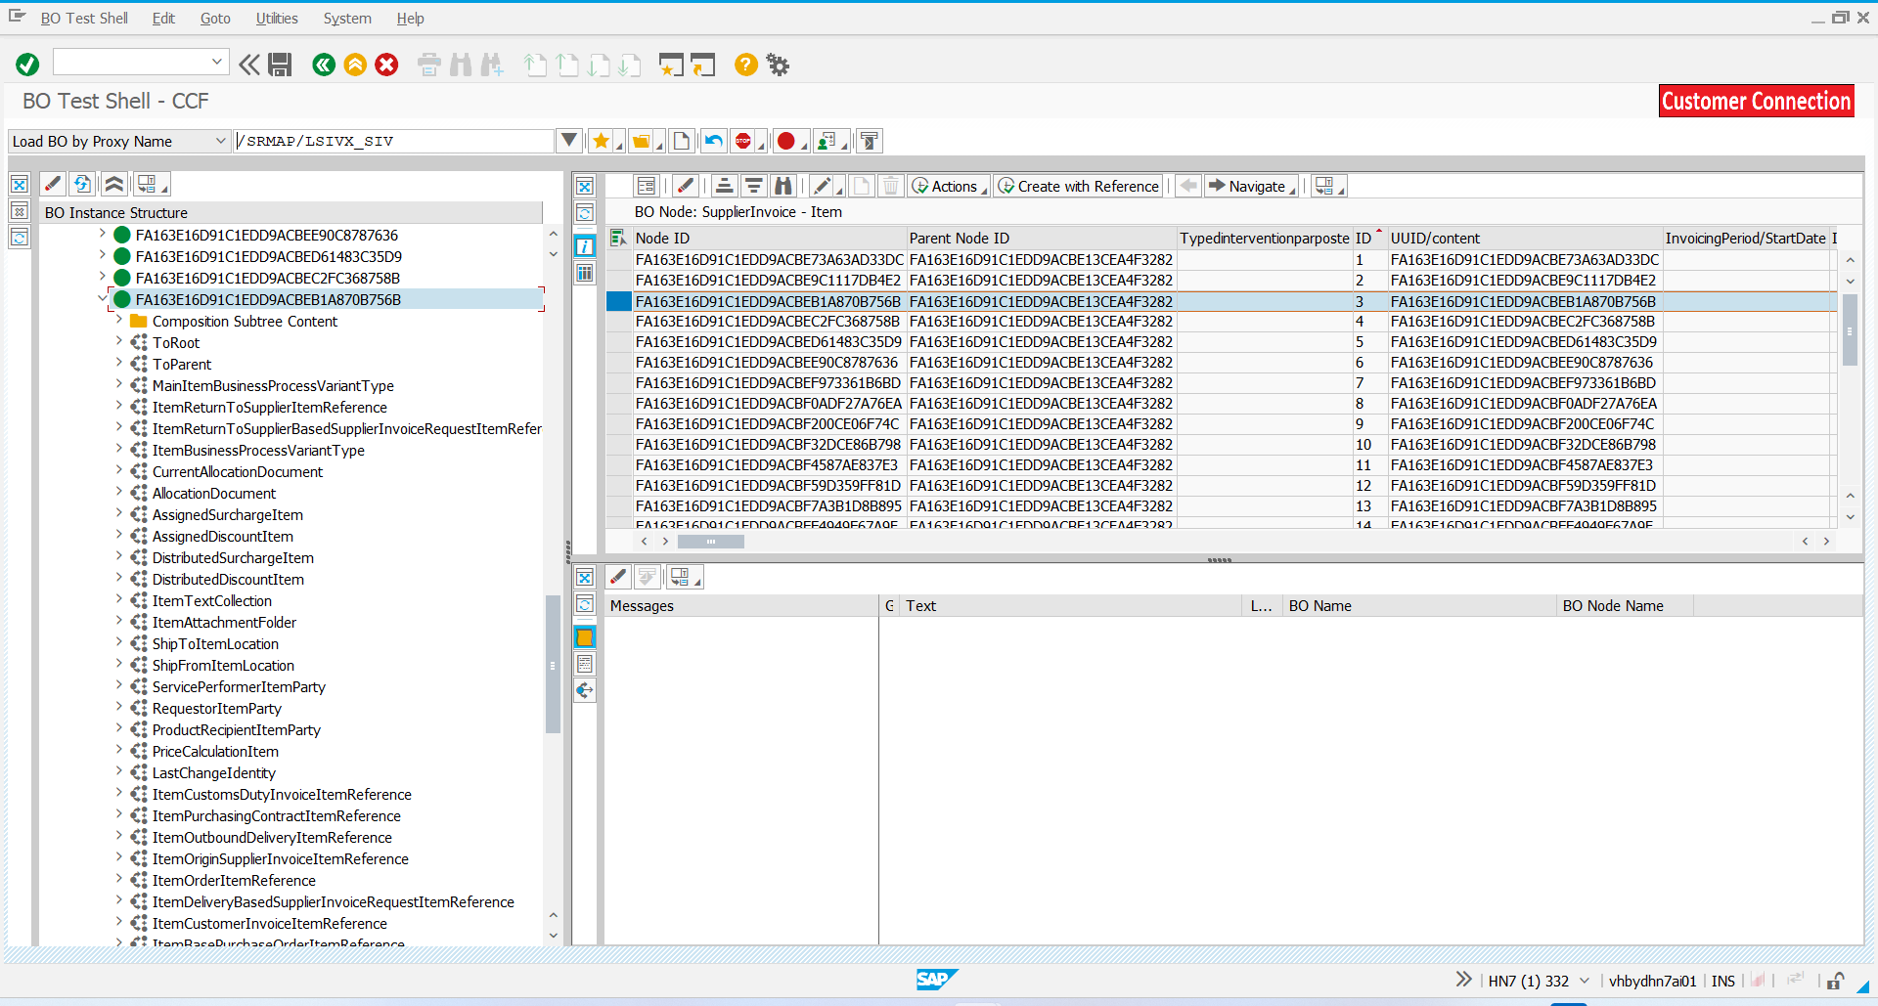

Method - RAISE_ERROR_GR_IS_MISSING line 215

Class - CL_FIA_PURLA_I2D_SERVICES

