Abstract

The Patients in Critical condition need intense monitoring and care. With ICU an Intensive Care unit we can provide this type of care to the patient. But nowadays shortage of Intensivist and Critical Care nurses is the major problem faced by the hospitals. To overcome such problems TeleICU (remotely handled ICU) centers are currently available. With the help of TeleICU control center, one can monitor the patients in Critical Care unit and can assist the person or doctor available at the physical location. TeleICU can provide round the clock monitoring. The person who is monitoring the patient from TeleICU control center should be proactive in monitoring. Another issue is one person can only able to monitor one patient at a time. So, this research aims to develop the system which overcomes the issues in current TeleICU system. For reducing the workload of the person in the control center and to automate some of the humans handled task we need the machine based interface which will take the decisions automatically and can able to collaborate with the existing system.

**Introduction**

Deep learning systems becoming more and more powerful in recognition of various things. There are so many types of neural network available for doing different type recognition or detection. Very popular deep neural network for object or person detection from the scene is Convolutional Neural Network. At present different type of architectures are available for Convolutional Neural Network (CNN) also. Some examples of CNN are recognition and detection of a person, detection any type of object, detection of several types of cancer disease etc.

An innovative monitoring system for TeleICU patients leverages cutting-edge technology to enhance the quality of care for critically ill patients remotely. This system integrates real-time patient monitoring through wearable devices and advanced bedside monitors, ensuring continuous tracking of vital signs such as heart rate, blood pressure, oxygen saturation, respiratory rate, and temperature. By utilizing high-resolution video conferencing and secure data transmission, healthcare professionals can perform virtual rounds, consultations, and real-time interventions. The system employs advanced data analytics and AI to predict potential complications, enabling proactive and personalized care. Overall, this comprehensive approach not only improves patient outcomes but also optimizes the efficiency of healthcare delivery in the intensive care setting.

**Dataset collection and generation**

Dataset collection and generations for the proposed system is challenging one. We need the real time data for ICU patients which are hard to find. So, we take the videos various videos related to ICU from the YouTube. This video contains many unwanted things like description and frames for the name of makers etc. So, we used below kind of approach displayed in the Fig.1. As depicted in the figure (project using video processig) first we get the videos from the various sources after that we clean the unwanted frames and separates each frame from the video for labeled data generation than we create the train and test for modeling purpose.

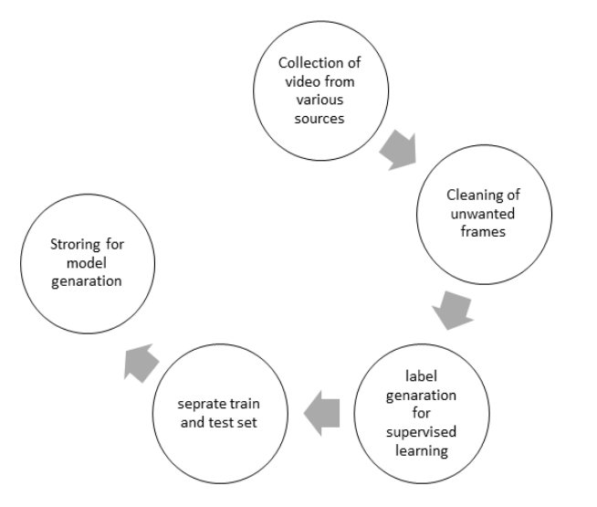

Fig. 1. Data Generation Flow

**Components of an Innovative TeleICU Monitoring System**

1. **Real-Time Patient Monitoring**
2. **High-Resolution Video Conferencing**
3. Secure Data Transmission
4. Advanced Data Analytics and Artificial Intelligence
5. Integrated Health Information Systems

**Benefits of an Innovative TeleICU Monitoring System**

* **Improved Patient Outcomes:** Continuous monitoring and early intervention can significantly improve patient outcomes, reducing mortality rates and the length of ICU stays.
* **Enhanced Access to Care:** TeleICU systems enable patients in remote or underserved areas to receive high-quality critical care from specialists who may not be locally available.
* **Cost Efficiency:** Reducing the need for physical transfers and optimizing resource utilization can lead to significant cost savings for healthcare facilities.
* **Better Resource Management:** Centralized monitoring allows for better allocation of ICU resources, ensuring that the most critical patients receive immediate attention.

**Challenges and Considerations**

* **Technical Issues:** Ensuring reliable connectivity and addressing potential technical failures are crucial for the system’s effectiveness.
* **Training and Adoption:** Healthcare providers need adequate training to effectively use TeleICU systems. Acceptance and integration into existing workflows are essential for success.
* **Regulatory Compliance:** Ensuring compliance with healthcare regulations and maintaining patient privacy and data security are paramount.

**Result**

The working of the code:

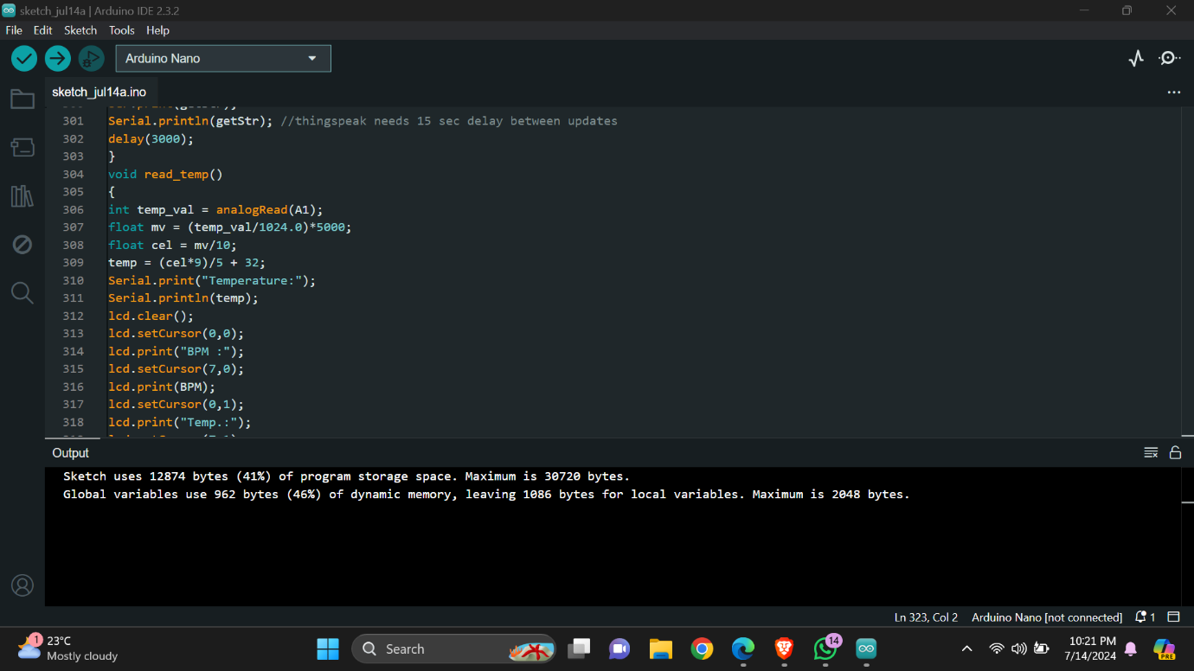

The setup:

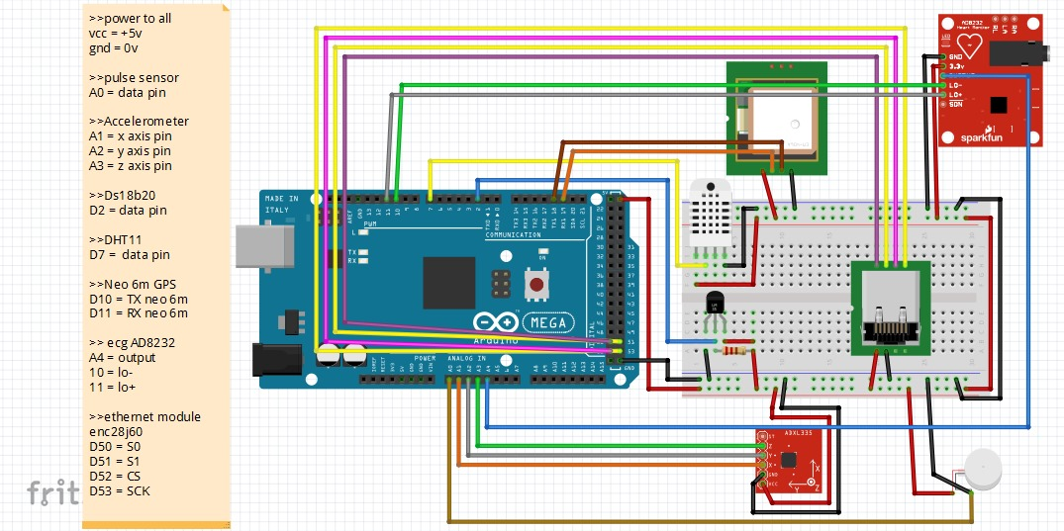

The outputs of the above-mentioned setup and code:

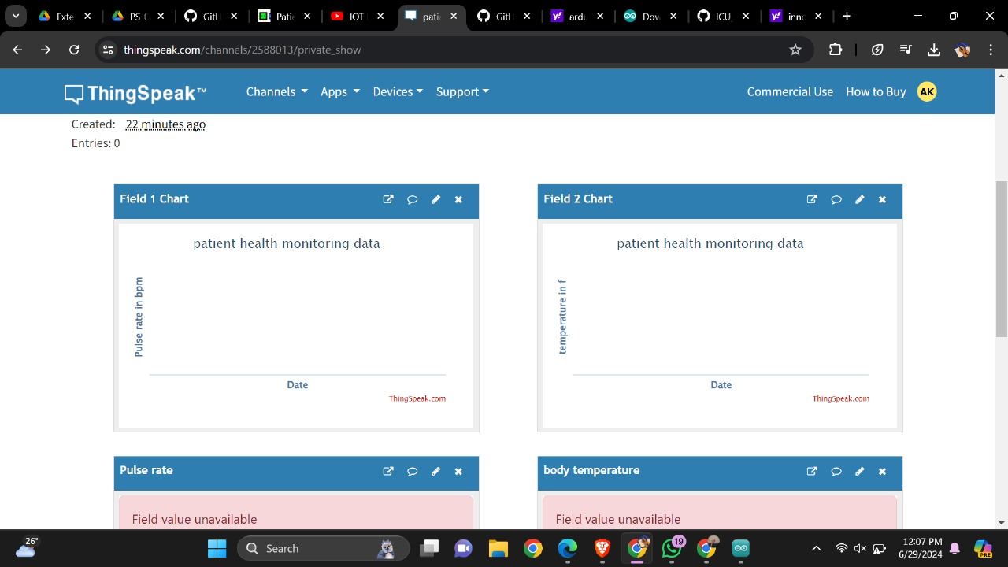

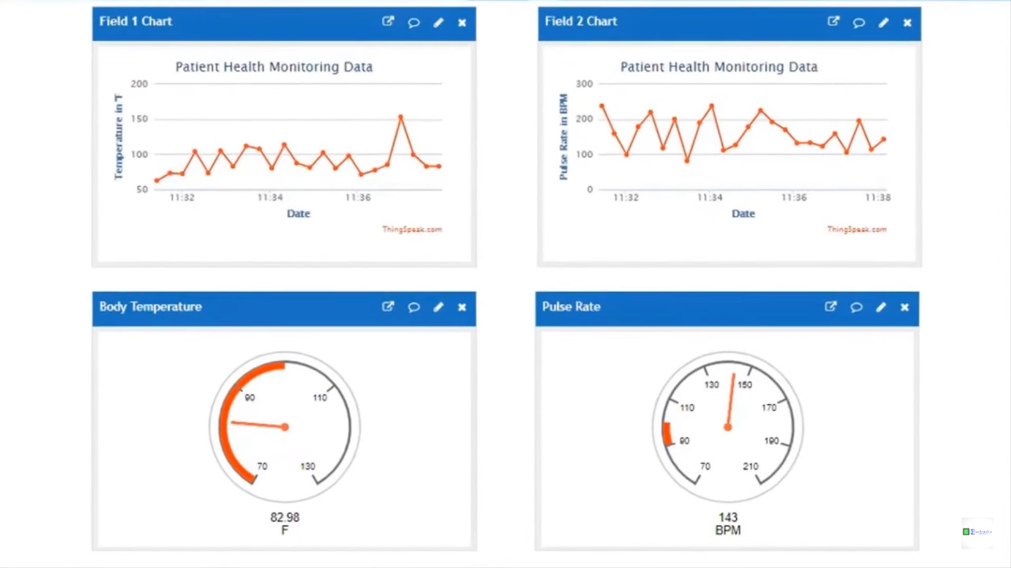

Conclusion

The project is detecting the type of person and motion of person and integrating it to the event handler which will notify on the screen of control center. The project will be expanded to the type of motions that patient will be making and segregating according to the motions and alarming intensivist according to the severity.

References

[1] Ren, S., He, K., Girshick, R., & Sun, J. (2015). Faster r-cnn: Towards real-time object detection with region proposal networks. In Advances in neural information processing systems.

[2] Redmon, J., & Farhadi, A. (2016). YOLO9000: Better, Faster, Stronger. arXiv preprint arXiv:1612.08242.

[3] Kumar, S., Merchant, S., & Reynolds, R. (2013). Tele-ICU: efficacy and cost-effectiveness approach of remotely managing the critical care. The open medical informatics journal, 7, 24.

[4] Chihaoui, M., Elkefi, A., Bellil, W., & Amar, C. B. (2016). Detection and tracking of the moving objects in a video sequence by geodesic active contour. In Computer Graphics, Imaging and Visualization (CGiV), 2016 13th International Conference.

[5] Rajput, S. J., & Oza, S. D. (2013)A New Algorithm for Tracking of Multiple Moving Objects. international Journal of Scientific Engineering and Technology, Volume, (2), 691-693.

[6] Raheja, J. L., Gopinath, D., & Chaudhary, A. (2014). GUI system for elders/patients in intensive care. In Technology Management Conference (ITMC), 2014 IEEE International.