WEEK 1 INTERNSHIP TASK
Data Modeling and Architecture Design – Virtual Retail Database
Role: SQL Developer Intern
Project: Virtual Retail Operations Database
Prepared for Week 1 Submission

1. Objective
The objective of this task is to design a clear, normalized, scalable relational database for a virtual retail business. The database should support customers, products, categories, suppliers, inventory, orders, order items, addresses, and payments. The design converts business requirements into entities, attributes, primary keys, foreign keys, relationships, and indexing strategies so that retail operations can be managed efficiently using SQL.

2. Business Requirements
- Maintain customer profiles including name, email, phone number and addresses.
- Maintain product information, category, supplier, price and product status.
- Track stock quantity and reorder levels for each product.
- Allow customers to place orders containing one or more products.
- Store order date, order status and calculated order total.
- Store each product purchased in a separate order-item record with quantity and unit price.
- Record payment method, payment amount, payment status and payment date.
- Support reporting such as sales by product/category, customer order history and low-stock products.
- Maintain data integrity through primary keys, foreign keys, unique constraints and validation rules.
- Provide an architecture that can scale as customers, products and orders increase.

3. Assumptions and Scope
- The system is designed for a single virtual retail business; multi-store support can be added later.
- A customer may have multiple addresses.
- A category can contain many products, while each product belongs to one primary category.
- A supplier can supply many products, while a product has one primary supplier in this version.
- An order belongs to one customer and contains one or more order items.
- An order item represents one product line and stores the selling price at the time of purchase.
- One order can have one payment record in the initial version; a payment transaction table can be introduced later for split or multiple payments.

4. Proposed Entities and Data Dictionary
Entity | Primary Key | Important Attributes | Purpose
Customers | CustomerID (PK) | CustomerName, Email, Phone, CreatedAt, Status | Stores customer master information.
Addresses | AddressID (PK) | CustomerID (FK), AddressLine1, City, State, Pincode, AddressType | Stores one or more customer addresses.
Categories | CategoryID (PK) | CategoryName, Description, Status | Groups products for navigation and reporting.
Suppliers | SupplierID (PK) | SupplierName, Email, Phone, Status | Stores supplier information.
Products | ProductID (PK) | CategoryID (FK), SupplierID (FK), ProductName, SKU, Price, Status | Stores product master information.
Inventory | InventoryID (PK) | ProductID (FK), QuantityOnHand, ReorderLevel, UpdatedAt | Tracks current stock.
Orders | OrderID (PK) | CustomerID (FK), OrderDate, Status, TotalAmount, ShippingAddressID (FK) | Stores order header information.
OrderItems | OrderItemID (PK) | OrderID (FK), ProductID (FK), Quantity, UnitPrice, LineTotal | Stores products included in each order.
Payments | PaymentID (PK) | OrderID (FK), PaymentMethod, Amount, PaymentDate, Status, TransactionRef | Stores payment information.

5. Entity Relationships
- Customers 1-to-many Addresses: one customer can save multiple addresses.
- Customers 1-to-many Orders: one customer can place many orders.
- Categories 1-to-many Products: one category can contain many products.
- Suppliers 1-to-many Products: one supplier can provide many products.
- Products 1-to-1 Inventory in the initial design: each active product has one current inventory record.
- Orders 1-to-many OrderItems: one order contains multiple line items.
- Products 1-to-many OrderItems: the same product can appear in many orders.
- Orders 1-to-1 Payments in the initial design: each completed order has its payment record.

6. ER Diagram
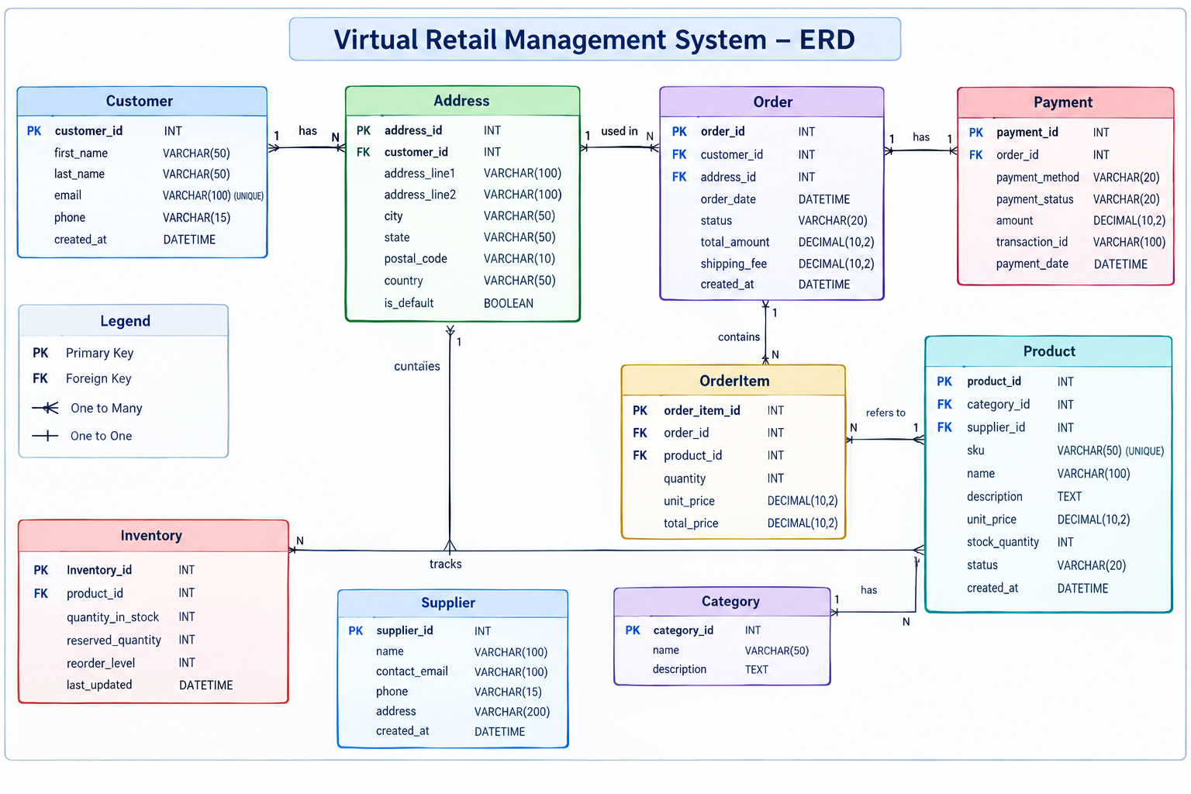
The ERD separates master data (customers, products, categories and suppliers) from transactional data (orders, order items and payments) and inventory data. This reduces duplication and makes the model easier to maintain.

7. Relational Schema
- Customers(CustomerID PK, CustomerName, Email UNIQUE, Phone, CreatedAt, Status)
- Addresses(AddressID PK, CustomerID FK → Customers.CustomerID, AddressLine1, City, State, Pincode, AddressType)
- Categories(CategoryID PK, CategoryName UNIQUE, Description, Status)
- Suppliers(SupplierID PK, SupplierName, Email, Phone, Status)
- Products(ProductID PK, CategoryID FK → Categories.CategoryID, SupplierID FK → Suppliers.SupplierID, ProductName, SKU UNIQUE, Price, Status)
- Inventory(InventoryID PK, ProductID FK → Products.ProductID, QuantityOnHand, ReorderLevel, UpdatedAt)
- Orders(OrderID PK, CustomerID FK → Customers.CustomerID, ShippingAddressID FK → Addresses.AddressID, OrderDate, Status, TotalAmount)
- OrderItems(OrderItemID PK, OrderID FK → Orders.OrderID, ProductID FK → Products.ProductID, Quantity, UnitPrice, LineTotal)
- Payments(PaymentID PK, OrderID FK → Orders.OrderID, PaymentMethod, Amount, PaymentDate, Status, TransactionRef UNIQUE)

8. Normalization Strategy
The database is designed approximately to Third Normal Form (3NF). In First Normal Form (1NF), each column contains atomic values and repeating product columns are avoided. In Second Normal Form (2NF), non-key attributes depend on the complete key; order-level information is therefore kept in Orders while product-line information is kept in OrderItems. In Third Normal Form (3NF), non-key attributes do not depend on other non-key attributes. For example, category details are stored in Categories instead of repeating category names in every product row, and supplier details are kept in Suppliers. This reduces update, insert and delete anomalies.

9. Indexing Strategy
- Primary keys automatically provide indexes in most relational database systems.
- Create a unique index on Customers.Email to support fast customer lookup and prevent duplicate emails.
- Create a unique index on Products.SKU because SKU is commonly used to search products.
- Index Orders.CustomerID and Orders.OrderDate for customer order history and date-based reporting.
- Index OrderItems.OrderID for quickly retrieving all items belonging to an order.
- Index OrderItems.ProductID for product sales analysis.
- Index Products.CategoryID and Products.SupplierID for filtering and joins.
- Index Inventory.ProductID and consider an index on QuantityOnHand for low-stock reports.
- Create an index on Payments.TransactionRef for payment reconciliation.

10. Architecture Overview
A three-tier architecture is proposed. The presentation layer contains the web/mobile retail interface. The application/service layer contains business rules, authentication, order processing, inventory validation and payment integration. The data layer contains the relational SQL database. The application layer should access the database through parameterized queries or a controlled data access layer rather than allowing direct client-side database access.
- Presentation Layer: Product catalogue, customer account, cart, checkout and order history.
- Application Layer: Authentication, product service, order service, inventory service, payment service and reporting service.
- Data Layer: SQL Server/MySQL relational database, indexes, constraints, transactions and backups.
- Security: role-based access, password hashing, least-privilege database users, parameterized SQL and encrypted connections.
- Reliability: database backups, transaction handling and logging.
- Scalability: connection pooling, indexed queries, caching of read-heavy catalogue data and future read replicas.

11. Order Processing Workflow
- Customer selects products and creates a cart.
- Application checks that products are active and sufficient stock is available.
- At checkout, an order header is inserted into Orders.
- Each selected product is inserted into OrderItems with quantity and current selling price.
- Inventory quantity is reduced within the same database transaction.
- Payment is processed and its result is stored in Payments.
- The order status is changed to Confirmed/Paid only after successful validation.
- If a critical step fails, the transaction is rolled back to prevent partial order creation.

12. Data Integrity and Validation Rules
- Primary keys must be NOT NULL and unique.
- Foreign keys must reference valid parent records.
- Product SKU and customer email should be unique.
- Price, quantity and payment amount should not be negative.
- OrderItems.Quantity should be greater than zero.
- Order status and payment status should use controlled values such as Pending, Confirmed, Shipped, Delivered, Cancelled and Failed.
- Deleting a customer or product should be restricted when historical transactions depend on the record; use status fields for deactivation instead.

13. Scalability and Future Enhancements
- Introduce ProductImages, Reviews, Coupons and ShoppingCart tables as requirements expand.
- Add an InventoryTransactions table to maintain an auditable history of stock movements.
- Support multiple warehouses by changing Inventory to a Product-Warehouse relationship.
- Introduce a PaymentTransactions table if an order can have retries, refunds or multiple payment attempts.
- Partition or archive very large Orders and OrderItems tables based on date when volume becomes significant.
- Use caching for frequently requested catalogue data.
- Add read replicas for reporting workloads if transaction volume grows.
- Add monitoring for slow SQL queries, failed transactions, deadlocks and storage usage.

14. Sample SQL DDL (Core Tables)
CREATE TABLE Categories (
CategoryID INT PRIMARY KEY,
CategoryName VARCHAR(100) NOT NULL UNIQUE,
Description VARCHAR(500),
Status VARCHAR(20) NOT NULL
);
CREATE TABLE Suppliers (
SupplierID INT PRIMARY KEY,
SupplierName VARCHAR(150) NOT NULL,
Email VARCHAR(150),
Phone VARCHAR(20),
Status VARCHAR(20) NOT NULL
);
CREATE TABLE Products (
ProductID INT PRIMARY KEY,
CategoryID INT NOT NULL,
SupplierID INT NOT NULL,
ProductName VARCHAR(200) NOT NULL,
SKU VARCHAR(50) NOT NULL UNIQUE,
Price DECIMAL(12,2) NOT NULL,
Status VARCHAR(20) NOT NULL,
FOREIGN KEY (CategoryID) REFERENCES Categories(CategoryID),
FOREIGN KEY (SupplierID) REFERENCES Suppliers(SupplierID)
);
CREATE TABLE Customers (
CustomerID INT PRIMARY KEY,
CustomerName VARCHAR(150) NOT NULL,
Email VARCHAR(150) NOT NULL UNIQUE,
Phone VARCHAR(20),
CreatedAt DATETIME NOT NULL,
Status VARCHAR(20) NOT NULL
);
CREATE TABLE Orders (
OrderID INT PRIMARY KEY,
CustomerID INT NOT NULL,
ShippingAddressID INT NULL,
OrderDate DATETIME NOT NULL,
Status VARCHAR(30) NOT NULL,
TotalAmount DECIMAL(12,2) NOT NULL,
FOREIGN KEY (CustomerID) REFERENCES Customers(CustomerID)
);
CREATE TABLE OrderItems (
OrderItemID INT PRIMARY KEY,
OrderID INT NOT NULL,
ProductID INT NOT NULL,
Quantity INT NOT NULL,
UnitPrice DECIMAL(12,2) NOT NULL,
LineTotal DECIMAL(12,2) NOT NULL,
FOREIGN KEY (OrderID) REFERENCES Orders(OrderID),
FOREIGN KEY (ProductID) REFERENCES Products(ProductID)
);

15. Methodology and Estimated Work Plan (30–35 Hours)
Activity | Time | Work Performed
Requirement analysis | 3 hours | Identify retail scenarios, assumptions and data requirements.
Entity and attribute identification | 4 hours | Define entities, attributes, keys and business rules.
ERD design | 5 hours | Create relationships and verify cardinality and referential integrity.
Normalization | 4 hours | Review the model against 1NF, 2NF and 3NF and remove duplication.
Architecture planning | 4 hours | Define application/data layers, security, transactions and scalability.
Indexing and integrity design | 3 hours | Plan indexes, unique constraints, validation and foreign keys.
SQL schema preparation | 4 hours | Translate the model into relational tables and core DDL.
Documentation and review | 4 hours | Prepare diagrams, explanations, assumptions and final quality check.

16. Evaluation Readiness / Key Decisions
- The model separates master data, transaction data and inventory data.
- Primary and foreign keys clearly define relationships and preserve referential integrity.
- The design targets 3NF to reduce redundancy while keeping transactional queries practical.
- Indexes are selected based on likely search, join and reporting patterns rather than indexing every column.
- Order creation and inventory deduction should be handled as an atomic transaction.
- The architecture can be extended for multiple warehouses, refunds, reviews, promotions and higher traffic.

17. Conclusion
This Week 1 design provides a structured relational foundation for a virtual retail system. The proposed model captures the main operational flow from customer and product management to inventory, ordering and payment. The use of normalization, constraints, indexes and transaction management improves data quality and consistency. The three-tier architecture also separates user interface concerns from business logic and database operations, making the system easier to maintain and scale. Future enhancements can be introduced without redesigning the core entities.

18. Suggested GitHub Project Structure (Optional)
If a GitHub URL is required, create a repository containing the database design and SQL scripts. A simple structure is:
- README.md – project overview, requirements and setup instructions
- docs/ERD.png – entity relationship diagram
- sql/01_create_tables.sql – table definitions
- sql/02_constraints_indexes.sql – constraints and indexes
- sql/03_sample_queries.sql – sample retail queries
- docs/Week1_Report.docx – submitted report

