WEEK 5 INTERNSHIP TASK
Automation and Integration of SQL Processes
Project: Virtual Retail Management System
SQL Developer Intern | MySQL 8.0+ implementation plan

1. Executive Summary
This report presents an automation design for the Virtual Retail Management System developed in Weeks 1–4. It uses stored procedures to perform controlled operations, triggers to maintain inventory and capture stock movements, and MySQL scheduled events to refresh daily sales summaries and copy older closed-order headers to an archive table. The design reduces repetitive manual work, improves consistency, and provides an audit trail for important retail operations. The operational Orders table is not automatically deleted; archiving is implemented as a safe copy so that retention and deletion decisions remain under business control.

2. Objectives and Business Requirements
- Automatically reduce available inventory when an order item is inserted and restore stock when an order item is reduced, changed or deleted.
- Record every automated stock movement with product, movement type, quantity change, reference and timestamp.
- Create one open low-stock alert when inventory reaches or falls below its reorder level, and resolve it when stock recovers.
- Provide a stored procedure for controlled product restocking with validation and transaction handling.
- Refresh daily sales metrics using a stored procedure that can also be called manually.
- Schedule daily summary refresh and weekly archival copy using the MySQL Event Scheduler.
- Keep automation auditable, repeatable, secure and recoverable.

3. Existing Week 1 Database and Added Automation Tables
The design extends the Week 1 schema. It expects the existing Customers, Products, Inventory, Orders and OrderItems tables. The Inventory table must contain ProductID, QuantityOnHand, ReorderLevel and UpdatedAt; OrderItems must contain OrderItemID, OrderID, ProductID, Quantity, UnitPrice and LineTotal; Orders must contain OrderID, CustomerID, OrderDate, Status and TotalAmount.
New table | Purpose | Important columns
InventoryMovements | Audit stock movement generated by orders and restocking | ProductID, MovementType, QuantityChange, ReferenceID, CreatedAt
LowStockAlerts | Track open and resolved low-stock alerts | ProductID, CurrentQuantity, ReorderLevel, AlertStatus, ResolvedAt
DailySalesSummary | Store daily reporting totals for fast retrieval | SalesDate, OrdersCount, ItemsSold, GrossSales
OrdersArchive | Keep a copy of older delivered/cancelled order headers | OrderID, CustomerID, OrderDate, OrderStatus, TotalAmount, ArchivedAt

4. Automation Components

4.1 Stored Procedures
- sp_restock_product(ProductID, Quantity, Remarks): validates a positive restock quantity, checks that an Inventory row exists, updates stock inside a transaction, and writes a RESTOCK movement record. Errors trigger rollback and are returned to the caller.
- sp_refresh_daily_sales_summary(SalesDate): calculates confirmed/shipped/delivered order count, items sold and gross sales for one date. It uses an upsert so that running it again refreshes the same date instead of creating duplicate summary rows.
- sp_archive_closed_orders(RetentionDays): copies old Delivered and Cancelled order headers to OrdersArchive. It does not delete live Orders or dependent OrderItems/Payments.

4.2 Triggers
- Inventory AFTER INSERT / AFTER UPDATE: create an OPEN alert when QuantityOnHand is less than or equal to ReorderLevel; avoid creating a second open alert; update the open alert quantity; resolve it when stock rises above the threshold.
- OrderItems BEFORE INSERT / BEFORE UPDATE: reject invalid quantities and negative unit prices, and recalculate LineTotal as Quantity × UnitPrice.
- OrderItems AFTER INSERT: deduct stock only when enough quantity exists; reject the insert if stock is insufficient or the inventory row is missing; record a SALE movement.
- OrderItems AFTER UPDATE: adjust stock when quantity changes or the product is replaced; record corresponding movement entries.
- OrderItems AFTER DELETE: restore the removed order-line quantity and record the return movement.

4.3 Scheduled Events
- ev_daily_sales_summary: once per day, calls the daily summary procedure for the previous calendar day.
- ev_weekly_archive_closed_orders: once per week, copies qualifying closed orders older than 730 days into OrdersArchive.
Event creation requires the EVENT privilege. Event execution requires the MySQL Event Scheduler to be ON. An administrator may need to enable it; manual CALL statements can still demonstrate the procedures when scheduled events are unavailable.

5. Workflow and Component Integration
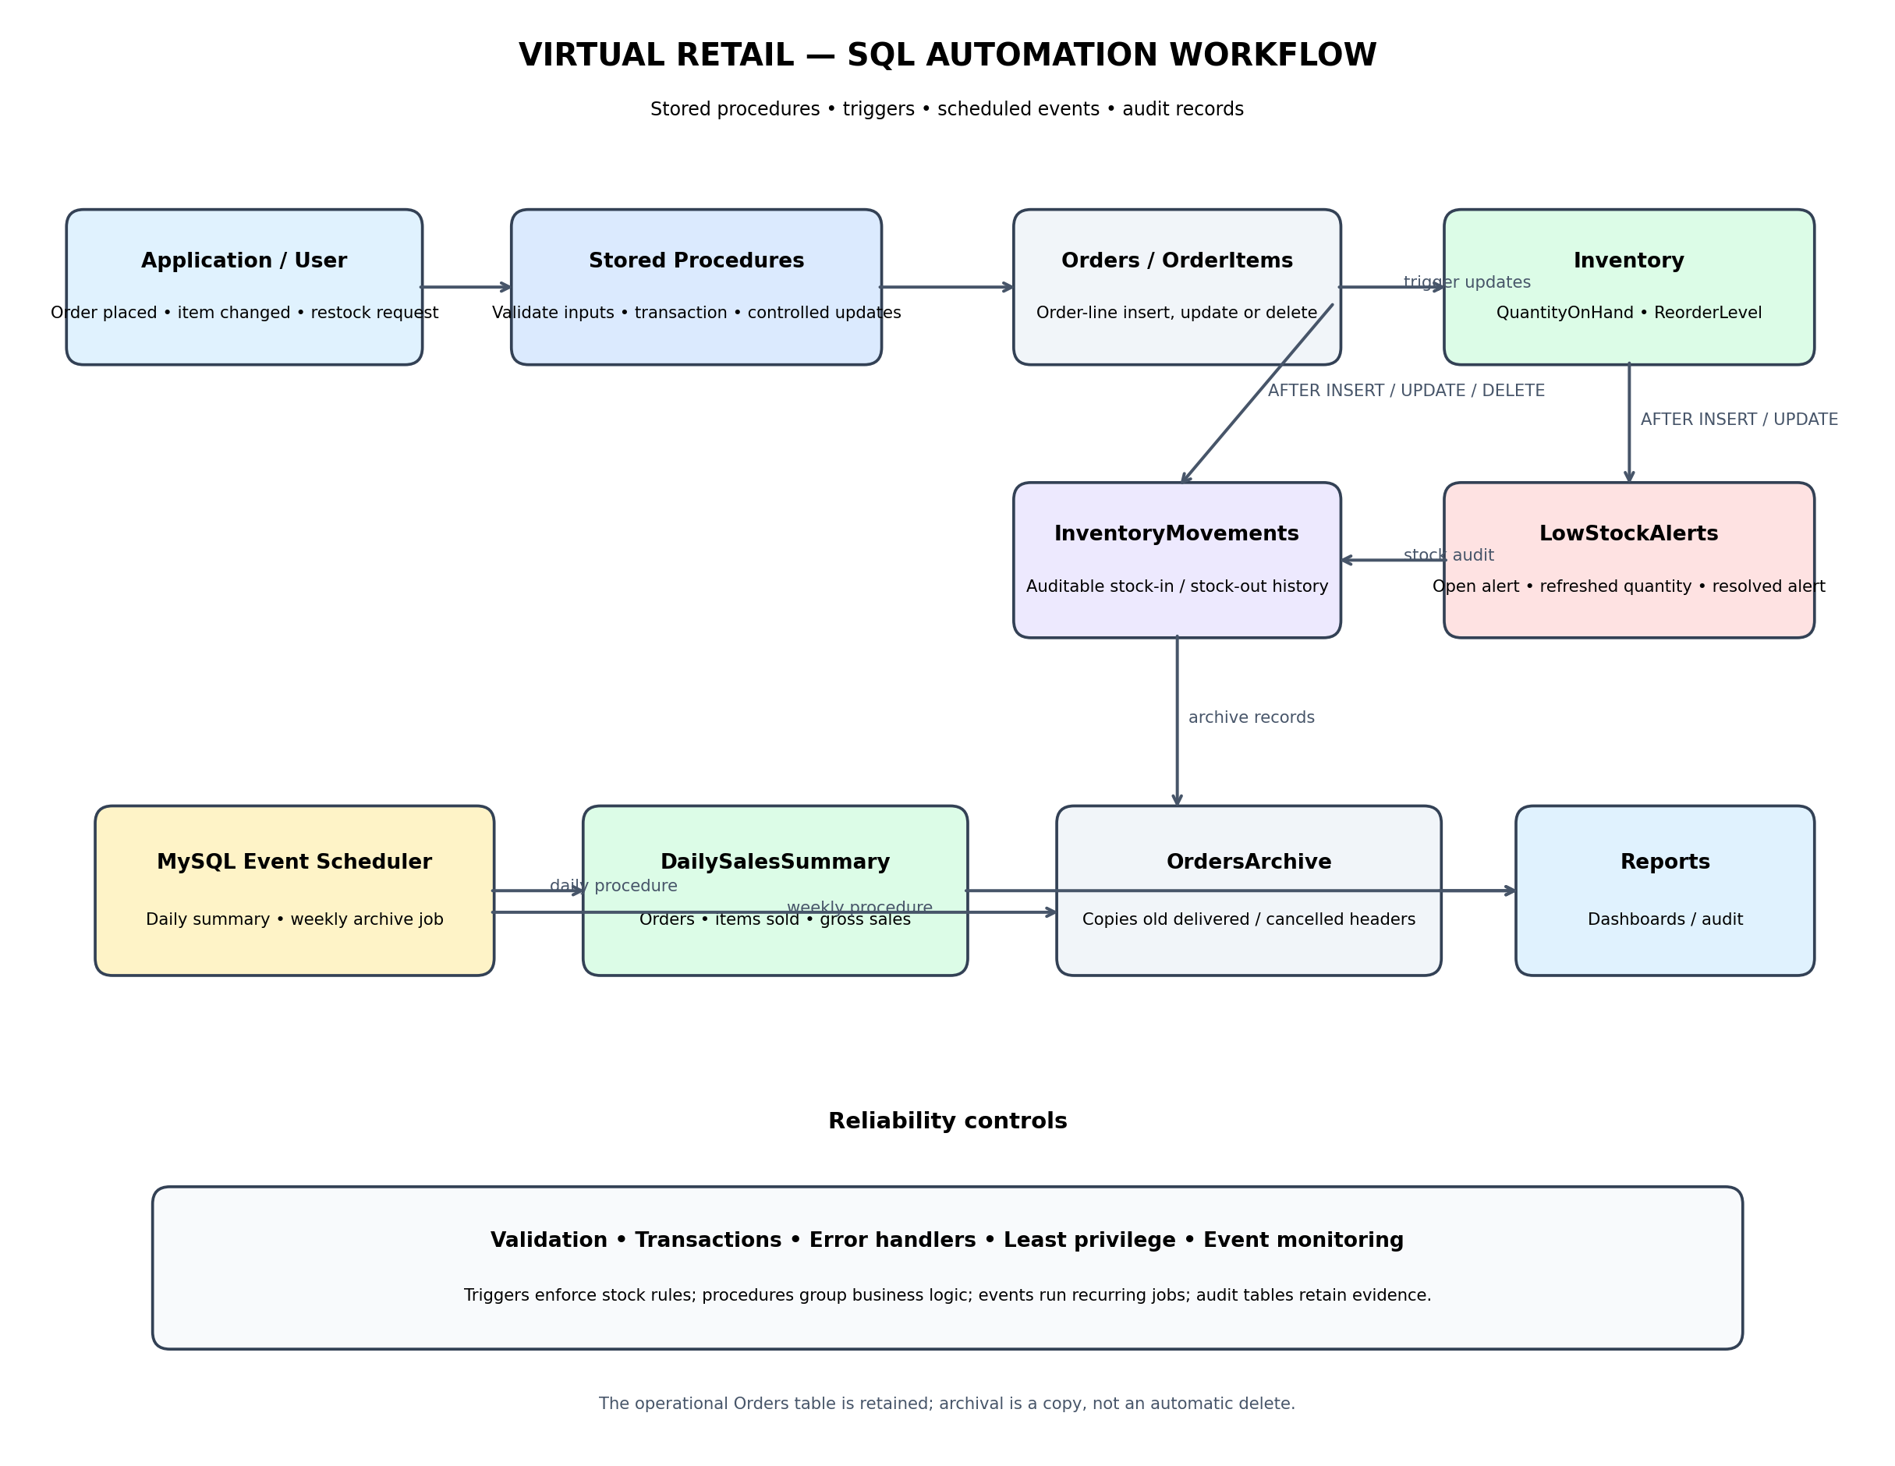
Workflow explanation: an application or user calls a stored procedure for controlled restocking. When order lines are inserted, updated or deleted, triggers adjust Inventory and write InventoryMovements. Inventory triggers maintain LowStockAlerts. Scheduled events call the daily sales refresh and weekly archive procedures. Reporting users read the summary, alert, movement and archive tables.

6. Detailed Process Examples

6.1 Order and Inventory Workflow
1. A customer order is created in Orders by the application.
2. The application inserts each purchased product into OrderItems.
3. The BEFORE INSERT trigger validates quantity and price values.
4. The AFTER INSERT trigger deducts the ordered quantity only if sufficient inventory exists.
5. The stock update activates the Inventory AFTER UPDATE trigger, which creates or updates a low-stock alert when needed.
6. An InventoryMovements row records the stock deduction and its OrderItem reference. If any trigger raises an error, the OrderItems statement is rejected; with InnoDB tables, associated trigger changes from that statement are rolled back.

6.2 Restocking Workflow
1. An authorized user identifies a product requiring replenishment.
2. The user calls sp_restock_product with ProductID, positive quantity and a remark.
3. The procedure checks inputs and verifies the Inventory row.
4. A transaction increases QuantityOnHand and inserts a RESTOCK movement.
5. The inventory trigger updates or resolves any open low-stock alert.
6. The procedure commits and returns the updated stock quantity.

6.3 Scheduled Reporting and Archiving
1. The daily event calls sp_refresh_daily_sales_summary for the previous date.
2. The procedure calculates metrics from Orders and OrderItems using the agreed order statuses.
3. The summary row is inserted or refreshed by SalesDate, making re-runs safe.
4. The weekly event calls sp_archive_closed_orders(730).
5. Older Delivered and Cancelled order headers are copied to OrdersArchive. The live transaction tables remain intact.

7. Error Handling and Data Integrity
- Use SIGNAL SQLSTATE '45000' for invalid input, missing inventory and insufficient stock conditions.
- Use an EXIT HANDLER FOR SQLEXCEPTION in the restock procedure to ROLLBACK and RESIGNAL.
- Use InnoDB so target updates and trigger actions participate in transactions.
- Use primary and foreign keys on supporting audit tables and indexes on alert status, product and movement date.
- Keep status values controlled and document which order statuses count as sales.
- Do not allow a low-stock trigger to send external email directly. Store an alert first; a separately secured application or notification service can deliver it.
- Record procedure failures in application/server logs and monitor event execution through SHOW EVENTS and MySQL logs.

8. Deployment and Execution Guide
1. Install MySQL Server 8.0+ and open MySQL Workbench.
2. Create and populate the Week 1 VirtualRetailDB schema first. Confirm the expected columns listed in Section 3.
3. Run 10_week5_automation_objects.sql as a database account with permission to create tables, triggers, procedures and events.
4. Check the output of SHOW TRIGGERS, SHOW PROCEDURE STATUS, SHOW EVENTS and SHOW VARIABLES LIKE 'event_scheduler'.
5. If the Event Scheduler is OFF, ask an administrator to enable it with SET GLOBAL event_scheduler = ON. This requires elevated privileges and may need server configuration to persist after restart.
6. Run 11_week5_automation_verification.sql to inspect alerts, movements, summaries and archive copies.
7. Test on a development database before using the automation on production data.

9. Demonstration Commands
-- Check current stock
SELECT ProductID, QuantityOnHand, ReorderLevel
FROM Inventory ORDER BY ProductID LIMIT 10;
-- Manually restock an existing ProductID (example: 1)
CALL sp_restock_product(1, 5, 'External teacher demonstration');
-- Refresh daily reporting for a date with orders
CALL sp_refresh_daily_sales_summary('2026-11-04');
-- Copy old closed order headers; live orders are not deleted
CALL sp_archive_closed_orders(730);
-- Inspect generated audit records and alerts
SELECT * FROM InventoryMovements ORDER BY CreatedAt DESC LIMIT 10;
SELECT * FROM LowStockAlerts ORDER BY CreatedAt DESC LIMIT 10;
SELECT * FROM DailySalesSummary ORDER BY SalesDate DESC LIMIT 10;
SELECT * FROM OrdersArchive ORDER BY ArchivedAt DESC LIMIT 10;
Replace ProductID and date values with records that exist in your local database. Do not assume ProductID = 1 exists.

10. Testing Plan and Expected Outcomes
Test | Action | Expected result
Restock valid product | Call sp_restock_product with existing ProductID and positive quantity | QuantityOnHand increases; RESTOCK movement is recorded.
Restock invalid quantity | Call procedure with 0 or negative quantity | Procedure returns a clear error; stock remains unchanged.
Order item with available stock | Insert an OrderItem where Inventory has enough stock | Stock decreases by order quantity; SALE movement is recorded.
Order item with insufficient stock | Attempt to insert an OrderItem quantity greater than available stock | Insert fails with insufficient-stock message; inventory remains unchanged.
Low-stock threshold | Reduce stock to or below ReorderLevel | One OPEN low-stock alert exists for that product.
Stock recovery | Restock above ReorderLevel | The open alert is marked RESOLVED.
Daily summary rerun | Call summary procedure twice for the same date | One row exists for the date; metrics are refreshed.
Archive rerun | Call archive procedure more than once | No duplicate OrderID rows; live Orders remain available.
Scheduled event | Enable Event Scheduler and inspect event status/logs | Events are enabled and become eligible to run at scheduled times.

11. Security, Reliability and Maintenance
- Grant EXECUTE on approved procedures to application users instead of granting broad table-update permissions where practical.
- Restrict CREATE ROUTINE, TRIGGER, EVENT and global scheduler privileges to database administrators/deployment accounts.
- Use parameterized statements in the application; never concatenate untrusted values into SQL.
- Back up the database before deployment and version-control SQL scripts.
- Monitor event status, failed executions, low-stock alert backlog and growth of archive/movement tables.
- Test trigger interactions and procedures with concurrent transactions in a non-production environment.

12. Limitations and Design Decisions
- This is a MySQL 8.0+ implementation template. Test exact server version and permissions before deployment.
- The order-item trigger deducts stock when the line is inserted. A complete commercial order lifecycle may need reservation, payment confirmation, cancellation and return rules; those rules should be implemented as explicit status-transition procedures before production use.
- The archive procedure copies order headers only and does not delete live rows. Archiving OrderItems and Payments requires a separate retention design and business approval.
- Scheduled events may not run if Event Scheduler is disabled or the database server is stopped.
- External email/SMS notifications need an application or messaging integration; SQL triggers only store alert records in this design.

13. Estimated Work Plan (30–35 Hours)
Activity | Estimated time
Review Week 1 schema and identify automation points | 3 hours
Design inventory, alert, movement and archive support tables | 4 hours
Develop and test stored procedures | 6 hours
Develop and test triggers | 7 hours
Configure and test scheduled events | 4 hours
Prepare integration flowchart and verification queries | 4 hours
Documentation, review and final corrections | 4 hours

14. Conclusion
The Week 5 design demonstrates how SQL automation can reduce repetitive retail database operations while maintaining control and traceability. Stored procedures centralize business operations, triggers keep inventory and alerts synchronized with order-line changes, and scheduled events automate daily summaries and weekly archive copies. Audit tables, validation, transactions and explicit deployment checks improve reliability. The project completes the progression from the Week 1 relational data model, through Week 2 ETL planning, Week 3 optimization and Week 4 reporting, to an integrated automation layer.

Appendix A — GitHub File Structure
virtual-retail-sql-database/
├── README.md
├── docs/
│ ├── ERD.png
│ ├── Week_1_Virtual_Retail_Data_Model_Architecture.docx
│ ├── Week_2_ETL_Planning_Report.docx
│ ├── Week_3_SQL_Query_Optimization_Report.docx
│ ├── Week_4_Dynamic_Reporting_and_Data_Visualization_Report.docx
│ ├── Week_5_Automation_and_Integration_Report.docx
│ └── Week5_Automation_Flowchart.png
└── sql/
├── 01_create_tables.sql
├── 02_constraints_indexes.sql
├── 03_sample_queries.sql
├── 04_etl_staging_and_transform_examples.sql
├── 05_week3_query_optimization_and_benchmark.sql
├── 08_week4_dynamic_reporting_queries.sql
├── 09_week4_monthly_trend_demo_seed.sql
├── 10_week5_automation_objects.sql
└── 11_week5_automation_verification.sql

