WEEK 2 INTERNSHIP TASK
Data Extraction, Transformation, and Loading (ETL) Planning
Project: Virtual Retail Management System
SQL Developer Intern | Reference platform: MySQL 8.x

1. Executive Summary
This report proposes a repeatable ETL pipeline for the Virtual Retail Management System designed in Week 1. The process extracts retail data from customer records, supplier product files, order exports, inventory feeds and payment records; lands source values in raw staging; validates and transforms the data; and loads trusted records into the relational target model. The design emphasizes traceability, data quality, referential integrity, safe reruns and measurable reconciliation. MySQL 8.x is used for examples, but the principles can be adapted to SQL Server or another relational database.

2. Objectives and Scope
- Identify hypothetical retail source systems and practical extraction methods.
- Describe raw staging, data profiling, cleaning, transformation and loading steps.
- Define data-quality rules and a reject/quarantine process for invalid records.
- Explain full and incremental loading, target load order, transactions and restartability.
- Identify SQL techniques and tools that support a maintainable ETL workflow.
- Provide a flowchart and step-by-step guide that another SQL developer can follow.

3. Retail Scenario and Source Systems
The following sources are hypothetical inputs for the project. A prototype can use synthetic sample files or appropriately licensed public data; it does not require a connection to a real retailer.
Source | Example fields | Extraction method | Typical risks
Customer export (CSV) | Source customer ID, name, email, phone, address | Scheduled CSV export or secure file drop | Missing email, duplicate customer, inconsistent phone
Product catalogue | SKU, product name, category, supplier, price, status | Supplier file or paginated API | Duplicate SKU, invalid price, unmapped category
Orders and order items | Source order ID, customer reference, date, SKU, quantity, unit price | Incremental query/export by modified timestamp or source ID | Late updates, missing parent key, repeated order line
Inventory feed | SKU, on-hand quantity, reorder threshold, updated timestamp | Scheduled snapshot or source query | Negative stock, duplicate/stale snapshot
Payment feed | Transaction reference, order reference, amount, payment status, date | Secure batch export or API | Duplicate transaction, amount mismatch, sensitive data

4. ETL Pipeline Flowchart
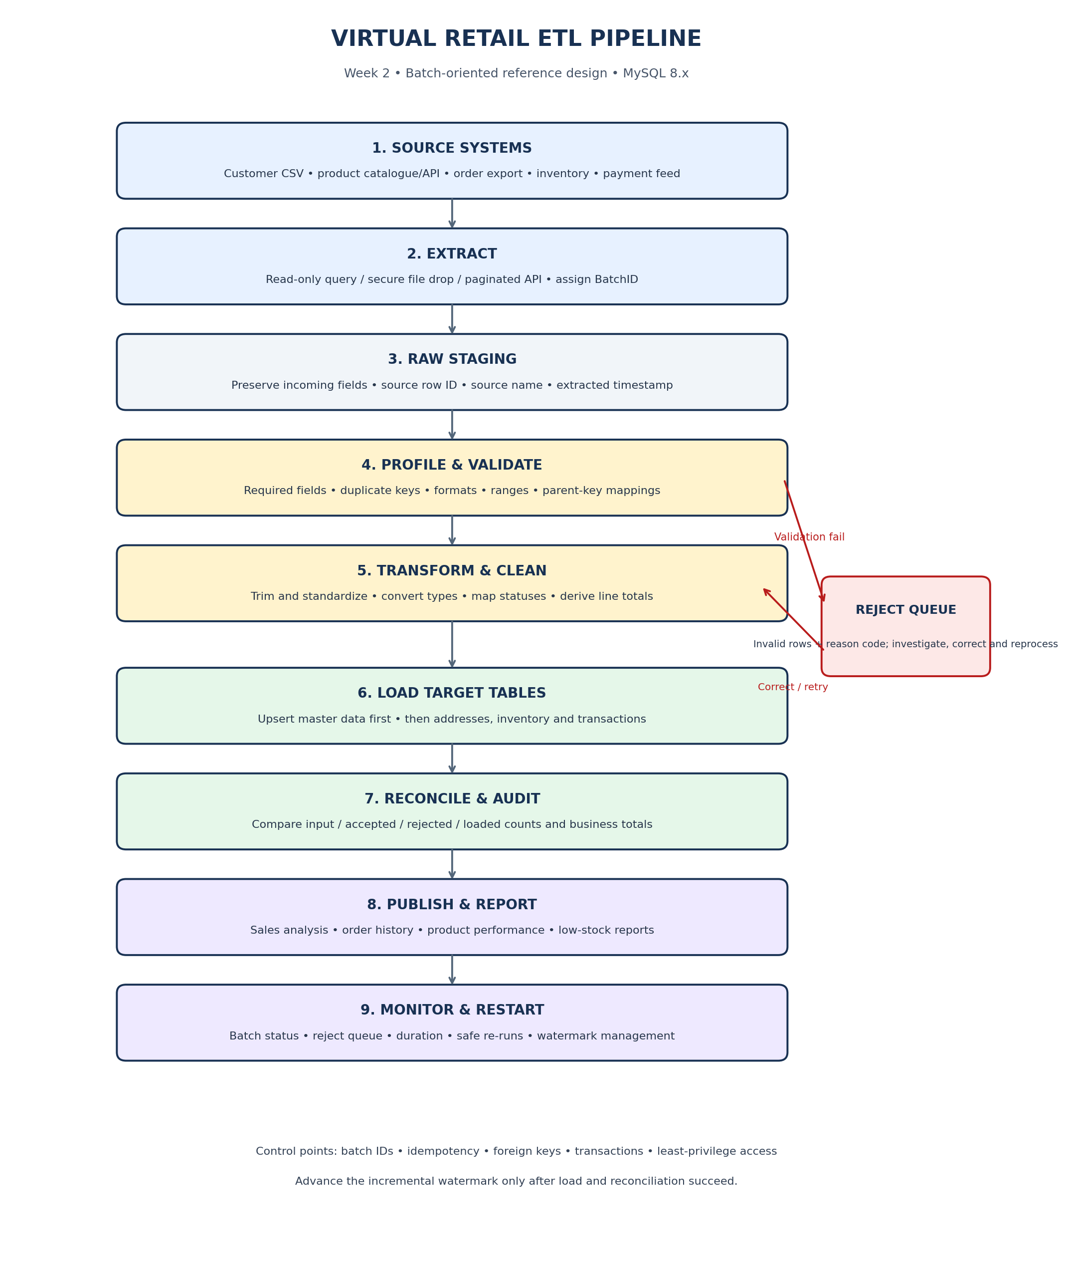
Flow interpretation: incoming rows are captured in raw staging before destructive edits. Validation and transformation produce trusted rows and a separate reject set. Accepted rows are loaded into the Week 1 schema, then row counts and business totals are reconciled before the batch is marked successful.

5. Step-by-Step ETL Process

Step 1 — Register the batch
Create a unique BatchID and record source name, run start time, expected file or API format, and the extraction watermark. A checksum may be stored when files are used. Batch metadata makes the run traceable and helps prevent accidental duplicate processing.

Step 2 — Extract source data
Use a read-only source database account, CSV ingestion, API pagination, or scheduled export. For incremental extraction, select records changed since the previous successful watermark. Keep the previous watermark until the new batch passes loading and reconciliation.

Step 3 — Land raw staging data
Preserve source values with source identifiers, source row number, BatchID, source name and extraction timestamp. Raw staging should allow investigation of errors and reprocessing without repeatedly retrieving the source.

Step 4 — Profile and validate
Check input row counts, missing required fields, duplicate keys, data types, date ranges, numeric bounds, allowed statuses and parent references such as CustomerID or ProductID. Run these checks before target insertion.

Step 5 — Transform and clean
Trim spaces; convert blank strings to NULL where appropriate; standardize status labels and date/time formats; convert validated numeric strings to DECIMAL or INT; resolve duplicates using documented business rules; and calculate line totals from quantity and unit price.

Step 6 — Quarantine invalid rows
Write invalid records to a reject table with BatchID, source row ID, reason code, reason detail and timestamp. Do not silently discard rows or invent missing business values. Correct the source or mapping rule, then reprocess the rejected records.

Step 7 — Load relational targets
Load parent/master data before child records. A recommended order is Categories and Suppliers, Customers, Addresses and Products, Inventory, Orders, OrderItems, and finally Payments. Use stable source IDs or business keys to decide whether each row is new or an update.

Step 8 — Reconcile and audit
Compare extracted rows with accepted plus rejected rows. Compare loaded rows with accepted inserts/updates, documenting legitimate exclusions. Reconcile order totals, payment totals and inventory counts when source control totals are available.

Step 9 — Publish and monitor
Make data available to reporting only after successful reconciliation. Monitor failed batches, reject rate, runtime, duplicate counts and stale inventory. Record completion time, status, error summary and successful watermark.

6. Transformation Rules and Data Quality
Data issue | Transformation / validation rule | Action if unresolved
Whitespace and inconsistent labels | TRIM text; standardize controlled values such as Active/Inactive; preserve display names sensibly. | Flag unexpected values for review.
Null or blank email | Convert empty strings to NULL; check requiredness; never invent an email address. | Quarantine if business rules require it or identity is unclear.
Duplicate customers | Use stable source ID first; normalized email can be a secondary match only when policy allows. | Manual review if match confidence is low.
Product SKU | Trim and normalize consistently; enforce uniqueness in target Products.SKU. | Reject blank or conflicting SKU rows.
Dates and timestamps | Parse known formats; document timezone; normalize storage/display conventions. | Quarantine unparseable or implausible dates.
Prices and quantities | Validate numeric syntax before conversion; price must be >= 0 and order quantity > 0. | Reject negative, missing or malformed values.
Unknown foreign key | Map source identifiers to target parent keys before loading child rows. | Quarantine until parent record or mapping is fixed.
Order line total | Calculate Quantity × UnitPrice using decimal arithmetic; compare to source total using defined rounding tolerance. | Flag material mismatches.
Inventory snapshot | Validate stock is non-negative; capture source snapshot timestamp; distinguish snapshot from stock movements. | Reject negative, stale or duplicate snapshots according to policy.
Unknown status code | Map only reviewed source terms to approved target values. | Quarantine values mapped to REVIEW/UNKNOWN.

7. Loading Strategy
- Full load: use for the initial population or a controlled rebuild when the data volume is manageable.
- Incremental load: extract only new/changed records using a reliable source ID or modified timestamp; account for late-arriving updates.
- Upsert strategy: insert new master data and update existing records using stable source identifiers or keys such as SKU. Avoid matching records on weak attributes alone.
- Load parent entities before dependent entities to protect foreign-key integrity.
- Use set-based INSERT ... SELECT and JOIN operations where practical instead of row-by-row loops.
- Wrap related target changes in transactions; roll back a failed transaction and mark the batch failed for safe retry.
- Make reruns idempotent: processing the same batch again should not create duplicate orders, order lines or payments. Use unique keys and a batch/source-key mapping.
- For large datasets, process manageable batches and schedule heavy loads away from peak retail traffic.

8. SQL Techniques and Supporting Technologies
- MySQL 8.x: staging tables, INSERT ... SELECT, JOIN, CASE, COALESCE, NULLIF, CAST, GROUP BY, transactions and UNIQUE/FOREIGN KEY/CHECK constraints.
- CSV ingestion: LOAD DATA [LOCAL] INFILE may be appropriate if enabled and authorized; validate file permissions and server settings.
- Incremental extraction: source modified timestamp or increasing ID, a batch-control table and a saved watermark.
- Scheduling/orchestration: scheduled scripts for a small prototype; SSIS, Apache Airflow, Azure Data Factory or similar tools for managed workflows.
- Monitoring: batch logs, reject logs, runtime metrics, row counts and reconciliation totals.
- Version control: store SQL scripts and documentation in GitHub; never commit passwords, API keys or real customer/payment data.

9. Example SQL Pattern for ETL Control and Staging
The script below is an illustrative MySQL 8.x pattern. It creates batch/reject tables and a raw product staging table, then shows validation and transformation queries. It is not a complete production ETL job; source mappings and validation must be tested before loading target tables.
-- Example: normalize product staging values before target loading
SELECT
StagingRowID,
NULLIF(TRIM(SourceSKU), '') AS CleanSKU,
NULLIF(TRIM(SourceProductName), '') AS CleanProductName,
CAST(TRIM(SourcePrice) AS DECIMAL(12,2)) AS CleanPrice,
CASE LOWER(TRIM(SourceStatus))
WHEN 'active' THEN 'Active'
WHEN 'enabled' THEN 'Active'
WHEN 'inactive' THEN 'Inactive'
WHEN 'disabled' THEN 'Inactive'
ELSE 'REVIEW'
END AS CleanStatus
FROM Stg_RawProducts
WHERE TRIM(COALESCE(SourceSKU, '')) <> ''
AND TRIM(COALESCE(SourceProductName, '')) <> ''
AND TRIM(COALESCE(SourcePrice, '')) REGEXP '^[0-9]+([.][0-9]{1,2})?$';
-- Full example script is supplied separately as: sql/04_etl_staging_and_transform_examples.sql

10. Error Handling, Security and Recovery
- Retain raw inputs and batch metadata for an approved period so failed records can be investigated.
- Log errors without exposing passwords, tokens, full payment-card details or unnecessary personal information.
- Use least-privilege accounts: read-only access to sources and controlled write access to the target.
- Store credentials in a secret manager or environment configuration, not in SQL files or GitHub.
- Use transaction rollback, backups, retry limits and escalation for repeat failures.
- Do not advance the incremental watermark until the load and reconciliation checks pass.
- Keep only the payment attributes needed for the business process; do not load full card details.

11. Performance Considerations
- Prefer set-based SQL transformations and joins over cursor-based row-by-row processing.
- Index keys used in lookups and joins, but measure index maintenance cost during bulk loads.
- Load parents before child tables to reduce referential failures.
- Choose batch sizes based on memory, locks, transaction duration and log capacity.
- Inspect query plans for expensive joins and test using realistic data volumes.
- Separate heavy analytics from live transactional workloads when scale justifies it.

12. Testing and Acceptance Criteria
- A valid batch loads the expected customer, product, inventory, order and payment records.
- Missing required fields and malformed numeric values are rejected with a reason code.
- Reprocessing the same file or BatchID does not create duplicate business records.
- Unknown foreign keys are stopped or quarantined before child-table insertion.
- ExtractedRows = AcceptedRows + RejectedRows, with all exceptions documented.
- Order and payment control totals reconcile within the approved rounding rules.
- A failed run can be retried without duplicating already loaded data.
- The batch log records source, start/end times, row counts, status and error summary.

13. Estimated Work Plan (30–35 Hours)
Activity | Hours | Expected output
Review retail source formats and rules | 4 | Source inventory and field mapping
Design raw staging, batch log and reject schema | 4 | Staging/audit data structures
Map extraction options and draw flowchart | 4 | Flowchart and extraction plan
Define transformations and quality rules | 6 | Transformation rule matrix
Specify load order, incremental strategy and restartability | 5 | Load and recovery plan
Prepare SQL examples and test scenarios | 5 | Example SQL and acceptance checklist
Document, review and refine submission | 4 | Final report and diagram

14. Assumptions and Limitations
- This deliverable is an ETL planning document with illustrative SQL; it does not connect to live retail systems.
- The Week 1 relational model is the target schema, and source identifiers must be mapped to target keys.
- MySQL 8.x is used to keep the examples consistent with the Week 1 project files.
- Actual source schedules, data retention, acceptable reject rates and business mappings require stakeholder approval.
- Use synthetic or properly licensed datasets for demonstrations and keep sensitive data out of GitHub.

15. Conclusion
The planned ETL process offers a controlled way to move data from different retail sources into the Week 1 relational database. Raw staging, explicit transformation rules, a reject queue, parent-first loading, idempotent processing and reconciliation protect data quality and make failures recoverable. Batch logging and measurable acceptance criteria make the workflow easier to test, operate and improve. The pipeline can begin with SQL and scheduled scripts and later move to an orchestration platform if data volume or operational complexity grows.

Appendix A — Recommended GitHub Structure
virtual-retail-sql-database/
├── README.md
├── docs/
│ ├── ERD.png
│ ├── Week_1_Virtual_Retail_Data_Model_Architecture.docx
│ ├── ETL_Flowchart.png
│ └── Week_2_ETL_Planning_Report.docx
└── sql/
├── 01_create_tables.sql
├── 02_constraints_indexes.sql
├── 03_sample_queries.sql
└── 04_etl_staging_and_transform_examples.sql

