WEEK 4 TASK REPORT
Dynamic Reporting and Data Visualization Using SQL
Project: Virtual Retail Management System | SQL Developer Internship | MySQL 8.x

1. Executive Summary
This report designs a set of dynamic SQL reports for the Virtual Retail Management System built in Weeks 1–3. The reports answer practical retail questions about sales performance, category contribution, top-selling products, inventory risk, customer purchasing behaviour, payment performance and order timing. SQL produces structured result sets; a dashboard or charting tool can then display those results for business users.
The report uses MySQL 8.x syntax, the Week 1 tables (Customers, Products, Categories, Suppliers, Inventory, Orders, OrderItems and Payments), and date parameters to make the reporting period easy to change. A separate SQL file contains the complete queries. Sample result tables and the dashboard image in this report are clearly labelled as mock/illustrative outputs; actual outputs will depend on the data loaded into MySQL.

2. Business Scenario and Reporting Questions
Business question | SQL report / KPI | Decision supported
How much did the store sell in a period? | Net sales, eligible orders, average order value (AOV) | Evaluate overall performance and targets
Which categories and products contribute most? | Category revenue share; top products by units and revenue | Merchandising, promotions and product placement
Which products need replenishment? | Stock status, reorder list and estimated days of stock | Purchase orders and inventory prioritization
Which customers are valuable or repeat buyers? | Frequency, monetary value, recency and repeat-purchase rate | Retention campaigns and customer engagement
Which payment methods perform well? | Payment attempts, success rate and collected amount | Payment troubleshooting and checkout decisions
When are orders most frequent? | Sales by month, weekday and hour | Staffing and campaign timing

3. Data Model, Scope and Reporting Definitions
The reporting layer reads from the Week 1 relational model. Orders is the transaction header; OrderItems contains product-level quantities and line totals; Products links to Categories and Inventory; Payments stores payment attempts and outcomes; Customers identifies buyers. Joins use primary/foreign keys rather than matching names.
- Reporting date range: @report_start is inclusive; @report_end is exclusive. This avoids missing records that occur late on the end date.
- Eligible sales orders: Confirmed, Shipped and Delivered. Pending and Cancelled orders are excluded from net sales in this report.
- Net sales: sum of Orders.TotalAmount for eligible orders. CompletedPaymentValue is calculated separately from Payments to avoid duplicate order totals if more than one payment exists.
- Average Order Value (AOV): eligible net order value divided by eligible order count.
- Product/category sales: sum of OrderItems.LineTotal for eligible orders. Validate detail totals against order header totals before publishing.
- Current stock is a point-in-time value from Inventory. Stock coverage is an estimate using recent average daily units sold, not a historical inventory turnover measure.
- True inventory turnover needs historical stock snapshots. A future InventorySnapshots table is included as an optional extension in the SQL script.

4. Dynamic Query Design
The SQL script begins with date parameters. Change these variables to reuse the same reports for another month, quarter or year. The reporting queries use joins, aggregations, conditional logic, common table expressions (CTEs), window functions and subqueries.
Query | Purpose | SQL techniques | Expected output
1. Executive KPI | Sales, orders, purchasing customers, AOV and completed payments | COUNT, SUM, AVG, scalar subquery | One KPI row
2. Monthly trend | Month sales, order count and month-over-month change | CTE, LAG() window function | One row per month
3. Category contribution | Revenue and share of category sales | JOIN, GROUP BY, SUM() OVER() | Ranked category list
4. Best sellers | Top products by units and revenue | JOIN, SUM, ORDER BY, LIMIT | Top 10 products
5. Inventory health | Out-of-stock, reorder, low and healthy products | CASE, conditional sort | Product stock watchlist
6. Stock coverage | Estimated days until stock runs out | CTE, LEFT JOIN, NULLIF | Coverage days per SKU
7. Customer segments | Frequency, recency and monetary value | LEFT JOIN, MAX, COUNT, SUM, CASE | Customer segment list
8. Repeat purchase | Customers with 2+ eligible orders | CTE, conditional aggregation | Repeat rate percentage
9. Payment performance | Payment success rate and collected amount | GROUP BY, conditional SUM | Method-level totals
10–11. Timing | Sales by weekday and hour | DAYNAME, DAYOFWEEK, HOUR | Staffing/campaign pattern
12. Top customers | Highest spending buyers | JOIN, GROUP BY, LIMIT | Top 10 customers

5. Sample SQL Excerpts and Explanation

5.1 Dynamic reporting period
SET @report_start = '2026-07-01';
SET @report_end = '2027-01-01'; -- exclusive end date
The multi-month demonstration uses July–December 2026. Run 09_week4_monthly_trend_demo_seed.sql once after the Week 1 sample data to add cross-month examples. For a different period, update both variables; the end date is exclusive.

5.2 Category revenue contribution
WITH category_sales AS (
SELECT c.CategoryName, SUM(oi.LineTotal) AS Revenue
FROM Categories c
JOIN Products p ON p.CategoryID = c.CategoryID
JOIN OrderItems oi ON oi.ProductID = p.ProductID
JOIN Orders o ON o.OrderID = oi.OrderID
WHERE o.OrderDate >= @report_start AND o.OrderDate < @report_end
AND o.Status IN ('Confirmed','Shipped','Delivered')
GROUP BY c.CategoryID, c.CategoryName
)
SELECT CategoryName, Revenue,
ROUND(100 * Revenue / NULLIF(SUM(Revenue) OVER (),0),2) AS SharePct
FROM category_sales ORDER BY Revenue DESC;
The query aggregates product line revenue by category. A window aggregate calculates the total across categories without another join. NULLIF prevents division by zero when the period contains no eligible sales.

5.3 Customer behaviour segment
SELECT c.CustomerID, c.CustomerName, COUNT(o.OrderID) AS Frequency,
MAX(o.OrderDate) AS LastOrderDate, COALESCE(SUM(o.TotalAmount),0) AS MonetaryValue,
CASE WHEN COUNT(o.OrderID)=0 THEN 'No purchase'
WHEN COUNT(o.OrderID)=1 THEN 'One-time buyer'
WHEN COUNT(o.OrderID)>=3 THEN 'Frequent buyer'
ELSE 'Repeat buyer' END AS Segment
FROM Customers c LEFT JOIN Orders o ON o.CustomerID=c.CustomerID
AND o.OrderDate >= @report_start AND o.OrderDate < @report_end
AND o.Status IN ('Confirmed','Shipped','Delivered')
GROUP BY c.CustomerID,c.CustomerName;
The complete version in the SQL file places the date and status filters in the JOIN condition so that customers with zero orders in the selected period remain visible in the report.

6. Mock Outputs (Illustrative Only)
Important: The following values are mock examples created to demonstrate how result sets can be interpreted. They are not measured results from your MySQL database. Replace them with actual query outputs before describing them as real findings.

6.1 Executive KPI mock output
Metric | Illustrative value | Interpretation
Net sales | ₹22,40,000 | Sales value from confirmed/shipped/delivered orders
Eligible orders | 2,480 | Orders included in the report period
Average order value | ₹903.23 | Average sales value per eligible order
Purchasing customers | 1,126 | Distinct customers with an eligible order
Completed payments | ₹21,85,600 | Payment amount with Completed status

6.2 Monthly sales mock output
Month | Net sales (₹ lakh) | Orders | MoM change
Jul 2026 | 3.10 | 350 | —
Aug 2026 | 3.30 | 372 | +6.5%
Sep 2026 | 3.00 | 341 | −9.1%
Oct 2026 | 3.80 | 421 | +26.7%
Nov 2026 | 4.10 | 455 | +7.9%
Dec 2026 | 5.10 | 541 | +24.4%
Interpretation: the illustrative series shows a rise in October and December. A business analyst should investigate campaigns, seasonal demand, stock availability and discount activity before concluding why sales increased.

6.3 Best-selling products mock output
Product | Units sold | Revenue (₹)
Wireless Mouse | 540 | 2,69,460
LED Desk Lamp | 430 | 3,22,070
Yoga Mat | 390 | 2,72,610
Steel Bottle | 350 | 1,04,650
Notebook Set | 310 | 77,500

6.4 Category mix and inventory watchlist mock output
Category | Revenue share
Electronics | 38%
Home & Kitchen | 24%
Fashion | 18%
Sports | 12%
Books | 8%
SKU | Available stock | Reorder level | Status
SKU-014 | 3 | 10 | REORDER
SKU-027 | 5 | 12 | REORDER
SKU-063 | 8 | 10 | LOW
SKU-088 | 2 | 8 | REORDER

7. Visualization Strategy and Dashboard Concept
The SQL result sets can be visualized in Excel, Power BI, Tableau or a web dashboard. Use charts that answer a specific business question; do not add visuals only for decoration.
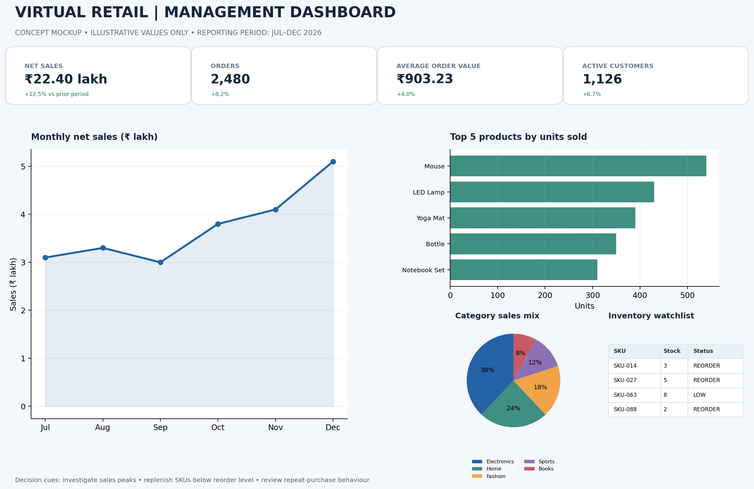
SQL output | Recommended visual | Why it helps
Monthly sales trend | Line chart with month labels | Shows direction, peaks and month-over-month change
Top-selling products | Horizontal bar chart, descending | Makes product ranking easy to compare
Category revenue share | Donut/pie chart or 100% stacked bar | Shows contribution to total; label shares
Inventory health | Conditional-format table / red-amber-green status | Highlights urgent replenishment actions
Customer segments | Stacked bar chart by segment and spend | Compares one-time, repeat and frequent buyers
Payment success rate | Clustered bar chart by payment method | Identifies checkout/payment issues
Orders by weekday/hour | Heatmap | Helps plan staffing and campaign timing

8. Recommendations Based on the Mock Dashboard
- Sales planning: investigate months with a strong sales increase and compare the result with campaign calendars and stock availability.
- Merchandising: review the top products for replenishment and ensure best sellers do not remain out of stock.
- Inventory: prioritize SKUs marked REORDER; confirm supplier lead times and minimum order quantities before raising purchase orders.
- Customer engagement: design repeat-purchase offers for one-time buyers and loyalty benefits for frequent buyers.
- Payment operations: monitor success rate by payment method; review failed/pending transactions with the payment provider.
- Staffing: use weekday/hour trends to schedule support and fulfilment capacity. Validate patterns over multiple months before changing shifts.

9. Data Quality, Validation and Performance Controls
- Check that OrderItems line totals reconcile to Orders.TotalAmount; investigate differences above the agreed tolerance.
- Exclude cancelled orders consistently from sales metrics and document treatment of pending orders.
- Avoid duplicate totals by aggregating Payments separately when a one-to-many payment relationship is possible.
- Use half-open time intervals (>= start and < end) so timestamps are included reliably.
- Use LIMIT for top-N reports and stable tie-breakers (for example, revenue after units sold).
- Review EXPLAIN plans for frequently executed reports. Create indexes based on measured query patterns, then retest write overhead.
- For dashboard refreshes, define a refresh schedule and show a Last Refreshed timestamp. Do not mix reporting periods in one chart.

10. Data Model Limitations and Future Enhancements
Week 1 stores current stock only and does not store product cost, discount, returns or daily stock history. Therefore, the current model can report stock status and estimated stock coverage, but it cannot calculate a fully accurate cost-based inventory turnover ratio or margin. The SQL file adds an optional InventorySnapshots table to demonstrate unit-based turnover after daily snapshots are collected. For accounting inventory turnover, also store cost of goods sold (COGS) at sale time and average inventory value at cost.
- Add a Returns table to report return rate and net sales after returns.
- Add discounts/tax/shipping columns to distinguish gross merchandise sales from net revenue.
- Store UnitCostAtSale or an effective-dated product cost history to report gross margin and COGS.
- Capture daily inventory snapshots to calculate average stock and stock turnover over time.
- Add a calendar/date dimension for financial periods, fiscal quarters and holiday analysis.

11. How to Run the Reports
- Open MySQL Workbench and connect to the MySQL 8.x server.
- Run Week 1 scripts in order: 01_create_tables.sql, 02_constraints_indexes.sql, then 06_demo_sample_data.sql once on an empty database.
- Run 09_week4_monthly_trend_demo_seed.sql once after 06_demo_sample_data.sql, then open 08_week4_dynamic_reporting_queries.sql and confirm USE VirtualRetailDB is selected.
- Set @report_start and @report_end. For the multi-month demo, use 2026-07-01 and 2027-01-01.
- Execute one report section at a time. Review the Result Grid and save/export result sets if required.
- Replace mock tables in the report with actual query outputs after execution. Preserve the period and query version used.
- Build the dashboard visuals using the SQL result sets and display the refresh date and reporting period.

12. Work Plan (30–35 Hours)
Activity | Hours | Deliverable
Scenario analysis and KPI definitions | 4 | Business questions and metric dictionary
Query design and joins | 7 | Core sales, product and customer reports
Advanced SQL and dynamic filters | 5 | CTEs, window functions, date parameters
Mock outputs and data validation | 4 | Sample result tables and reconciliation checks
Visualization design | 5 | Dashboard concept and chart recommendations
Testing, optimization and review | 5 | Validated SQL scripts and revised outputs
Documentation and final quality check | 3 | Final Word report and GitHub update

13. Conclusion
The Week 4 reporting design converts the Virtual Retail database into actionable management information. Dynamic date filters make the reports reusable, aggregations and joins reveal sales and customer patterns, and inventory/payment reports support operational decisions. The dashboard concept links each result set to a suitable visual. Before submission, the SQL should be executed against the demonstration database and the illustrative mock outputs should be replaced or clearly retained as mock examples. This provides a transparent, reproducible reporting solution.

Appendix A — GitHub Project Structure
virtual-retail-sql-database/
├── README.md
├── docs/
│ ├── Week_4_Dynamic_Reporting_and_Data_Visualization_Report.docx
│ ├── Week_3_Benchmark_Evidence_Addendum.docx
│ └── Week4_Dashboard_Concept.png
└── sql/
├── 08_week4_dynamic_reporting_queries.sql
└── 09_week4_monthly_trend_demo_seed.sql

