WEEK 3 INTERNSHIP TASK
SQL Query Optimization and Performance Tuning
Project: Virtual Retail Management System
SQL Developer Intern | MySQL 8.x reference implementation

1. Executive Summary
This report explains a structured approach to improving SQL query performance in the Virtual Retail Management System designed in Weeks 1 and 2. The workload includes monthly sales reporting, customer order history, order-detail retrieval and low-stock inventory checks. The process begins by capturing a baseline, inspecting execution plans, identifying costly operations, applying a targeted query rewrite or index, and then validating both correctness and performance. The report avoids claiming that timings were measured on a live database: the benchmark worksheet is provided for actual MySQL results, while any numerical example is clearly marked as illustrative.

2. Objectives and Scope
- Identify representative queries used in retail operations and define their expected results.
- Capture baseline execution plans and timing before making changes.
- Apply query rewriting and carefully selected indexes where they fit the query pattern.
- Measure the optimized versions using the same data, parameters and environment.
- Check that optimization does not change the result set or weaken data integrity.
- Document trade-offs, future improvements and a repeatable tuning method.

3. Test Environment and Assumptions
Item | Assumption / configuration
Database engine | MySQL 8.x; examples use MySQL syntax. EXPLAIN ANALYZE is available in MySQL 8.0.18 and later.
Target database | VirtualRetailDB created from the Week 1 schema.
Main tables | Customers, Products, Categories, Suppliers, Inventory, Orders, OrderItems and Payments.
Existing indexes | Week 1 design includes PK/FK indexes plus useful indexes such as Customers.Email (unique), Orders.CustomerID/OrderDate, OrderItems.OrderID/ProductID, and Products.CategoryID/SupplierID.
Test data | Use synthetic test data with enough rows to expose scan/join costs. Tiny datasets may correctly result in table scans.
Measurement | Same machine, dataset, query parameters and server load for baseline and optimized runs.

Important: an index does not guarantee a faster query. The optimizer may choose a table scan when the table is small or when a predicate returns a large percentage of rows. Always inspect the plan and measure on representative data.

4. SQL Performance Tuning Workflow
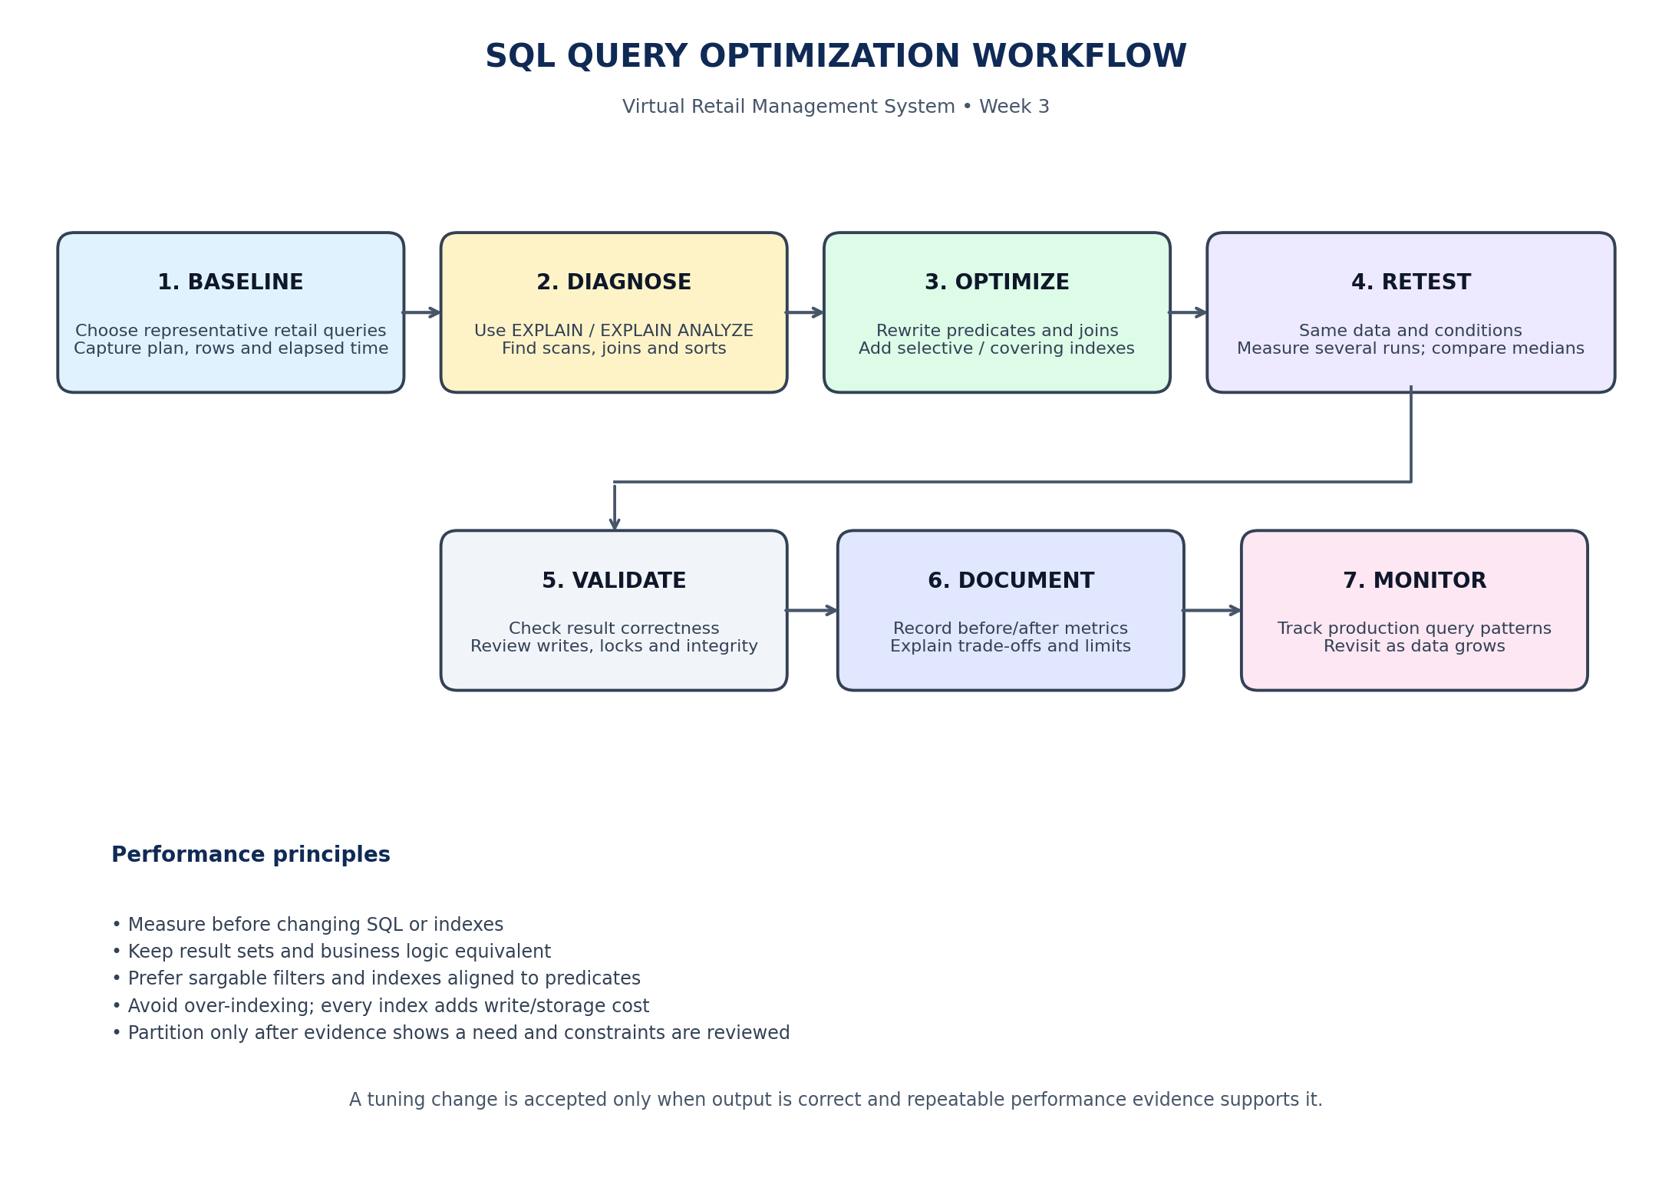
The workflow follows a measure–diagnose–change–retest cycle. A tuning change is accepted only when the result is correct and repeatable performance evidence supports it.

5. Baseline Workload: Retail Queries
Query | Retail purpose | Typical performance concern
Q1 Monthly sales | Sum order line totals for a selected month. | Applying DATE_FORMAT() to OrderDate in WHERE can make a date index less useful.
Q2 Customer order history | Find a customer by email and list recent orders. | Applying LOWER() to the indexed Email column can prevent use of a normal index.
Q3 Order detail lookup | Retrieve items for one OrderID and join product names. | Needs efficient filtering by OrderID and lookup by ProductID.
Q4 Low-stock check | Find products where current stock is at/below reorder level. | The comparison is between two columns; a simple index may not fully optimize it.

6. Query Optimization Techniques

6.1 Make date filters sargable
Baseline pattern: WHERE DATE_FORMAT(OrderDate, '%Y-%m') = '2026-10'. The function is applied to every candidate OrderDate value, which can prevent a normal range scan on the date column. Optimized pattern: WHERE OrderDate >= '2026-10-01' AND OrderDate < '2026-11-01'. This half-open range includes every time on October 2026 and leaves the indexed column unwrapped. DATE_FORMAT may still be used in SELECT/GROUP BY for display.

6.2 Avoid unnecessary functions on indexed lookup columns
If customer email is normalized to lowercase during ingestion and the stored value is guaranteed to follow that rule, compare Email directly with a normalized parameter. A predicate such as LOWER(Email) = LOWER(parameter) can make a conventional index on Email less effective. Do not remove LOWER() unless the data-normalization rule is enforced consistently; otherwise, use an appropriately designed normalized/generated column and index it.

6.3 Add indexes that match real filters and joins
Week 1 already includes several useful indexes. Week 3 proposes two additional candidates: Orders(OrderDate, Status) for date-window reports and OrderItems(OrderID, ProductID) for order-item retrieval and product joins. A Products(CategoryID, Status) index may help category pages that filter active products. For frequent low-stock alerts, a STORED generated flag (QuantityOnHand <= ReorderLevel) can be indexed and filtered; retain it only if the flag is selective enough to benefit the query. Create only indexes that match observed workload patterns. Composite index column order matters: the leading columns should reflect common equality/range predicates.

6.4 Rewrite joins and projections carefully
- Select only required columns instead of SELECT * to reduce data transfer and may allow covering-index access.
- Join tables using matching key columns and ensure data types/collations are compatible.
- Use EXISTS when the task is to test whether a related row exists and a join would multiply parent rows.
- Filter rows as early as is logically safe; avoid applying functions to indexed predicate columns.
- Do not add DISTINCT or GROUP BY merely to hide duplicate rows caused by an incorrect join.

6.5 Partitioning is a later-stage option
Date partitioning can help lifecycle management and partition pruning for very large time-based tables, but it increases operational complexity and may impose database-engine restrictions involving keys and foreign keys. It should not be applied to this small training project automatically. First measure table size, query patterns, retention needs and engine-version compatibility; use partitioning only when a tested design shows a clear benefit.

7. Index Strategy for This Project
Table / index | Purpose | Decision
Customers.Email (unique) | Customer lookup by normalized email; enforce uniqueness. | Already part of Week 1 design; verify it exists.
Orders(CustomerID, OrderDate) | Customer order history sorted by date. | Already planned in Week 1; inspect with SHOW INDEX.
Orders(OrderDate, Status) | Date-windowed sales reports with status filter. | Week 3 candidate; benchmark before retaining.
OrderItems(OrderID, ProductID) | Fetch all lines for an order and support product join. | Week 3 candidate; may overlap existing single-column indexes.
Products(CategoryID, Status) | Browse active items in a category. | Optional candidate; retain only if actual workload benefits.
Inventory(IsLowStock, ProductID) | Indexed generated low-stock flag for repeated low-stock alerts. | Optional Week 3 candidate; test selectivity and write overhead.

Indexes improve some reads but consume disk space and add work to INSERT, UPDATE and DELETE operations. They can also increase maintenance and lock costs. Compare read benefits with write overhead before retaining a candidate index.

8. Before-and-After Benchmark Method
- Use a development database populated with realistic synthetic data. Record the row counts for Orders, OrderItems, Products and Customers.
- Run ANALYZE TABLE on the tested tables so the optimizer has current statistics.
- Run EXPLAIN FORMAT=TREE for each baseline query and save the plan. Look for table scans, index lookups, join order, sorting and estimated rows.
- Run EXPLAIN ANALYZE for each SELECT on MySQL 8.0.18 or later. It executes the query and reports actual iterator timing and rows. Use safe read-only test queries.
- Execute each query multiple times under comparable conditions. Record first-run and warm-run times separately where useful, then compare medians rather than a single run.
- Apply one change at a time (query rewrite or index), update statistics, and capture the new plan and timings.
- Compare output row counts and aggregate values to confirm that the optimized query returns equivalent results.
- Retain the change only when the measured gain is repeatable and the impact on write operations/storage is acceptable.

9. Performance Metrics and Recording Sheet
The following table is intentionally left for measurements from your own MySQL run. No execution-time values have been invented. Populate each cell after running the baseline and optimized queries on your test database.
Query | Baseline median (ms) | Optimized median (ms) | Rows examined before / after | Plan change / notes
Q1 Monthly sales | ________ | ________ | ________ / ________ | ________________________
Q2 Customer history | ________ | ________ | ________ / ________ | ________________________
Q3 Order details | ________ | ________ | ________ / ________ | ________________________
Q4 Low-stock lookup | ________ | ________ | ________ / ________ | ________________________

Percentage improvement formula: ((Baseline median − Optimized median) / Baseline median) × 100. A positive value indicates lower elapsed time. If the optimized time is higher, report the regression honestly and investigate whether the index is unnecessary or the test is noisy.

10. Illustrative Calculation (Not a Measured Result)
For example only, suppose a test run measured a baseline median of 120 ms and an optimized median of 45 ms. The calculated reduction would be ((120 − 45) / 120) × 100 = 62.5%. These numbers are fictional teaching values, not results from your database. Do not present them as actual measurements; replace them with the values from your own runs.

11. SQL Tools and Commands
- EXPLAIN and EXPLAIN FORMAT=TREE: inspect the optimizer’s proposed plan and access paths.
- EXPLAIN ANALYZE: execute a SELECT and report actual iterator timing/row information (supported in MySQL 8.0.18+).
- SHOW INDEX FROM table_name: verify existing indexes and avoid duplicates.
- ANALYZE TABLE: refresh optimizer statistics after material data/index changes.
- MySQL Workbench: run queries, view plans and capture execution timings.
- Performance Schema / sys schema: investigate workload-level statement activity when enabled and permitted.

12. Correctness, Risks and Trade-offs
- Result equivalence: compare row counts, values and totals between baseline and optimized queries.
- Data semantics: direct email comparison is valid only if email normalization is consistently enforced.
- Index overhead: more indexes increase storage and write/maintenance cost.
- Small test data: the optimizer may prefer table scans; use representative data volumes and do not force an index without evidence.
- Cache and concurrency: keep test conditions stable and document whether timings are cold or warm cache.
- Partitioning: defer until scale and compatibility requirements are understood.
- Production safety: test in development first; avoid DDL or long-running benchmarks during peak trading/retail activity.

13. Recommended Future Improvements
- Build a scheduled benchmark set for the most frequently used retail reports.
- Review slow-query logs and top statements periodically.
- Introduce pagination for large order-history screens and avoid unbounded result sets.
- Consider summary tables or pre-aggregated reporting tables for very expensive recurring reports, with a refresh and reconciliation strategy.
- Review schema statistics and index usage after major changes in data volume or application behavior.

14. Estimated Work Plan (30–35 Hours)
Activity | Hours | Output
Select representative retail queries and define expected results | 4 | Baseline query set
Inspect schema, row counts and existing indexes | 3 | Environment and index inventory
Capture baseline EXPLAIN plans and timings | 5 | Baseline evidence
Rewrite queries and design candidate indexes | 7 | Optimized SQL and index plan
Run repeatable tests and validate results | 6 | Before/after benchmark records
Review trade-offs, risks and next steps | 3 | Performance recommendations
Prepare report and GitHub documentation | 4 | Final Week 3 deliverables
Total | 32 | Within task estimate

15. Conclusion
SQL performance tuning should be evidence-driven. For the Virtual Retail Management System, the most useful starting points are sargable date filters for sales reports, direct lookup predicates on normalized customer email, and composite indexes aligned with order and product access patterns. The low-stock query requires separate analysis because its comparison is between two columns; a generated low-stock flag is an optional testable approach. The proposed process measures a baseline, diagnoses the plan, applies one change at a time, validates business results, and records repeatable metrics. This approach improves query efficiency without sacrificing correctness or creating unnecessary indexes.

Appendix A — GitHub Files for Week 3
Add the following to the existing virtual-retail-sql-database repository:
- docs/Week_3_SQL_Query_Optimization_Report.docx
- docs/SQL_Performance_Tuning_Flowchart.png
- sql/05_week3_query_optimization_and_benchmark.sql

Appendix B — SQL Commands to Capture Evidence
-- Confirm database and table row counts
USE VirtualRetailDB;
SELECT COUNT(*) AS OrdersRows FROM Orders;
SELECT COUNT(*) AS OrderItemsRows FROM OrderItems;
SELECT COUNT(*) AS ProductsRows FROM Products;
-- Inspect current indexes
SHOW INDEX FROM Orders;
SHOW INDEX FROM OrderItems;
-- Refresh statistics before comparing plans
ANALYZE TABLE Orders, OrderItems, Products, Customers;
-- Paste a baseline or optimized SELECT after EXPLAIN ANALYZE
EXPLAIN ANALYZE SELECT ...;

