**Industrial Internship Report on**

**”Url Shortner”**

**Prepared by**

**[Shruti Ingale]**

|  |
| --- |
| *Executive Summary* |
| This report provides details of the Industrial Internship provided by Upskill Campus and The IoT Academy in collaboration with Industrial Partner UniConverge Technologies Pvt Ltd (UCT).  This internship was focused on a project/problem statement provided by UCT. We had to finish the project including the report in 6 weeks.  My project was The URL Shortener a Python project that converts long URLs into shorter, more manageable links. It takes a long URL as input, generates a unique shortened URL, and redirects users to the original URL when the shortened link is accessed.  This internship gave me a very good opportunity to get exposure to Industrial problems and design/implement solutions for them. It was an overall great experience to have this internship. |

**TABLE OF CONTENTS**

1 Preface 3

2 Introduction 4

2.1 About UniConverge Technologies Pvt Ltd 4

2.2 About upskill Campus 9

2.3 Objective 11

2.4 Reference ….**Error! Bookmark not defined.**11

3 Problem Statement **Error! Bookmark not defined.**12

4 . Existing and Proposed Solution………………………………………………………………………………………………………12

## 4.1 Code submission (Github link)

4.2 Report submission (Github link) :

## 4.3Interfaces (if applicable)

## 5 Performance Outcome………………………………………………………………………………..14

## 6 . My learnings………………………………………………………………………………..14

# . Future work scope…………………………………………………………………………………14

# Preface

This internship is divided into 6 weeks and in that 6 weeks every week submit a weekly report in

Throughout the internship, 3 quizzes are arranged to check the knowledge of interns and this is beneficial for increasing the knowledge

In week 1 I learned about Python with data science. Then introduces some projects and choose one project among them and work on that project during the internship I will choose my project topic as a URL shortener. The URL shortener is a Python project that converts long URLs into shorter, more manageable links. It takes a long URL as an input, generates a unique shortened URL, and redirects users to the original URL when the shortened link is accessed

In week 2 I will learn more about Python and attain the quiz based on the learning which its help me to analyze my knowledge in Python. In week 1, I did some work on a project I completed the fronted URL shortener using the Django frameworks and HTML, CSS, and JavaScript. my project is in progress and this is helped me for experience

In the week3 I will learn about the introduction of Python to data science and understand how Python is used in data analysis

In week 4 I learn about the numpy and pandas and attained Quiz3 In that quiz I will analyze myself and get more knowledge about Python I have done practice of NumPy and pandas.

In week 5 I learn about NumPy and pandas and operations in NumPy and learn about search engine optimization in Python I have done my project of URL shortener using the Django framework

Unfortunately, in today’s job market, passing exams with high scores and getting a degree doesn’t offer the much-needed work experience, you will need to succeed in a workspace.

By partaking in an internship, you can gain real-life exposure, grow your knowledge, and determine if you are in the right career field. Internships not only provide you with first-hand experience in the real working world but also enable you to understand the career trajectory for your desired job title. You can learn how to apply the knowledge you have acquired during an internship to your future workplaces.

In addition to this, it is an excellent learning curve for young graduates and students while meeting new people and making connections in the professional world.

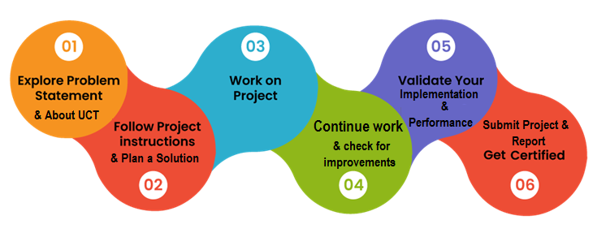

# Introduction

## About UniConverge Technologies Pvt Ltd

A company established in 2013 and working in the Digital Transformation domain and providing Industrial solutions with a prime focus on sustainability and RoI.

For developing its products and solutions it is leveraging various**Cutting Edge Technologies e.g. Internet of Things (IoT), Cyber Security, Cloud computing (AWS, Azure), Machine Learning, Communication Technologies (4G/5G/LoRaWAN), Java Full Stack, Python, Front end,** etc.

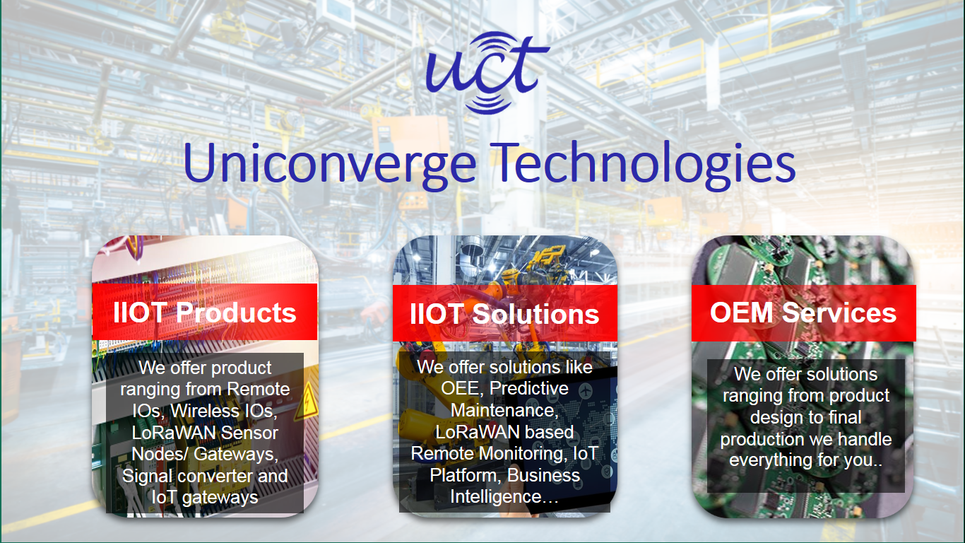

1. UCT IoT Platform **(****)**

**UCT Insight** is an IOT platform designed for quick deployment of IOT applications on the same time providing valuable “insight” for your process/business. It has been built in Java for the backend and ReactJS for the Front end. It has support for MySQL and various NoSQL Databases.

* It enables device connectivity via industry standard IoT protocols - MQTT, CoAP, HTTP, Modbus TCP, OPC UA
* It supports both cloud and on-premises deployments.

It has features to  
• Build Your dashboard  
• Analytics and Reporting  
• Alert and Notification  
• Integration with third party application(Power BI, SAP, ERP)  
• Rule Engine

 

1. **Smart Factory Platform (****)**

Factory watch is a platform for smart factory needs.

It provides Users/ Factory

* with a scalable solution for their Production and asset monitoring
* OEE and predictive maintenance solution scaling up to digital twin for your assets.
* to unleased the true potential of the data their machines are generating and help to identify the KPIs and improve them.
* A modular architecture that allows users to choose the service they want to start and then can scale to more complex solutions per their demands.

Its unique SaaS model helps users to save time, cost, and money.

 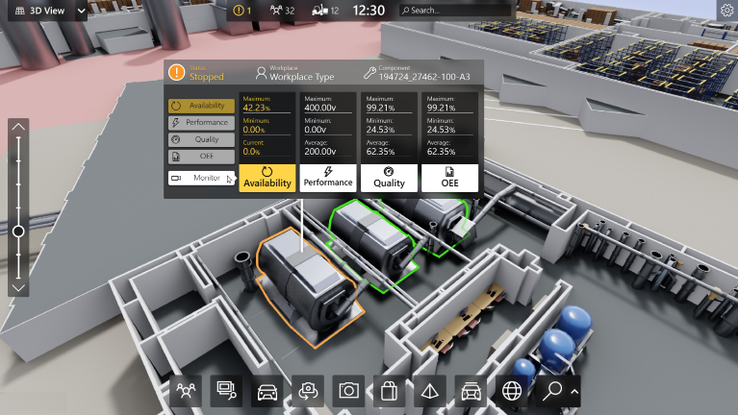

1. 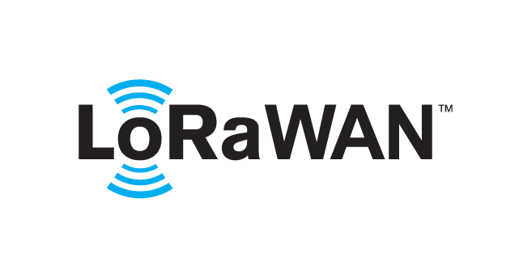 based Solution

UCT is one of the early adopters of LoRAWAN technology and provides solutions in Agritech, Smart Cities, Industrial Monitoring, Smart Street lights, Smart Water/ Gas/ Electricity metering solutions, etc.

1. Predictive Maintenance

UCT is providing Industrial Machine health monitoring and Predictive maintenance solution leveraging Embedded systems, Industrial IoT, and Machine Learning Technologies by finding the Remaining useful lifetime of various Machines used in the production process.



## About upskill Campus (USC)

upskill Campus along with The IoT Academy and in association with Uniconverge Technologies has facilitated the smooth execution of the complete internship process.

USC is a career development platform that delivers **personalized executive coaching** in a more affordable, scalable, and measurable way.



Seeing need of upskilling in self paced manner along-with additional support services e.g. Internship, projects, interaction with Industry experts, Career growth Services

<https://www.upskillcampus.com/>

upSkill Campus aiming to upskill 1 million learners in next 5 year

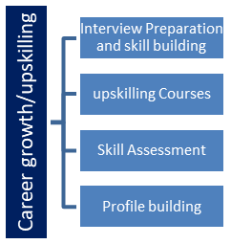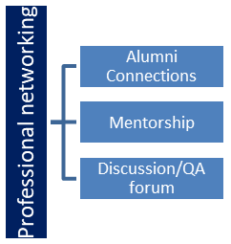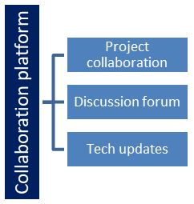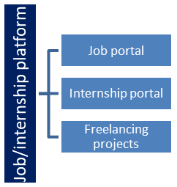

## The IoT Academy

The IoT academy is the EdTech Division of UCT that is running long executive certification programs in collaboration with EICT Academy, IITK, IITR, and IITG in multiple domains.

## Objectives of this Internship Program

The objective of this internship program was to

 ☛ get practical experience working in the industry.

 ☛ to solve real-world problems.

 ☛ to have improved job prospects.

 ☛ to have an Improved understanding of our field and its applications.

 ☛ to have Personal growth like better communication and problem-solving.

## Reference

I will take the references and information about the URL shortener on google the links are given below

<https://www.docker.com/blog/how-to-build-and-deploy-a-django-based-url-shortener-app-from-scratch/>

<https://www.geeksforgeeks.org/how-to-build-a-url-shortener-with-django/>

**3 project/problem statement.**

**Url shortener by using the Django framework**

**Problem statement:** The URL shortener is a Python project that converts long URLs into shorter, more manageable links. It takes a long URL as input, generates a unique shortened URL, and redirects users to the original URL when the shortened link is accessed.

This project's scope involves designing a user interface to input long URLs and display the shortened links, implementing a database to store the mapping between original and shortened URLs, and developing functions to generate unique shortened URLs and handle redirection.

**Opportunity is given by USC/UCT.**

I want Thank to upskill giving me the chance to enhance my skill in that internship I will learn Python. And how Python is used in data science the UCT helps me to find out my interests in Python and increase my knowledge. So I will explore more about Python more and develop more projects in Python UCT provides me with industry-based experience this experience I will show in my resume and is very beneficial for me

In that internship, mentors are guided in the project and conduct the session on how libraries are used in python

And all your doubts solve through mentors. this internship is very helpful to reach your knowledge at the next level and helpful to explore yourself professionally

# 4. Existing and Proposed solution

This project's scope involves designing a user interface to input long URLs and display the shortened links, implementing a database to store the mapping between original and shortened URLs, and developing functions to generate unique shortened URLs and handle redirection.

I will utilize my efforts to make this URL shortener into more effective way.

## 4.1 Code submission (Github link)

<https://github.com/shruti-ingale/urlshortner1>

## 4.2 Report submission (Github link) :

## 4.3Interfaces (if applicable)

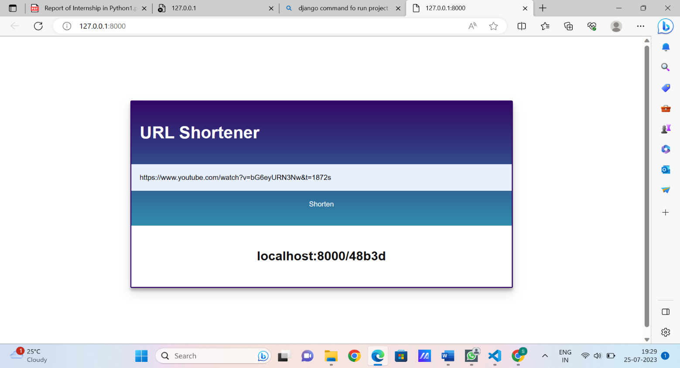

**The frontend of project Url Shortener**

This is the front showing the long URL is converted into the shortened URL .and this shortened URL is used if you used this shortened URL then this link is also to reach the same page

## 5 . Performance Outcome

In that project is used Django has converted to a long website so this reaches you on the same page this efficient solution is to use the short website in place of a large and complex website .for the data sql is used .this url shortener worked effectively and converts Complex website into the number then the website is easy to use.

**6 .**  **My learnings**

In that project I used the Django framework in Python and HTML, CSS, and JavaScript through this project I have gained more knowledge about this. l have learned how to project is made through Django and I have learned about Django commands how to run the project into the server and created a website page using Django.

I learned how databases are connected in Django and worked on that. some errors arise with that errors I knew which type of errors are come. through this project, problem-solving skills also increase and In the future, I can explore myself at the next level and gain more knowledge about Python. through this internship, I generate the confidence to learn technology and explore myself. And this is helpful for me to get industry-based experience and generate the professional skills

# . Future work scope

In that project, my outcome comes the long URL is being shortened but there is scope to make these URLs shortened I have not created the login page because I thought it was not needed but if create a login page it looks good. then first we create the register page that registers demand from users to enter their Name, email address, password and after user registration, the login page is created on that login page through email and password users are login and then created the dashboard likewise we made 3 to 4 pages so it made more effective.