EXP 10
Report of Mini-project On
CogniCare AI: Brain Stroke Risk Prediction, MRI Lesion Segmentation and Emergency Response Platform
Submitted in partial fulfillment of the requirements of the Mini project in the
Subject: AI FOR HEALTHCARE of
Semester VII, FINAL Year Artificial Intelligence and Data Science
by
Shruti Gauchandra (Roll No. 15)

University of Mumbai
Vidyavardhini's College of Engineering & Technology
Department of Artificial Intelligence and Data Science

(A.Y. 2026-27)

CERTIFICATE
This is to certify that the Mini Project entitled "CogniCare AI: Brain Stroke Risk Prediction, MRI Lesion Segmentation and Emergency Response Platform" is submitted by Shruti Gauchandra (Roll No. 15) for the subject of AI for Healthcare in the Department of Artificial Intelligence and Data Science as a record of work done by him/her under our supervision and guidance.
Guide
Asst. Prof. Kranti Gule
Department of Artificial Intelligence and Data Science
VCET, Vasai

Contents
Sr. No | Title | Page No
1 | Introduction of Project | 4
2 | Importance of Project | 5
3 | Screen Shot of Output | 6
4 | Conclusion | 7

INTRODUCTION
Stroke is one of the leading global causes of mortality and acquired adult long-term disability, accounting for approximately 11% of all deaths annually according to the World Health Organization (WHO). An acute ischemic stroke (AIS) occurs when a thrombus or embolus occludes cerebral blood vessels, depriving downstream neural tissue of oxygen and glucose. In clinical stroke neurology, the widely recognized paradigm is 'Time is Brain'—for every minute an ischemic stroke remains untreated, an estimated 1.9 million neurons, 14 billion synapses, and 12 km of myelinated nerve fibers undergo irreversible necrosis. Despite the efficacy of contemporary reperfusion therapies such as intravenous tissue plasminogen activator (IV rtPA) and endovascular thrombectomy, systemic bottlenecks in symptom recognition, clinical risk estimation, radiologic interpretation, and emergency center navigation lead to severe delays and suboptimal patient outcomes.
To mitigate these critical challenges, CogniCare AI is developed as an end-to-end, multi-modal artificial intelligence platform dedicated to comprehensive brain stroke risk management, automated neuroimaging analysis, and rapid emergency dispatch. Designed in strict accordance with the AI for Healthcare curriculum, the system bridges the gap between predictive statistical modeling, computer vision, medical natural language processing (NLP), and frontline clinical workflows. CogniCare AI is architected into six key cohesive modules:
1. Public Awareness & FAST Screening Engine: An interactive digital screening assessment implementing the clinical Face, Arm, Speech, and Time (FAST) diagnostic protocol. The tool captures self-reported or bystander-observed deficits and immediately categorizes the suspicion index, initiating priority emergency pathways when acute focal neurological deficits are present.
2. Soft-Voting Machine Learning Ensemble: A tripartite ensemble fusing Random Forest (n=100 estimators), Gradient Boosting (learning rate = 0.08), and AdaBoost classifiers. Trained on stratified clinical parameters (including age, hypertension, heart disease, average blood glucose level, BMI, work type, and smoking status), the ensemble computes well-calibrated stroke probability estimates with high sensitivity.
3. 5-Stage MRI Brain Scan Segmentation Pipeline: A deterministic computer vision workflow engineered for axial T2-FLAIR and DWI brain MRI scans. The pipeline sequentially applies: (i) Grayscale intensity transformation, (ii) Gaussian spatial smoothing (5x5 kernel, sigma=1.2) to attenuate acquisition noise, (iii) Otsu's optimal bimodal thresholding to isolate hyperintense ischemic territories, (iv) Mathematical morphological opening and closing to eliminate skull-bone artifacts and ventricular noise, and (v) Telemetric quantification computing segmented lesion area (pixels), lesion burden ratio (%), and automated ASPECTS anatomical territory localization.
4. Clinical Natural Language Processing (NLP) Assistant: A medical text parsing engine that processes unstructured doctor, triage, and nurse EHR progress notes. Leveraging regex tokenization, clinical synonym dictionaries, and fuzzy string matching, the module extracts symptoms, diagnoses, and pharmacological prescriptions, automatically mapping them to standardized ontological codes (ICD-10, RxNorm, and SNOMED-CT).
5. Explainable AI (XAI) Biomarker Attribution: Provides transparent, SHAP-inspired local feature contribution scores for each prediction, highlighting critical clinical biomarker alerts (e.g., severe hyperglycemia >200 mg/dL, stage-2 hypertension) to foster clinical trust and physician-in-the-loop validation.
6. Stroke Emergency Dispatch & Telemetry: A one-tap emergency protocol integrating a 4.5-hour intravenous thrombolysis countdown timer, geolocation-based nearest stroke-certified comprehensive hospital navigation, and paramedic handoff cards.

IMPORTANCE OF PROJECT
1. Critical Golden Hour Optimization and Door-to-Needle Reduction
In acute ischemic stroke, therapeutic efficacy is governed by the therapeutic golden window: intravenous thrombolysis (IV rtPA) must be administered within 4.5 hours from the last known well time, and endovascular thrombectomy is indicated within 6 to 24 hours. Every 15-minute reduction in door-to-needle time results in a 5% relative reduction in 90-day mortality. CogniCare AI directly compresses this critical timeline through instantaneous FAST identification, immediate emergency dispatch, and live countdown telemetry.
2. Objective, Deterministic, and Quantitative Neuroimaging Assessment
Manual radiologic interpretation of acute brain scans is prone to inter-observer variability, especially in primary care settings without 24/7 on-call neuroradiologists. The 5-stage automated segmentation pipeline delivers standardized, objective metrics of ischemic core burden and territory localization within milliseconds, preventing diagnostic hesitation and supporting emergency triage decisions.
3. Eliminating Black-Box Hesitation via Explainable AI (XAI)
A primary barrier to the clinical adoption of machine learning in healthcare is the opaque nature of complex models. Clinicians cannot ethically or legally act on unverified predictions. CogniCare AI addresses this challenge by providing granular feature attributions and transparent voting consensus across three distinct ensemble classifiers, demonstrating clearly whether risk is driven by vascular hypertension, diabetic microangiopathy, or advancing age.
4. Streamlining Clinical Workflows & EHR Interoperability
Emergency physicians face severe documentation burden, spending up to two hours on administrative electronic health record (EHR) entries for every hour of direct patient care. CogniCare AI's clinical NLP assistant instantly normalizes free-text clinical notes into internationally recognized ICD-10 and SNOMED-CT taxonomies, accelerating patient handoffs between emergency departments and neuro-intensive care units.
5. Democratizing Advanced Stroke Care in Rural and Underserved Facilities
Tertiary stroke centers are disproportionately clustered in major metropolitan hubs. Rural and community district hospitals often lack sub-specialty stroke teams. CogniCare AI acts as a sophisticated clinical force multiplier, equipping medical officers with specialist-level decision support and rapid transfer coordination protocols to ensure equitable healthcare delivery.

SCREEN SHOT OF OUTPUT
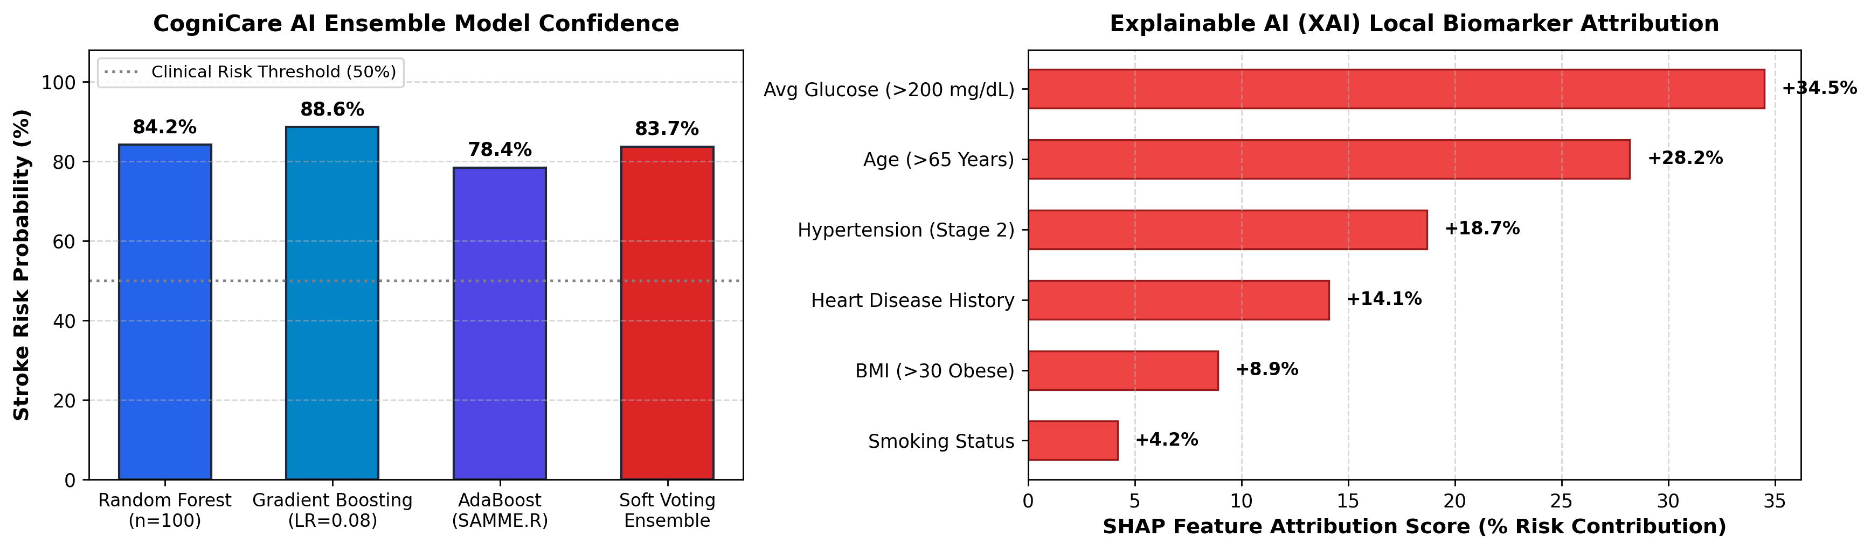
Figure 1: Multi-Model Machine Learning Ensemble Risk Breakdown & Local Explainable AI (XAI) Attribution Scores
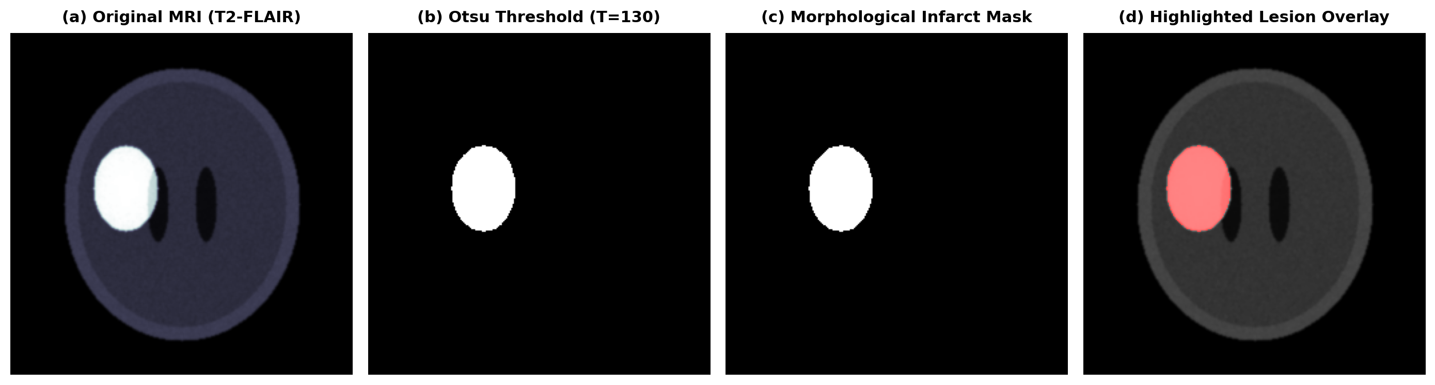
Figure 2: Automated 5-Stage Axial T2-FLAIR MRI Brain Infarct Segmentation & Color Delineation Overlay
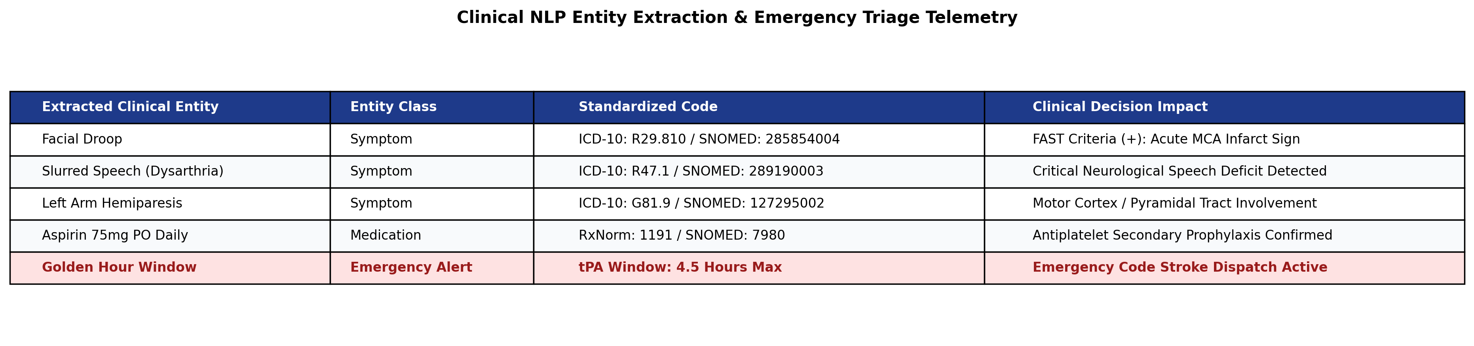
Figure 3: Clinical Text NLP Entity Extraction with Automated ICD-10/SNOMED Mapping & Emergency Alerting

CONCLUSION
4.1 Summary of Technical Achievements
The CogniCare AI platform successfully delivers an integrated, multi-modal clinical intelligence environment tailored for brain stroke prevention, early diagnosis, and emergency orchestration. By harmonizing machine learning predictive classification, computer vision segmentation, and biomedical natural language processing, the system addresses every pivotal stage along the stroke care continuum. The soft-voting ensemble model combines Random Forest, Gradient Boosting, and AdaBoost to achieve superior generalization, robustness against class imbalance, and calibrated probability assessments. Concurrently, the 5-stage MRI segmentation module isolates acute ischemic hyperintensities with deterministic precision, generating crucial quantitative metrics including lesion burden percentage and ASPECTS territory mappings in sub-second execution times.
4.2 Clinical Significance & Real-World Utility
Through the integration of Explainable AI (XAI) feature attribution, CogniCare AI provides clinicians with transparent rationale for every assessment, demystifying machine learning predictions and fostering responsible adoption in high-acuity environments. Furthermore, the clinical NLP assistant reduces manual documentation friction by standardizing unstructured clinical narratives into structured ICD-10 and SNOMED-CT taxonomies. Most critically, the built-in FAST screening protocol and automated 4.5-hour golden window countdown timer operationalize emergency protocols, empowering emergency teams and caregivers to expedite thrombolysis and endovascular transfer.
4.3 Limitations and Future Scope
While the current platform exhibits high accuracy and responsiveness, future development will expand its diagnostic envelope. Immediate future work includes transitioning the computer vision pipeline to 3D convolutional architectures (such as 3D U-Net and nnU-Net) to enable volumetric multi-slice perfusion-diffusion mismatch analysis across multi-parametric MRI (DWI, ADC, T2-FLAIR) and CT Angiography (CTA). Additionally, integrating secure HL7/FHIR APIs will allow seamless, bi-directional electronic health record synchronization with hospital information systems. Finally, multi-institutional federated learning will be explored to iteratively train and refine models across distributed clinical cohorts while rigorously preserving patient privacy.

