-------------------------------------------------------- Trigger-----------------------
A Trigger is a special database object that automatically executes when a particular event occurs on a table.
The events are:
INSERT
UPDATE
DELETE
Trigger Syntax--------------------------------------------------------------------------------------------------------
DELIMITER //
CREATE TRIGGER trigger_name
BEFORE/AFTER INSERT/UPDATE/DELETE
ON table_name
FOR EACH ROW
BEGIN
-- SQL statements
END //
DELIMITER ;
Trigger means---------------------------------------------------------------------------
A Trigger is a special database object that automatically executes when a particular event occurs on a table.
The events are:
INSERT
UPDATE
DELETE
Easy example
Suppose:
INSERT INTO employee VALUES (1, 'Rahul', 5000);
If an AFTER INSERT trigger exists, it will automatically run after this INSERT.
You don't need to call the trigger manually.
Interview definition
A trigger is a database object that automatically executes in response to an INSERT, UPDATE, or DELETE event on a table.
Simple Hindi:
Trigger = aisa SQL code jo kisi event ke hone par automatically execute hota hai.
syntax
Trigger Syntax
General syntax
DELIMITER //
CREATE TRIGGER trigger_name
BEFORE/AFTER INSERT/UPDATE/DELETE
ON table_name
FOR EACH ROW
BEGIN
-- SQL statements
END //
DELIMITER ;
Example
DELIMITER //
CREATE TRIGGER before_emp_insert
BEFORE INSERT ON employee
FOR EACH ROW
BEGIN
SET NEW.salary = 5000;
END //
DELIMITER ;
Shortcut:----------------------------------------------------------------------------------------
CREATE TRIGGER → timing → event → table → FOR EACH ROW → BEGIN → logic → END
Delimiter*----------------------------------------------------------------------------------------------------------------
DELIMITER MySQL को बताता है कि एक SQL statement कहाँ खत्म होगा।
Normally MySQL में delimiter:
;
होता है।
लेकिन Trigger में multiple statements होते हैं, इसलिए हम temporarily delimiter बदल देते हैं:
DELIMITER //
अब पूरा trigger // पर खत्म माना जाएगा।
Trigger types-------------------------------------------------------------
1. BEFORE INSERT--------------------------------------------------
Meaning: Data insert hone se pehle trigger chalega.
Example: salary negative hai to 0 kar do.
DELIMITER //
CREATE TRIGGER before_emp_insert
BEFORE INSERT ON employee
FOR EACH ROW
BEGIN
IF NEW.salary < 0 THEN
SET NEW.salary = 0;
END IF;
END //
DELIMITER ;
INSERT INTO employee VALUES (1, 'Rahul', -500);
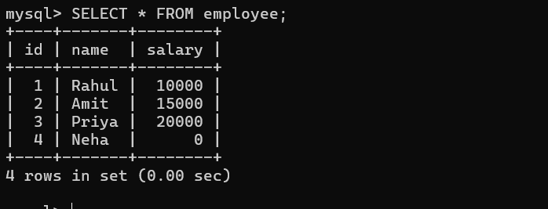
2. AFTER INSERT Trigger---------------------------
इसके लिए एक log table बनाते हैं
CREATE TABLE employee_log (
message VARCHAR(100)
);
DELIMITER //

CREATE TRIGGER after_employee_insert
AFTER INSERT ON employee
FOR EACH ROW
BEGIN
INSERT INTO employee_log
VALUES ('New employee inserted');
END //
DELIMITER ;
INSERT INTO employee VALUES (5, 'Riya', 12000);
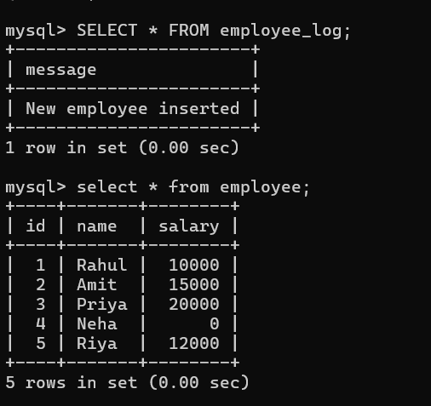
3. BEFORE UPDATE Trigger-------------------------------------
Salary को negative होने से रोकेंगे.
DELIMITER //

CREATE TRIGGER before_employee_update
BEFORE UPDATE ON employee
FOR EACH ROW
BEGIN
IF NEW.salary < 0 THEN
SET NEW.salary = 0;
END IF;
END //
DELIMITER ;
UPDATE employee
SET salary = -2000
WHERE id = 1;
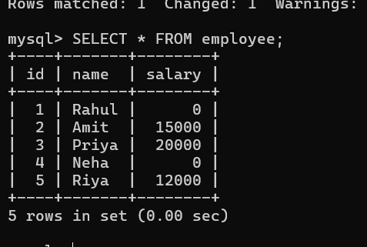
4. AFTER UPDATE Trigger---------------------------------------------------------------------
Update होने के बाद log बनाएंगे.
DELIMITER //

CREATE TRIGGER after_employee_update
AFTER UPDATE ON employee
FOR EACH ROW
BEGIN
INSERT INTO employee_log
VALUES ('Employee updated');
END //
DELIMITER ;
UPDATE employee
SET salary = 25000
WHERE id = 2;

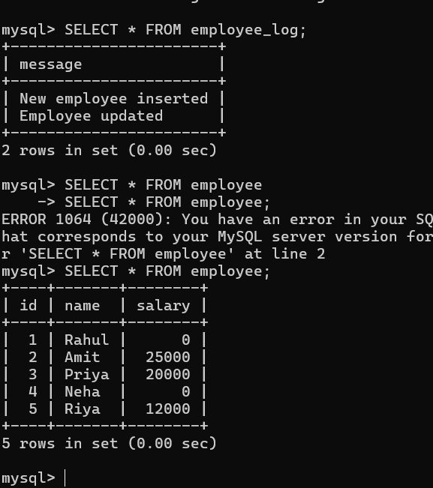
5. BEFORE DELETE Trigger----------------------------------------
Delete होने से पहले employee की information save करेंगे.
DELIMITER //

CREATE TRIGGER before_employee_delete
BEFORE DELETE ON employee
FOR EACH ROW
BEGIN
INSERT INTO employee_log
VALUES ('Employee will be deleted');
END //

DELIMITER ;
DELETE FROM employee
WHERE id = 1;
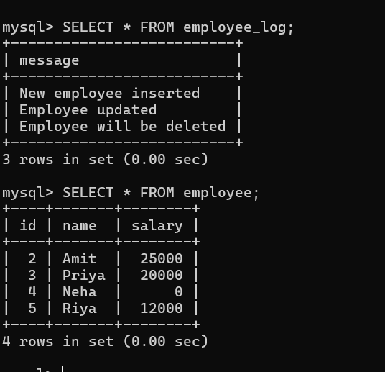
6) After DELETE Trigger-------------------------------------------------
DELIMITER //
CREATE TRIGGER after_employee_delete
AFTER DELETE ON employee
FOR EACH ROW
BEGIN
INSERT INTO employee_log
VALUES ('Employee deleted');
END //
DELIMITER ;

DELETE FROM employee
WHERE id = 2;

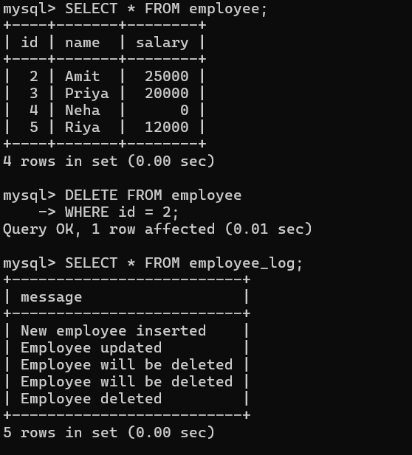
Trigger | NEW | OLD
BEFORE INSERT | ✅ | ❌
AFTER INSERT | ✅ | ❌
BEFORE UPDATE | ✅ | ✅
AFTER UPDATE | ✅ | ✅
BEFORE DELETE | ❌ | ✅
AFTER DELETE | ❌ | ✅

