MSDS-451: Week 8 Term Project Checkpoint C
Shruti Kalaskar
November 9, 2025

Introduction
The purpose of this research is to model and simulate potential future outcomes of a financial index, specifically the S&P 500 to help investors and portfolio managers evaluate risk and return over a one-year investment horizon. This checkpoint implements a Monte Carlo simulation using historical return data to estimate the range of possible ending prices, which is essential in understanding the stochastic nature of financial markets.
Potential users of this simulation and model include:
- Retail investors looking to assess possible future returns and market behavior.
- Financial analysts and portfolio managers managing equity allocations.
- AI trading bots or algorithmic trading systems, which can use simulation outputs to adjust weights or risk thresholds.
- Students and researchers exploring risk modeling or portfolio theory.
The application developed will allow users to:
- Generate future price trajectories.
- Understand the distribution of possible outcomes.
- Integrate this into broader portfolio optimization or value-at-risk (VaR) frameworks.

Literature Review
Monte Carlo simulation is a widely used tool in financial engineering, portfolio theory, and quantitative analysis. Notable applications include:
- J.P. Morgan’s RiskMetrics and Value-at-Risk (VaR) methodology, where Monte Carlo simulation is used to generate potential losses under normal conditions.
- Bodie, Kane, and Marcus (Investments, 12th Edition) detail how expected returns and volatility can be used in Monte Carlo simulation to forecast asset prices.
- Black-Scholes simulation approaches often use Monte Carlo methods to price derivatives and options.
- Academic research (e.g., Hull & White, 1987) has shown how such simulations, when calibrated with historical volatility, can offer probabilistic insights into asset behavior.
In short, this work stands on the shoulders of foundational methods in financial economics, but adapts them for educational and exploratory use with Python.

Methods
The steps followed in this checkpoint included:
- Data Retrieval:
  - Historical price data for the S&P 500 index (^GSPC) was downloaded from Yahoo Finance using the yfinance package.
  - The "Close" prices were used to compute daily log returns.
- Statistical Summary:
  - The mean (μ) and standard deviation (σ) of daily returns were computed.
  - These values were used as parameters for simulating returns.
- Monte Carlo Simulation:
  - 1000 simulations of 252 trading days were generated using np.random.normal(μ, σ, size=252).
  - Each simulation starts from the most recent index value and evolves by multiplying cumulative returns.
- Visualization:
  - A histogram of ending prices was plotted using matplotlib and saved as simulated_prices_hist.png.
- Code Used: The final Python script (included in the Jupyter notebook Week8_Term_Project_CheckpointC.ipynb) ensures robust handling of missing columns, dimensionality mismatches, and includes appropriate error checking.

Results
The histogram below shows the distribution of simulated ending prices for the S&P 500 index over a one-year horizon.
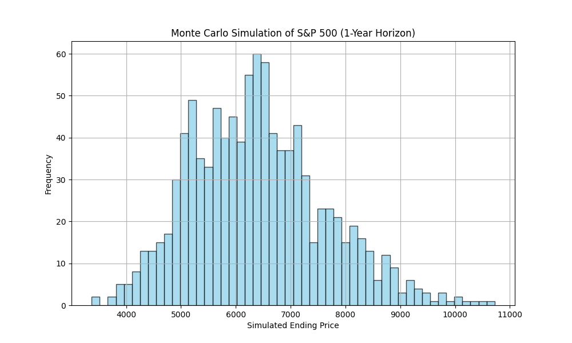
Summary:
- Mean daily return: ~0.000526
- Daily return standard deviation: ~0.0114
- Median ending price: Approximately $6,565
- 5th percentile (risk lower bound): Around $4,300
- 95th percentile (risk upper bound): Over $9,400
These results show a right-skewed distribution with a long tail of positive outliers, consistent with equity market behavior. The bulk of simulated outcomes suggest moderate growth, but there's a significant chance of downside.

Conclusions
The Monte Carlo simulation provides a probabilistic foundation to assess the future value of the S&P 500 over one year. It illustrates the importance of volatility and compounding in driving long-term outcomes.
Key Takeaways:
- Despite a modest daily return, the compounding effect and volatility lead to a wide range of potential outcomes.
- This model can be integrated into further portfolio optimization, risk-adjusted performance metrics (like Sharpe or Sortino ratios), or asset allocation frameworks.
- This checkpoint successfully demonstrates a complete end-to-end simulation process.
Concerns or Open Questions:
- Assumes returns are normally distributed and indep endent, this may not reflect real-world market dynamics (e.g., fat tails, volatility clustering).
- Simulation does not incorporate macroeconomic factors, regime shifts, or black swan events.

