Question:
You are given two Java List<String> objects, list1 and list2. Write a Java program that uses HashMap to perform the following operations:
- Frequency Map of Combined Lists: Create a HashMap<String, Integer> that stores each unique string from both lists as a key, and its total number of occurrences across both lists as the value.
- Common Elements with Count: Create a HashMap<String, Integer> that contains only the elements that appear in both lists, with the value being the minimum count of occurrences between the two lists.
- Exclusive Elements from list1: Create a HashMap<String, Integer> containing elements that appear in list1 but not in list2, with their respective frequencies.
Note: You may assume the input lists may contain duplicates.

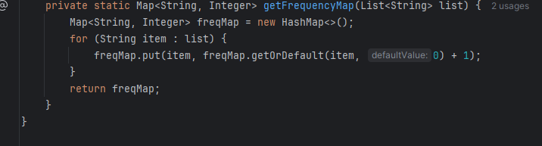
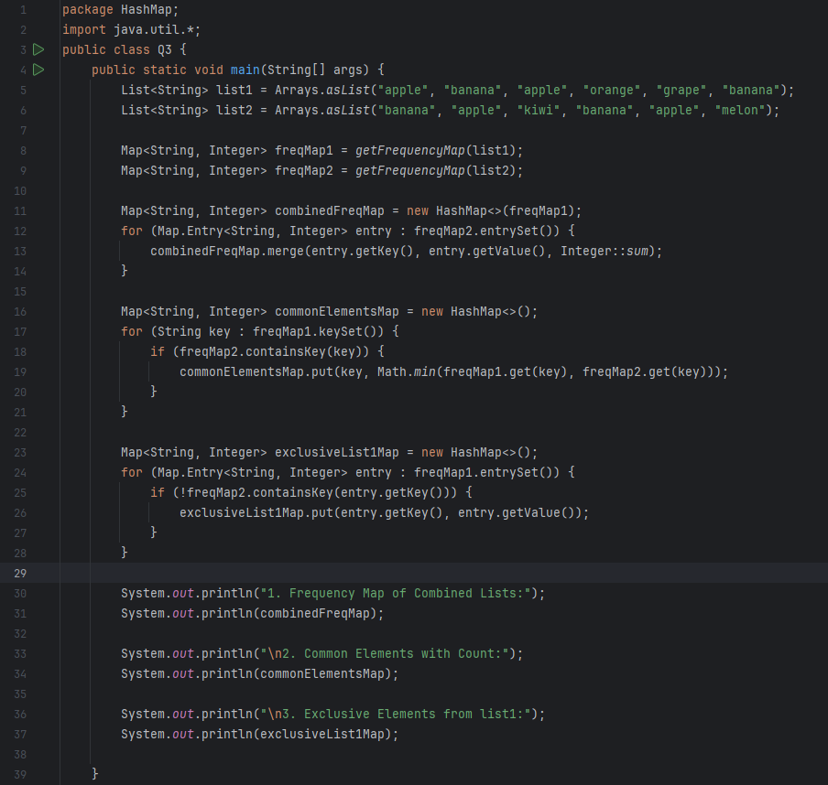

Question:
You are given a List<String> containing multiple strings. Write a Java program that uses a PriorityQueue to:
- Retrieve the shortest string (by length) from the list.
- Retrieve the longest string (by length) from the list.
- Retrieve the top 3 shortest unique strings in ascending order of their lengths.
Note: Strings with the same length should be ordered lexicographically.

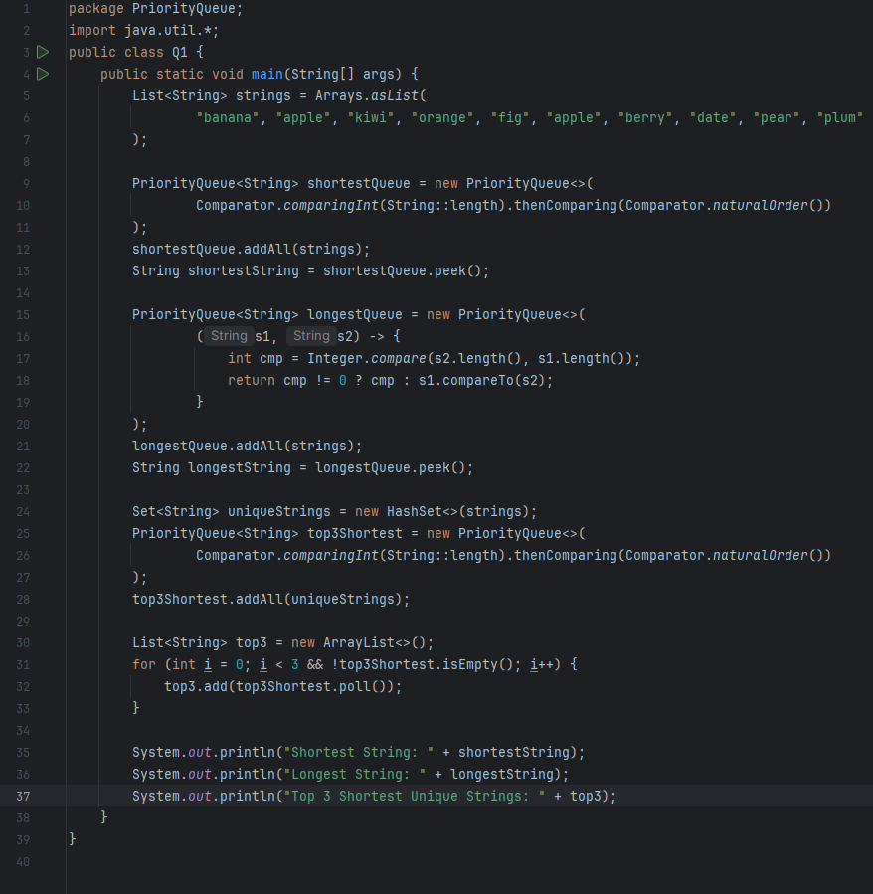
Question: Write a Java program that takes a sentence and counts the frequency of each word using a TreeMap. Your program should:
- Treat words as case-insensitive (e.g., "Hello" and "hello" are the same).
- Ignore all punctuation (e.g., commas, periods, exclamation marks, etc.).
- Use a TreeMap<String, Integer> to store and display the words in alphabetical order, along with their frequencies.
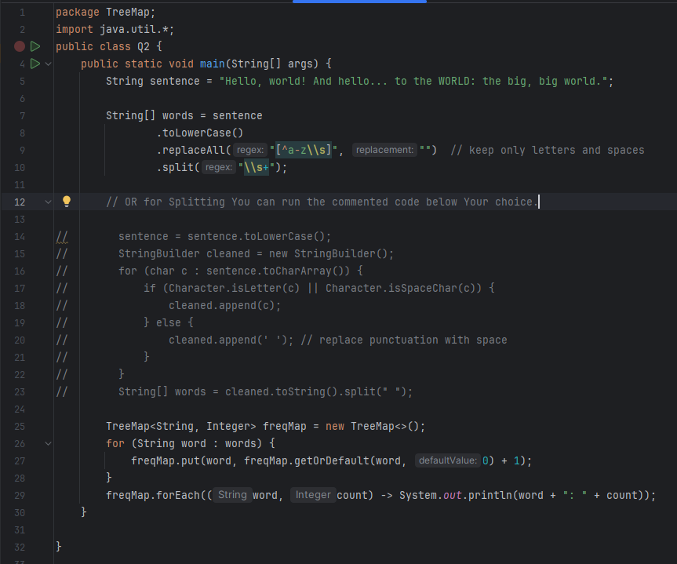
Question:
You are given an ArrayList<String> containing a collection of strings, which may include duplicates.
Write a Java program that performs the following using the TreeSet collection:
- Remove all duplicate strings from the list.
- Sort the unique strings in ascending alphabetical order and return the result.
- As a bonus, implement functionality to sort the unique strings in descending (reverse alphabetical) order using a custom comparator.
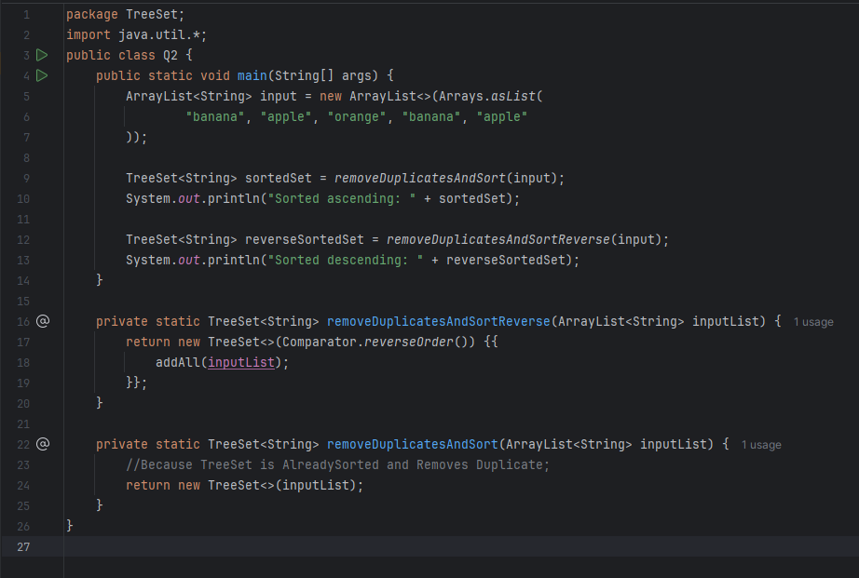
Question:
Write a Java program that reads a decimal number (double) input from the user and prints the input. If the user enters anything other than a valid decimal number, your program should print "Invalid input".
Input Format:
The program will take a single input from the user. This input should be a string which may or may not represent a valid double.
Output Format:
- If the input is a valid double, print the double value.
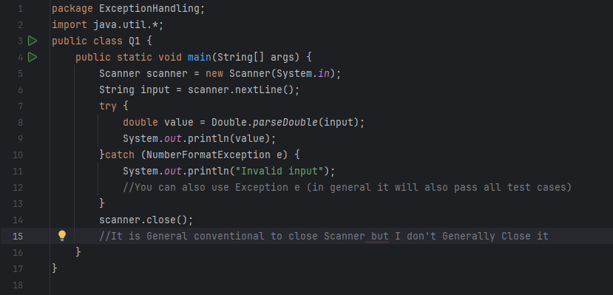
- If the input is not a valid double, print "Invalid input".

Question:
You are given two List<String> objects: list1 and list2, which may contain duplicate elements.
Write a Java program that performs the following operations using LinkedHashSet to preserve insertion order and remove duplicates:
- Union – Create a set containing all unique elements from both list1 and list2.
- Intersection – Create a set containing only the elements that are common to both lists.
- Difference – Create a set containing elements that are in list1 but not in list2.
Constraints:
- Both list1 and list2 can have duplicates.
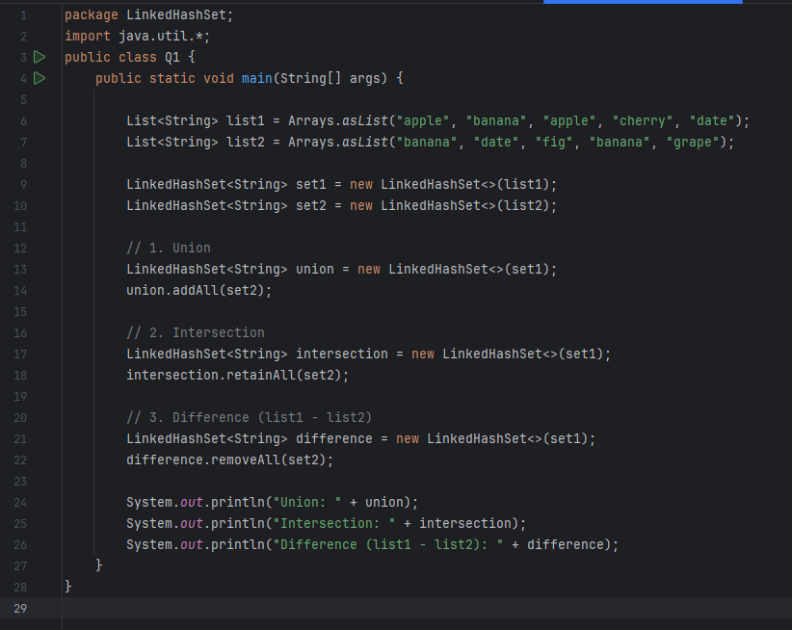
- The order of elements should follow their first appearance (insertion order) from the original lists.
Question:
Write a Java program to check if two strings are isomorphic to each other using a HashMap.
Definition:
Two strings are said to be isomorphic if the characters in one string can be replaced to get the second string, with the following conditions:
- Each character from the first string must map to only one character from the second string.
- A character cannot map to multiple characters.
- The order of characters must be preserved.
- Ignore case differences.
Requirements:
- Treat uppercase and lowercase characters as the same (i.e., case-insensitive).
- Use a HashMap<Character, Character> to store character mappings from the first string to the second.
Input Format:
The program should read two strings from the user using Scanner.
Output Format:
- If the strings are isomorphic, print "Isomorphic".
- Otherwise, print "Not Isomorphic".

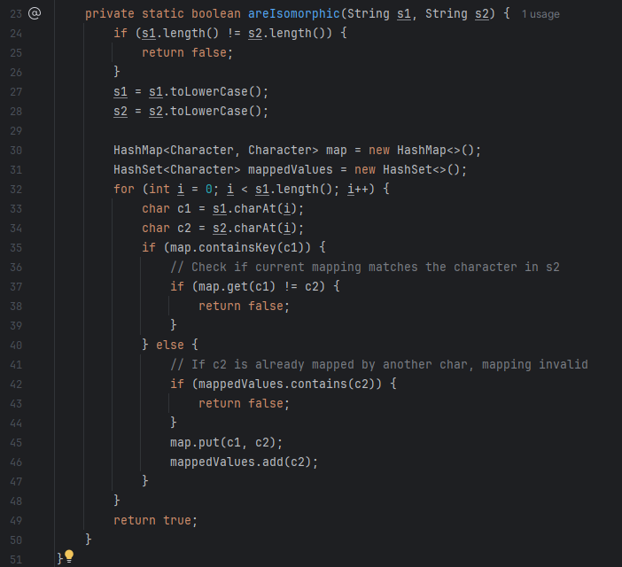
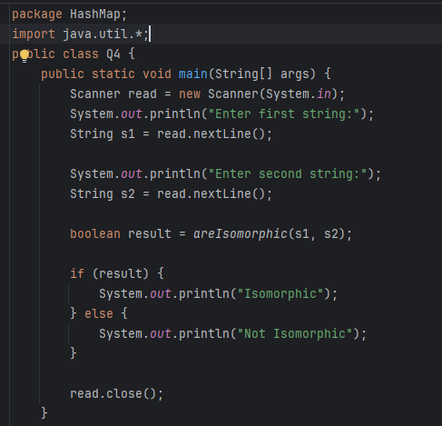
Advanced Error Handling Question:
Write a Java program that performs safe division of two integers entered by the user, incorporating the following requirements:
- Input Validation Loop:
The program should continuously prompt the user to enter two integers until both inputs are valid integers and the division can be performed successfully.
- Custom Exception:
Create a custom exception class named NegativeNumberException that is thrown if the user enters a negative integer for either input. Catch this exception and display the message:
"Error: Negative numbers are not allowed."
- Division by Zero Handling:
If the user tries to divide by zero, catch the exception and print:
"Error: Cannot divide by zero."
- Invalid Input Handling:
If the user enters a non-integer value, catch the appropriate exception and print:
"Invalid input: Please enter a valid integer."
- Unexpected Exceptions:
Catch any other exceptions and print:
"An unexpected error occurred: " followed by the exception message.
- Successful Operation:
When valid input is received and division is successful, print the result formatted to two decimal places and terminate the program.

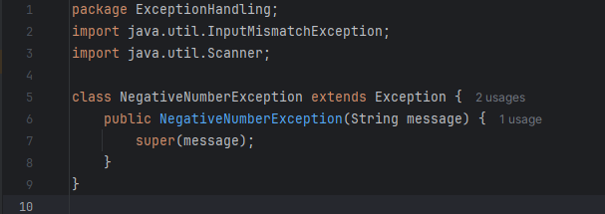
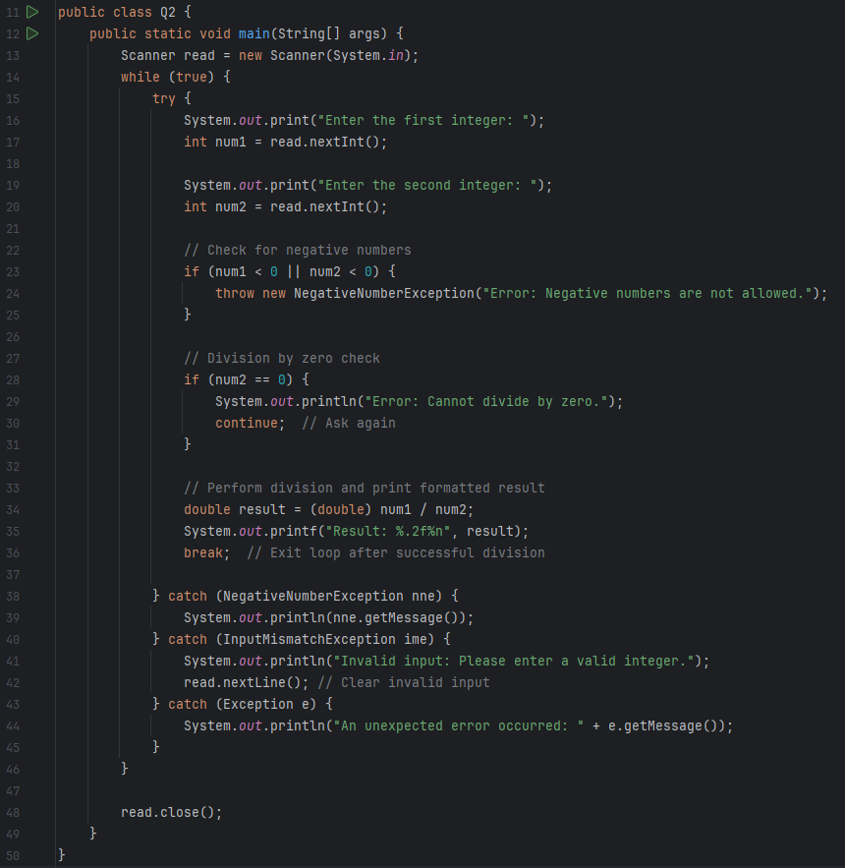
Advanced Inheritance Question:
Write a Java program demonstrating inheritance and polymorphism using the following classes:
- Create an abstract class Animal with:
  - An abstract method makeSound() that has no implementation.
  - A concrete method displayInfo() that prints "This is an animal."
- Create a class Dog that extends Animal and:
  - Provides its own implementation of makeSound() by printing "Dog barks."
  - Overrides displayInfo() to first call the base class’s displayInfo() method and then print "Specifically, it is a dog."
- Create a class Cat that extends Animal and:
  - Provides its own implementation of makeSound() by printing "Cat meows."
  - Overrides displayInfo() similarly to the Dog class but prints "Specifically, it is a cat."
- In the main method:
  - Create an array or list of Animal references that hold both Dog and Cat objects.
  - Use a loop to invoke displayInfo() and makeSound() on each object, demonstrating polymorphism.

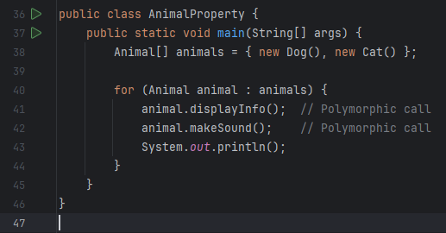
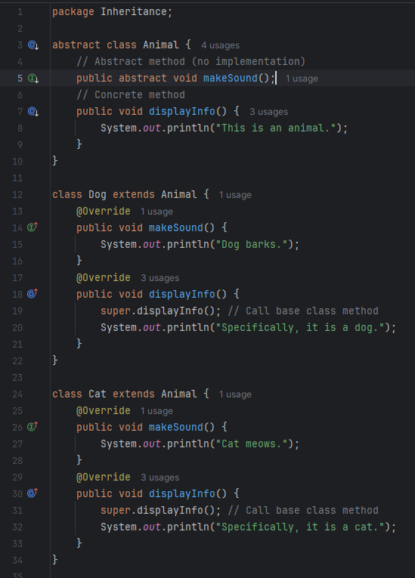
Advanced Inheritance & Polymorphism Problem:
Write a Java program that demonstrates hierarchical inheritance and runtime polymorphism by modeling various types of vehicles.
Requirements:
- Create an abstract base class Vehicle that has:
  - An abstract method drive()
  - An abstract method fuelType()
- Create three subclasses that extend Vehicle:
  - Car
  - Bike
  - Truck
Each subclass should:
  - Provide its own implementation of the drive() and fuelType() methods.
  - Have an additional method (unique to the class) representing a specific behavior:
    - Car: playMusic()
    - Bike: doWheelie()
    - Truck: loadCargo()
- In the main() method:
  - Prompt the user to select a vehicle type using a numbered menu:
  - Select a vehicle:
  - 1. Car
  - 2. Bike
  - 3. Truck
  - Use input validation to handle invalid inputs (non-integer or out-of-range).
  - Based on the user's choice, create the appropriate object using a Vehicle reference (demonstrating polymorphism).
  - Call the drive() and fuelType() methods.
  - Then, use downcasting (with instanceof checks) to call the class-specific method (e.g., playMusic() for Car).

Input Format:
Prompt the user to select one of the three vehicle types using a menu.

Output Format:
Display the vehicle’s drive behavior, fuel type, and class-specific feature.

