**Online Event Management**

An Event Management System (EMS) is a web-based application or platform designed to streamline the planning, organization, and executions of events such as parties, seminar, conferences, wedding, receptions, business meet, and more.

**Scope**

An Event Management System (EMS) is a web-based application or platform designed to streamline the planning, organization, and executions of events such as parties, seminar, conferences, wedding, receptions, business meet, and more.

**User Guide:**

1. When a new user wants to book an event, User needs to Fill the registration form.  
   Details of registration form:

* Name
* User Name
* Password
* Date of Birth
* Mobile Number
* Email Address
* Location

1. After Registration User needs to Login with the username and Password user provided during the registration.

* User Name
* Password

1. After Successful Login users can perform various tasks.

* Users can create a Plan Request by providing their requirements.
* Users can send the created Plan Request to the vendors
* Users can view all the quotations provided by different vendors.
* Users can accept or reject the Quotation provided by vendors.
* Users can view their profile.
* Users can update their profile ( Email,Phone number,Address and Password)

1. User can Logout:

* Once the user is logged out, User needs to Login again to perform all tasks.

**Admin Guide:**

1. Admin is pre-populated in the database. All the details of admin are already present in database which the admin provide at the time of database creation.  
   Details of Admin:

* Admin Id
* Full Name
* Password
* Mobile Number
* Email Address

1. After that Admin needs to Login with the username and Password.

* Username
* Password

1. After Successful Login Admin can perform various tasks.

* Admin can see all the vendors.
* Admin can add vendors.
* Admin can see all the user.
* Admin can activate or deactivate the user.

1. Admin can Logout

**Vendor Guide:**

1. Vendor is pre-populated in the database by the admin. All the details of vendor are added in the database.

Details of Vendor:

* Vendor Id
* Full Name
* Password
* Mobile Number
* Email Address
* Address

1. After that Vendor needs to Login with the username and Password.

* Username
* Password

1. After Successful Login Vendor can perform various tasks.

* Vendor can add packages.
* Vendor can view packages.
* Vendor can view all the plan requests.
* Vendor can create quotation.

1. Vendor can Logout.

**Database Schema**

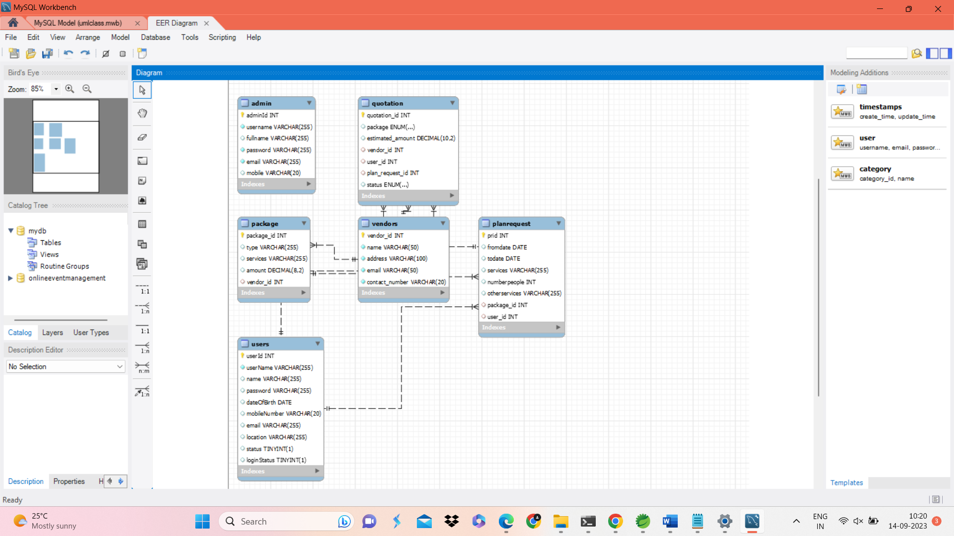

**Admin**: Stores admin information for system access.

**Vendors**: Stores vendor details, including services offered.

**Users**: Stores user information for system access and user management.

**Quotations**: Tracks quotations provided by vendors in response to user requests.

**Packages**: Defines the types of event packages vendors offer.

**PlanRequests**: Stores user requests for event planning, including details about the event, services needed, and number of attendees.

These tables and columns collectively support the functionality of the event planning system, facilitating interactions between administrators, vendors, and users while maintaining information about event packages, plan requests, and quotations.

**Class Diagram**

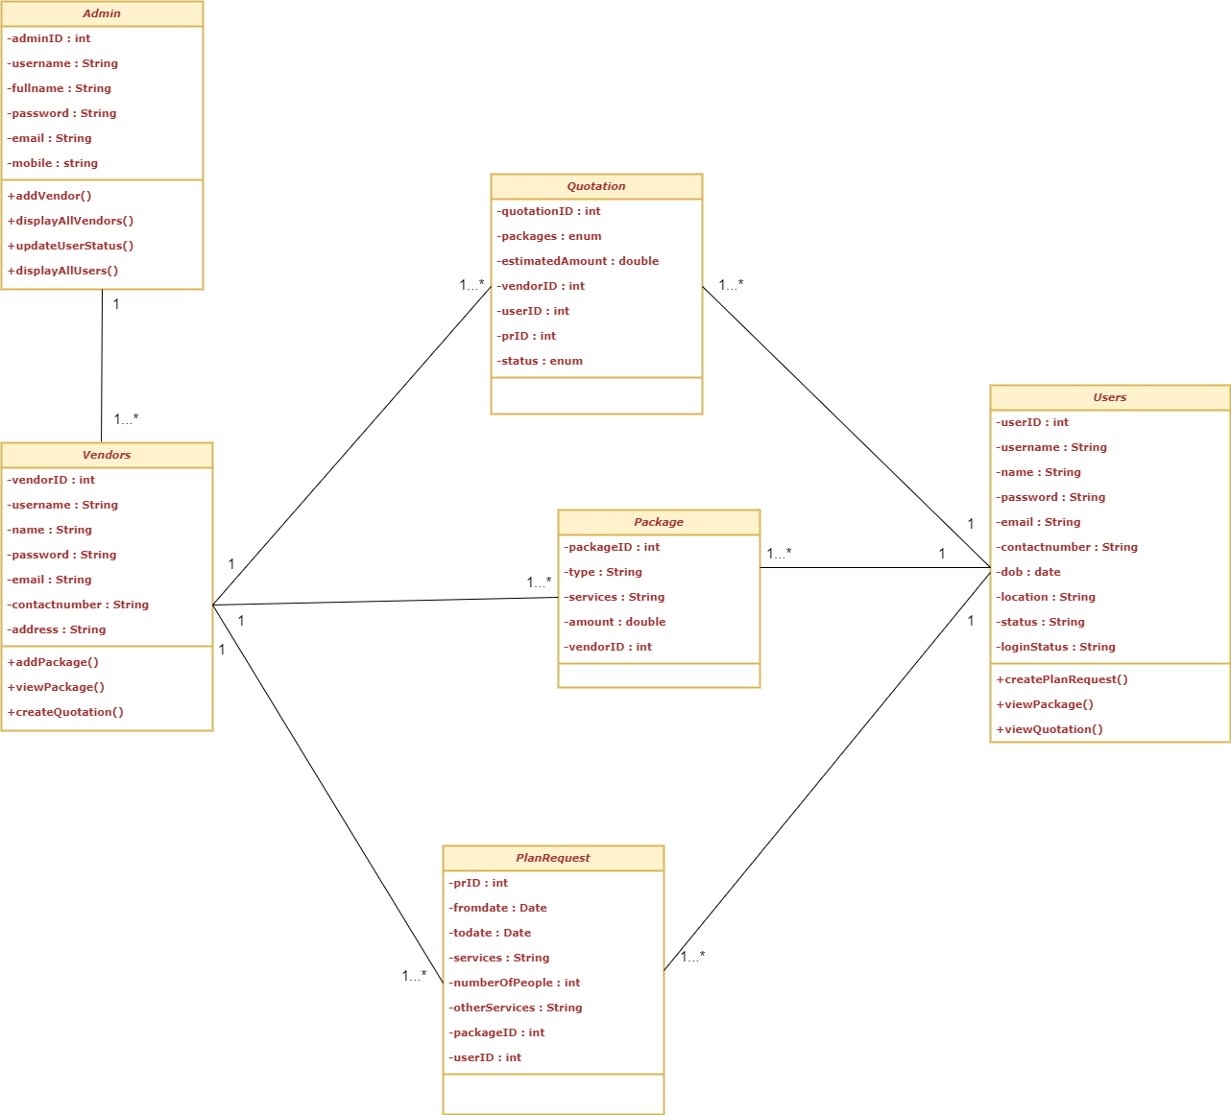

**Error Handling**

We encountered various errors in the application like user login error which was caused by incorrect userid and password. So to handle the errors and the exceptions using Exception Handling in java. Various Exception classes were used according to exceptions caused.

1. Invalid Credentials

2. User Not Found

3. User or Vendor Already Exists

4. Login Exceptions of User, Admin and Vendor

**Database and the table screenshots:**

