TITANIC SURVIVAL PREDICTION
Machine Learning Project Report

Task 1 — Binary Classification on Passenger Survival
Dataset: Titanic-Dataset.csv (Kaggle)
891 passenger records · 12 original fields
June 2026

1. Introduction
This project builds a machine learning model to predict whether a Titanic passenger survived the 1912 disaster, using passenger attributes such as age, sex, ticket class, fare, and family details. This is a well-known beginner classification project, commonly used to practice the end-to-end machine learning workflow: data cleaning, feature engineering, model training, evaluation, and interpretation.
The dataset used contains 891 passenger records with 12 original columns, including the target variable Survived (0 = did not survive, 1 = survived).

1.1 Objective
- Clean and prepare the raw Titanic dataset for modeling.
- Engineer informative features from existing columns (family size, title, cabin presence).
- Train and compare two classification models: Logistic Regression and Random Forest.
- Evaluate the selected model using accuracy, a confusion matrix, and a classification report.
- Identify which passenger attributes most influenced survival.

2. Dataset Overview
The raw dataset contains 891 rows and 12 columns. The target class distribution is imbalanced: 549 passengers did not survive and 342 survived, roughly a 62/38 split.
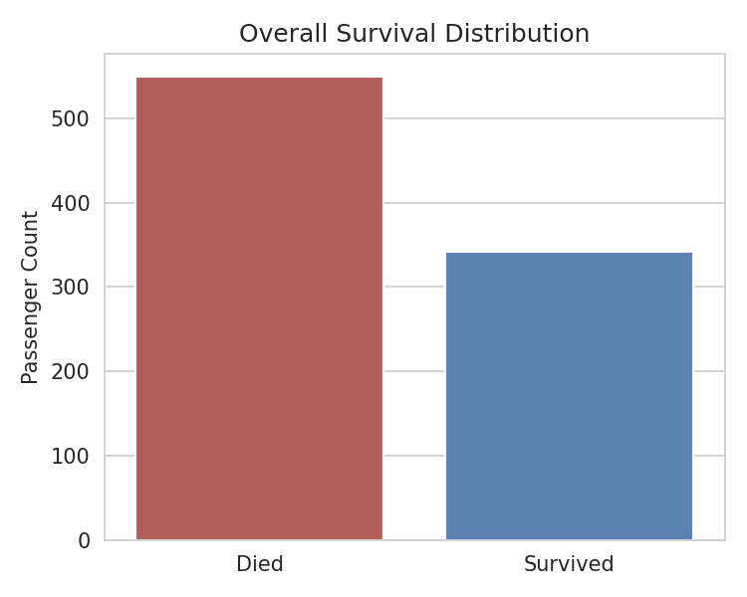
Figure 1. Overall survival distribution (0 = Died, 1 = Survived)

2.1 Missing Data
Three columns contained missing values that needed to be addressed before modeling:
Column | Missing Values | % Missing | Treatment
Age | 177 | 19.9% | Filled with training-set median
Cabin | 687 | 77.1% | Converted to a binary HasCabin flag, then dropped
Embarked | 2 | 0.2% | Filled with training-set mode

3. Data Preparation

3.1 Feature Engineering
Three new features were derived from the existing columns:
- FamilySize — sum of SibSp (siblings/spouses aboard) and Parch (parents/children aboard), plus 1 for the passenger.
- IsAlone — binary flag indicating whether a passenger had no family aboard.
- HasCabin — binary flag for whether a cabin number was recorded (a proxy for ticket class/wealth, since cabin data is mostly missing for lower classes).
- Title — extracted from the Name field (e.g. Mr, Mrs, Miss, Master), with rare titles grouped into a single Rare category. This captures social status and age-group signals that Name itself does not.

3.2 Encoding and Splitting
Sex was mapped to a binary value, while Embarked and Title — both unordered categorical fields — were one-hot encoded rather than label-encoded, avoiding a false sense of numeric order between categories.
The dataset was split into training and test sets before any imputation or encoding was fitted, to prevent information from the test set leaking into the training process. The training set contains 712 passengers and the test set contains 179 passengers (80/20 split, stratified by survival).

4. Modeling and Results

4.1 Model Comparison
Two models were trained and compared using 5-fold cross-validation on the training set, followed by evaluation on the held-out test set:
Model | CV Accuracy (mean ± std) | Test Accuracy
Logistic Regression | 81.75% ± 1.20% | 81.56%
Random Forest | 80.63% ± 4.52% | 80.45%

Logistic Regression achieved a marginally higher and more stable cross-validation score, while Random Forest offers the additional benefit of feature importance ranking, which is useful for interpretation. The Random Forest model (200 trees) was selected as the final model for detailed evaluation.

4.2 Final Model Performance
The final Random Forest model achieved a test accuracy of 80.45% on unseen data.
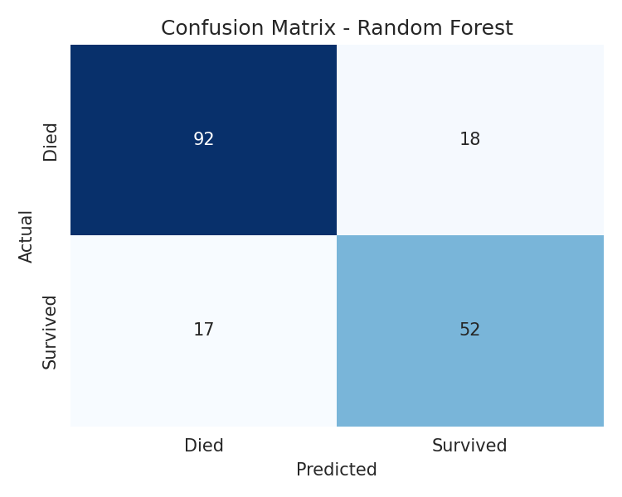
Figure 2. Confusion matrix for the Random Forest model on the test set
Class | Precision | Recall | F1-Score | Support
Died (0) | 0.84 | 0.84 | 0.84 | 110
Survived (1) | 0.74 | 0.75 | 0.75 | 69
Weighted Avg | 0.81 | 0.80 | 0.80 | 179

The model is more accurate at predicting passengers who did not survive than those who did, which is expected given the class imbalance in the training data (more non-survivors than survivors).

4.3 Feature Importance
The Random Forest model's built-in feature importance scores show which attributes most influenced its predictions:
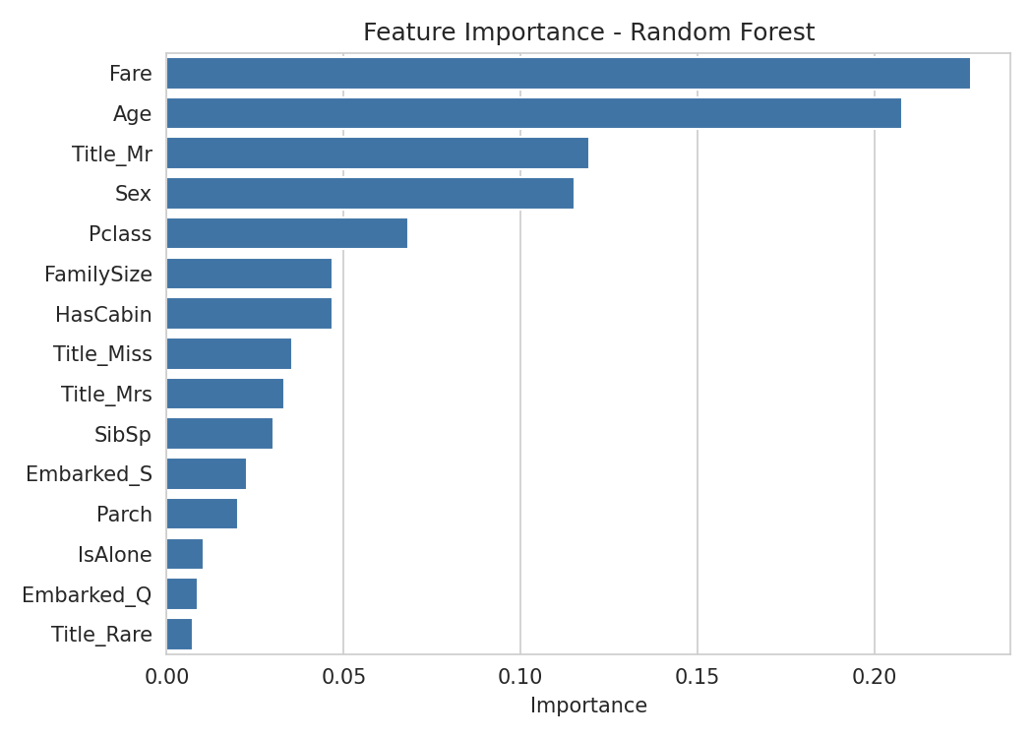
Figure 3. Feature importance ranking from the Random Forest model
Fare and Age were the strongest predictors, followed by the engineered Title_Mr flag and Sex — confirming that wealth/class proxies (fare), age, and gender were the dominant factors in survival, consistent with well-documented Titanic evacuation patterns (women, children, and higher-class passengers had priority access to lifeboats).

5. Exploratory Data Analysis
The charts below summarize key survival patterns observed in the raw data, supporting the feature importance findings above.

5.1 Survival by Gender
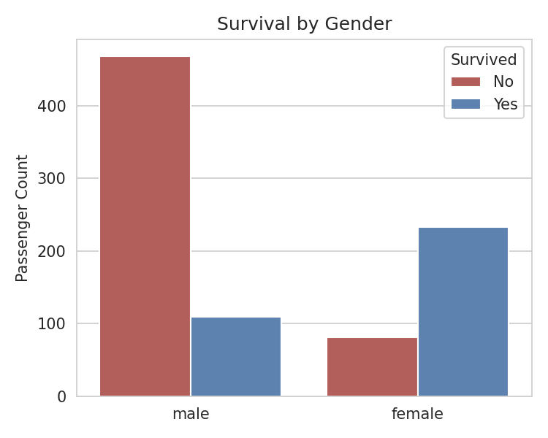
Figure 4. Survival counts split by gender
Female passengers survived at a substantially higher rate than male passengers, consistent with the historical "women and children first" evacuation policy.

5.2 Survival by Passenger Class
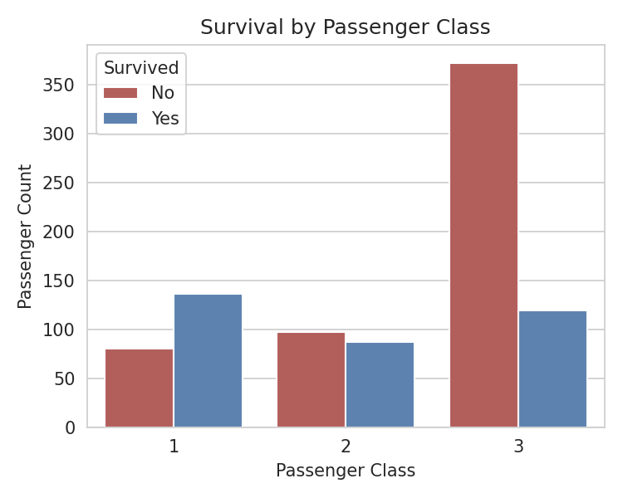
Figure 5. Survival counts split by passenger class (1st, 2nd, 3rd)
First-class passengers had the highest survival rate, while third-class passengers had the lowest — reflecting both lifeboat access and cabin location relative to the deck.

5.3 Age Distribution
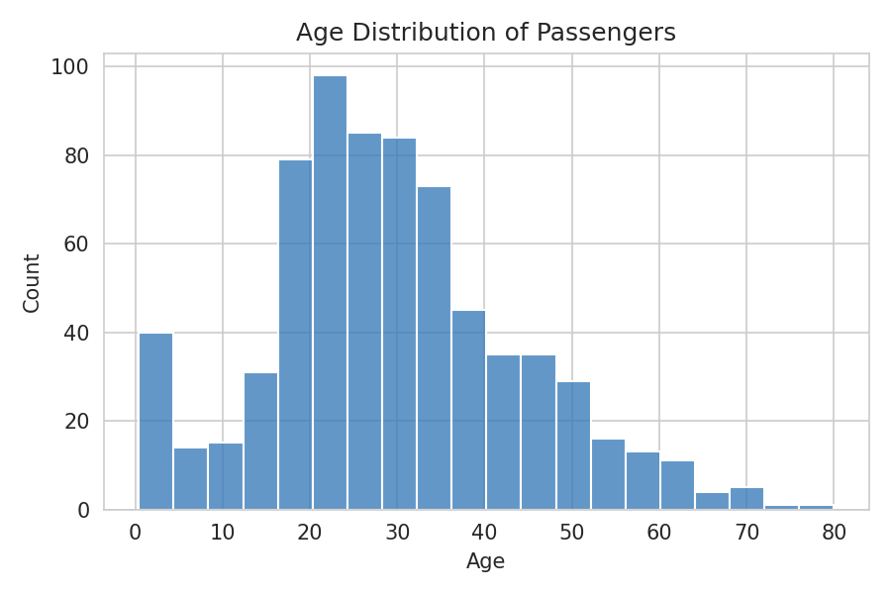
Figure 6. Distribution of passenger ages
The age distribution is right-skewed, with most passengers between 20 and 40 years old, and a smaller number of infants, children, and elderly passengers.

6. Conclusion
- The final Random Forest model correctly predicted survival outcomes for 80.4% of passengers in the held-out test set.
- Fare, Age, Sex, and passenger Title were the most influential features, aligning with known historical evacuation patterns.
- Splitting the data before imputation and encoding ensured the evaluation reflects genuine generalization performance rather than leaked information.
- Engineered features (Title, HasCabin, FamilySize) added meaningful predictive signal beyond the raw columns.

6.1 Possible Next Steps
- Hyperparameter tuning (e.g. grid search on tree depth, number of estimators) to improve Random Forest performance.
- Trying gradient boosting models (XGBoost, LightGBM) for potentially higher accuracy.
- Addressing class imbalance directly with techniques such as class weighting or SMOTE.
- Generating predictions on the official Kaggle test.csv file for leaderboard submission.

