MOVIE RATING PREDICTION
Machine Learning Project Report

Regression Analysis of Genre, Director, and Cast on IMDb Ratings
Dataset: IMDb Movies India.csv (Kaggle)
15,509 movie records · 10 original fields
June 2026

1. Introduction
This project builds a regression model to predict a movie's IMDb rating based on attributes such as genre, director, lead actors, release year, duration, and vote count. Predicting a continuous rating (rather than a yes/no outcome) makes this a regression problem, evaluated with error-based metrics rather than classification accuracy.
The dataset used contains 15,509 Indian movie records with 10 original columns, including the target variable Rating, a continuous score typically between 1 and 10.

1.1 Objective
- Clean and prepare raw IMDb movie data for regression modeling.
- Engineer informative features from genre, director, and cast information.
- Train a Random Forest Regressor and benchmark it against a naive baseline.
- Evaluate the model using MAE, RMSE, and R².
- Identify which movie attributes most influence predicted ratings.

2. Dataset Overview
The raw dataset contains 15,509 rows. A large share of movies are missing a Rating value (no votes recorded yet) or other fields. Since Rating is the prediction target, rows without a Rating cannot be used for training and were removed first, leaving 7,919 usable rows — rather than dropping any row with any missing field, which would have discarded the majority of the dataset unnecessarily.

2.1 Missing Data
Column | Missing (raw) | % Missing
Rating (target) | 7590 | 48.9%
Votes | 7589 | 48.9%
Duration | 8269 | 53.3%
Genre | 1877 | 12.1%
Actor 3 | 3144 | 20.3%

After removing rows with no Rating, the numeric fields Year, Duration, and Votes were cleaned from text formats (e.g. "(2019)", "109 min", "1,086") into proper numbers, then remaining gaps were filled with the training-set median. Rows still missing Genre, Director, or any of the three Actor fields were removed, since these are identity fields that cannot be meaningfully imputed. This left a final modeling dataset of 7,558 rows.
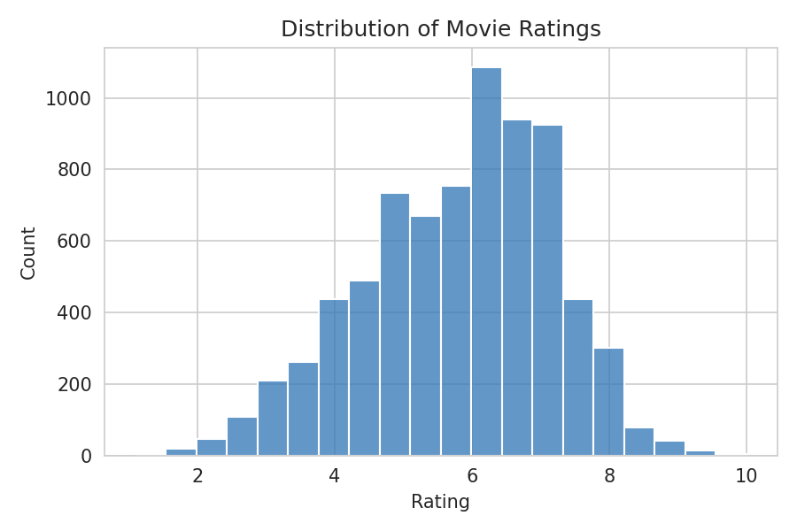
Figure 1. Distribution of movie ratings in the cleaned dataset

3. Data Preparation

3.1 Numeric Cleaning
- Year — extracted the 4-digit year from values like "(2019)".
- Duration — extracted the numeric minute count from values like "109 min".
- Votes — removed thousands-separator commas from values like "1,086" before converting to numeric.

3.2 Feature Engineering
Genre is a multi-label field — a single movie can belong to several genres at once (e.g. "Comedy, Romance"). Treating the whole string as one category would have hidden this structure, so each genre was split out and one-hot encoded into its own binary column, producing 22 separate genre indicator features.
Director and the three Actor fields are high-cardinality identity columns — thousands of unique names. Rather than label-encoding them (which would impose a meaningless numeric ordering, e.g. assigning arbitrary integers to director names), each name was replaced with its frequency of appearance in the training set. This captures how often a director or actor appears in the dataset as a usable numeric signal, without inventing a false rank between names.

3.3 Splitting and Leakage Prevention
The dataset was split into training and test sets before the frequency-encoding maps were computed. Encoding statistics were derived only from the training set and then applied to the test set, ensuring no information about test-set movies leaked into the encoding process. The training set contains 6,046 movies and the test set contains 1,512 movies (80/20 split).

4. Modeling and Results

4.1 Baseline Comparison
A naive baseline model — always predicting the average rating in the training set, regardless of any movie attribute — was used as a reference point. Any useful model must clearly outperform this baseline.
Model | MAE | RMSE | R²
Baseline (mean) | 1.101 | 1.361 | -0.0000
Random Forest | 0.818 | 1.087 | 0.3624

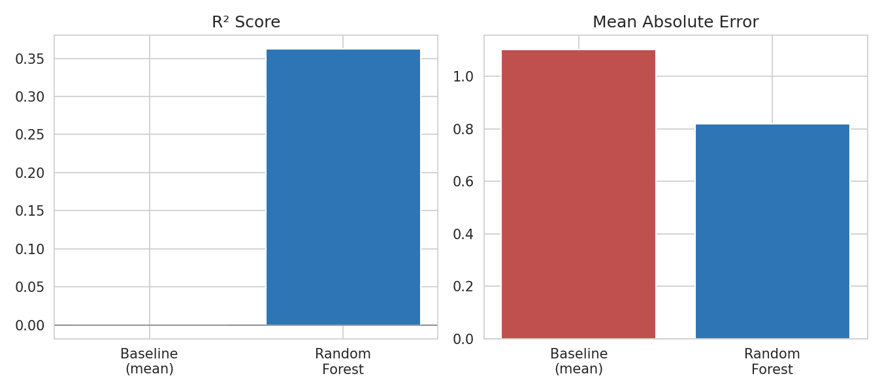
Figure 2. Baseline vs. Random Forest on R² and MAE
The Random Forest model explains roughly 36% of the variance in movie ratings (R² = 0.36), compared to the baseline's R² of approximately zero, confirming that genre, director, cast, and release attributes carry genuine predictive signal.

4.2 Cross-Validated Performance
5-fold cross-validation on the training set gave an R² of 37.9% ± 1.5%, consistent with the held-out test set score, indicating the model's performance is stable rather than a result of a lucky train/test split.

4.3 Prediction Accuracy
On the held-out test set, the Random Forest model achieved a Mean Absolute Error of 0.82 rating points and a Root Mean Squared Error of 1.09, compared to the baseline's MAE of 1.10.
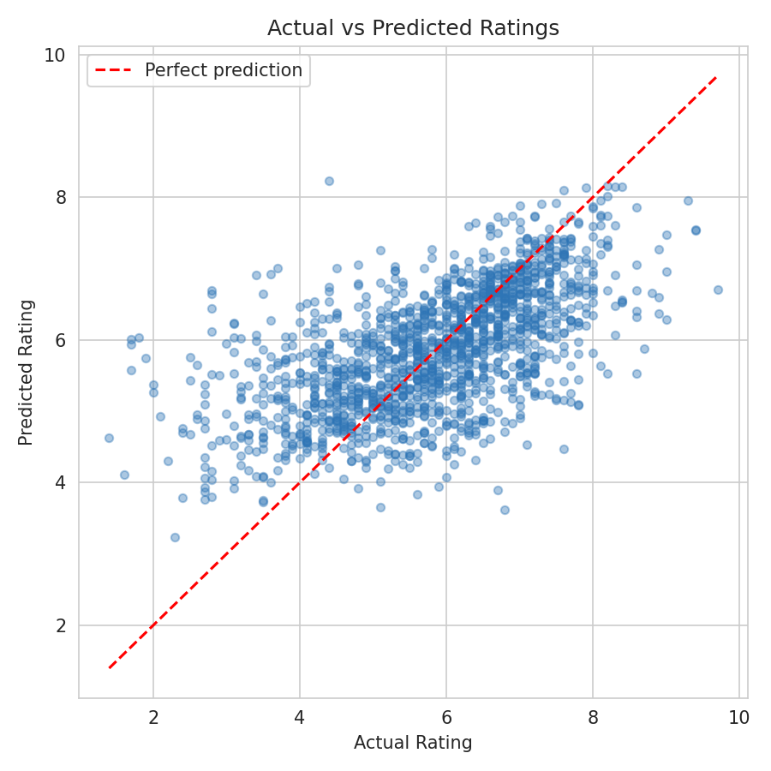
Figure 3. Actual vs. predicted ratings on the test set, with the red dashed line marking perfect prediction
The model captures the overall trend but compresses predictions toward the middle of the rating scale — a typical pattern for tree-based regressors on noisy, sparse-feature data, where extreme high or low ratings are harder to predict precisely than mid-range ones.

4.4 Feature Importance
The Random Forest's built-in feature importance scores reveal which attributes drove its predictions most strongly:
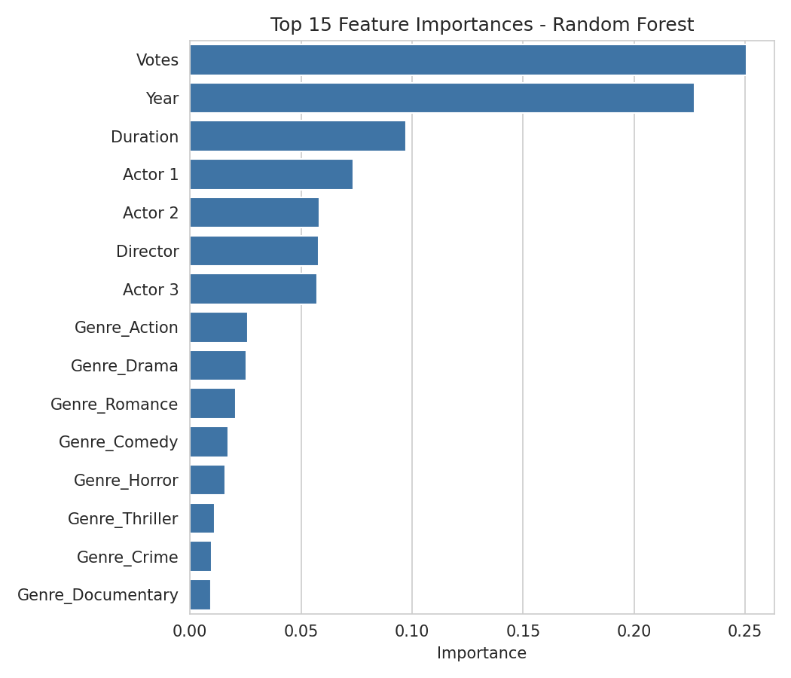
Figure 4. Top 15 feature importances from the Random Forest model
Votes and Year were the two strongest predictors, followed by the lead actors and director (encoded by appearance frequency). This suggests that how widely a movie was watched/discussed (Votes) and when it was released (Year) carry more signal than any single genre tag, though genres like Action and Drama still contribute meaningfully.

5. Exploratory Data Analysis
The charts below summarize patterns in the raw rating data that help explain the model's behavior.

5.1 Average Rating by Genre
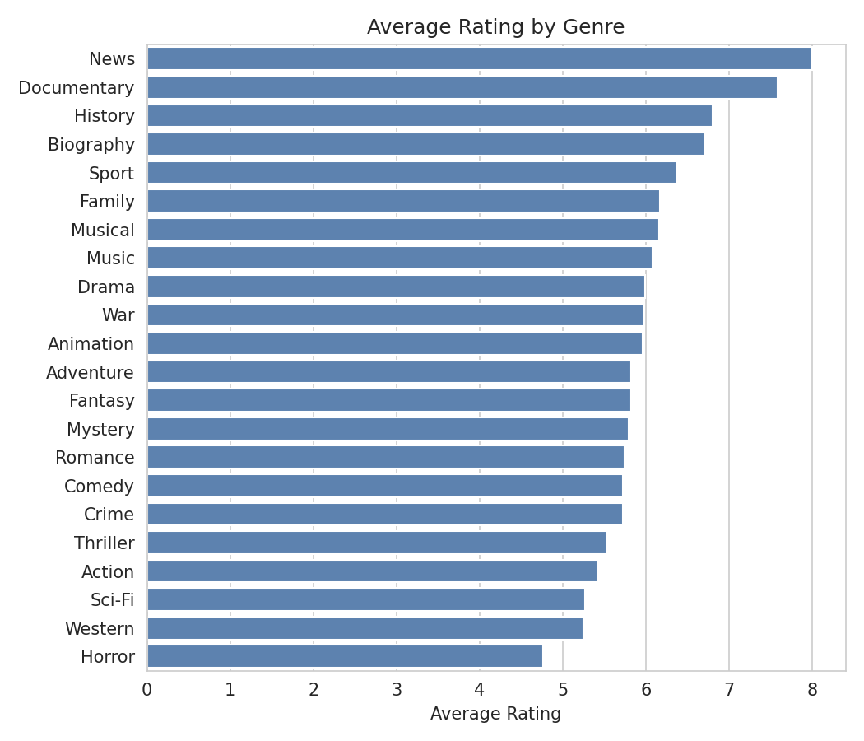
Figure 5. Average rating for movies tagged with each genre
News, Documentary, History, and Biography titles show the highest average ratings, while Horror and Western titles rank lowest — though these categories also tend to have far fewer movies, so the averages are noisier.

5.2 Rating Trend by Release Year
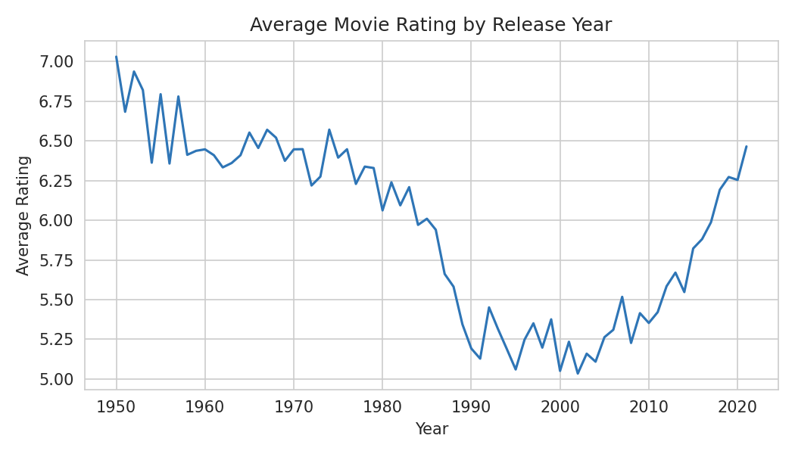
Figure 6. Average rating of movies by release year (1950–2021)
Average ratings show some drift across decades, which the model partially captures through the Year feature — though this trend is also influenced by which older films had enough survivors/re-releases to accumulate votes and reviews at all.

6. Conclusion
- The Random Forest model explained approximately 36% of the variance in movie ratings (R² = 0.36), a clear improvement over the near-zero baseline.
- Average prediction error was 0.82 rating points (MAE), meaning predictions are typically within roughly 0.8 points of the true IMDb rating.
- Votes and Year were the dominant predictive features, ahead of any individual genre or cast member.
- Splitting the data before encoding, and using frequency encoding instead of arbitrary label encoding for director/actor names, ensured the evaluation reflects genuine generalization rather than leaked information or artificial numeric relationships.
- Treating Genre as a multi-label field (rather than one combined category) preserved meaningful structure that a single-label encoding would have discarded.

6.1 Possible Next Steps
- Hyperparameter tuning (tree depth, number of estimators, minimum samples per leaf) to reduce the compression toward mid-range ratings seen in Figure 3.
- Trying gradient boosting models (XGBoost, LightGBM, CatBoost) which often handle high-cardinality categorical features more effectively.
- Incorporating additional features such as production budget, language, or critic reviews if available.
- Excluding Votes as a feature and re-evaluating, since vote count is partly a consequence of a movie's popularity rather than a property knowable before release.

