Install a web server on a Linux system. Install and configure Snort as IDS on this system. Add following rules to Snort to generate an alert for following threats.

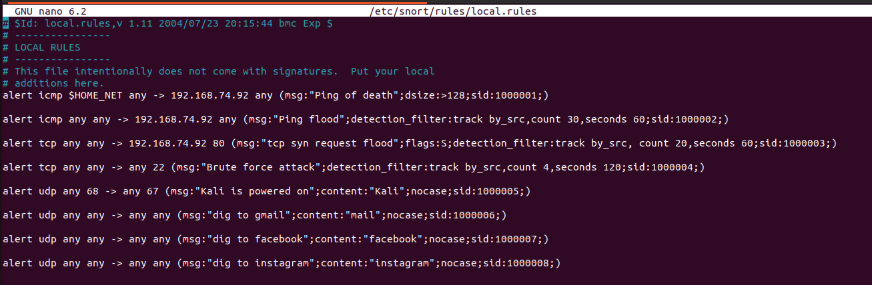

- If a ping packet with size grater than 128 bytes is received.

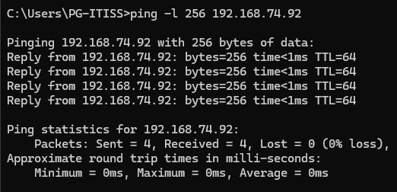

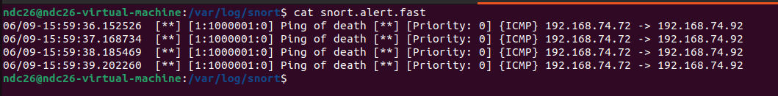

2. If from an outside IP address 30 ICMP packets are received within 1 min.

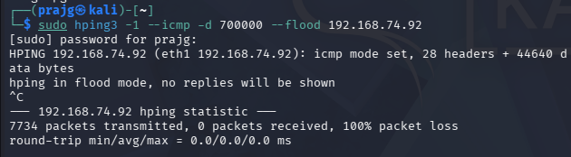

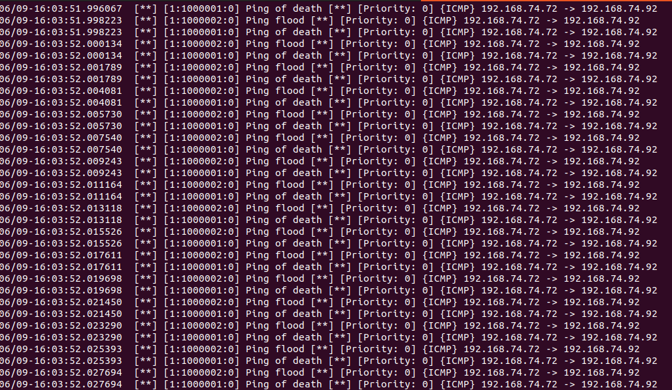

3. If from an outside single IP address more that 20 TCP SYN requests are received in 1 min to the web server

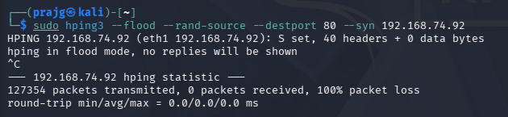
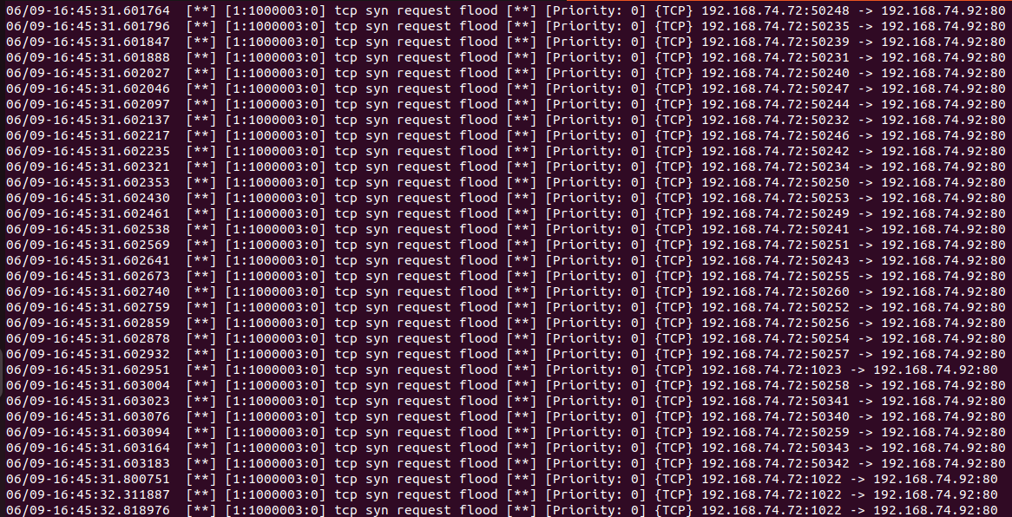

- If a brute force attack is done on the SSH service.

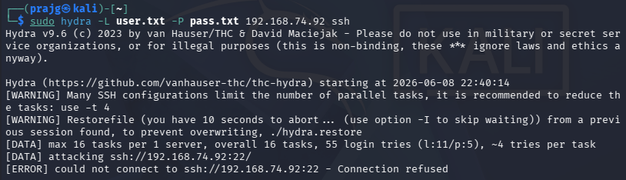

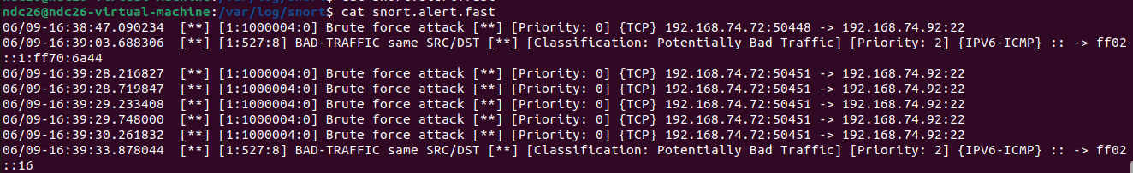

- If a Kali Linux machine,boots in the network.

- If gmail website is accessed from the web server.

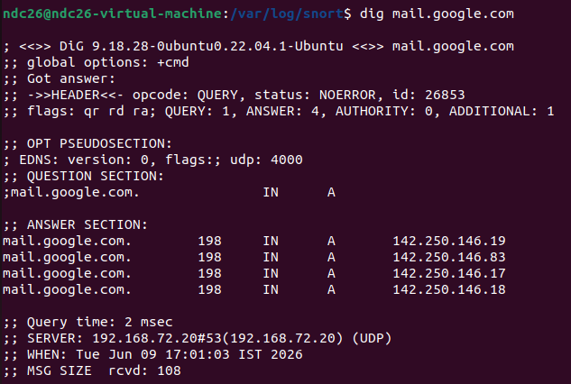

- If facebook website is accessed from the web server.

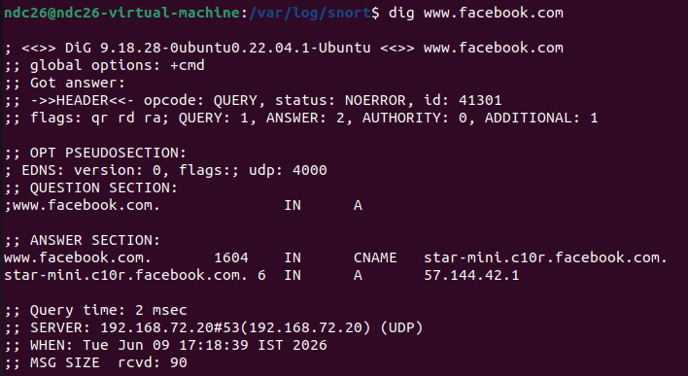

- If instagram website is accessed from the web server.

