- Configure nginx as a reverse proxy such that when you type ip address (192.168.74…) website of 192.168.25.25 should open and when you type ip_address/exam the website of 192.168.25.35 should open

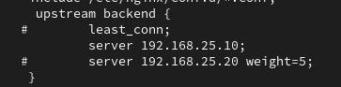

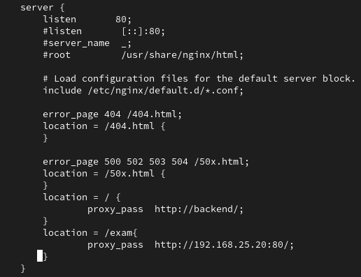\

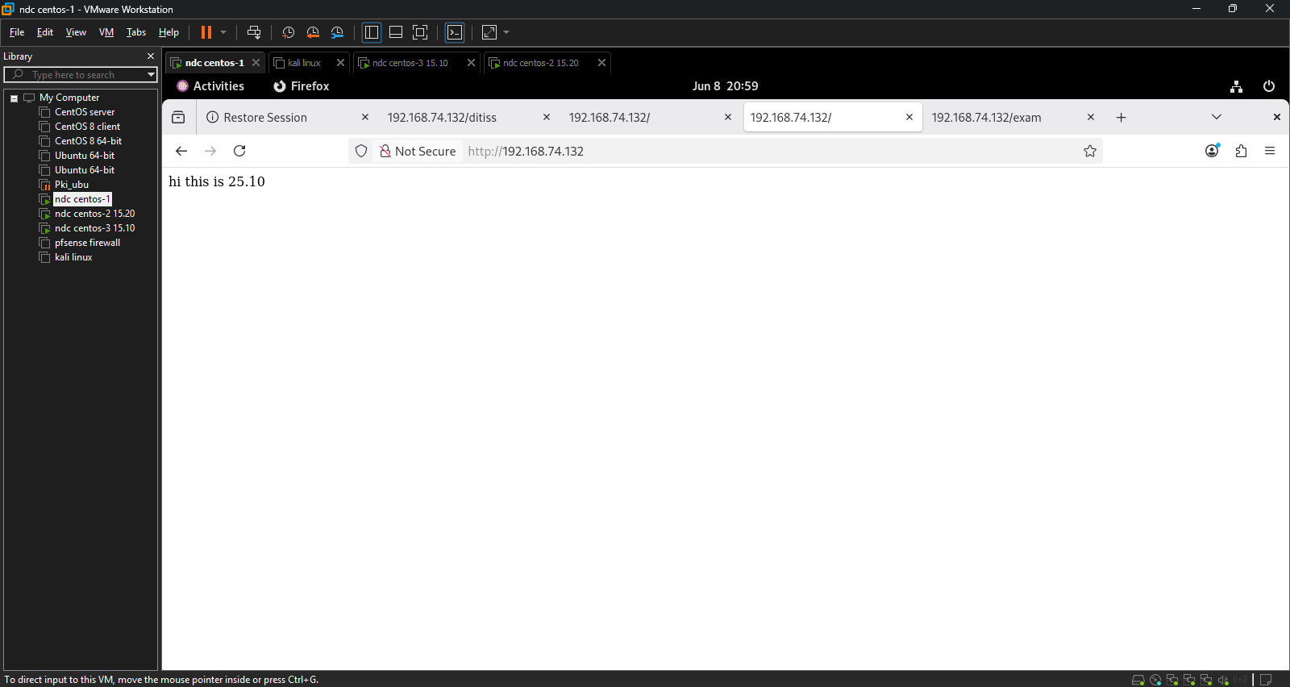

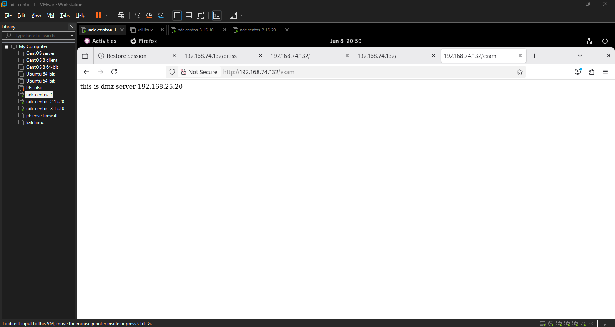

- Configure nginx as a load balancer such that the first web server gets 7 connections and then second web server gets 1 connection

