**Network Design Lab**

## **Name:** Shruti Chaube

**Roll No**: 66

Chapter3: Simulation of Wireless Router in CPT

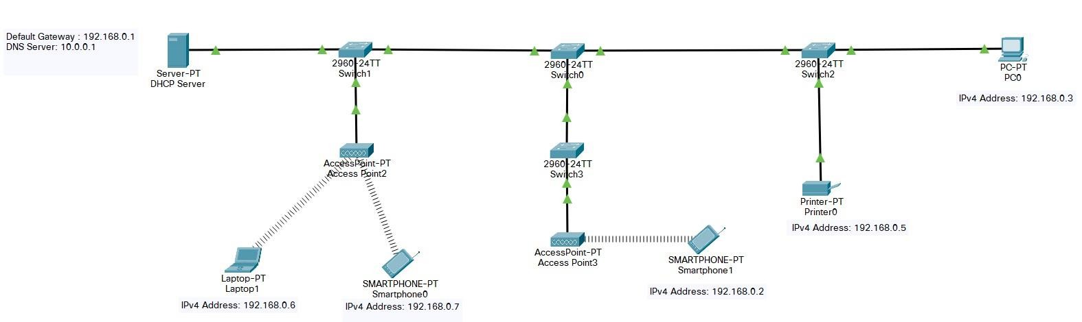

Learning Objective:

1. Simulate Access Point configuration
2. Simulate DHCP

# DHCP Server:

## Default Gateway : 192.168.0.1

* + DNS Server: 10.0.0.1 **Device IP Address List:**

## Laptop1 – 192.168.0.6

* + Smartphone0 – 192.168.0.7

## Smartphone1– 192.168.0.2

* + PC0 – 192.168.0.3

## Printer0 – 192.168.0.5

**DHCP Service Configuration**:

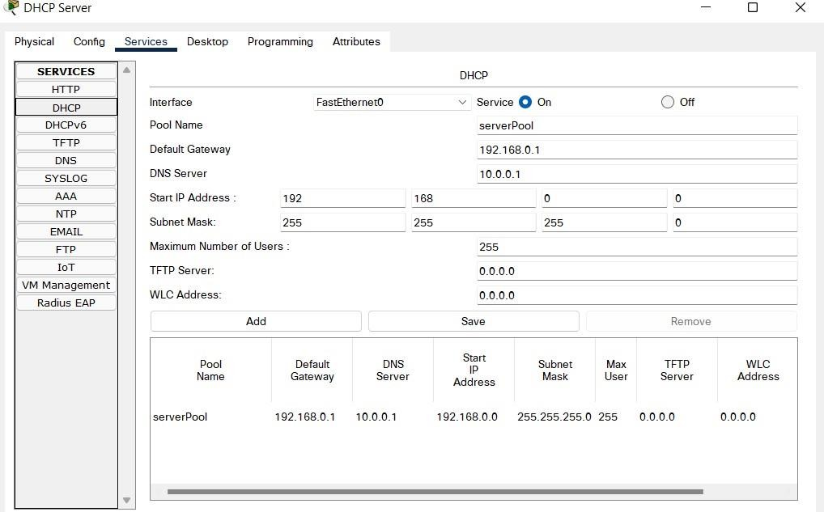

# ICMP Ping Results:

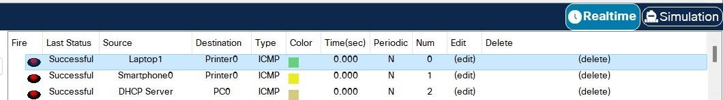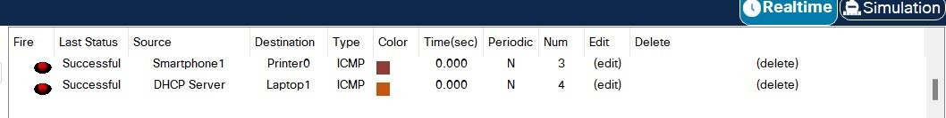

**Access Point 1 (AP1) WPA2-PSK Authentication:**

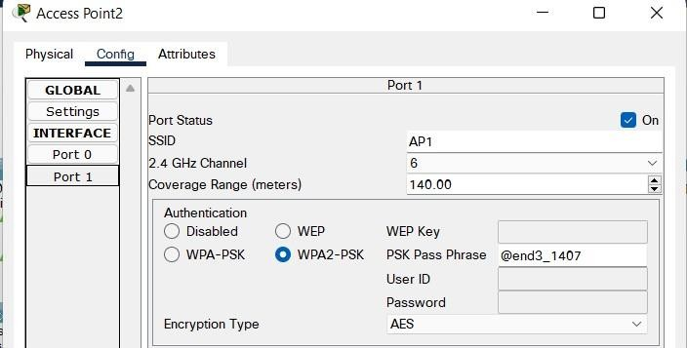

**Access Point 2 (AP2) WEP Authentication:**

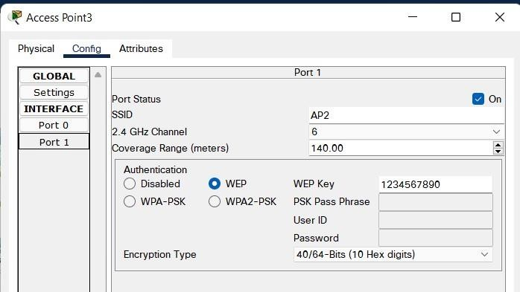

**Conclusion:**

Using Cisco Packet Tracer, I was able to do DHCP Configuration and all devices were automatically assigned IP Addresses by the DHCP Server. All Access Points are configured securely by using authentication methods like WEP and WPA2-PSK