**Network Design Lab**

**Name:** Shruti Chaube

**Roll No:** 66

Chapter4: Simulation of RIP routing in CPT

Learning Objective:

1. Configuration of RIP based routing
2. Learn concept of DCE and DTE devices in serial communication

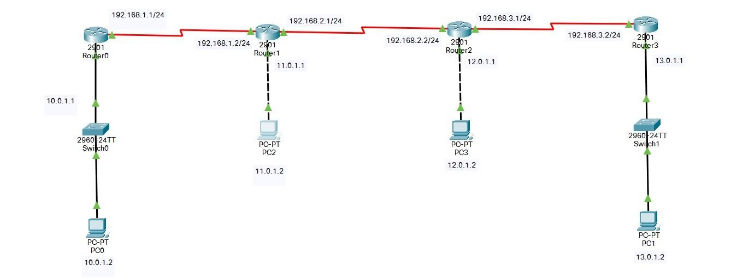

# IP Address of Devices:

* + Router0 – o Serial 0/3/0 - 192.168.1.1
  + Router1 – o Serial 0/3/0 - 192.168.1.2 o Serial 0/3/1 - 192.168.2.1
  + Router2 – o Serial 0/3/0 - 192.168.2.2

o Serial 0/3/1 - 192.168.3.1

* + Router3 – o Serial 0/3/0 - 192.168.3.2
  + PC0 – 10.0.1.2
  + PC1 – 11.0.1.2
  + PC2 – 12.0.1.2
  + PC3 – 13.0.1.2

# Router0:

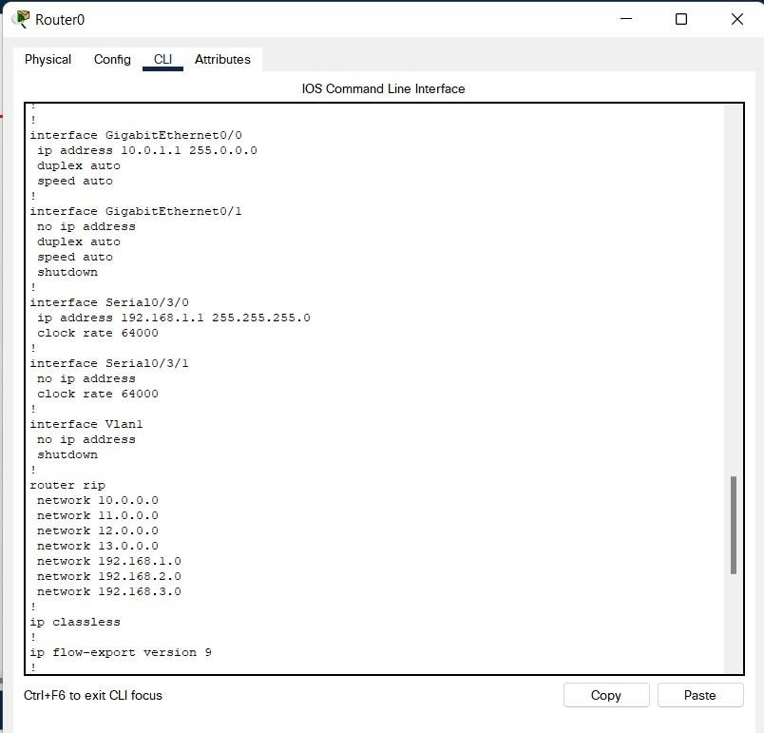

**Router1:**

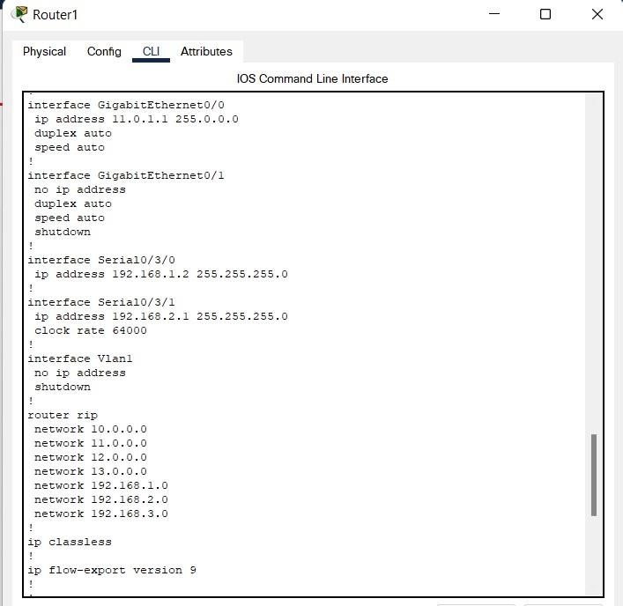

# Router2:

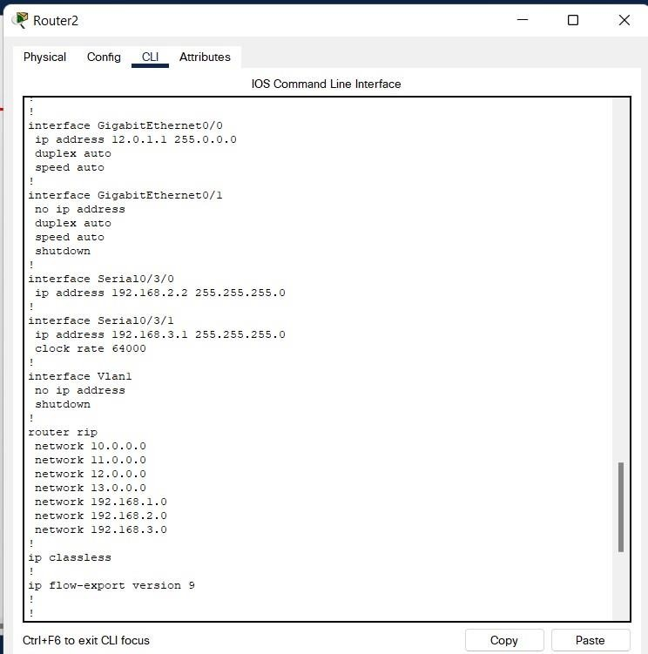

**Router3:**

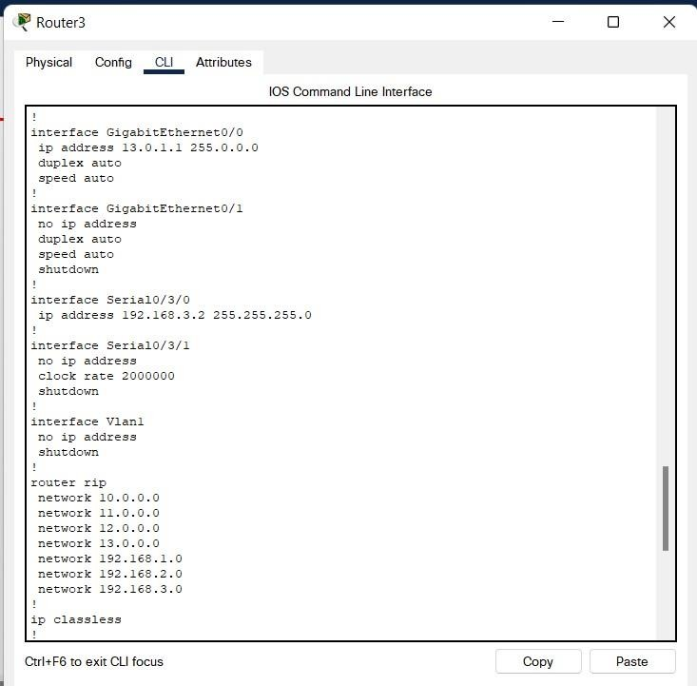

# Route:

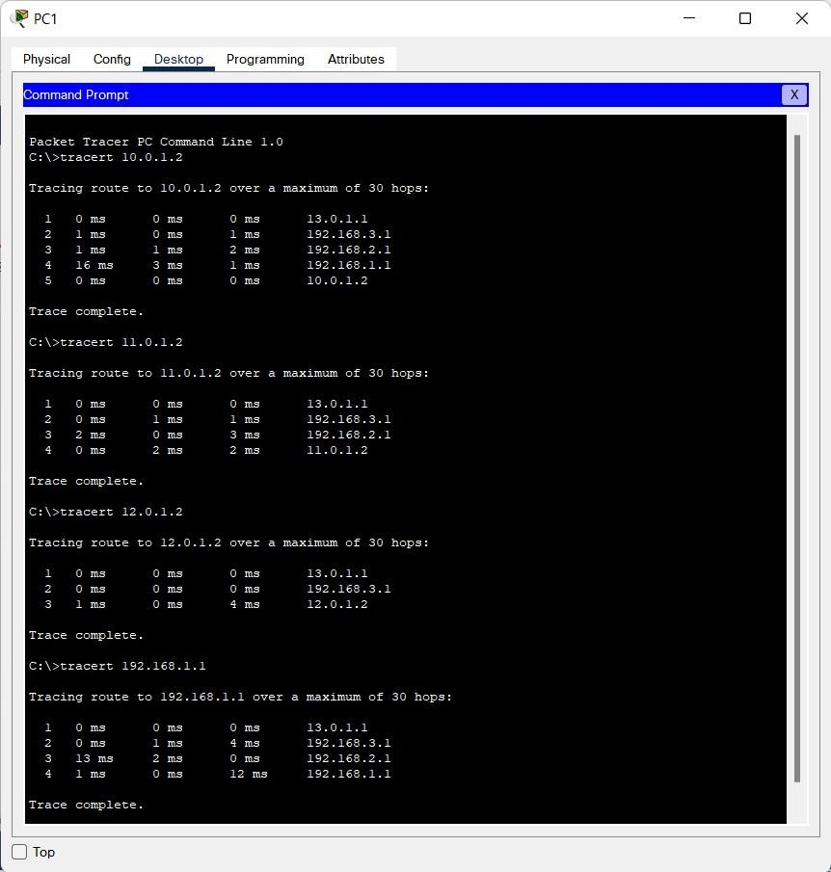

**Simulation Results:**

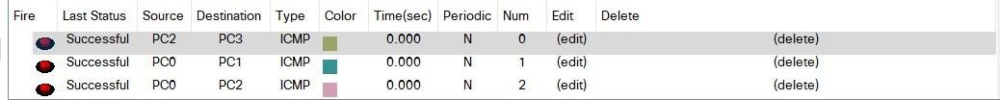

# Conclusion:

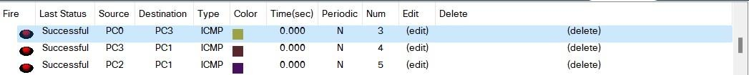

Using Cisco Packet Tracer, I was able to do configuration of RIP based routing and also learn concept of DCE and DTE devices in serial communication.