JAVA_LAB8_2348508

**INPUT FRAME:**

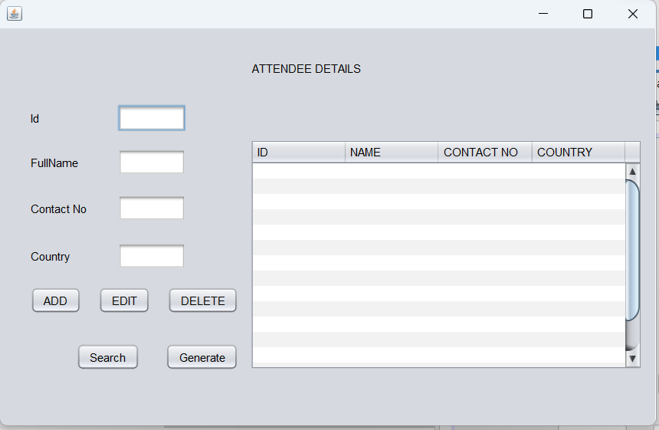

**OUTPUT DATAFRAME**

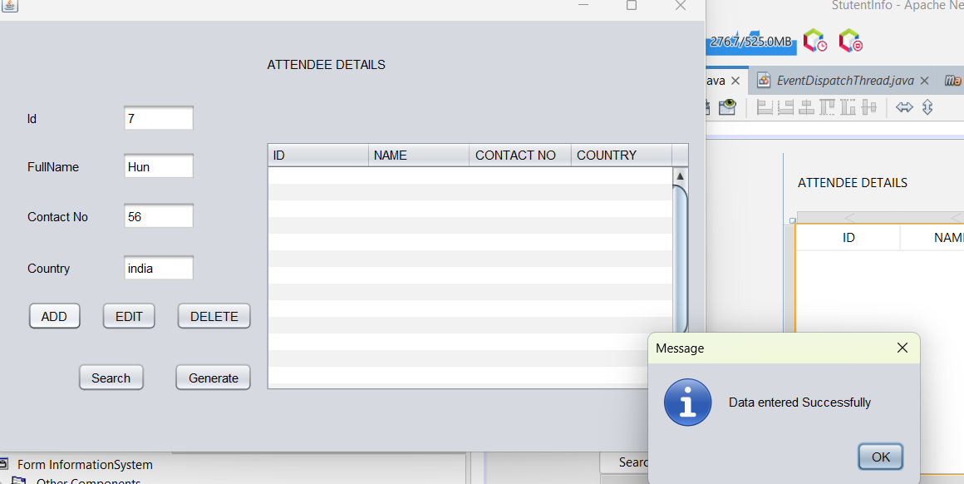

**DATABASE TABLE**

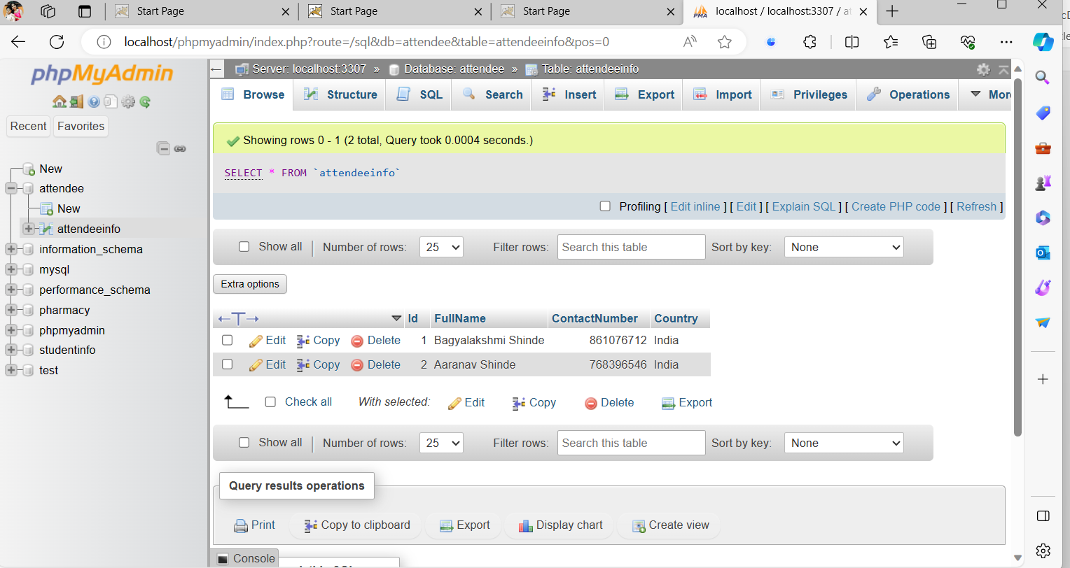

**CODE:**

package com.mycompany.mavenproject1;

import java.sql.*;

import java.util.Vector;

import java.util.logging.Level;

import java.util.logging.Logger;

import javax.swing.JOptionPane;

import javax.swing.table.DefaultTableModel;

/*

* Click nbfs://nbhost/SystemFileSystem/Templates/Licenses/license-default.txt to change this license

* Click nbfs://nbhost/SystemFileSystem/Templates/GUIForms/JFrame.java to edit this template

*/

/**

*

* @author Bagyalakshmi S

*/

public class InformationSystem extends javax.swing.JFrame {

/**

* Creates new form InformationSystem

*/

public InformationSystem() {

initComponents();

}

Connection con = null;

PreparedStatement pst = null;

/**

* This method is called from within the constructor to initialize the form.

* WARNING: Do NOT modify this code. The content of this method is always

* regenerated by the Form Editor.

*/

@SuppressWarnings("unchecked")

// <editor-fold defaultstate="collapsed" desc="Generated Code">

private void initComponents() {

jScrollPane1 = new javax.swing.JScrollPane();

jTable1 = new javax.swing.JTable();

jLabel1 = new javax.swing.JLabel();

jLabel2 = new javax.swing.JLabel();

jLabel3 = new javax.swing.JLabel();

jLabel4 = new javax.swing.JLabel();

txtId = new javax.swing.JTextField();

txtName = new javax.swing.JTextField();

txtAge = new javax.swing.JTextField();

txtCourse = new javax.swing.JTextField();

jButton1 = new javax.swing.JButton();

jButton2 = new javax.swing.JButton();

jButton3 = new javax.swing.JButton();

jLabel5 = new javax.swing.JLabel();

jButton5 = new javax.swing.JButton();

jButton6 = new javax.swing.JButton();

setDefaultCloseOperation(javax.swing.WindowConstants.EXIT_ON_CLOSE);

jTable1.setModel(new javax.swing.table.DefaultTableModel(

new Object [][] {

{null, null, null, null},

{null, null, null, null},

{null, null, null, null},

{null, null, null, null},

{null, null, null, null},

{null, null, null, null},

{null, null, null, null},

{null, null, null, null},

{null, null, null, null},

{null, null, null, null},

{null, null, null, null},

{null, null, null, null},

{null, null, null, null},

{null, null, null, null},

{null, null, null, null},

{null, null, null, null}

},

new String [] {

"ID", "NAME", "CONTACT NO", "COUNTRY"

}

));

jScrollPane1.setViewportView(jTable1);

jLabel1.setText("Id");

jLabel2.setText("FullName");

jLabel3.setText("Contact No");

jLabel4.setText("Country");

txtName.addActionListener(new java.awt.event.ActionListener() {

public void actionPerformed(java.awt.event.ActionEvent evt) {

txtNameActionPerformed(evt);

}

});

jButton1.setText("ADD");

jButton1.addActionListener(new java.awt.event.ActionListener() {

public void actionPerformed(java.awt.event.ActionEvent evt) {

jButton1ActionPerformed(evt);

}

});

jButton2.setText("EDIT");

jButton3.setText("DELETE");

jLabel5.setText("ATTENDEE DETAILS");

jButton5.setText("Search");

jButton6.setText("Generate");

javax.swing.GroupLayout layout = new javax.swing.GroupLayout(getContentPane());

getContentPane().setLayout(layout);

layout.setHorizontalGroup(

layout.createParallelGroup(javax.swing.GroupLayout.Alignment.LEADING)

.addGroup(javax.swing.GroupLayout.Alignment.TRAILING, layout.createSequentialGroup()

.addGap(32, 32, 32)

.addGroup(layout.createParallelGroup(javax.swing.GroupLayout.Alignment.LEADING)

.addGroup(layout.createSequentialGroup()

.addGroup(layout.createParallelGroup(javax.swing.GroupLayout.Alignment.LEADING)

.addComponent(jLabel1, javax.swing.GroupLayout.PREFERRED_SIZE, 37, javax.swing.GroupLayout.PREFERRED_SIZE)

.addComponent(jLabel4)

.addComponent(jLabel3, javax.swing.GroupLayout.PREFERRED_SIZE, 73, javax.swing.GroupLayout.PREFERRED_SIZE)

.addComponent(jLabel2, javax.swing.GroupLayout.PREFERRED_SIZE, 61, javax.swing.GroupLayout.PREFERRED_SIZE))

.addGap(18, 18, 18)

.addGroup(layout.createParallelGroup(javax.swing.GroupLayout.Alignment.LEADING)

.addComponent(txtCourse, javax.swing.GroupLayout.PREFERRED_SIZE, 71, javax.swing.GroupLayout.PREFERRED_SIZE)

.addComponent(txtAge, javax.swing.GroupLayout.PREFERRED_SIZE, 71, javax.swing.GroupLayout.PREFERRED_SIZE)

.addComponent(txtId, javax.swing.GroupLayout.PREFERRED_SIZE, 71, javax.swing.GroupLayout.PREFERRED_SIZE)

.addComponent(txtName, javax.swing.GroupLayout.PREFERRED_SIZE, 71, javax.swing.GroupLayout.PREFERRED_SIZE)))

.addGroup(layout.createParallelGroup(javax.swing.GroupLayout.Alignment.TRAILING)

.addGroup(layout.createSequentialGroup()

.addComponent(jButton5)

.addGap(27, 27, 27)

.addComponent(jButton6))

.addGroup(layout.createSequentialGroup()

.addComponent(jButton1)

.addGap(18, 18, 18)

.addComponent(jButton2)

.addGap(18, 18, 18)

.addComponent(jButton3))))

.addGroup(layout.createParallelGroup(javax.swing.GroupLayout.Alignment.LEADING)

.addGroup(layout.createSequentialGroup()

.addPreferredGap(javax.swing.LayoutStyle.ComponentPlacement.RELATED, 14, Short.MAX_VALUE)

.addComponent(jLabel5, javax.swing.GroupLayout.PREFERRED_SIZE, 309, javax.swing.GroupLayout.PREFERRED_SIZE)

.addGap(113, 113, 113))

.addGroup(layout.createSequentialGroup()

.addPreferredGap(javax.swing.LayoutStyle.ComponentPlacement.UNRELATED)

.addComponent(jScrollPane1, javax.swing.GroupLayout.PREFERRED_SIZE, 410, javax.swing.GroupLayout.PREFERRED_SIZE)

.addContainerGap(javax.swing.GroupLayout.DEFAULT_SIZE, Short.MAX_VALUE))))

);

layout.setVerticalGroup(

layout.createParallelGroup(javax.swing.GroupLayout.Alignment.LEADING)

.addGroup(layout.createSequentialGroup()

.addGroup(layout.createParallelGroup(javax.swing.GroupLayout.Alignment.LEADING, false)

.addGroup(layout.createSequentialGroup()

.addGap(14, 14, 14)

.addComponent(jLabel5, javax.swing.GroupLayout.PREFERRED_SIZE, 56, javax.swing.GroupLayout.PREFERRED_SIZE)

.addPreferredGap(javax.swing.LayoutStyle.ComponentPlacement.RELATED, javax.swing.GroupLayout.DEFAULT_SIZE, Short.MAX_VALUE)

.addComponent(jScrollPane1, javax.swing.GroupLayout.PREFERRED_SIZE, 241, javax.swing.GroupLayout.PREFERRED_SIZE))

.addGroup(layout.createSequentialGroup()

.addGap(80, 80, 80)

.addGroup(layout.createParallelGroup(javax.swing.GroupLayout.Alignment.BASELINE)

.addComponent(jLabel1)

.addComponent(txtId, javax.swing.GroupLayout.PREFERRED_SIZE, javax.swing.GroupLayout.DEFAULT_SIZE, javax.swing.GroupLayout.PREFERRED_SIZE))

.addGap(18, 18, 18)

.addGroup(layout.createParallelGroup(javax.swing.GroupLayout.Alignment.BASELINE)

.addComponent(jLabel2)

.addComponent(txtName, javax.swing.GroupLayout.PREFERRED_SIZE, javax.swing.GroupLayout.DEFAULT_SIZE, javax.swing.GroupLayout.PREFERRED_SIZE))

.addGap(20, 20, 20)

.addGroup(layout.createParallelGroup(javax.swing.GroupLayout.Alignment.BASELINE)

.addComponent(jLabel3)

.addComponent(txtAge, javax.swing.GroupLayout.PREFERRED_SIZE, javax.swing.GroupLayout.DEFAULT_SIZE, javax.swing.GroupLayout.PREFERRED_SIZE))

.addGap(22, 22, 22)

.addGroup(layout.createParallelGroup(javax.swing.GroupLayout.Alignment.BASELINE)

.addComponent(jLabel4)

.addComponent(txtCourse, javax.swing.GroupLayout.PREFERRED_SIZE, javax.swing.GroupLayout.DEFAULT_SIZE, javax.swing.GroupLayout.PREFERRED_SIZE))

.addGap(18, 18, 18)

.addGroup(layout.createParallelGroup(javax.swing.GroupLayout.Alignment.BASELINE)

.addComponent(jButton1)

.addComponent(jButton2)

.addComponent(jButton3))

.addGap(31, 31, 31)

.addGroup(layout.createParallelGroup(javax.swing.GroupLayout.Alignment.BASELINE)

.addComponent(jButton5)

.addComponent(jButton6))))

.addContainerGap(58, Short.MAX_VALUE))

);

pack();

}// </editor-fold>

private void jButton1ActionPerformed(java.awt.event.ActionEvent evt) {

// TODO add your handling code here:

String Id, Name, ContactNo, Country;

Id = txtId.getText();

Name = txtName.getText();

Age = txtCN.getText();

Course = txtCountry.getText();

if(Id.equals("")){

JOptionPane.showMessageDialog(null, "Please enter Id");

}

else if(Name.equals("")){

JOptionPane.showMessageDialog(null, "Please enter Name");

}

else if(ContactNO.equals("")){

JOptionPane.showMessageDialog(null, "Please enter ContactNo");

}

else if(Country.equals("")){

JOptionPane.showMessageDialog(null, "Please enter Country");

}

else {

try {

//load the mysql jdbc driver

try{Class.forName("com.mysql.cj.jdbc.Driver");

}

catch(ClassNotFoundException e ){}

//Establish a connection

con = DriverManager.getConnection("jdbc:mysql://localhost:3307/studentinfo", "root", "");

pst = con.prepareStatement("insert into info (Id, Name, Age, Course)values (?,?,?,?)");

pst.setString(1, Id);

pst.setString(2, Name);

pst.setString(3, ContactNo);

pst.setString(4, Coutry);

pst.executeUpdate();

JOptionPane.showMessageDialog(null, ("Data entered Successfully"));

txtId.setText("");

txtName.setText("");

txtCN.setText("");

txtCountry.setText("");

} catch (SQLException ex) {

Logger.getLogger(InformationSystem.class.getName()).log(Level.SEVERE, null, ex);

}

}

}

private void txtNameActionPerformed(java.awt.event.ActionEvent evt) {

// TODO add your handling code here:

}

/**

* @param args the command line arguments

*/

public static void main(String args[]) {

/* Set the Nimbus look and feel */

//<editor-fold defaultstate="collapsed" desc=" Look and feel setting code (optional) ">

/* If Nimbus (introduced in Java SE 6) is not available, stay with the default look and feel.

* For details see http://download.oracle.com/javase/tutorial/uiswing/lookandfeel/plaf.html

*/

try {

for (javax.swing.UIManager.LookAndFeelInfo info : javax.swing.UIManager.getInstalledLookAndFeels()) {

if ("Nimbus".equals(info.getName())) {

javax.swing.UIManager.setLookAndFeel(info.getClassName());

break;

}

}

} catch (ClassNotFoundException ex) {

java.util.logging.Logger.getLogger(InformationSystem.class.getName()).log(java.util.logging.Level.SEVERE, null, ex);

} catch (InstantiationException ex) {

java.util.logging.Logger.getLogger(InformationSystem.class.getName()).log(java.util.logging.Level.SEVERE, null, ex);

} catch (IllegalAccessException ex) {

java.util.logging.Logger.getLogger(InformationSystem.class.getName()).log(java.util.logging.Level.SEVERE, null, ex);

} catch (javax.swing.UnsupportedLookAndFeelException ex) {

java.util.logging.Logger.getLogger(InformationSystem.class.getName()).log(java.util.logging.Level.SEVERE, null, ex);

}

//</editor-fold>

/* Create and display the form */

java.awt.EventQueue.invokeLater(new Runnable() {

public void run() {

new InformationSystem().setVisible(true);

}

});

}

// Variables declaration - do not modify

private javax.swing.JButton jButton1;

private javax.swing.JButton jButton2;

private javax.swing.JButton jButton3;

private javax.swing.JButton jButton5;

private javax.swing.JButton jButton6;

private javax.swing.JLabel jLabel1;

private javax.swing.JLabel jLabel2;

private javax.swing.JLabel jLabel3;

private javax.swing.JLabel jLabel4;

private javax.swing.JLabel jLabel5;

private javax.swing.JScrollPane jScrollPane1;

private javax.swing.JTable jTable1;

private javax.swing.JTextField txtAge;

private javax.swing.JTextField txtCourse;

private javax.swing.JTextField txtId;

private javax.swing.JTextField txtName;

// End of variables declaration

}