* We create our S3 bucket and upload our HTML files.

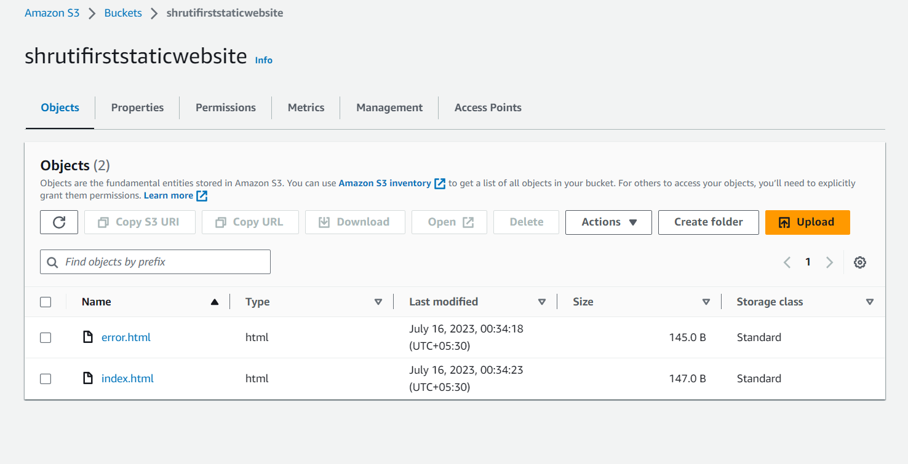

* Now for enable static website hosting go on properties tab and scroll down to the static website hosting and click on edit button then in the dialog box check options as shown below in the image and click on save changes.

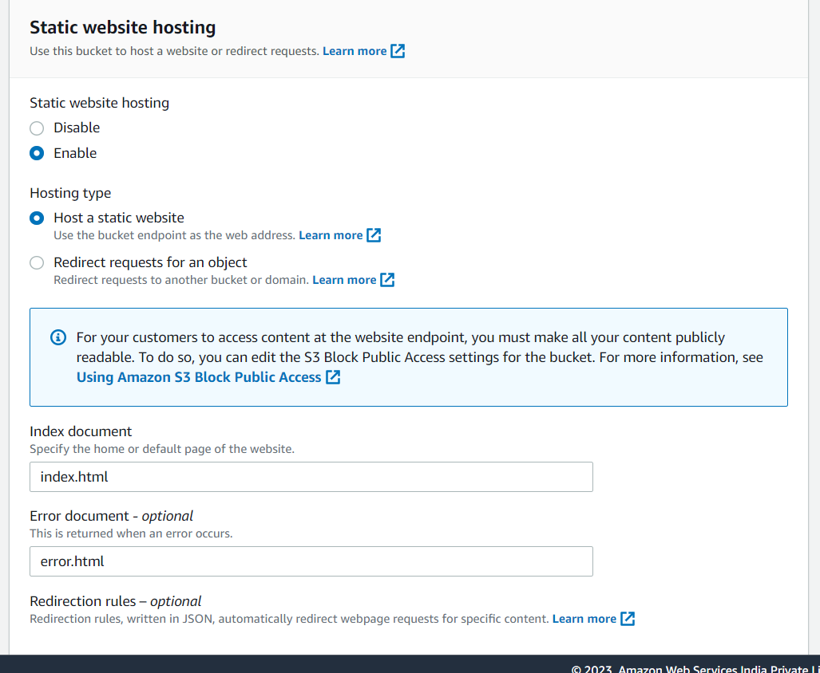

* In the permissions tab , click on the edit button beside the bucket policy and write policy as shown below in the image (in resource option write ARN of your bucket).

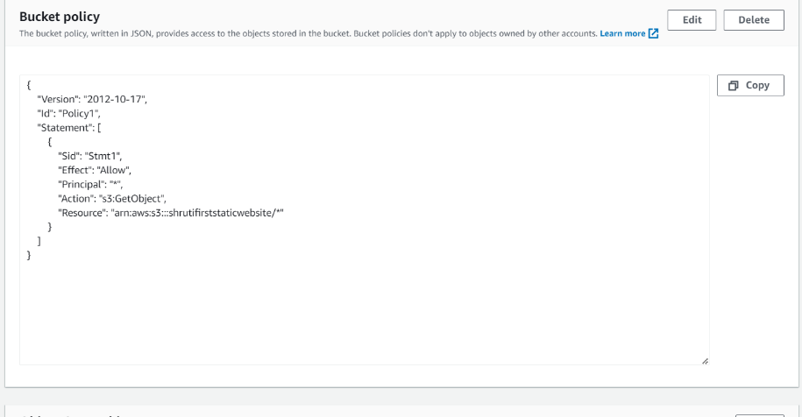

* Now copy your endpoint URL and start browsing it in your browser then you can find your (index.html) page.



* Now add some characters in your endpoint URL and start browsing it then you can find below page.

