|  |
| --- |
| AKS Gamers |
| 3D – FPP Simple Game |
| **[Assignment 3]** |
| Version #1.1  All work Copyright © 2015 by AKS Games.  All rights reserved. |
| **Shruti Kirti Kaushal** |
|  |



**Insempany Logo here**

|  |
| --- |
| November 21st 2015 |

Table of Contents

Version History 3

Game Report 4

Game Overview 4

Game Play Mechanics 4

Camera 4

Controls 4

Interface Sketch 4

Menu and Screen Descriptions 5

Characters 5

Enemies 6

Scoring 6

Puzzles 6

Sound Index 6

# Version History

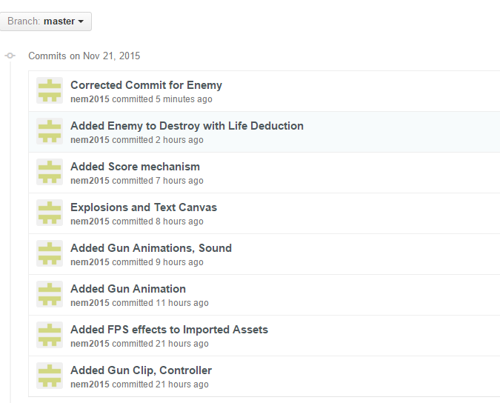

# Game Report

## Game Overview

*A simple 3D game which uses FPP for its functioning. The player is supposed to grab high scores by destroying objects, before he dies.*

## Game Play Mechanics

*The player aims at the cardboard boxes in order to shoot them. The player loses a life if it shoots the volcanic spheres that keeps moving on the platform. The volcanic collider changes its direction of motion if the touches it.*

## Camera

*First Person Perspective*

## Controls

*Left Ctrl or Left Mouse Button: Fire*

*Left Alt or Right Mouse Button: Aims at the point*

## Interface Sketch

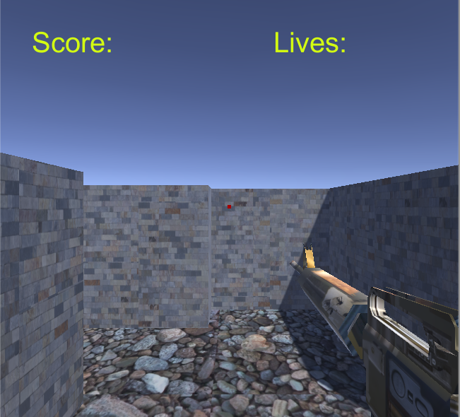

## Menu and Screen Descriptions

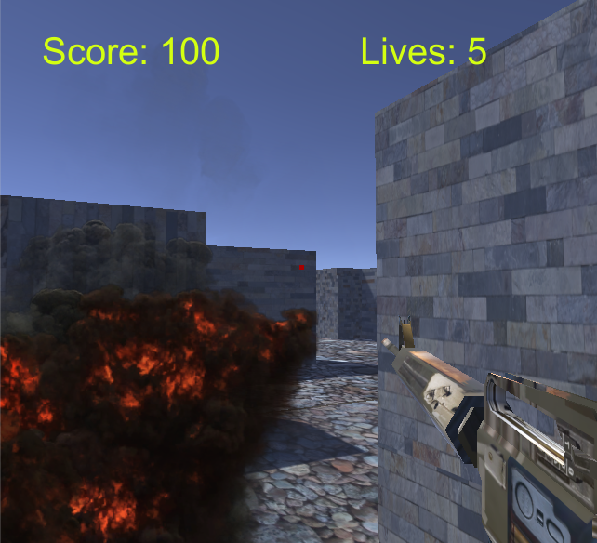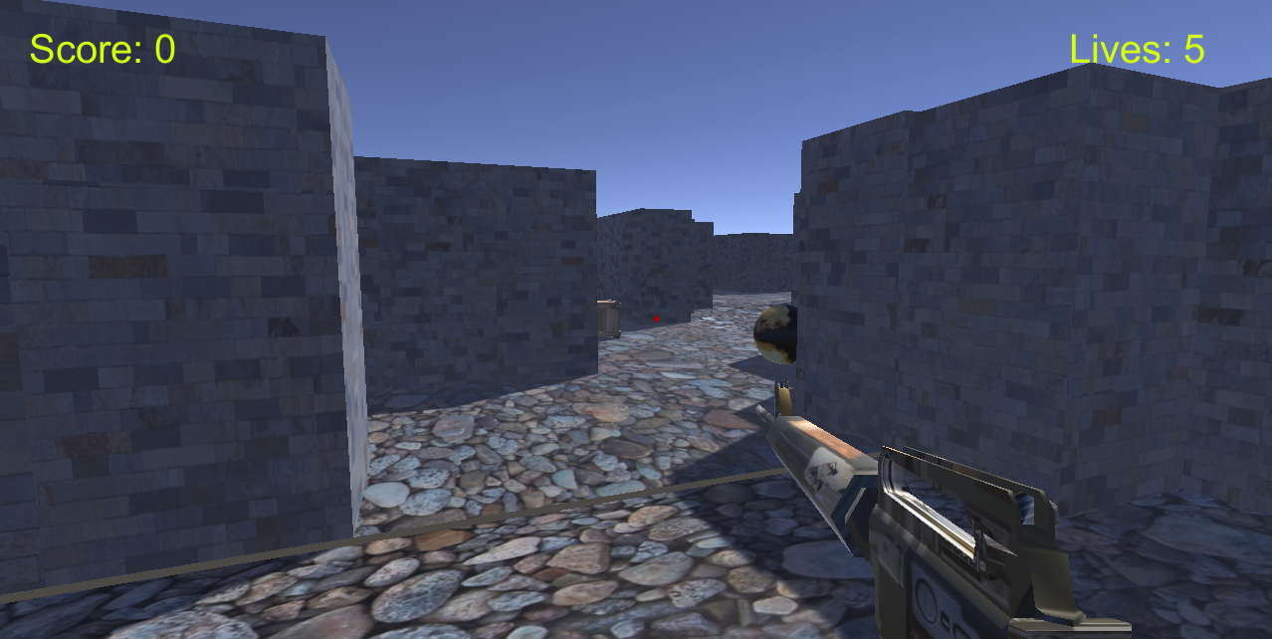

## Characters

*The Avatar is the Gun itself which has some special effects: particle effects when shot is fired, aim effects when left ctrl or right mouse is clicked to aim (represented by a red image in canvas).*

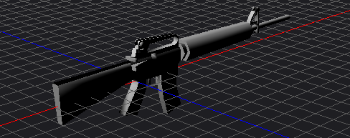

## Enemies

*Enemy is in the form of volcanic sphere which starts moving if collided with any object. You can only AVOID enemy, destroying enemy will result in volcanic explosion which will decrease the life of Player.*

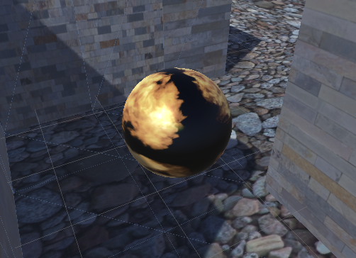

## Scoring

*When the player hits boxes, the score is increased by 100.*

## Puzzles

*The platform is maze itself which has destroyers and scoring boxes hidden at specific points.*

## Sound Index

* *Player Foot-step*
* *Brick Bullet Impact*
* *MK16 Rifle*