Name : Shruti Rajesh Kayande

BEFORE :

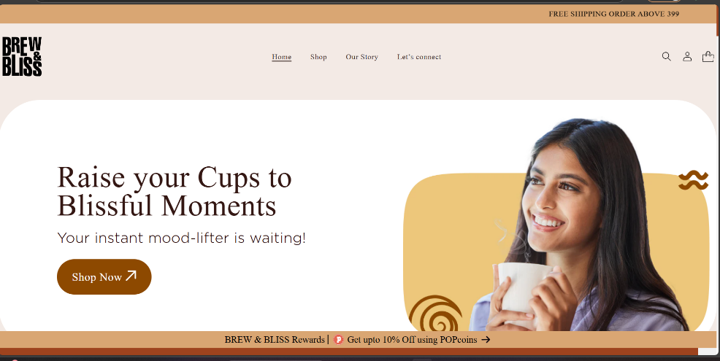

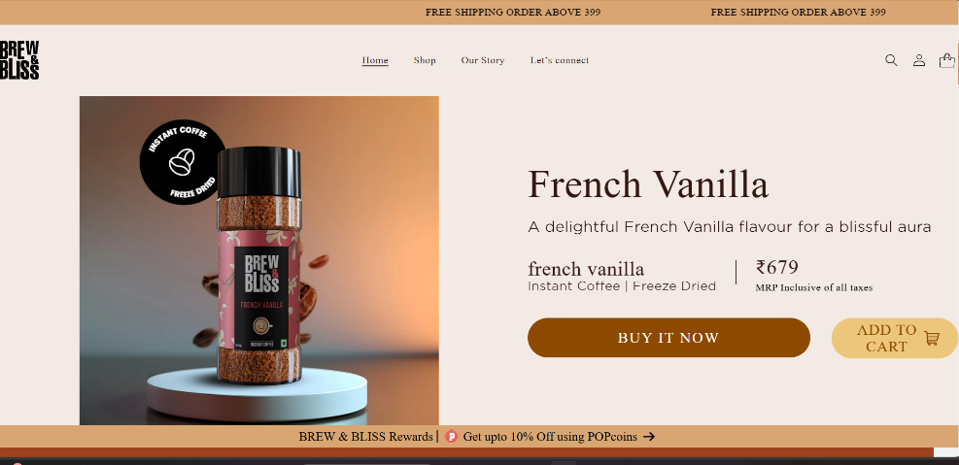

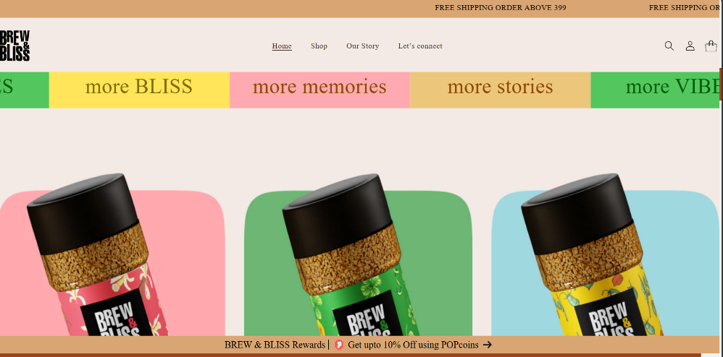

AFTER :

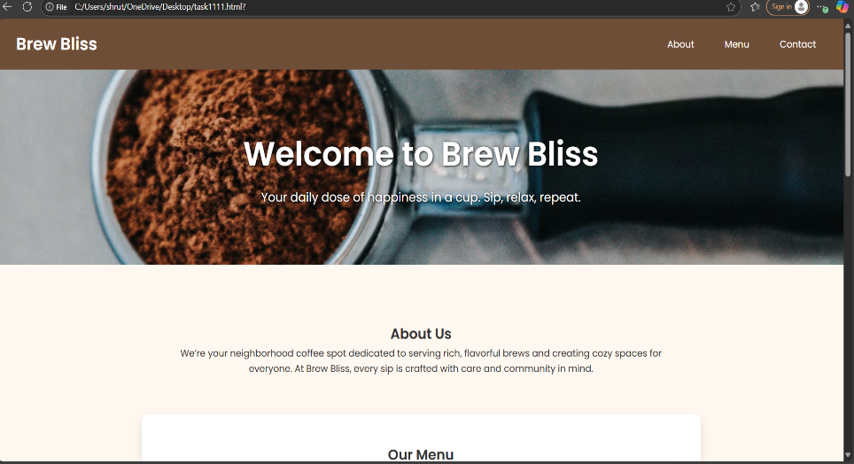

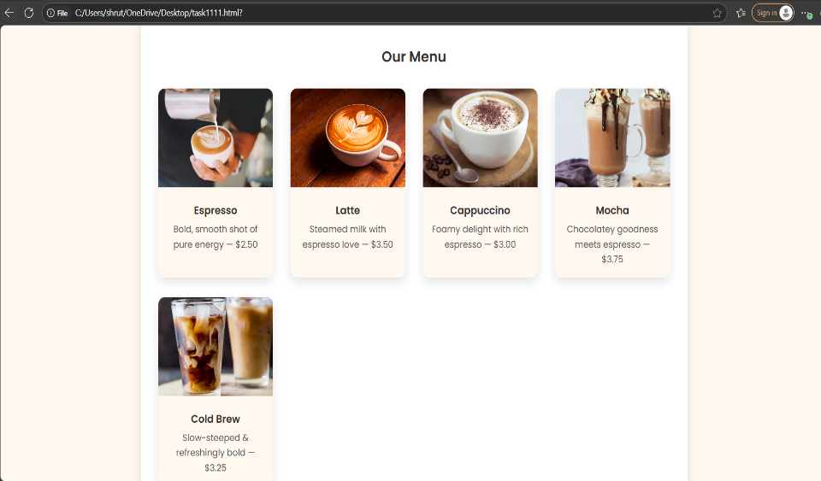

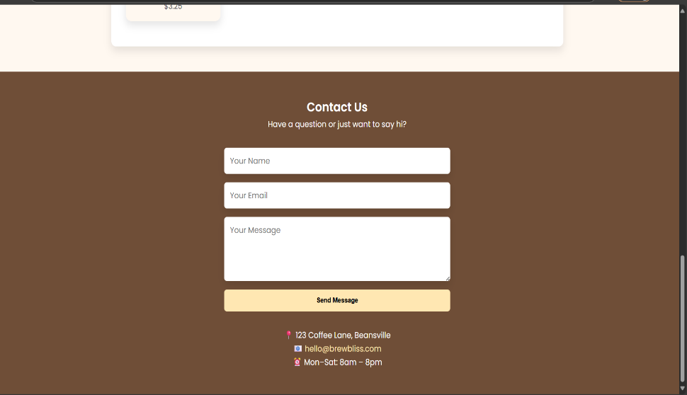

This coffee shop landing page is a fully responsive and visually appealing one-page website built using only HTML and CSS. It’s designed for a fictional café called Brew Bliss, and it provides a warm, welcoming feel through the use of soft colors, modern typography (Poppins from Google Fonts), and high-quality background and menu images sourced from Unsplash.

At the top, the navigation bar contains a logo and smooth-scroll links to different sections of the page. The nav items change subtly on hover for a more interactive experience.

The hero section is visually impactful, using a large background image of a cozy café and welcoming text to draw in users immediately. Below this, the About section gives a short but engaging description of the café’s mission and vibe.

The Menu section is a highlight of the page. It uses a CSS grid layout to display coffee items in styled cards, each with an image, title, and description. These cards have rounded corners, shadows, and hover animations to provide a smooth, professional feel.

The Contact section doubles as the footer and includes:

A simple contact form (Name, Email, Message)

Business address, email link, and open hours

Animations and transitions throughout (like fade-ins and hover effects) add polish without needing any JavaScript. The layout adapts gracefully to different screen sizes, so it looks great on desktops, tablets, and mobile devices.

🔧 Summary of Key Features:

✅ Clean layout with sections: Hero, About, Menu, Contact

✅ Mobile-first, responsive design using CSS Grid and Flexbox

✅ Image-rich coffee menu using real product images

✅ Contact form with styled inputs (no backend logic)

✅ Lightweight, fast-loading, and fully functional using just HTML + CSS

✅ Professional design suitable for real-world small businesses or portfolios

The enhanced landing page design introduces several improvements over a typical basic coffee shop website. While many existing sites use simple layouts with minimal styling, this version adopts a modern, responsive layout that adapts beautifully across devices. The typography is upgraded with the clean and stylish Google Font "Poppins," replacing default system fonts to give the site a more polished and professional feel. Visually, the site is much richer—featuring a large, welcoming hero section with a full-screen background image and engaging text that immediately sets the tone.

Unlike basic sites that often list menu items in plain text, this design presents each coffee item in a grid of image-based cards, each with subtle shadows, rounded corners, and hover effects, making the menu both informative and visually appealing. The navigation bar is sleek, responsive, and interactive, with button-like hover effects, improving usability. Color-wise, the site adopts a warm, café-inspired palette of browns, creams, and soft yellows, replacing the stark black-and-white scheme commonly seen on simpler pages. Animations and transitions—such as smooth fade-ins—add depth and motion without relying on JavaScript.

The contact section is also enhanced with a styled form and clear business details, encouraging user engagement, whereas basic websites typically show plain text. Overall, this upgraded version transforms a static, text-heavy site into an engaging, brand-focused experience that is visually inviting, user-friendly, and suitable for real businesses or portfolio use.

**PROGRAM:**

<!DOCTYPE html>

<html lang="en">

<head>

<meta charset="UTF-8" />

<meta name="viewport" content="width=device-width, initial-scale=1.0"/>

<title>BrewBliss Coffee</title>

<style>

/* Reset & Base */

* {

margin: 0;

padding: 0;

box-sizing: border-box;

}

body {

font-family: 'Segoe UI', sans-serif;

line-height: 1.6;

color: #333;

background-color: #fffaf5;

}

a {

text-decoration: none;

color: inherit;

}

.container {

width: 90%;

max-width: 1200px;

margin: auto;

}

/* Header */

header {

background-color: #3b2c2c;

color: #fff;

padding: 1.2rem 0;

box-shadow: 0 2px 6px rgba(0,0,0,0.1);

}

.logo {

font-size: 2rem;

font-weight: bold;

}

nav {

float: right;

}

nav ul {

list-style: none;

display: flex;

gap: 2rem;

}

nav a {

color: #fff;

font-weight: 500;

transition: color 0.3s ease;

}

nav a:hover {

color: #d3a675;

}

/* Hero Section */

.hero {

background-image: url('https://images.unsplash.com/photo-1511920170033-f8396924c348?auto=format&fit=crop&w=1500&q=80');

background-size: cover;

background-position: center;

color: #fff;

text-align: center;

padding: 8rem 1rem;

position: relative;

}

.hero::after {

content: '';

position: absolute;

top: 0; left: 0; right: 0; bottom: 0;

background-color: rgba(0,0,0,0.6);

z-index: 1;

}

.hero-content {

position: relative;

z-index: 2;

max-width: 700px;

margin: auto;

}

.hero h2 {

font-size: 3rem;

margin-bottom: 1rem;

}

.hero p {

font-size: 1.25rem;

margin-bottom: 2rem;

}

.btn {

display: inline-block;

background-color: #d3a675;

color: #fff;

padding: 0.8rem 1.8rem;

border-radius: 5px;

font-weight: bold;

transition: background-color 0.3s ease;

}

.btn:hover {

background-color: #b88958;

}

/* Sections */

section {

padding: 5rem 1rem;

text-align: center;

}

h2.section-title {

font-size: 2.5rem;

margin-bottom: 2rem;

color: #4b2e2e;

}

/* Menu */

.menu-items {

display: grid;

grid-template-columns: repeat(auto-fit, minmax(250px, 1fr));

gap: 2rem;

margin-top: 2rem;

}

.menu-item {

background-color: #f9f5f1;

border-radius: 8px;

box-shadow: 0 4px 12px rgba(0,0,0,0.08);

padding: 1.5rem;

transition: transform 0.3s ease;

}

.menu-item:hover {

transform: translateY(-5px);

}

.menu-item img {

width: 100%;

border-radius: 8px;

margin-bottom: 1rem;

}

.menu-item h3 {

margin-bottom: 0.5rem;

color: #6b3e3e;

}

/* About */

.about-section {

background-color: #f3ece7;

}

.about-section p {

max-width: 700px;

margin: auto;

font-size: 1.1rem;

}

/* Contact */

.contact-section p {

margin: 0.5rem 0;

}

/* Footer */

footer {

background-color: #3b2c2c;

color: #fff;

text-align: center;

padding: 1.5rem 1rem;

margin-top: 2rem;

}

@media (max-width: 600px) {

nav {

float: none;

text-align: center;

margin-top: 1rem;

}

nav ul {

flex-direction: column;

gap: 1rem;

}

}

</style>

</head>

<body>

<header>

<div class="container">

<div style="display: flex; justify-content: space-between; align-items: center;">

<h1 class="logo">BrewBliss</h1>

<nav>

<ul>

<li><a href="#menu">Menu</a></li>

<li><a href="#about">About</a></li>

<li><a href="#contact">Contact</a></li>

</ul>

</nav>

</div>

</div>

</header>

<section class="hero">

<div class="hero-content">

<h2>Awaken Your Senses</h2>

<p>Delicious, handcrafted coffee brewed with passion and care.</p>

<a href="#menu" class="btn">Explore Menu</a>

</div>

</section>

<section id="menu">

<div class="container">

<h2 class="section-title">Our Menu</h2>

<div class="menu-items">

<div class="menu-item">

<img src="https://images.unsplash.com/photo-1511920170033-f8396924c348?auto=format&fit=crop&w=600&q=80" alt="Espresso">

<h3>Espresso</h3>

<p>Strong and bold single shot of espresso, perfect to kickstart your day.</p>

</div>

<div class="menu-item">

<img src="https://images.unsplash.com/photo-1523942839745-7848d4aaf8a7?auto=format&fit=crop&w=600&q=80" alt="Latte">

<h3>Latte</h3>

<p>Silky smooth espresso with steamed milk and light foam on top.</p>

</div>

<div class="menu-item">

<img src="https://images.unsplash.com/photo-1587733849037-0dfc5c27f841?auto=format&fit=crop&w=600&q=80" alt="Cappuccino">

<h3>Cappuccino</h3>

<p>Equal parts espresso, steamed milk, and foam — rich and creamy.</p>

</div>

<div class="menu-item">

<img src="https://images.unsplash.com/photo-1587825140708-dfaf72ae4b04?auto=format&fit=crop&w=600&q=80" alt="Cold Brew">

<h3>Cold Brew</h3>

<p>Slow-steeped, ultra-smooth cold brew served chilled and refreshing.</p>

</div>

</div>

</div>

</section>

<section id="about" class="about-section">

<div class="container">

<h2 class="section-title">About BrewBliss</h2>

<p>At BrewBliss, coffee isn't just a drink — it's an experience. We're committed to brewing high-quality, ethically sourced coffee in a warm and welcoming space. Come in for a cup, stay for the community.</p>

</div>

</section>

<section id="contact" class="contact-section">

<div class="container">

<h2 class="section-title">Contact Us</h2>

<p><strong>Email:</strong> hello@brewbliss.com</p>

<p><strong>Phone:</strong> (123) 456-7890</p>

<p><strong>Visit Us:</strong> 123 Bean Street, Roastville, USA</p>

</div>

</section>

<footer>

<div class="container">

<p>&copy; 2025 BrewBliss. All rights reserved.</p>

</div>

</footer>

</body>

</html>