SQL Queries and Their Outcomes

This document contains SQL queries and their respective outcomes based on the dataset 'Retail_with_categories.csv'.

# Query 1

SQL:

SELECT * FROM enhanced_retail_transactions_dataset LIMIT 10;

Output:

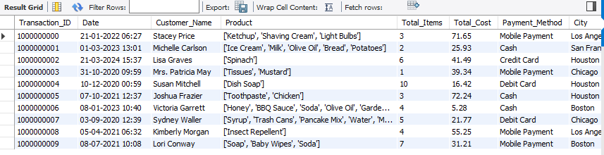

# Query 2

SQL:

SELECT

SUM(CASE WHEN Transaction_ID IS NULL THEN 1 ELSE 0 END) AS null_Transaction_ID,

SUM(CASE WHEN Date IS NULL THEN 1 ELSE 0 END) AS null_Date,

SUM(CASE WHEN Customer_Name IS NULL THEN 1 ELSE 0 END) AS null_Customer_Name,

SUM(CASE WHEN Product IS NULL THEN 1 ELSE 0 END) AS null_Product,

SUM(CASE WHEN Profit IS NULL THEN 1 ELSE 0 END) AS null_Profit,

SUM(CASE WHEN Product_Category IS NULL THEN 1 ELSE 0 END) AS null_Product_Category

FROM enhanced_retail_transactions_dataset;

Output:

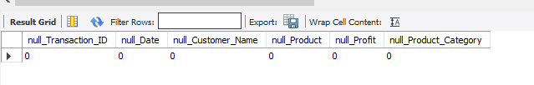

# Query 3

SQL:

SELECT DISTINCT Product_Category FROM enhanced_retail_transactions_dataset;

Output:

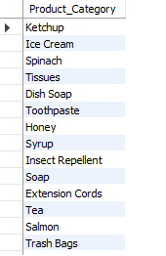

# Query 4

SQL:

CREATE VIEW retail_with_categories AS

SELECT *,

CASE

WHEN Product_Category IN ('Ketchup', 'Mustard', 'BBQ Sauce', 'Mayonnaise') THEN 'Condiments'

WHEN Product_Category IN ('Ice Cream', 'Yogurt', 'Cheese', 'Butter') THEN 'Dairy'

WHEN Product_Category IN ('Spinach', 'Tomatoes', 'Potatoes', 'Carrots', 'Onions') THEN 'Vegetables'

WHEN Product_Category IN ('Banana', 'Apple', 'Orange') THEN 'Fruits'

WHEN Product_Category IN ('Cereal', 'Cereal Bars', 'Pancake Mix', 'Bread', 'Pasta', 'Rice') THEN 'Grains & Bakery'

WHEN Product_Category IN ('Salmon', 'Shrimp', 'Tuna', 'Beef', 'Chicken', 'Eggs') THEN 'Meat & Seafood'

WHEN Product_Category IN ('Tea', 'Coffee') THEN 'Beverages'

WHEN Product_Category IN ('Soda', 'Chips', 'Jam', 'Pickles', 'Peanut Butter', 'Honey', 'Syrup', 'Olive Oil', 'Vinegar', 'Canned Soup') THEN 'Pantry & Snacks'

WHEN Product_Category IN ('Toothpaste', 'Toothbrush', 'Shampoo', 'Shaving Cream', 'Deodorant', 'Feminine Hygiene Products', 'Hair Gel', 'Soap', 'Shower Gel') THEN 'Personal Care'

WHEN Product_Category IN ('Laundry Detergent', 'Dish Soap', 'Cleaning Spray', 'Sponges', 'Tissues', 'Paper Towels', 'Trash Bags', 'Toilet Paper', 'Cleaning Rags') THEN 'Cleaning Supplies'

WHEN Product_Category IN ('Vacuum Cleaner', 'Iron', 'Ironing Board', 'Extension Cords', 'Power Strips', 'Light Bulbs') THEN 'Household Electronics'

WHEN Product_Category IN ('Mop', 'Broom', 'Dustpan', 'Trash Cans') THEN 'Cleaning Equipment'

WHEN Product_Category IN ('Lawn Mower', 'Garden Hose', 'Plant Fertilizer') THEN 'Garden Tools'

WHEN Product_Category IN ('Diapers', 'Baby Wipes') THEN 'Baby Care'

WHEN Product_Category IN ('Air Freshener', 'Bath Towels', 'Hand Sanitizer') THEN 'Home & Misc'

ELSE 'Other'

END AS Category,

Product_Category AS Sub_Category

FROM enhanced_retail_transactions_dataset;

Output:

Whole table

# Query 5

SQL:

select * from retail_with_categories;

Output:

Error executing query: "Column(s) ['UnitPrice'] do not exist"

# Query 6

SQL:

select DISTINCT Category from retail_with_categories;

Output:

# 

# Query 7

SQL:

select DISTINCT Sub_Category from retail_with_categories;

Output:

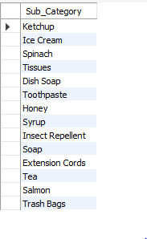

# Query 8

SQL:

SELECT

Category,

Sub_Category,

COUNT(*) AS total_transactions,

SUM(Total_Cost) AS total_sales,

SUM(Profit) AS total_profit,

ROUND(SUM(Profit) / SUM(Total_Cost) * 100, 2) AS profit_margin_percent

FROM retail_with_categories

GROUP BY Category, Sub_Category

ORDER BY profit_margin_percent ASC;

Output:

