DBMS Assignment

Table employee:

create table `employee`(

`employee_name` varchar(20),

`city` varchar(10),

`street` varchar(10),

primary key(`employee_name`));

insert into employee values('Neena','Banglore',10);

insert into employee values('Shanta','Hyderabad',6);

insert into employee values('Raman','Dehli',12);

insert into employee values('Dravid','Banglore',4);

insert into employee values('julia','Dehli',7);

insert into employee values('Hermann','Banglore',12);

insert into employee values('Sarah','Mumbai',10);

insert into employee values('Kevin','Hydrabad',6);

insert into employee values('Nandita','Dehli',7);

insert into employee values('Robin','Banglore',12);

create table `company`(

`company_name` varchar(20),

`city` varchar(10),

primary key(`company_name`,`city`));

create table `works`(

`employee_name` varchar(20),

`company_name` varchar(20),

`salary` int(5),

primary key(`employee_name`,`company_name`),

constraint fk1 foreign key(`employee_name`) references `employee`(`employee_name`),

constraint fk2 foreign key(`company_name`) references `company`(`company_name`));

create table `manages`(

`employee_name` varchar(20),

`manager_name` varchar(20),

primary key(`employee_name`,`manager_name`),

constraint fk3 foreign key(`employee_name`) references `employee`(`employee_name`),

constraint fk4 foreign key(`manager_name`) references `employee`(`employee_name`));

insert into company values('ABCNetworks','Hydrabad');

insert into company values('FirstBankCrop','Dehli');

insert into company values('XYZSystem','Banglore');

insert into company values('ABCNetworks','Banglore');

insert into company values('XYZSystem','Mumbai');

insert into company values('SmallBankCorp','Dehli');

insert into `works` values ('Neena','ABCNetworks','35000');

insert into `works` values ('Shanta','ABCNetworks','40000');

insert into `works` values ('Raman','FirstBankCrop','60000');

insert into `works` values ('Dravid','XYZSystem','35000');

insert into `works` values ('Julia','FirstBankCrop','60000');

insert into `works` values ('Hermann','XYZSystem','35000');

insert into `works`values ('Sarah','XYZSystem','45000');

insert into `works` values ('Kevin','ABCNetworks','60000');

insert into `works` values ('Nandita','FirstBankCrop','80000');

insert into `works` values ('Robin','XYZSystem','70000');

insert into manages values('Neena','Kevin');

insert into manages values('Shanta','Kevin');

insert into manages values('Raman','Nandita');

insert into manages values('Dravid','Robin');

insert into manages values('Julia','Nandita');

insert into manages values('Hermann','Robin');

insert into manages values('Sarah','Robin');

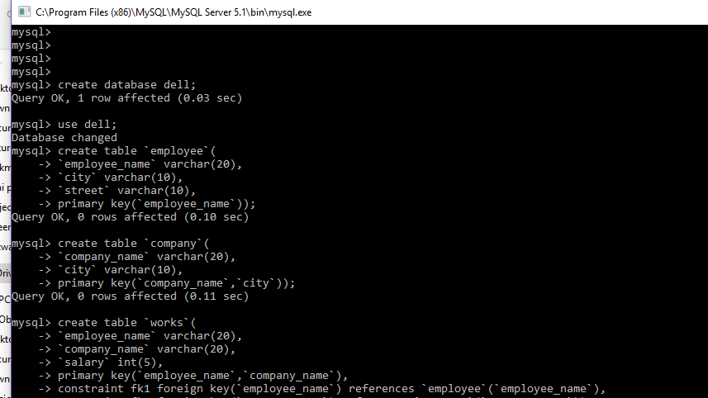

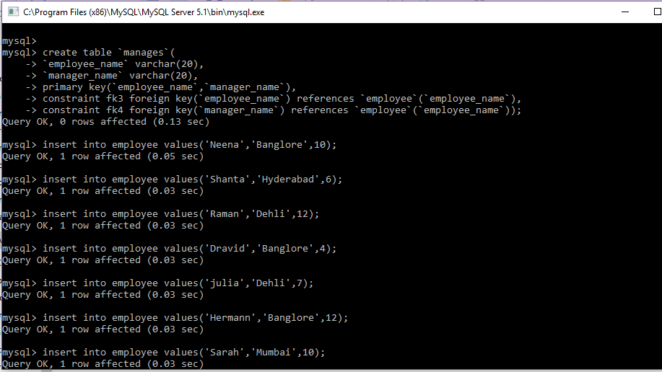

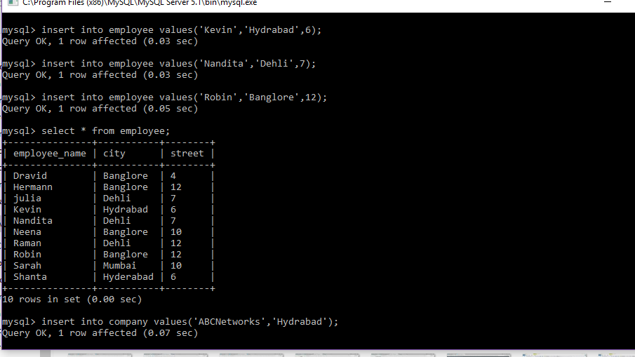

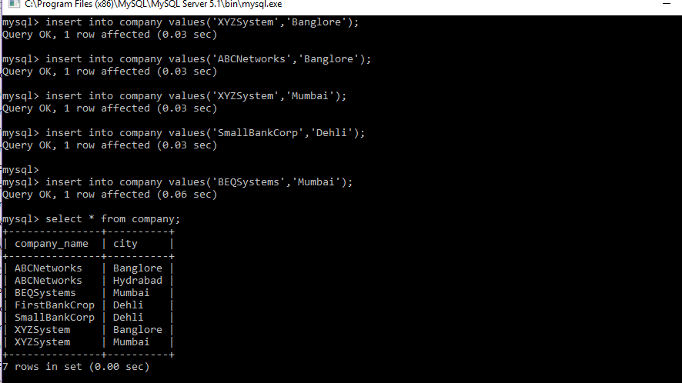

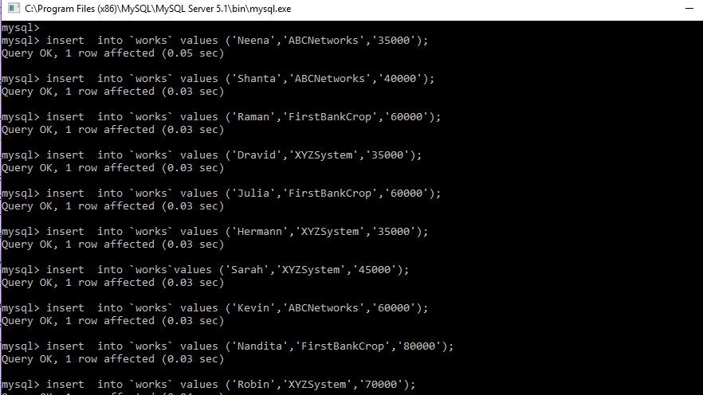

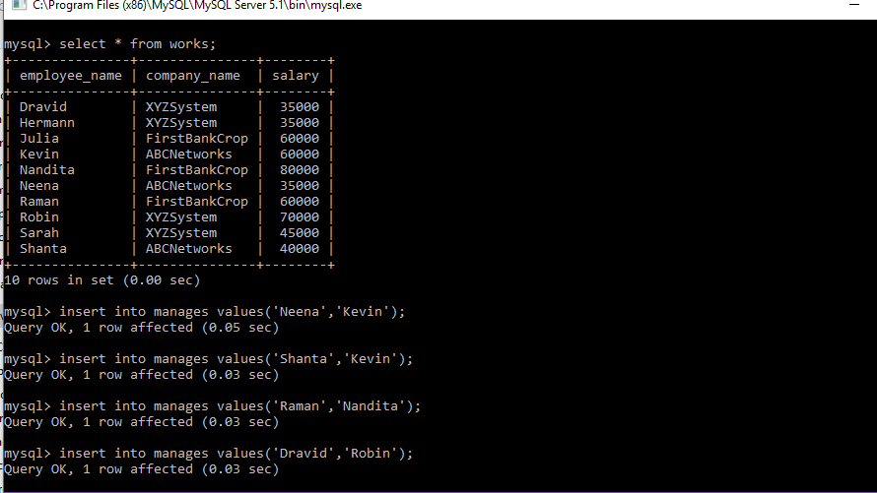

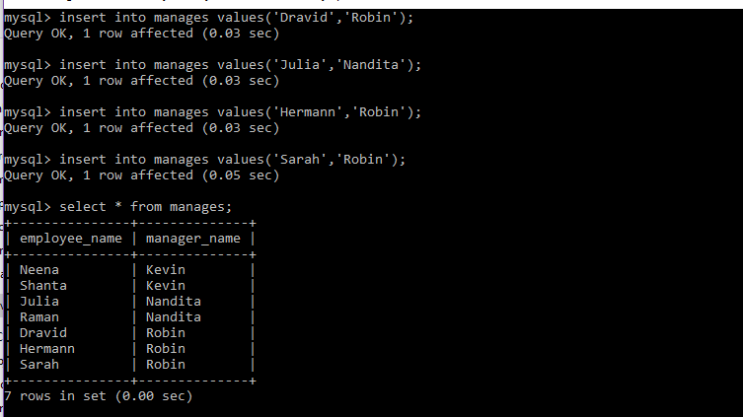

1.select e.employee_name,e.street,e.city

from employee e,works w,company c

where w.company_name="FirstBankCrop" and e.employee_name=w.employee_name;

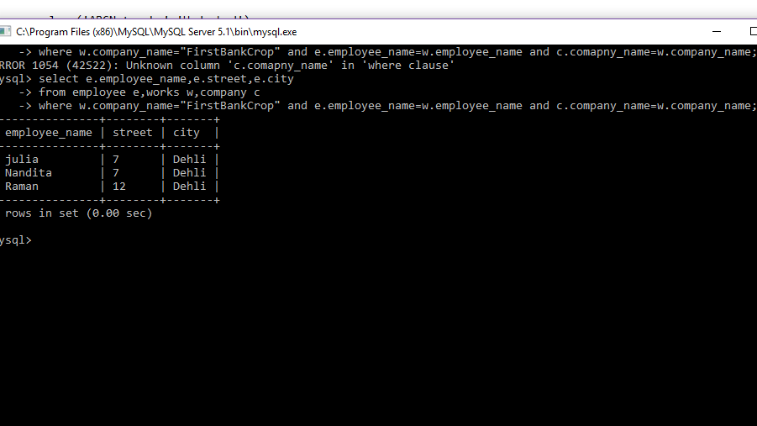

2.select e.employee_name,e.street,e.city

from employee e,works w

where w.salary="40000" and e.employee_name=w.employee_name;

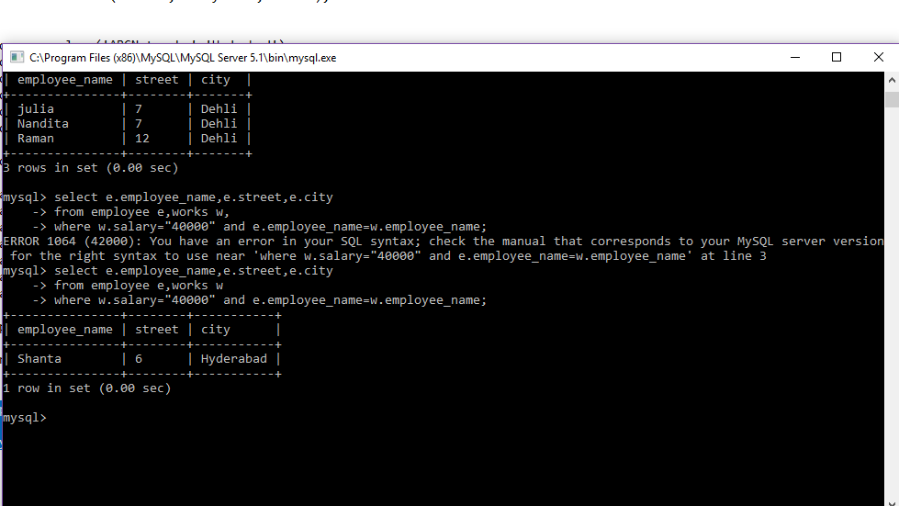

3.select distinct (employee_name)

from employee e,company c

where c.city=e.city;

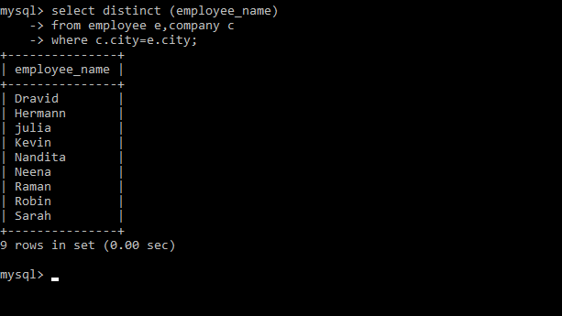

4.select e.employee_name

from employee e,employee r,manages m

where e.employee_name=m.employee_name and m.manager_name=r.employee_name and e.street=r.street and e.city=r.city;

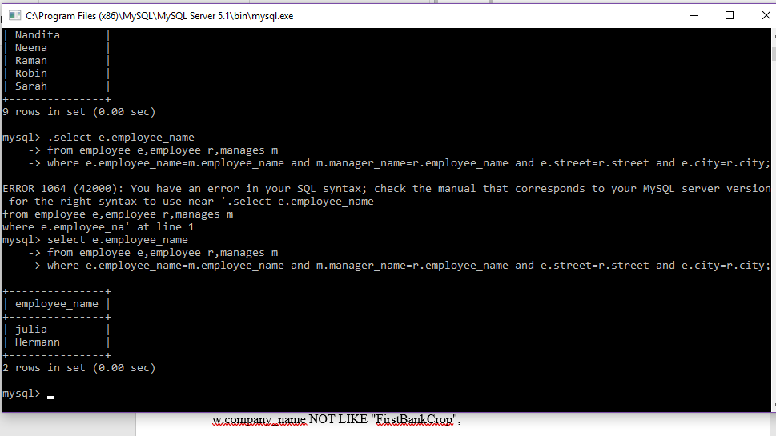

5.select distinct(e.employee_name)

from employee e,works w,company c

where e.employee_name=w.employee_name and w.company_name=c.company_name and w.company_name NOT LIKE "FirstBankCrop";

6.select avg(salary)

from works w

where w.company_name="XYZSystem";

7.select employee_name

from works w

where salary>all(select avg(salary)

from works);

8.select employee_name

from works w

where w.company_name NOT LIKE "ABCNetworks";

9.select employee_name,city,street

from employee e

ORDER BY e.employee_name desc;

10.select employee_name,salary

from works w

ORDER BY w.salary;

11.select count(employee_name)

from works w

where company_name="XYZSystem";

12.select e.employee_name,w.salary,w.salary*12

from employee e,works w

where w.salary in(select s.salary

from works s);

13:select min(salary),max(salary)

from employee e,works w

where e.employee_name=w.employee_name;

14:select c.company_name

from company c

where not exists

((select city

from company

where company_name="XYZSystem")

except

(select city

from company t

where c.company_name=t.company_name));

15.select w.company_name,count(employee_name)

from works w

where company_name=all(select c.company_name from

company c);

16.select company_name

from company

group by(city);

17.select count(employee_name)

from manages;

18.select e.employee_name

from employee e

where e.city="Bangalore" OR e.city="Hyderabad";

19.select employee_name

from employee

where employee_name LIKE "R%";

20.

select distinct(city)

from company;

21.select employee_name,manager_name

from manages

order by(employee_name);

22.update works

set salary=5000

where employee_name="Neena";

23.insert into company(company_name,city)VALUES('SmallBankCrop',"Mumbai");

24.ALTER TABLE manages ADD department VARCHAR(60);

25.drop table tablename;

RESULT

mysql>

mysql> use dell;

Database changed

5. mysql> select distinct(e.employee_name)

-> from employee e,works w,company c

-> where e.employee_name=w.employee_name and w.company_name=c.company_name and w.company_name NOT LIKE "FirstBankCrop";

+---------------+

| employee_name |

+---------------+

| Kevin |

| Neena |

| Shanta |

| Dravid |

| Hermann |

| Robin |

| Sarah |

+---------------+

7 rows in set (0.00 sec)

6. mysql> select avg(salary)

-> from works w

-> where w.company_name="XYZSystem";

+-------------+

| avg(salary) |

+-------------+

| 46250.0000 |

+-------------+

1 row in set (0.00 sec)

7. mysql> select employee_name

-> from works w

-> where salary>all(select avg(salary)

-> from works);

+---------------+

| employee_name |

+---------------+

| Julia |

| Kevin |

| Nandita |

| Raman |

| Robin |

+---------------+

5 rows in set (0.00 sec)

8. mysql> select employee_name

-> from works w

-> where w.company_name NOT LIKE "ABCNetworks";

+---------------+

| employee_name |

+---------------+

| Julia |

| Nandita |

| Raman |

| Dravid |

| Hermann |

| Robin |

| Sarah |

+---------------+

7 rows in set (0.00 sec)

9.mysql> select employee_name,city,street

-> from employee e

-> ORDER BY e.employee_name desc;

+---------------+-----------+--------+

| employee_name | city | street |

+---------------+-----------+--------+

| Shanta | Hyderabad | 6 |

| Sarah | Mumbai | 10 |

| Robin | Banglore | 12 |

| Raman | Dehli | 12 |

| Neena | Banglore | 10 |

| Nandita | Dehli | 7 |

| Kevin | Hydrabad | 6 |

| julia | Dehli | 7 |

| Hermann | Banglore | 12 |

| Dravid | Banglore | 4 |

+---------------+-----------+--------+

10 rows in set (0.00 sec)

10. mysql> select employee_name,salary

-> from works w

-> ORDER BY w.salary;

+---------------+--------+

| employee_name | salary |

+---------------+--------+

| Dravid | 35000 |

| Neena | 35000 |

| Hermann | 35000 |

| Shanta | 40000 |

| Sarah | 45000 |

| Julia | 60000 |

| Kevin | 60000 |

| Raman | 60000 |

| Robin | 70000 |

| Nandita | 80000 |

+---------------+--------+

10 rows in set (0.00 sec)

11.mysql> select count(employee_name)

-> from works w

-> where company_name="XYZSystem";

+----------------------+

| count(employee_name) |

+----------------------+

| 4 |

+----------------------+

1 row in set (0.00 sec)

13. mysql> select min(salary),max(salary)

-> from employee e,works w

-> where e.employee_name=w.employee_name;

+-------------+-------------+

| min(salary) | max(salary) |

+-------------+-------------+

| 35000 | 80000 |

+-------------+-------------+

1 row in set (0.00 sec)

15. mysql> select w.company_name,count(employee_name)

-> from works w

-> where company_name=all(select c.company_name from

-> company c);

+--------------+----------------------+

| company_name | count(employee_name) |

+--------------+----------------------+

| NULL | 0 |

+--------------+----------------------+

1 row in set (0.00 sec)

16. mysql> select company_name

-> from company

-> group by(city);

+---------------+

| company_name |

+---------------+

| ABCNetworks |

| FirstBankCrop |

| ABCNetworks |

| BEQSystems |

+---------------+

4 rows in set (0.00 sec)

17. mysql> select count(employee_name)

-> from manages;

+----------------------+

| count(employee_name) |

+----------------------+

| 7 |

+----------------------+

1 row in set (0.00 sec)

18. mysql> select e.employee_name

-> select e.employee_name

-> from employee e//doubt

-> where e.city="Bangalore" OR e.city="Hyderabad";

ERROR 1064 (42000): You have an error in your SQL syntax; check the manual that corresponds to your MySQL server version for the right syntax to use near 'select e.employee_name

from employee e//doubt

where e.city="Bangalore" OR e.cit' at line 2

mysql>

mysql>

mysql>

mysql>

19. mysql> select employee_name

-> from employee

-> where employee_name LIKE "R%";

+---------------+

| employee_name |

+---------------+

| Raman |

| Robin |

+---------------+

2 rows in set (0.00 sec)

20. mysql> select distinct(city)

-> from company;

+----------+

| city |

+----------+

| Banglore |

| Hydrabad |

| Mumbai |

| Dehli |

+----------+

4 rows in set (0.00 sec)

21. mysql> select employee_name,manager_name

-> from manages

-> order by(employee_name);

+---------------+--------------+

| employee_name | manager_name |

+---------------+--------------+

| Dravid | Robin |

| Hermann | Robin |

| Julia | Nandita |

| Neena | Kevin |

| Raman | Nandita |

| Sarah | Robin |

| Shanta | Kevin |

+---------------+--------------+

7 rows in set (0.00 sec)

22. mysql> update works

-> set salary=5000

-> where employee_name="Neena";

Query OK, 1 row affected (0.05 sec)

Rows matched: 1 Changed: 1 Warnings: 0

mysql> select * from works;

+---------------+---------------+--------+

| employee_name | company_name | salary |

+---------------+---------------+--------+

| Dravid | XYZSystem | 35000 |

| Hermann | XYZSystem | 35000 |

| Julia | FirstBankCrop | 60000 |

| Kevin | ABCNetworks | 60000 |

| Nandita | FirstBankCrop | 80000 |

| Neena | ABCNetworks | 5000 |

| Raman | FirstBankCrop | 60000 |

| Robin | XYZSystem | 70000 |

| Sarah | XYZSystem | 45000 |

| Shanta | ABCNetworks | 40000 |

+---------------+---------------+--------+

10 rows in set (0.00 sec)

23. mysql> insert into company(company_name,city)VALUES('SmallBankCrop',"Mumbai");

Query OK, 1 row affected (0.03 sec)

mysql> select * from company;

+---------------+----------+

| company_name | city |

+---------------+----------+

| ABCNetworks | Banglore |

| ABCNetworks | Hydrabad |

| BEQSystems | Mumbai |

| FirstBankCrop | Dehli |

| SmallBankCorp | Dehli |

| SmallBankCrop | Mumbai |

| XYZSystem | Banglore |

| XYZSystem | Mumbai |

+---------------+----------+

8 rows in set (0.00 sec)

24. mysql> ALTER TABLE manages ADD department VARCHAR(60);

Query OK, 7 rows affected (0.22 sec)

Records: 7 Duplicates: 0 Warnings: 0

mysql> select * from manages;

+---------------+--------------+------------+

| employee_name | manager_name | department |

+---------------+--------------+------------+

| Dravid | Robin | NULL |

| Hermann | Robin | NULL |

| Julia | Nandita | NULL |

| Neena | Kevin | NULL |

| Raman | Nandita | NULL |

| Sarah | Robin | NULL |

| Shanta | Kevin | NULL |