DATABASE TESTING DOCUMENTATION

Document Information:
Project Name: ClassicModels Database Testing
Database Name: classicmodels
Database Type: MySQL
Prepared By: Shruti Kumari Karna

Objective
To verify data integrity, consistency, accuracy, and CRUD operations in the classicmodels database using SQL queries.

Scope of Testing
1. Data Integrity, Consistency & Accuracy Testing
These scopes of testing verify the integrity, consistency and accuracy of data by executing SQL queries
- Validate primary key uniqueness
- Validate foreign key relationships
- Check duplicate records
- Validate null constraints
2. Proper Data Manipulation Testing (CRUD Testing)
These scopes of testing verify the proper data manipulation by executing SQL queries
- Validate Create operation
- Validate Insert operation
- Validate Update operation
- Validate Delete operation

Test Environment
- OS: Windows 11
- Tool Used: MySQL Workbench
- DB Version: 8.0
- Server: Localhost

Test Scenarios & Test Cases

TC01 - Validate Primary Key Uniqueness
Scenario: Ensure customerNumber is unique in customers table.
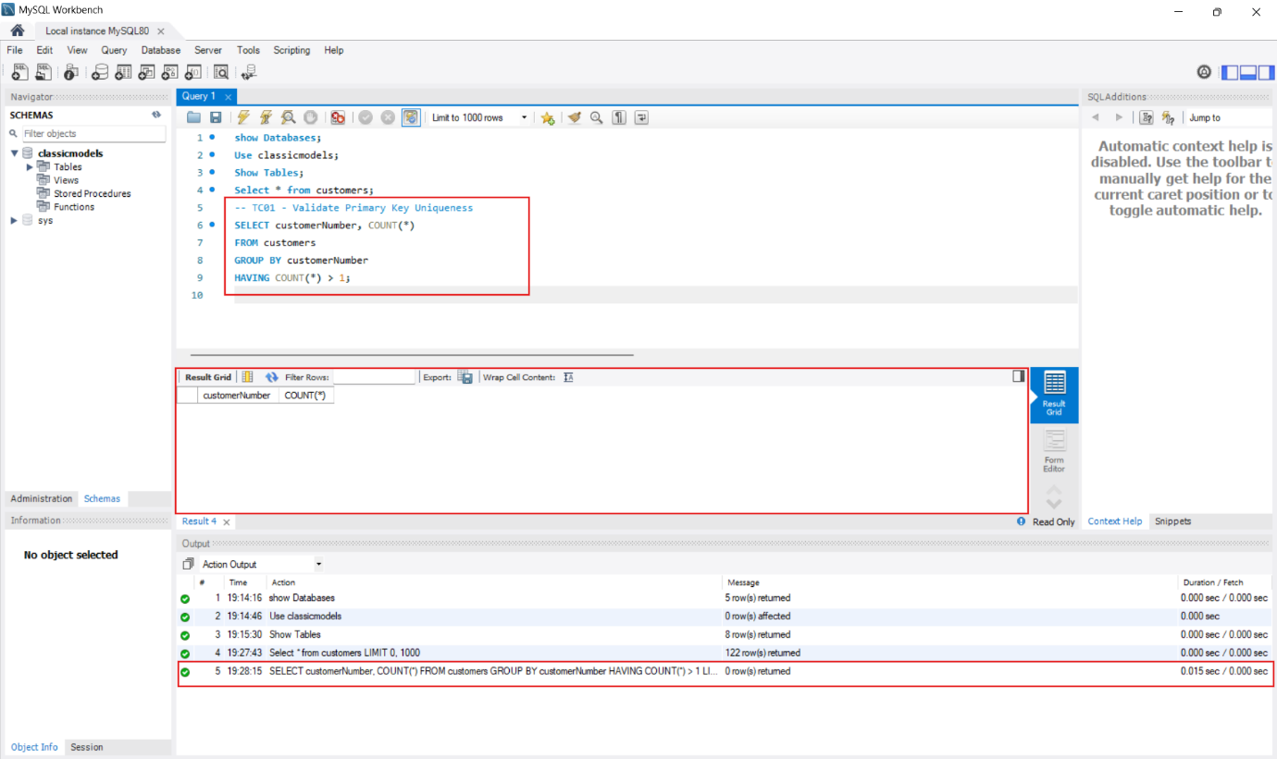
Expected Result: 0 records
Actual Result: 0 records
Status: Pass

TC02 - Check NULL Values in Required Field
Scenario: Verify customerName is not NULL in customers table
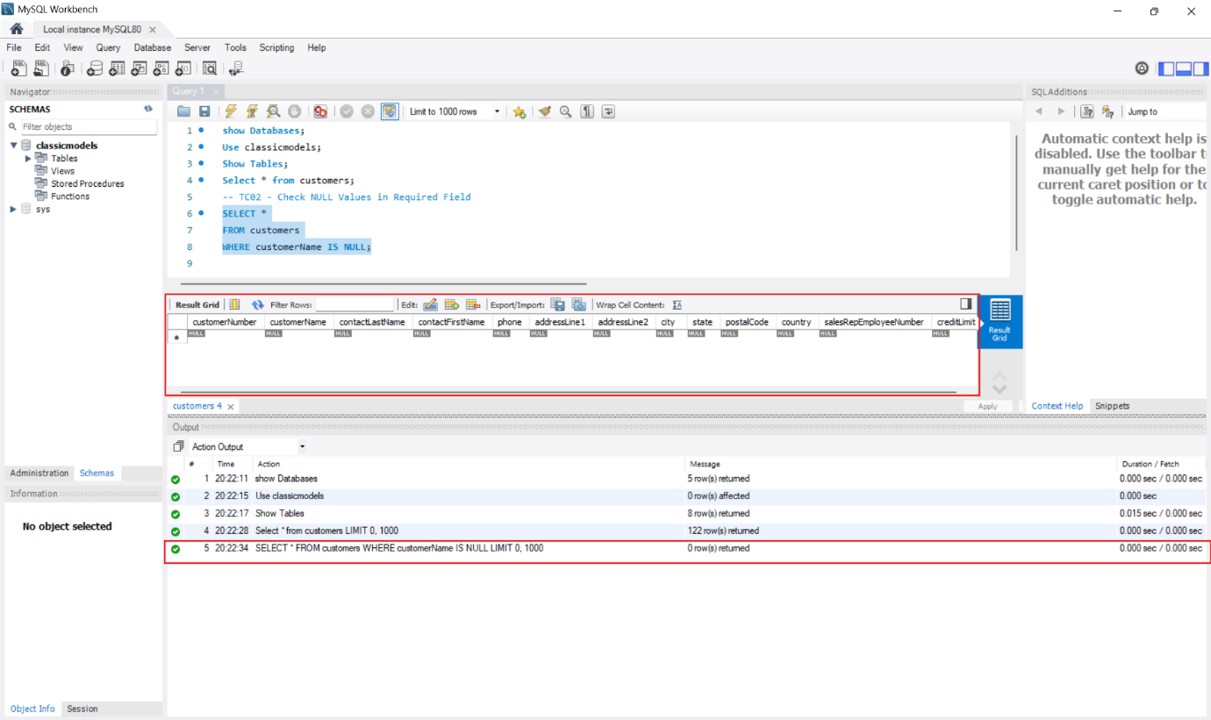
Expected Result: 0 records
Actual Result: 0 records
Status: Pass

TC03 - Verify Foreign Key Integrity (Orders and Customers) table
Scenario: Ensure every order has valid customerNumber
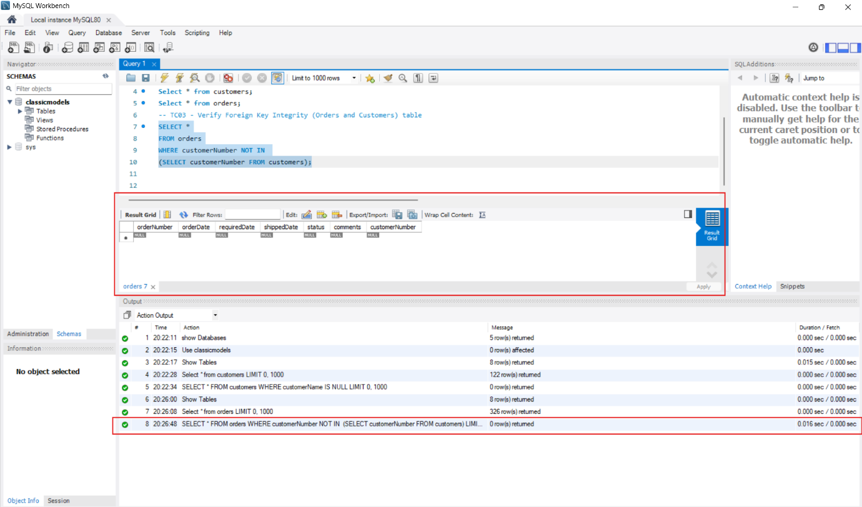
Expected Result: 0 records
Actual Result: 0 records
Status: Pass

TC04 - Check Duplicate Records
Scenario: Verify no duplicate primary key values in customers table.
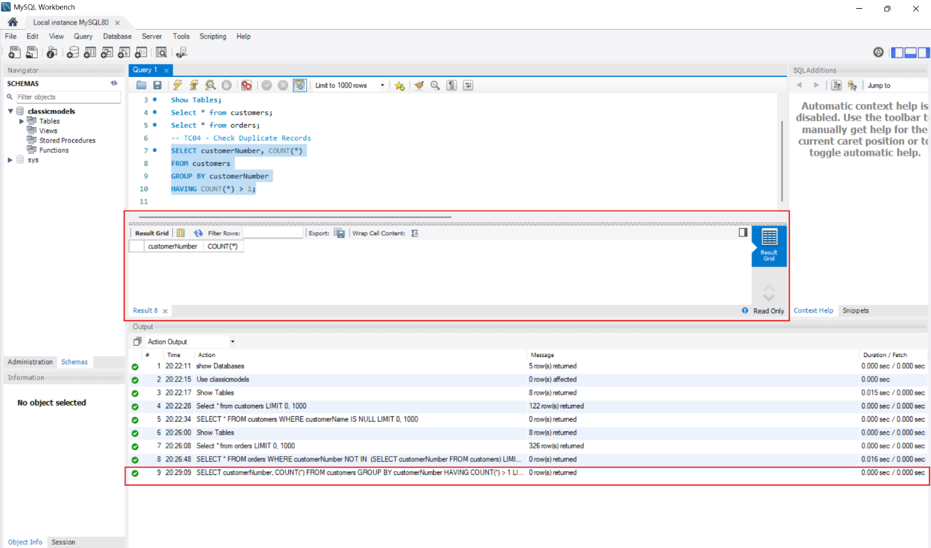
Expected Result: 0 duplicate records found
Actual Result: 0 duplicate records found
Status: Pass

TC05 - Verify Create Operation
Scenario: Ensure new table creation is successful
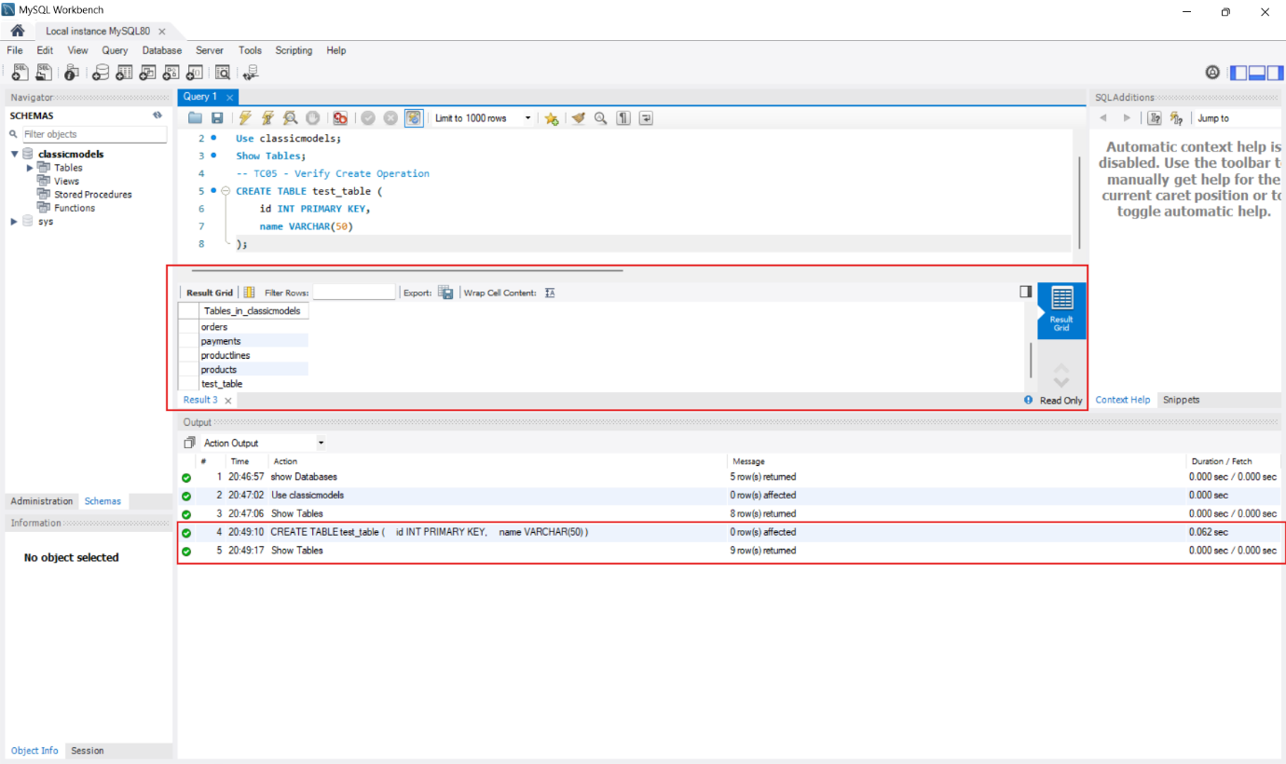
Expected Result: Table created successfully without errors
Actual Result: Table created successfully
Status: Pass

TC06 - Verify Insert Operation
Scenario: Ensure record is inserted correctly into test_table
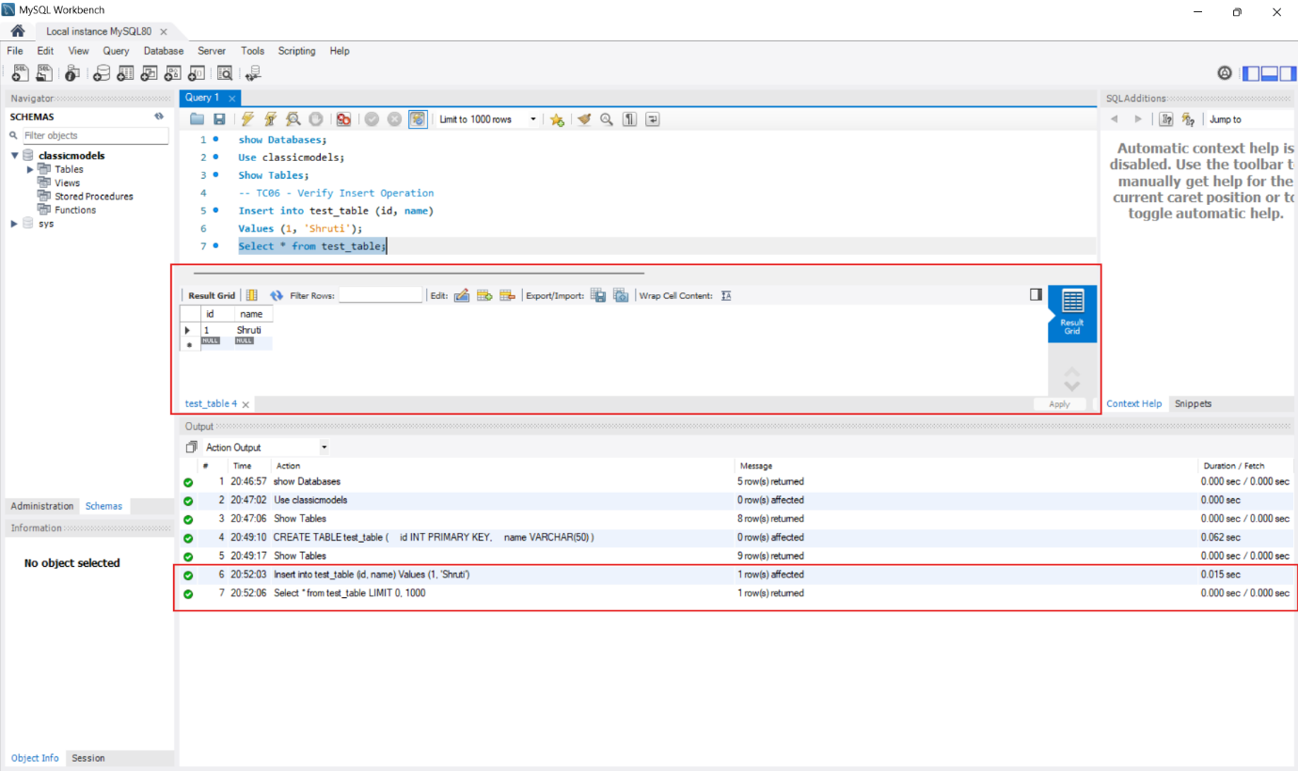
Expected Result: 1 record inserted successfully
Actual Result: 1 record inserted successfully
Status: Pass

TC07 - Verify Update Operation
Scenario: Ensure existing record is updated correctly
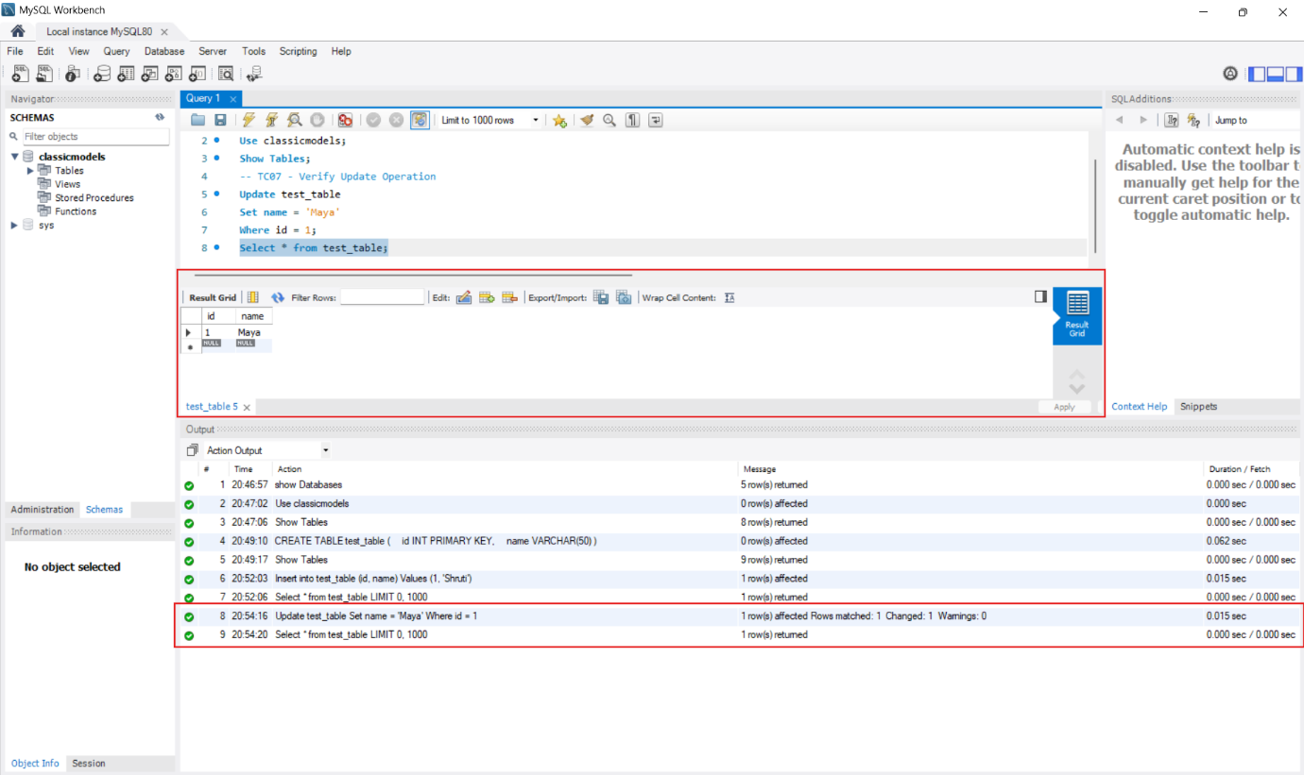
Expected Result: 1 record updated successfully
Actual Result: 1 record updated successfully
Status: Pass

TC08 - Verify Delete Operation
Scenario: Ensure record is deleted correctly
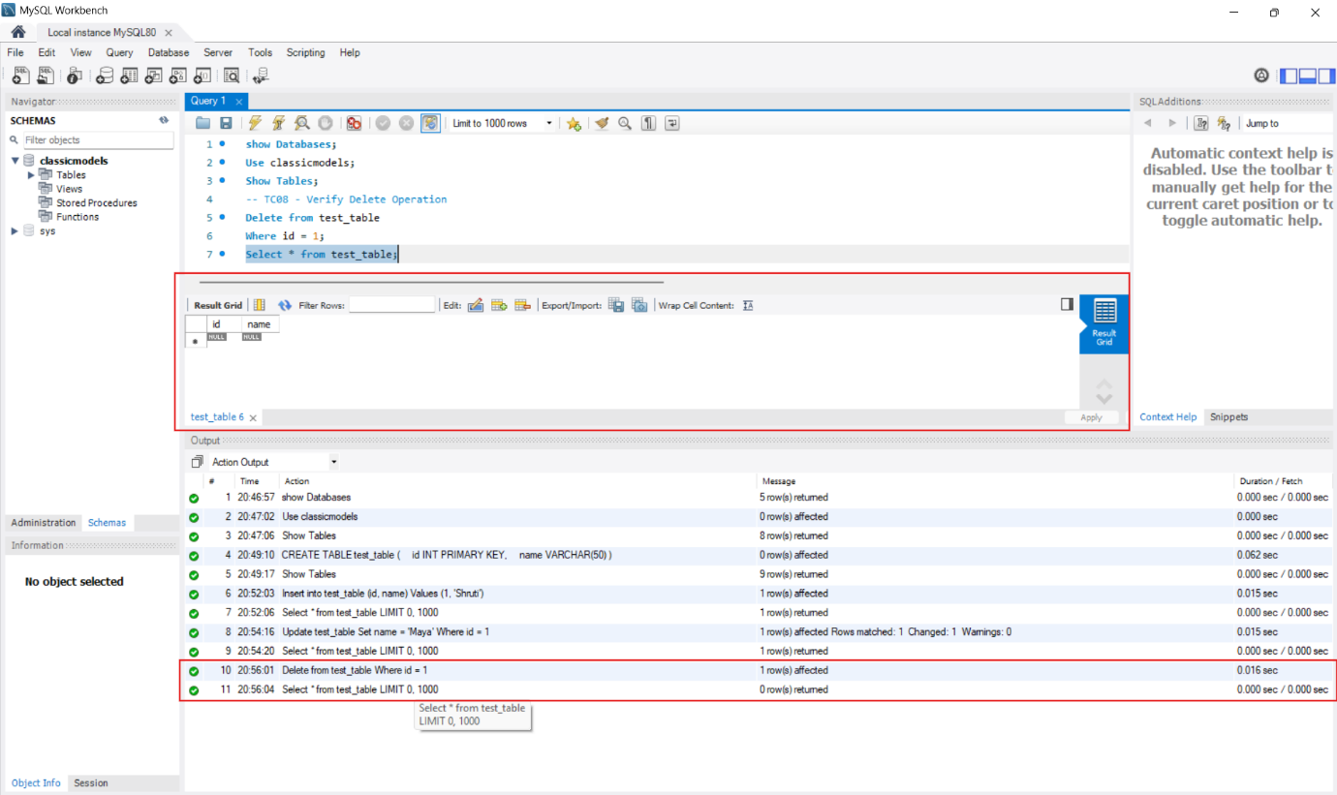
Expected Result: 1 record deleted successfully
Actual Result: 1 record deleted successfully
Status: Pass

Defect Summary Table

Total Test Case Execution | Pass | Fail | Total Defect
8 | 8 | 0 | 0
Database testing was carried out on the classicmodels database using MySQL Workbench. The test cases covered data integrity, consistency, accuracy, and CRUD operations. All SQL queries were executed and the results were verified. The expected results matched the actual results during testing. No defects were found. Based on the testing performed, the database constraints and data operations are working properly.

Conclusion
Database integrity, consistency, and CRUD operations were successfully validated in the classicmodels database. No critical issues were identified.

