1. Introduction
1.1 Project Title
End-to-End Time Series Forecasting System with REST API and Interactive Dashboard

1.2 Problem Statement
The objective of this project is to forecast the next 8 weeks of sales for different states using historical sales data. The system must handle missing data, capture seasonality and trends, compare multiple forecasting algorithms, automatically select the best model, and expose predictions through a REST API.

1.3 Project Objectives
The main objectives of this project are:
- Forecast future sales for multiple states
- Handle missing dates and missing values
- Capture trends and seasonality
- Implement multiple forecasting models
- Compare models using evaluation metrics
- Automatically select the best performing model
- Build a REST API for prediction serving
- Create an interactive forecasting dashboard
- Design the system like a production-ready backend service

2. System Architecture
2.1 Overall Workflow
Historical Data
↓
Data Cleaning & Preprocessing
↓
Feature Engineering
↓
Train-Validation Split
↓
Model Training
(SARIMA, Prophet, XGBoost, LSTM)
↓
Model Evaluation
↓
Best Model Selection
↓
Final Forecast Generation
↓
FastAPI REST API
↓
Streamlit Dashboard

3. Dataset Description
3.1 Dataset Source
The dataset was provided in Excel format and contains historical sales information for multiple states.

3.2 Dataset Features
Feature | Description
Date | Sales transaction date
State | State name
Sales | Total sales value

4. Data Preprocessing
4.1 Data Loading
The dataset was loaded using Pandas from the Excel file into a DataFrame for preprocessing and analysis.

4.2 Handling Missing Values
Missing values were identified using:
df.isnull().sum()
Strategies used:
- Missing sales values were handled using interpolation or forward filling.
- Missing dates were filled using continuous date generation.

4.3 Date Conversion
The Date column was converted into datetime format:
df['Date'] = pd.to_datetime(df['Date'])

4.4 Sorting Data
The dataset was sorted based on:
- State
- Date
This ensures correct time series ordering.

5. Exploratory Data Analysis (EDA)
5.1 Purpose of EDA
EDA was performed to:
- Understand sales distribution
- Detect trends
- Analyze seasonality
- Identify anomalies
- Understand state-wise sales behavior

5.2 Trend Analysis
Sales trends were visualized using line plots.
Key observations:
- Seasonal fluctuations were observed.
- Certain states showed strong upward sales trends.
- Weekly sales patterns were visible.

5.3 Seasonal Decomposition
Seasonality and trend components were analyzed using:
seasonal_decompose()
The decomposition included:
- Trend
- Seasonal component
- Residual component
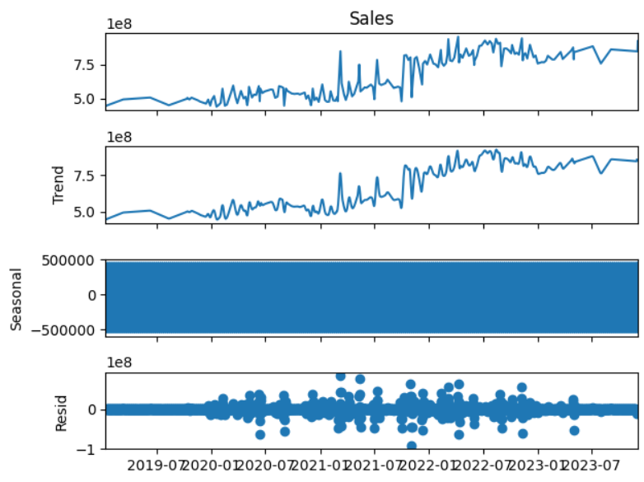

6. Feature Engineering
Feature engineering was one of the most important phases of the project.

6.1 Lag Features
Lag features help machine learning models learn past dependencies.
Created lag features:
Feature | Description
lag_1 | Previous day sales
lag_7 | Previous week sales
lag_30 | Previous month sales

6.2 Rolling Statistics
Rolling statistics help capture local trends and variability.
Features created:
Feature | Description
rolling_mean_7 | 7-day rolling average
rolling_mean_30 | 30-day rolling average
rolling_std_7 | 7-day rolling standard deviation

6.3 Date-Based Features
Date features were extracted from the Date column.
Features:
- day_of_week
- month
- quarter
- week_of_year
- year

6.4 Holiday Feature
A holiday flag feature was created to indicate whether a particular date is a holiday.
Feature | Description
is_holiday | 1 if holiday else 0

7. Train-Validation Split
7.1 Time Series Split Logic
Traditional random train-test split cannot be used in time series forecasting due to data leakage.
A chronological split was used:
Training Data → Past
Validation Data → Future
The final 56 days were used as validation data.

8. Forecasting Models
Multiple forecasting models were implemented and compared.

8.1 SARIMA Model
Description
SARIMA (Seasonal AutoRegressive Integrated Moving Average) is a statistical forecasting model that captures:
- Trend
- Seasonality
- Autocorrelation

Advantages
- Strong statistical foundation
- Effective for seasonal data
- Interpretable parameters

8.2 Facebook Prophet
Description
Prophet is a forecasting model developed by Meta for business forecasting.
It automatically handles:
- Seasonality
- Holidays
- Trend changes

Advantages
- Easy to use
- Robust to missing values
- Business-oriented forecasting

8.3 XGBoost Model
Description
XGBoost is a gradient boosting machine learning algorithm.
It uses engineered features such as:
- Lag features
- Rolling statistics
- Calendar features

Advantages
- High forecasting accuracy
- Handles non-linear relationships
- Excellent performance on tabular data

8.4 LSTM Model
Description
LSTM (Long Short-Term Memory) is a deep learning model designed for sequential data.
It learns temporal dependencies automatically.

Advantages
- Learns long-term dependencies
- Effective for sequence learning
- Captures complex temporal behavior

9. Model Evaluation
9.1 Evaluation Metrics
The following metrics were used:

MAE
$$MAE=\frac{1}{n}∑∣y_{i}-{\hat{y}}_{i}∣$$
Measures average absolute forecasting error.

RMSE
$$RMSE=\sqrt{\frac{1}{n}∑(y_{i}-{\hat{y}}_{i})^{2}}$$
Penalizes large forecasting errors.

MAPE
$$MAPE=\frac{100}{n}∑∣\frac{y_{i}-{\hat{y}}_{i}}{y_{i}}∣$$
Measures percentage forecasting error.

10. Model Comparison & Selection
All models were compared using RMSE.
The model with the lowest RMSE was automatically selected as the best forecasting model.
Example workflow:
Train Models
↓
Evaluate Models
↓
Compare RMSE
↓
Select Best Model
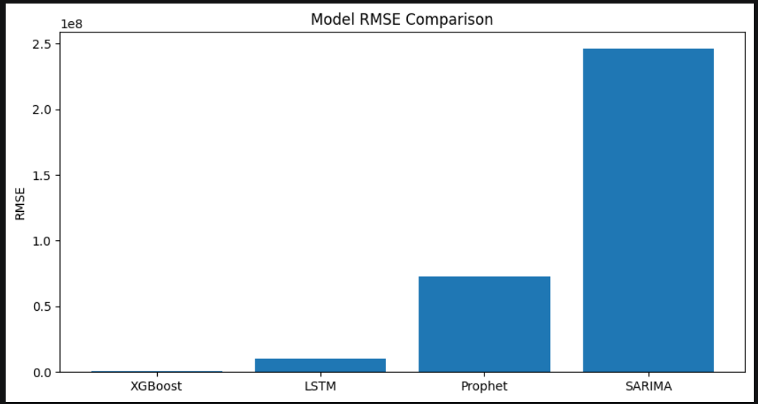

11. Final Forecast Generation
The best model was retrained on the complete dataset and used to generate forecasts for the next 56 days.
Forecast outputs included:
- Forecast dates
- Predicted sales values

12. FastAPI REST API
12.1 Purpose
The FastAPI backend was developed to expose forecasting predictions via REST endpoints.

12.2 API Endpoints
Endpoint | Method | Description
/ | GET | API health check
/model-info | GET | Returns model details
/forecast | POST | Returns sales forecast

12.3 Forecast API Response
Example:
{
"state": "California",
"forecast": [
{
"date": "2026-05-08",
"sales": 123456
}
]
}
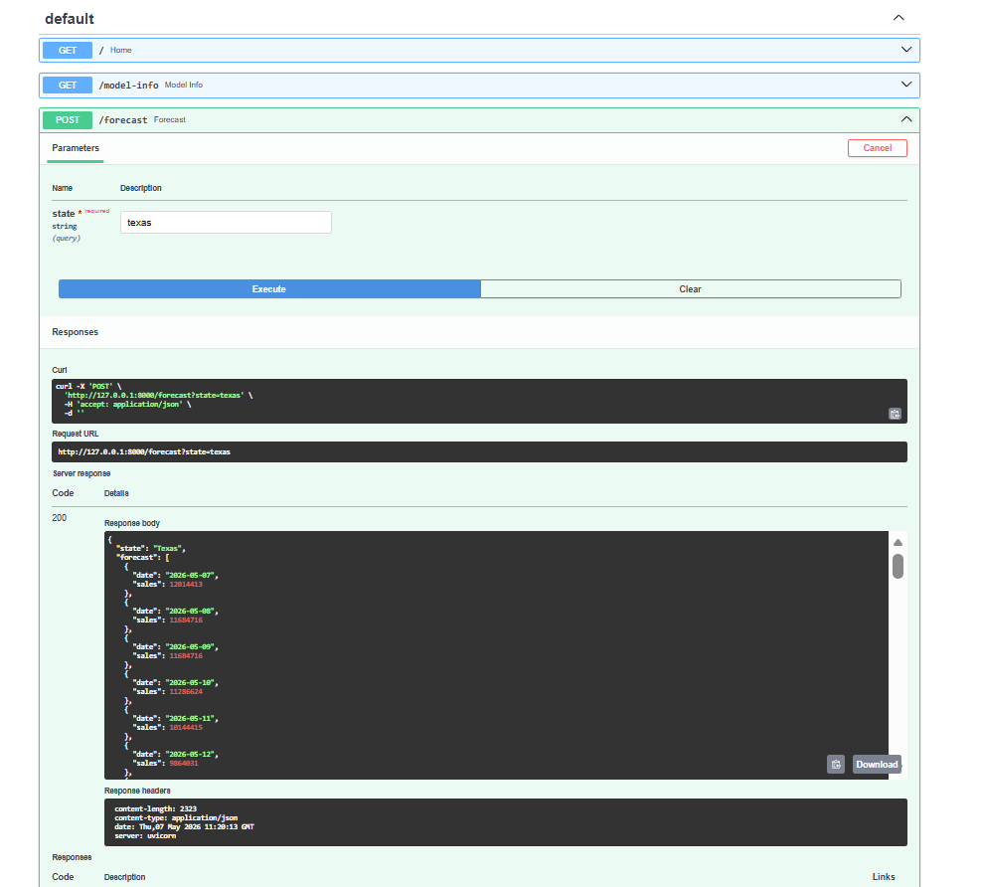
13. Streamlit Dashboard
13.1 Dashboard Features
The dashboard provides:
- State selection
- Forecast generation
- Interactive visualization
- Forecast table
- API status monitoring
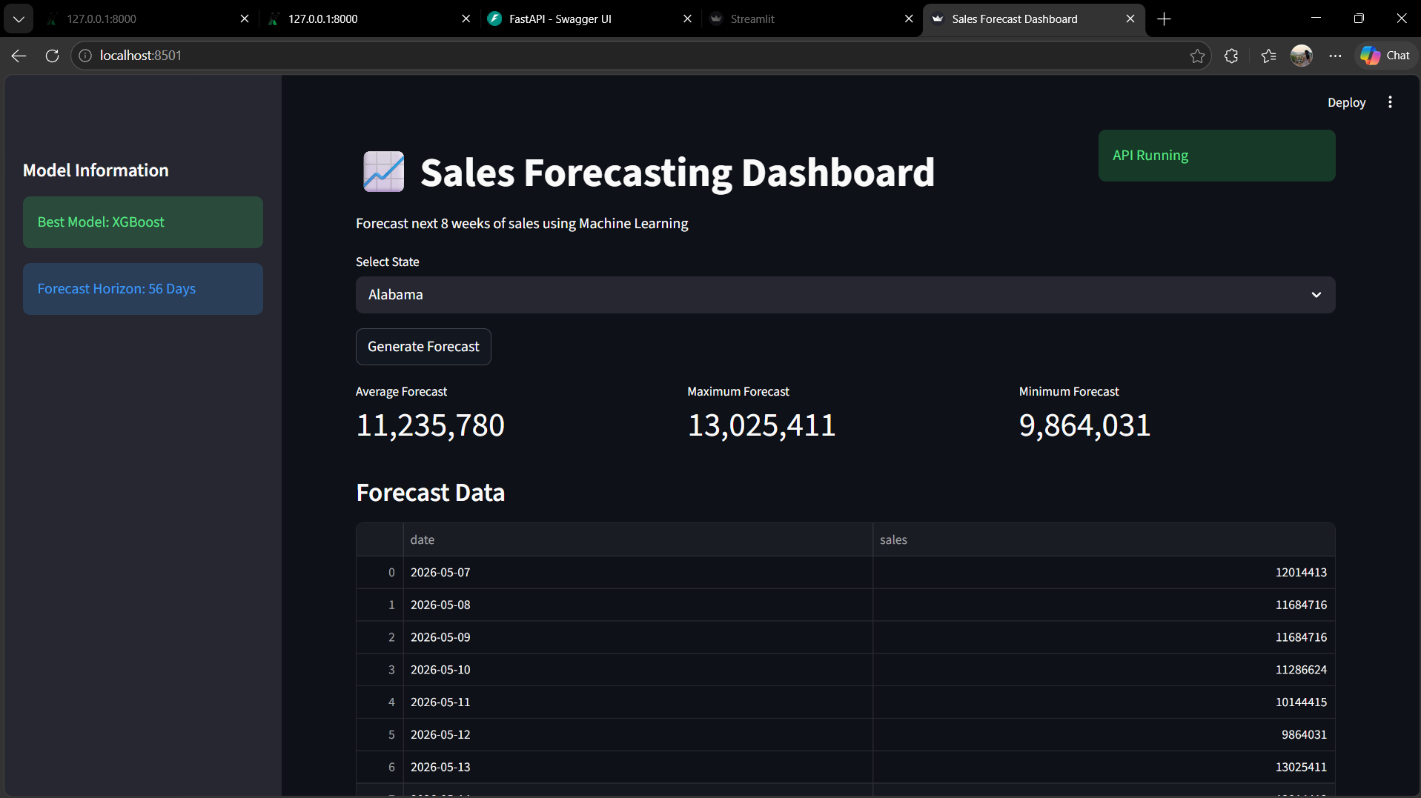
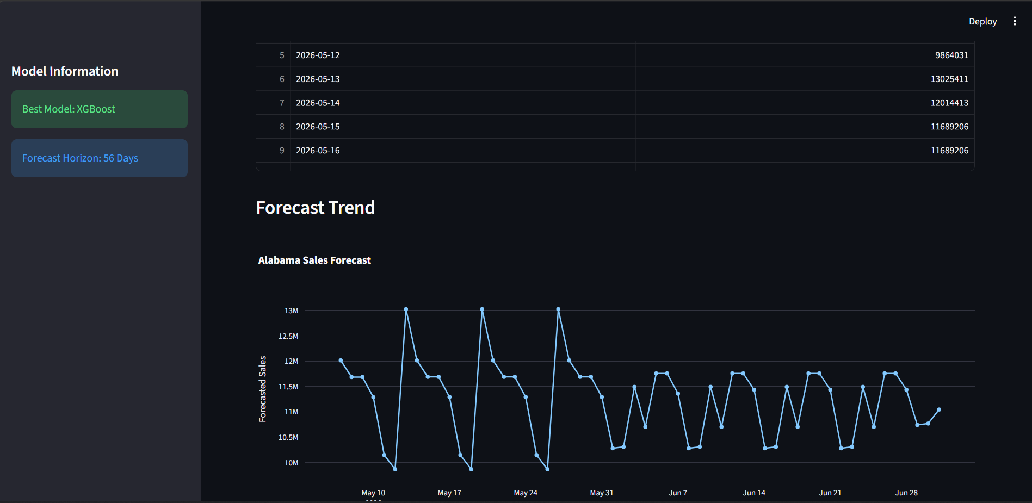

13.2 Technologies Used
- Streamlit
- Plotly
- FastAPI

14. Production-Style Design
The project follows a modular production-style architecture.
Modules:
- Data processing
- Model training
- API serving
- Dashboard visualization

15. Challenges Faced
Some challenges encountered during development:
- Handling missing dates
- Preventing time-series data leakage
- Creating rolling and lag features
- LSTM input reshaping
- API integration with dashboard
- Managing feature consistency across models

16. Conclusion
This project successfully demonstrates an end-to-end production-ready time series forecasting system.
The system combines:
- Statistical forecasting
- Machine learning
- Deep learning
- REST API deployment
- Interactive dashboard visualization
The final solution provides automated sales forecasting with scalable backend architecture and interactive visualization capabilities.

