**Introduction**

In our project we use visual studio code(IDE), node.js(framework), html, CSS, JavaScript, Git, GitHub, Heroku.

**Visual Studio Code 1.66.2v**

****Visual studio code is a free coding editor that helps us start coding quickly.

Use it to code in any programming language, without switching editors. Visual studio code has support for many language including, Python, Java, C++, JavaScript and more.

**Why VS Code :-** It works collaborate and code remotely, work together remotely with your teachers or classmates using the free LiveShare extension. Weather we are working on an assignment or teaching a lesson, we can invite multiple people to join our session and code together.

Visual studio code highlights keywords in our code in different colors to helps us easily identify coding patterns and learn faster.

Fix errors as we code, visual studio code gives us suggestions to complete lines of code and quick fixes for common mistakes.

We can change the look and feel of VS Code by picking your favorite fonts and icons and choosing from hundreds of color theme.

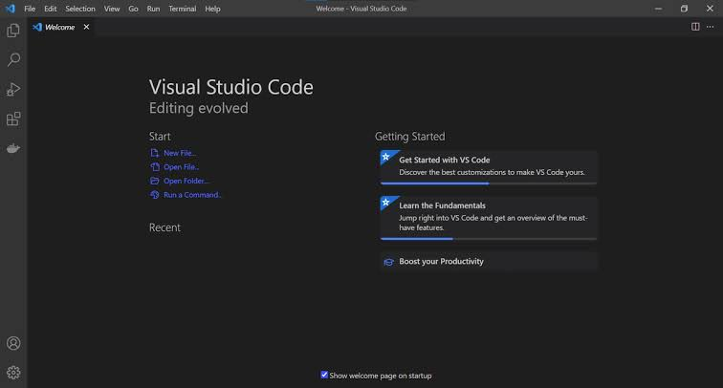When we start the editors for first time, we will see the welcome screen:

There is a toolbar on the left with 5 icons. That gives access to:

* The file explorer
* Search
* Source control
* The debugger
* The extensions

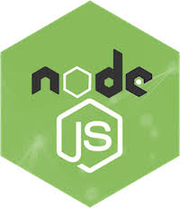**node.js(framework) 16.14.2v**

node.js is an open-source and cross-platform JavaScript runtime environment. It is popular tool for almost any kind of project.

**Why node.js :-** A node.js app run in a single process, without creating a new thread for every request. node.js provides a set of asynchronous I/O primitives in its standard library that prevent JavaScript code from blocking and generally, libraries in node.js are written using non-blocking paradigms, making blocking behavior the exception rather than the norm.

This allows node.js to handle thousands of concurrent connections with a single server without introducing the burden of managing threads concurrency, which could be a significant source of bugs.

In node.js the new ECMAScript standards can be used without problems, as you don’t need have to wait for all your users to update their browsers.

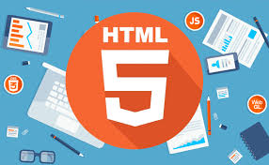**HTML 5**

HTML 5 is the next version of html. Here we will get some brand-new features which will make html much easier. There are some elements like <header>, <footer>, <nav>, and <articles> that define the layout of a website.

**Why use HTML 5 :-** It is enriched with advance features which makes it easy and interactive for designer/ developers and users.

It allows us to play a video and audio file.

It allows us to draw on a canvas. It facilitates us it designs better forms and build web application that work offline.

It provides us advance features for that we would normally have to write JavaScript to do.

The most important reason to use html 5 is, we believe it is not going anywhere. It will be here to serve for a long time according to W3C recommendation.

**CSS3**

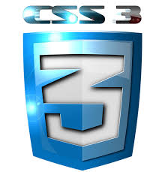Cascading Style Sheets (CSS) is a language that is used to illustrate the look, style, and format of a document written in any markup language. In simple words, it is used to style and organize the layout of Web pages. CSS3 is the latest version of an earlier CSS version, CSS2.

**Some of the key modules of CSS3 are:**

* Box model
* Image values and replaced content
* Text effects
* Selectors
* Backgrounds and borders
* Animations
* User interface (UI)
* Multiple column layouts
* 2D/3D transformations

**Why I use CSS3:-** To help build highly interactive online pages, CSS3 is highly commended as it provides wider options for designing. When advertising products and services, the website is first viewed by a customer, it should be appealing and attractive, and this can be achieved with the help of CSS3.

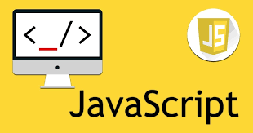**JavaScript**

JavaScript was initially created to “make web pages alive”.

The programs in this language are called scripts. They can be written right in a web page’s HTML and run automatically as the page loads.

Scripts are provided and executed as plain text. They don’t need special preparation or compilation to run.

Todays, JavaScript can execute not only in the browser, but also on the server, or actually on any device that has a special program called the JavaScript engine.

The browser has an embedded engine sometimes called “JavaScript virtual machine”.

**What makes the JavaScript unique ?**

* Full integration with HTML/CSS.
* Simple things are done simply.
* Supported by all major browsers and enables by default.

With JavaScript’s extension collection of frameworks, developers can efficiently build apps for mobile and web. Frameworks are libraries of pre-written JavaScript code that developers use for standard features. We can think of a JavaScript framework like a blueprint.

The most popular JavaScript application frameworks are :

* React
* React native
* Node.js

In our project we used node.js framework which is the collection that enables two-way communication with servers for exchanging data.

**Why I select JavaScript :**

Faster to execute the code, build dynamic pages, reducing memory use, building responsive user interface, reloading certain parts of the page independently, responsive content, autocomplete.

**Git**

Git is a free and open-source software project meaning that the code that implement Git is publicly available. No single company owns Git and anyone can make contributions to improve it.

Git is a distributed version control system(DVCS)

* Each user has a local copy of the complete history of the project which is known as a repository.
* Users can work offline
* Can easily synchronize repositories.

**Git Bash**

Git Bash is a source control management system for windows. It allows users to type Git commands that makes source code management easier .

**GitHub**

It is a web-based hosting service for Git repositories. It offers all Git’s DVCS and has some additional features. This includes collaboration functionality like project management, support ticket management and bug tracking. With GitHub developers can share their repositories, access other developers’ repositories, store remote copies of repositories to server as backups.

**Heroku**

Heroku is a container-based cloud Platform as services.

Developers use Heroku to deploy, manage, scale modern apps. Heroku platform is elegant, flexible, easy to use, offering developers the simplest path to getting their apps to market.

Heroku is fully managed, giving developers the freedom to focus on their core product without the distraction of maintaining servers, hardware, infrastructure.

The Heroku provides services, tools workflows, etc., to enhance developer productivity.