**Himanshu Ojha**

**Homework 1**

**CS 4457 Computer Networks**

**Spring 2016**

**On my honor, as a UVA student, I have neither given nor received unauthorized aid on this assignment.**

***Himanshu Ojha***

**CS4457 (SP2016) Computer Networks**

**Homework 1**

**Points: 7**

**Due: February 2, 2016 (3:30 p.m.)**

(1) What advantage does a circuit-switched network have over a packet-switched network?

*Circuit switching allows for a a constant transfer rate once a connection is established.*

(2) What advantage does a packet-switched network have over a circuit-switched network?

*Packet switching is faster because it does not require establishing a dedicated connection. It is also much simpler, more efficient, and less costly to implement.*

(3) Which layers in the Internet protocol stack does a router process? Which layers does a link layer switch process? Which layers does a host process?

*Routers process the network layer, link layer, physical layer.*

*Link layer switches process the data link layer, and physical layer.*

*A host processes all layers (application, transport, network, data link, and physical).*

(4) Explain why multiplexing/demultiplexing services do not include the application layer.

*Multiplexing/demultiplexing services' job is not to consume the data. The application layer consumes the data and therefore it does not concern itself with which protocol was used internally to transfer the data.*

*Application layer is the topmost layer so it does not have input from a higher layer thus not allowing it to multiplex/demultiplex.*

(5) Assume we have created a packet-switched internet. Using the TCP/IP protocol suite, we need to transfer a huge file. What is the advantage and disadvantage of sending large packets? Answer the question from the perspectives of overhead on extra bytes needed to generate a packet and retransmission due to packet loss/corruption.

*Advantages*

*\* sending large packets reduces overhead of bytes because large packets allow for fewer packets to be sent which means there are fewer headers overall that are generated.*

*\* sending large packets lowers the probability of packet loss because larger packets allow for fewer packets to be sent which means fewer packets arrive at the output queue**thus there is a lower probability of packet loss due to congestion.*

*Disadvantages*

*\* The disadvantage of sending large packets is that if a packet is lost, the cost in resending that packet is more.*

(6) Assume a private internet uses three different protocols at the data-link layer (i.e. L1, L2, and L3). Redraw the figure shown in class for multiplexing and demultiplexing with this assumption.

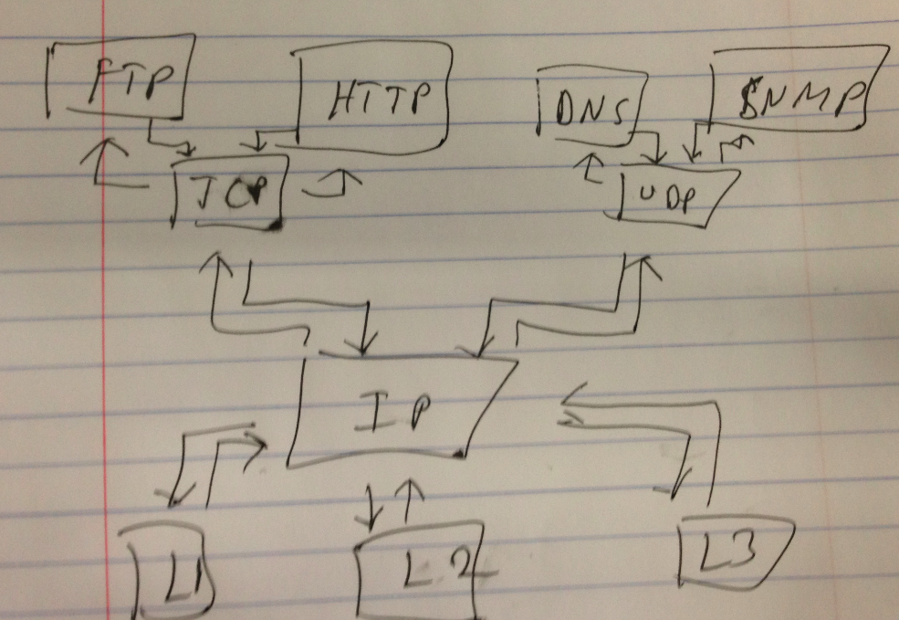

(7) Assume that a private internet requires that the messages at the application layer be encrypted and decrypted for security purposes. If we need to add some information about the encryption/decryption process, does it mean that we are adding one layer to the TCP/IP protocol suite? Redraw the TCP/IP stack if you think so.

*No, the encryption/decryption can be done within the application layer. In the OSI protocol, encryption/decryption is done in the presentation, however, it does not necessarily need to be split out into its own layer.*