# Next Word Prediction

***E20003 Akshay Amrit E20005 Aman Gupta, E200033 Shruti Nair***

A [language model](https://machinelearningmastery.com/statistical-language-modeling-and-neural-language-models/) is a key element in many natural language processing models such as machine translation and speech recognition. The choice of how the language model is framed must match how the language model is intended to be used. Language prediction is a Natural Language Processing - NLP application concerned with predicting the text given in the preceding text. Auto-complete or suggested responses are popular types of language prediction.

Wouldn’t it be cool for your device to predict what could be the next word that you are planning to type? This is similar to how a predictive text keyboard works on apps like WhatsApp, Facebook Messenger, Instagram, e-mails, or even Google searches.

**Advantage:**

* It would save a lot of time by understanding the user’s patterns of texting.
* This could be also used by our virtual assistant to complete certain sentences.

**Approach**

Long Short Term Memory (LSTM).

**Steps:**

1. Analysing the data followed by the pre-processing of the data.
2. Tokenize this data and finally build the deep learning model

**Task**

|  |  |  |
| --- | --- | --- |
| Step | Task | Assigned to |
| 1 | Data collection and data cleaning. Data collected from twitter, blog, news | Aman Gupta |
| 2 | Experiment by building deep learning model on twitter, blog | Akshay Amrit |
| 3 | Experiment by building deep learning model on news and combining all data | Shruti Nair |

**Code:**

**https://github.com/ShrutiNair5/NLP/tree/main**

**Experiment**

1. **Data: Twitter data**

Epoch=500

Optimizer=Adam

Training accuracy:

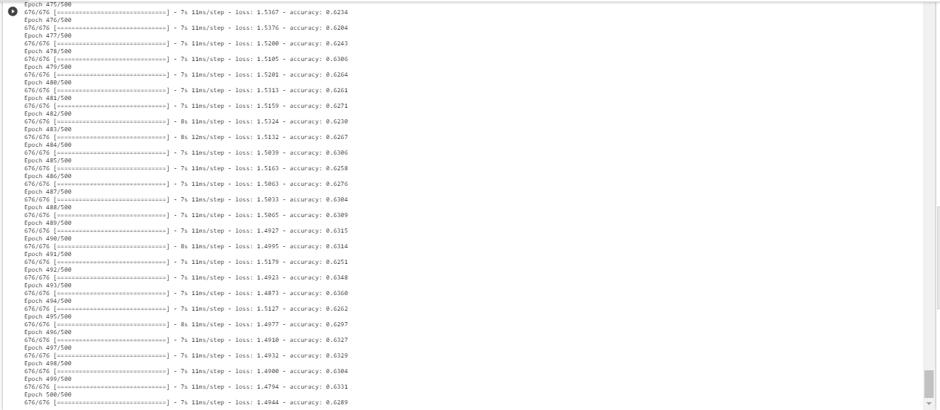

Result:

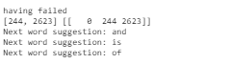

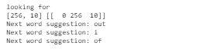

1. **Data: Blog data**

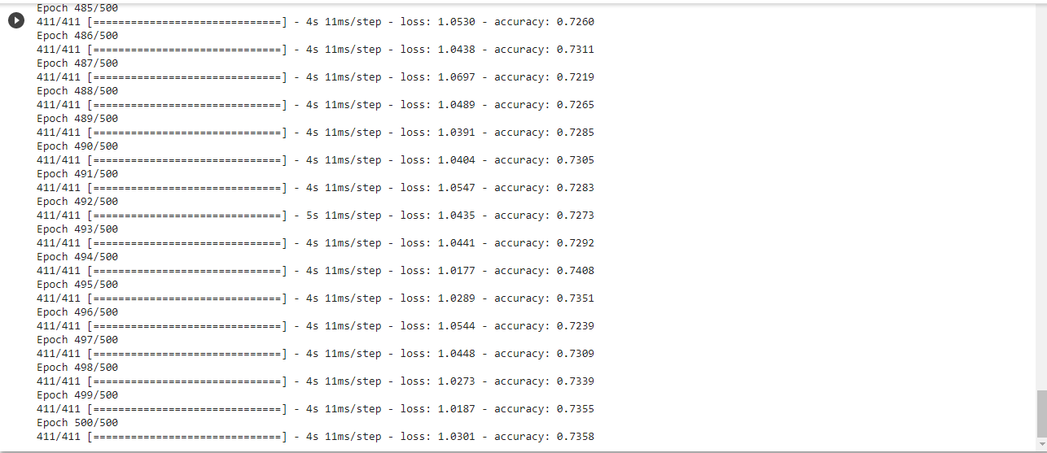

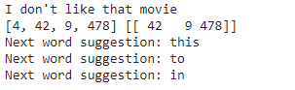

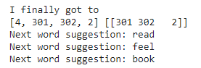

1. **Data: News data**

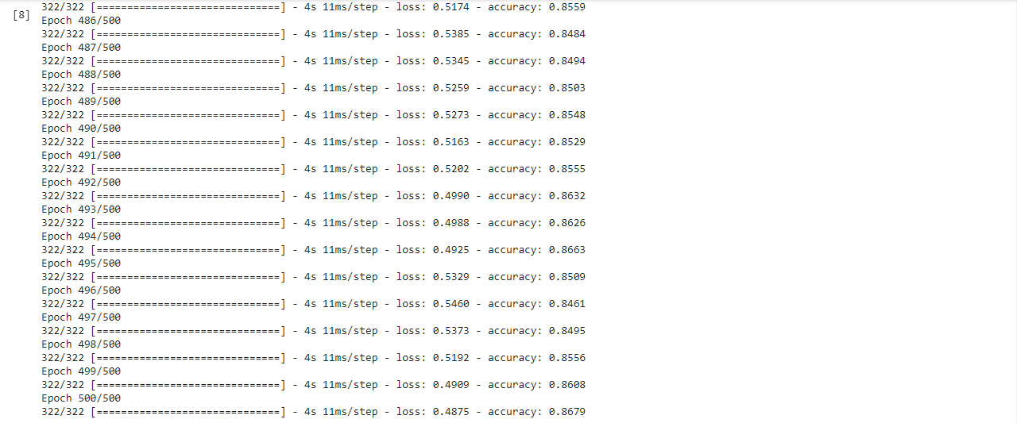

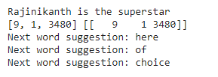

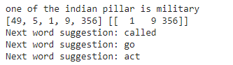

1. **Data: Combining all data**

Epoch=500

Optimizer=Adam

Training accuracy:

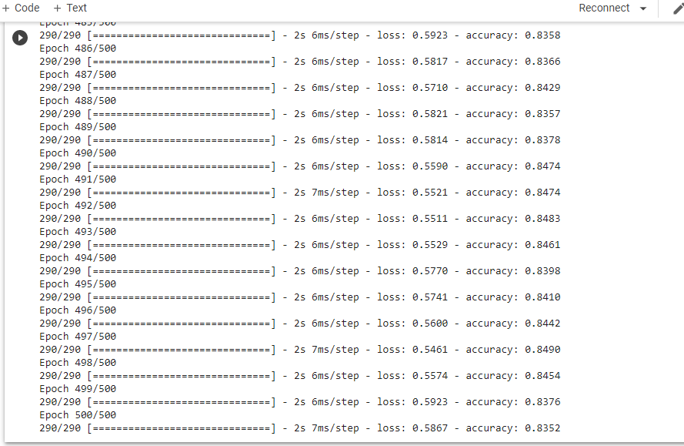

Result:

Taking suggestion

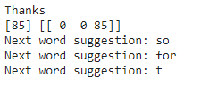

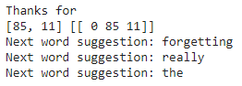

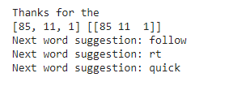

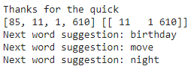

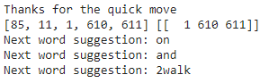

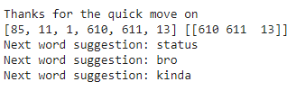

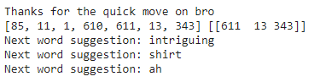

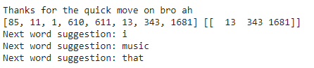

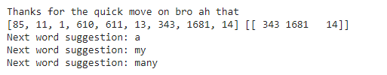

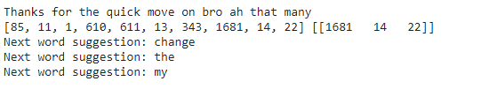

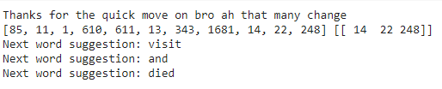

**Conclusion**

LSTMs are a very promising solution to sequence and time series related problems. However, the one disadvantage that is the difficulty in training them. A lot of time and system resources go into training even a simple model.

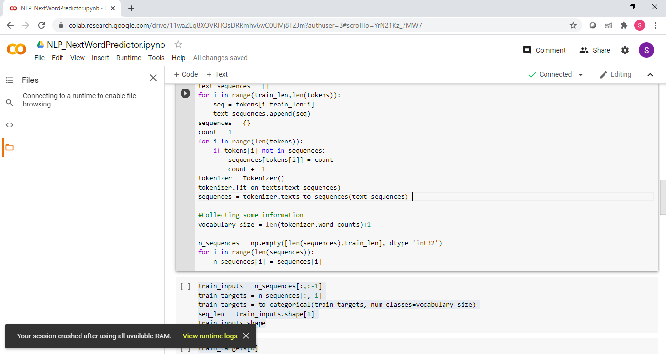

To sum this up, RNN’s are good for processing sequence data for predictions but suffers from short-term memory. LSTM is created as a method to mitigate short-term memory using mechanisms called gates. Gates are just neural networks that regulate the flow of information flowing through the sequence chain. LSTM is used in state of the art deep learning applications like speech recognition, speech synthesis, natural language understanding, etc.