RAG and Riches Financial Inc: Comparison Report and Reranking Impact Analysis
A report on fixed-size, semantic, and hybrid retrieval quality across the financial corpus.
Prepared for benchmark review and retrieval quality analysis.
We used LlamaIndex to build 3 parallel RAG pipelines over SEC filings, earnings call transcripts, insurance claims, and loan agreements. The only difference between the pipelines was the chunking strategy - fixed-size versus semantic chunking - allowing us to directly measure the impact of chunking on retrieval quality, answer relevance, and faithfulness.
Executive Summary
The practical question is simple: when a financial chatbot needs to explain liquidity pressure, reserve movement, covenant terms, or claim activity, which retrieval path gives the clearest and most defensible evidence?

This benchmark isolates the retrieval layer so we can see how each design choice affects the quality of evidence returned to the answer generator. The report focuses on retrieval rank, first-hit quality, reranking lift, and faithfulness, which together tell the story of how well the app stays anchored to the source material.

This benchmark compares how retrieval behaves when the same financial corpus is split and indexed in different ways. The goal is to isolate the effect of chunking, then measure what reranking adds on top of that baseline.

The comparison report focuses on four questions:

1. Which chunking strategy retrieves the most relevant evidence?
2. Does reranking improve the order of the retrieved chunks?
3. Does hybrid retrieval, using Reciprocal Rank Fusion, produce stronger combined evidence than a single strategy alone?
4. Are the resulting answers more faithful to the underlying documents?

Tool Stack Used
Tool | Role in the report
LlamaIndex | Orchestrates the RAG pipelines and keeps the comparison workflow aligned across strategies.
Pinecone | Provides vector search for chunk retrieval, with a local fallback path when external services are unavailable.
Nebius | Handles query rewrite and optional reranking so we can measure the impact of ordering improvements.
OpenAI embeddings | Serve as one embedding baseline in the embedding comparison table.
BGE embeddings | Serve as the second embedding baseline for side-by-side retrieval comparison.
LlamaParse | Parses optional PDF sources when available, extending the corpus beyond the built-in sample set.
Streamlit | Powers the interactive UI, comparison views, and benchmark tables.
Pipeline Architecture
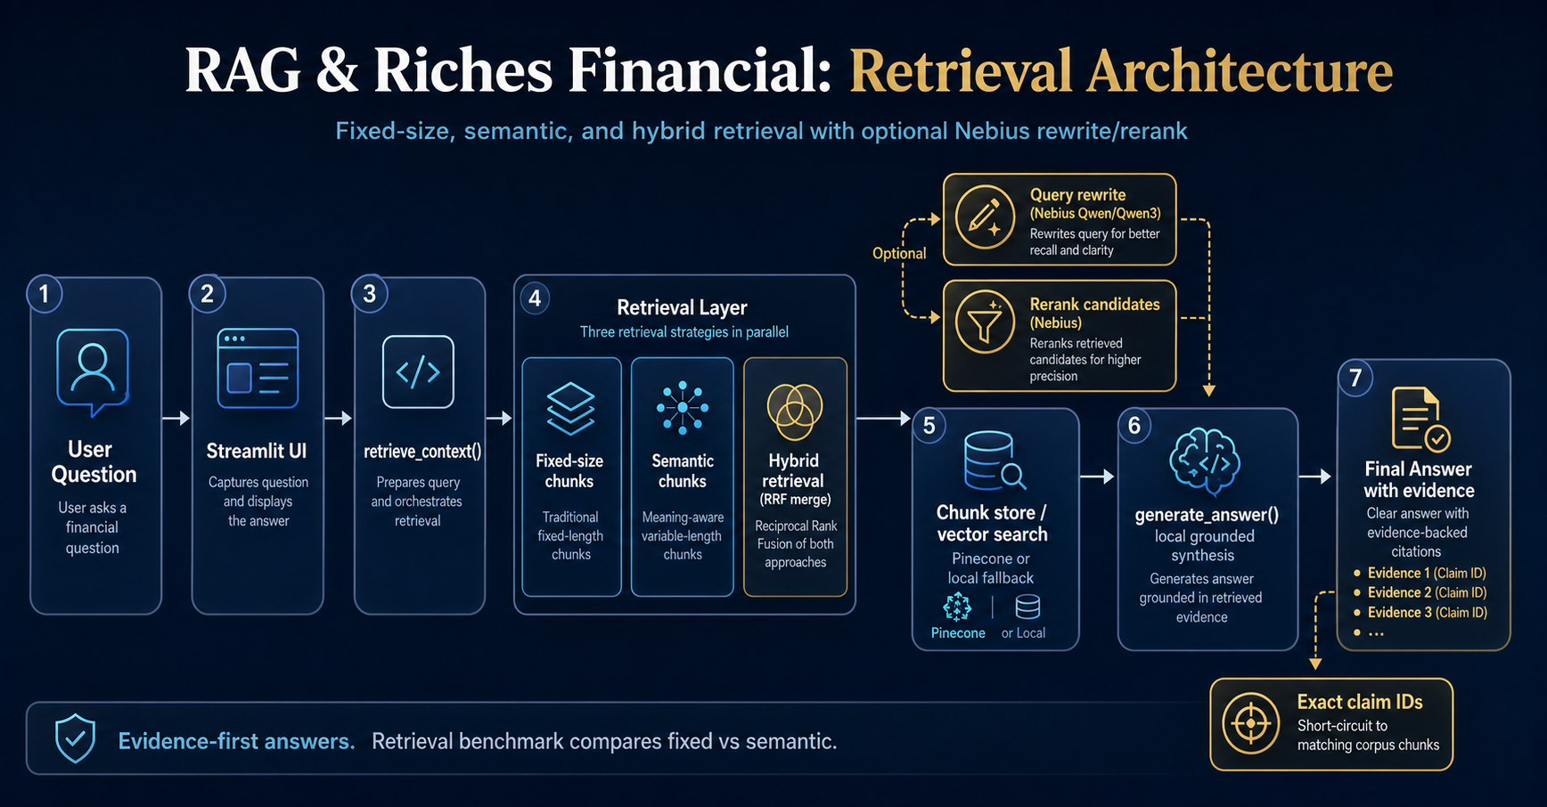
Data and Corpus
The benchmark corpus includes four document families:
- SEC filings
- Earnings call transcripts
- Insurance claims
- Loan agreements
For benchmark stress testing, the sample corpus is expanded with synthetic variants so the app can be evaluated across more queries, more retrieval targets, and more exact-identifier lookups.
Comparison Design
Fixed-size chunking
Documents are split into overlapping word windows. This is the most mechanical baseline and is useful for broad keyword retrieval, but it can break sentence-level meaning when the answer depends on a precise clause, claim, or numeric detail.
Semantic chunking
Documents are split along sentence-aware boundaries so that each chunk better preserves a complete thought. This tends to improve retrieval precision when the query is looking for a statement, a risk disclosure, or a claim-specific detail.
Hybrid retrieval with RRF
Hybrid retrieval runs fixed-size and semantic retrieval in parallel, then merges their ranked results using Reciprocal Rank Fusion. This helps recover evidence that one strategy may miss while still promoting strong candidates from both retrieval paths.
Reranking Impact
Reranking does not replace retrieval. It reorders the retrieved candidates after the first pass so the most relevant passages rise to the top. In practice, this improves the usefulness of the context presented to the answer generator, especially when the first retrieval pass returns several plausible but uneven candidates.
The impact should be interpreted as an ordering improvement rather than a recall improvement. If reranking lifts the first relevant source, the answer often becomes more focused and easier to defend with evidence. If reranking improves rank but the answer still wanders, the generation layer may need tightening.
Reranking is applied after the first retrieval pass. Its job is not to discover new documents from scratch, but to reorder the retrieved candidates so the most relevant passages rise to the top.
In practice, reranking can help when:
- the query is broad and returns several plausible candidates
- the first retrieval pass brings back mixed evidence quality
- the most relevant source is present, but not ranked first
Reranking usually improves the top of the list more than the total recall. That is why it is best evaluated together with retrieval quality, not in isolation.

How to Read the Comparison Report
When reviewing the report, look for these patterns:
- Higher first-hit rank means the strategy found the right evidence earlier.
- Higher reciprocal rank means the right evidence is closer to the top.
- Better faithfulness means the answer stayed more tightly grounded in the retrieved chunks.
- If reranking improves rank but not faithfulness, the answer generator may still be too loose.
- If hybrid retrieval improves recall, it is often a good default for mixed document families.

What the Benchmark Shows
The comparison is intended to answer a practical question: which retrieval path gives the most reliable evidence for a financial chatbot?
Typical interpretation:
- Fixed-size chunking is useful as a strong baseline.
- Semantic chunking can improve precision for sentence-level claims.
- Hybrid retrieval often gives the best coverage across heterogeneous documents.
- Reranking usually improves ordering and can help the final answer stay more focused.

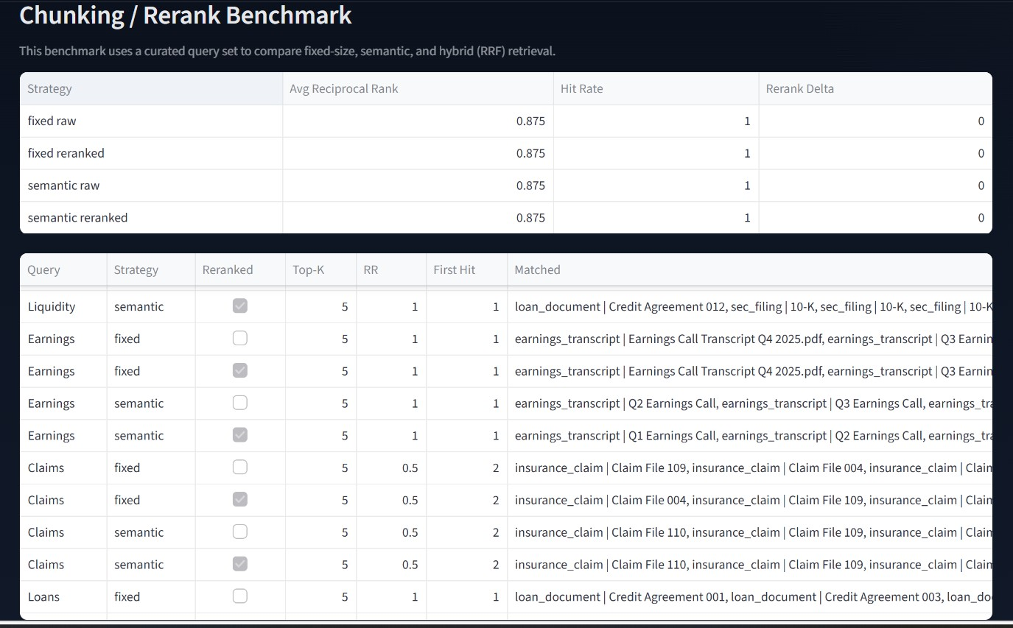
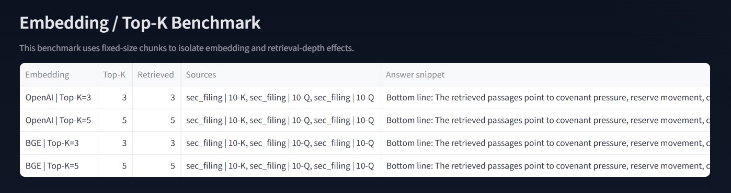
Demo Questions Used For Benchmarking
Demo theme | Question
Liquidity | What liquidity risks and funding pressure are disclosed across the SEC filings and loan documents?
Margins | What do the earnings calls say about margin pressure, pricing, and guidance?
Claims | How are claim reserves, settlement timing, and litigation exposure changing?
Covenants | What covenant obligations and default triggers should we watch in the loan documents?
Hybrid | Which documents mention both liquidity pressure and compliance or control remediation?
Exact ID | What happened with claim CLM-2026-1048?
Exact ID | What is the status of claim CLM-2026-1057?
Final reminder of refusal rule
The assistant must stay grounded in the provided financial documents. If a question is not supported by the corpus, the answer should refuse briefly rather than inventing details.

