**VIRTUAL REALITY HORROR GAME**

|  |  |  |
| --- | --- | --- |
| Prof. Punam Bagul  Guide  KCCEMSR, Thane East punam.bagul@kccemsr.edu  .in | Ritvik Babre  Student  KCCEMSR, Thane East ritvikbabre@kccemsr.edu.in | Hitesh Behera  Student  KCCEMSR, Thane East hiteshbehera@kccemsr.ed  u.in |
| Shruti Sabbani  Student  KCCEMSR, Thane East shrutisabbani@kccemsr.ed  u.in | Swapnil Yadav  Student  KCCEMSR, Thane East swapnilyadav@kccemsr.ed  u.in |  |

**ABSTRACT**

The horror game serves as a medium to introduce VR and integrate as a technology into everyday life as a lifestyle choice. Through immersive environments, we aim to showcase the transformative potential of interactive computing.

**General Terms**

Virtual Reality Horror Gaming Experience, Stereoscopic View, AI Behaviour, Virtual Terror, VR Horror Quest.

**Keywords :**

Virtual Reality, VR, horror game, Immersive Experience, First-person perspective, Android, Gyroscope, Immersive, Jump Scares, Atmospheric Environment, Narrative Storytelling, Motion Controller, Head-tracking, Google-Cardboard, Unity Game Engine, HMD.

1. **INTRODUCTION**

Virtual reality (VR) horror games offer an unparalleled immersion by leveraging first-person perspective, realistic graphics, and interactive gameplay. Players experience the game world through the eyes of the protagonist, enhancing the feeling of presence and intensifying the horror experience. Detailed environments, coupled with atmospheric lighting, create a sense of dread, while interactivity allows players to manipulate objects and solve puzzles. Jump scares are effectively utilized to startle players, taking advantage of the heightened sense of immersion in VR. Compelling narratives further engage players, drawing them deeper into the terrifying world of VR horror gaming.

* 1. Aim:

The VR horror game leverages immersive environments to evoke strong emotional responses, tapping into the rising interest in gaming and timeless appeal of ghost stories. By integrating cutting-edge VR technology, we aim to create a unique experience that merges traditional cultural horror stories with the future of gaming.

* 1. Importance of VR:

Virtual reality (VR) is highly valuable for consumers in day-to-day life, offering practical benefits across various areas. In education, VR provides immersive learning experiences, enabling students to explore virtual environments and grasp complex concepts effectively. It also enhances training programs, allowing professionals to practice skills in realistic simulations. In healthcare, VR aids in rehabilitation, pain management, and mental health treatments, improving overall well-being. Additionally, VR offers immersive entertainment experiences, allowing users to escape into virtual worlds and enjoy interactive content. Its versatility and utility make VR a transformative technology for consumers, enhancing education, healthcare, and entertainment in daily life.

* 1. Why opted for Horror Genre ?

Opting for the horror genre in VR gaming is a strategic choice with several compelling reasons. Firstly, horror games consistently rank highly across demographics and gaming platforms, showcasing their widespread appeal and engagement. In VR, horror games excel in delivering an immersive experience that truly transports users to another world, creating a heightened sense of fear and suspense that showcases VR's capabilities effectively. The use of eerie sounds and immersive audio further enhances this sense of immersion, drawing players deeper into the game environment. In India, where horror stories and supernatural themes hold cultural significance, VR horror games have the potential to resonate strongly with audiences, particularly younger demographics who are enthusiastic consumers of horror content. By leveraging the universal appeal and emotional impact of horror games, VR technology can be effectively promoted and embraced as a powerful medium for immersive experiences and storytelling in the future.

1. **LITERATURE SURVEY:**
2. Konstantinos Ntokos's "Level of Fear" research offers game developers a valuable tool for horror game design, enabling the analysis and categorization of fear levels throughout gameplay. By plotting fear intensity and classifying in-game elements based on their fear impact, developers can maintain a balanced and immersive experience, enhancing player engagement and immersion in the terrifying world of horror games.
3. The research conducted by Årnell and Stojanovic in 2020 investigates the impact of horror game design theories and level design patterns on player behaviour within a horror environment. They explore the elements that instil fear in players, aiming to understand how design choices influence player reactions and experiences in horror games.
4. Ziwen Zhang's research on horror game design utilizes a comprehensive approach, combining qualitative, quantitative, and biometric methods to enhance validity and reliability. The study uncovers that horror games evoke emotions like fear and excitement, influenced by player experience levels. It also identifies factors like a sense of achievement and puzzle-solving as crucial for player satisfaction, providing valuable insights for game designers and researchers in the horror gaming field.
5. The research by de Lima, Silva, and Galam in 2022 explores the concept of adaptive virtual reality horror games. Their study focuses on integrating machine learning techniques and player modelling to create horror games that dynamically adjust gameplay elements based on individual player behaviour and preferences. By employing these mechanisms, the researchers aim to enhance player engagement and immersion in virtual reality horror gaming experiences.
6. The research paper explores how self-efficacy affects enjoyment in VR horror games. Authored by Jih-Hsuan Tammy Lin, Dai-Yun Wu, and Chen-Chao Tao, it shows that individuals' confidence in handling fear influences their enjoyment. Through surveys and interviews, the study indicates that higher self-efficacy correlates with greater enjoyment, emphasizing the significance of users' confidence in managing fear for an immersive gaming experience.
7. In the referenced work authored by Tammy Jin-Hsuan Lin and published in the Oxford Research Encyclopaedia of Communication in 2023, the focus is on exploring the impact of virtual reality horror games on the experience of fear in gaming. The research provides a scholarly examination of how virtual reality technology influences the elicitation and perception of fear within gaming contexts, contributing to the understanding of psychological and immersive elements in horror gaming.
8. The paper "Research on the Application of VR in Games" by Shijie Bian explores how virtual reality (VR) technology enhances gaming experiences. It discusses improved immersion, interactivity, and realism in VR gaming, citing existing applications and technological advancements. The paper underscores VR's potential to revolutionize gaming and outlines associated challenges and opportunities, guiding future research and innovation in this dynamic field.
9. The paper "Research on the Progress of VR in Game" by Ruiqi Zhang provides an overview of advancements in virtual reality (VR) technology within the gaming industry. It explores integration of VR in game design, covering graphics, user interfaces, and gameplay mechanics. Through analysis of recent trends and innovations, the paper offers insights into the evolving landscape of immersive gaming experiences, discussing the potential impact of VR on the future of gaming and opportunities for enhancing player engagement.

**3. PROPOSED METHODOLOGY:**

Creating a VR horror game in Unity involves carefully planning and building it step by step. First, you have to document the story, how the game will work, and what players will do. Then, you keep trying out different ideas and fixing any problems until the game feels just right. Unity Game Engine is the main tool used to make the game, and it's great for VR because it supports a number of VR gadgets, like the Jio dive headset. Additionally, developers utilize languages like C# for scripting gameplay mechanics, implementing AI behaviours, and integrating VR features. Technologies, such as 3D modelling software for asset creation and audio engines for immersive sound design, are also utilized to enhance the horror atmosphere. By leveraging a combination of these methodologies, technology, and programming languages, developers can craft a compelling and terrifying VR horror game that immerses players in a chilling experience.

**4. Parameters for Severity in Horror Games:**

1. **Environment:** The environment in which the horror story takes place plays a significant role. Dark, eerie settings with limited visibility can heighten fear levels.
2. **Sound Design:** Eerie sounds, sudden noises, and unsettling music contribute to the overall atmosphere and can intensify the feeling of dread.
3. **Visuals and Graphics:** Realistic visuals, detailed character designs, and gruesome imagery can evoke strong emotional responses from players or viewers.
4. **Narrative and Storytelling:** A well-crafted storyline with suspenseful twists, unexpected events, and a sense of mystery can keep the audience engaged and on edge.
5. **Character Design and Behaviour:** Scary or menacing characters, their movements, and behaviour can instil fear and create tension in horror experiences.
6. **Gameplay Mechanics:** Interactions with the game world, such as jump scares, timed events, and survival mechanics, can increase the intensity and adrenaline rush.

**5. IMPLEMENTATION DETAILS:**

* 1. Hardware and Software Requirements:

**Table 1: Hardware and Software Requirements**

|  |  |
| --- | --- |
| **Hardware** | **Software** |
| Android mobile device | Game Engine - Unity |
| Gyroscope | Version Control System - Git |
| Gamepad Controller | Scripting Language – C# |
| VR Headset (Jio Dive) | IDE – Visual Studio |

5.2Methodology:

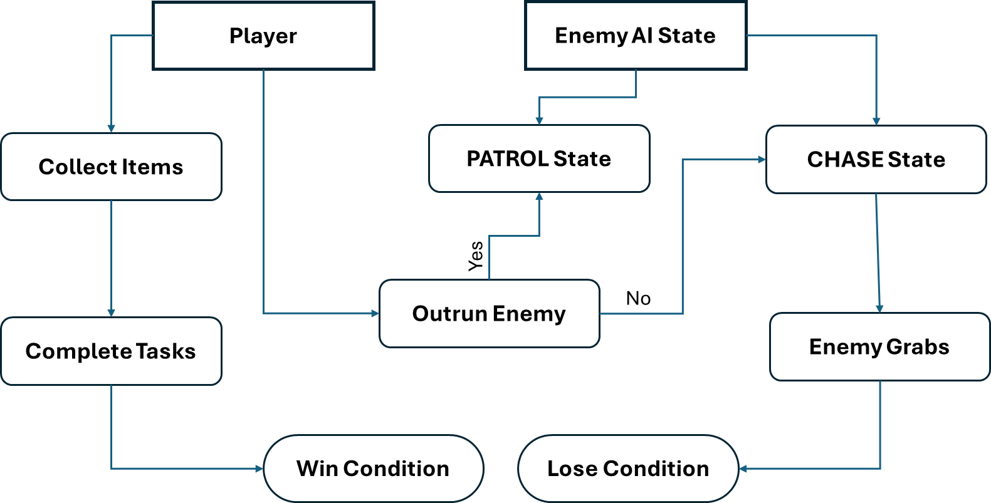

Fig 1: Mechanism of the Game

The game is a survival horror experience, challenging players to complete all quests to achieve victory.

**1. Object Collection:** Players collect various items essential for completing tasks and progressing.

**2. AI Enemies:** Dynamic AI enemies relentlessly search players, instilling a constant sense of terror.

**3. Google Cardboard SDK:** Integrates VR functionalities on Android devices, including stereoscopic rendering and headtracking.

**4. Gyroscope:** Utilizes sensor data to track players' head movements, enhancing immersion.

**5. Game manager:** The Game Manager is the central hub overseeing game elements like states, UI, input, events, scene changes, logic, and win-loss condition. It synchronizes the elements to ensure a cohesive player experience.

**6.** **Item Spawner:** The algorithm enhances game replayability by randomly spawning items from strategically positioned points across the map.

**7. Audio Management:** Implements 3D spatial audio, ambient music, and eerie sounds for a heightened atmosphere.

**8. User Interface (UI):** VR-friendly UI elements provide essential information and enhance player interaction.

**9. Win Condition:** Victory is achieved by completing all tasks and escaping from pursuing enemies.

**10. Lose Condition:** Failure occurs when players are caught by enemies, leading to game over.

5.3 SYSTEM FEATURES:

5.3.1 HEAD TRACKING:

Head tracking in the VR horror games on Android will be implemented using Google Cardboard SDK which uses the device's built-in sensors, particularly the gyroscope. These sensors detect the user's head movements, including rotation and tilt. Unity's Android VR integration allows to access this sensor data and update the virtual camera's position and orientation accordingly.

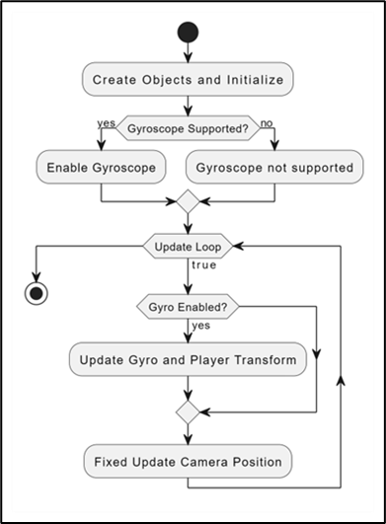Top of Form

# Fig 2: Gyroscopic head tracking flowchart

5.3.2 ITEM PICKUP & SPAWNER:

The game uses raycasting for item pickup, enabling players to interact with virtual objects. When the player's VR camera focuses on an object, a ray is cast from the camera's position. If this ray intersects with an interactable object, players can trigger a pickup by pressing a button on their VR controller. Raycasting offers a natural and intuitive interaction method, enhancing immersion and gameplay in the VR horror experience.

The game objects spawn at specified spawn points. The game engine randomly selects spawn points from corresponding lists and instantiates objects based on the specified count, ensuring a varied and engaging gameplay experience. This approach adds randomness and unpredictability to the game world, enhancing player exploration and interaction with objects throughout the game.

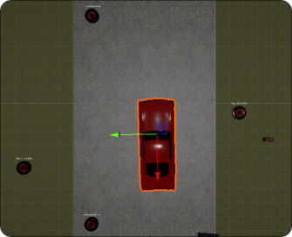 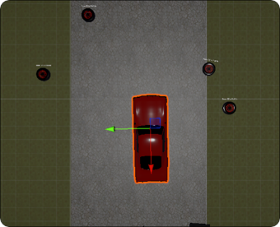

**Fig 3: Random Item Spawner**

5.3.3 ENEMY AI:

The enemy's AI is designed with various states like idle, patrol, chase, grab, and return to patrol. These states dynamically change based on player proximity and randomized movement algorithms, creating suspenseful gameplay. To navigate the terrain, the enemy utilizes a Nav Mesh Agent for smooth movement. The patrol radius gradually reduces over time, adding strategic depth to the enemy's movements and behaviour.

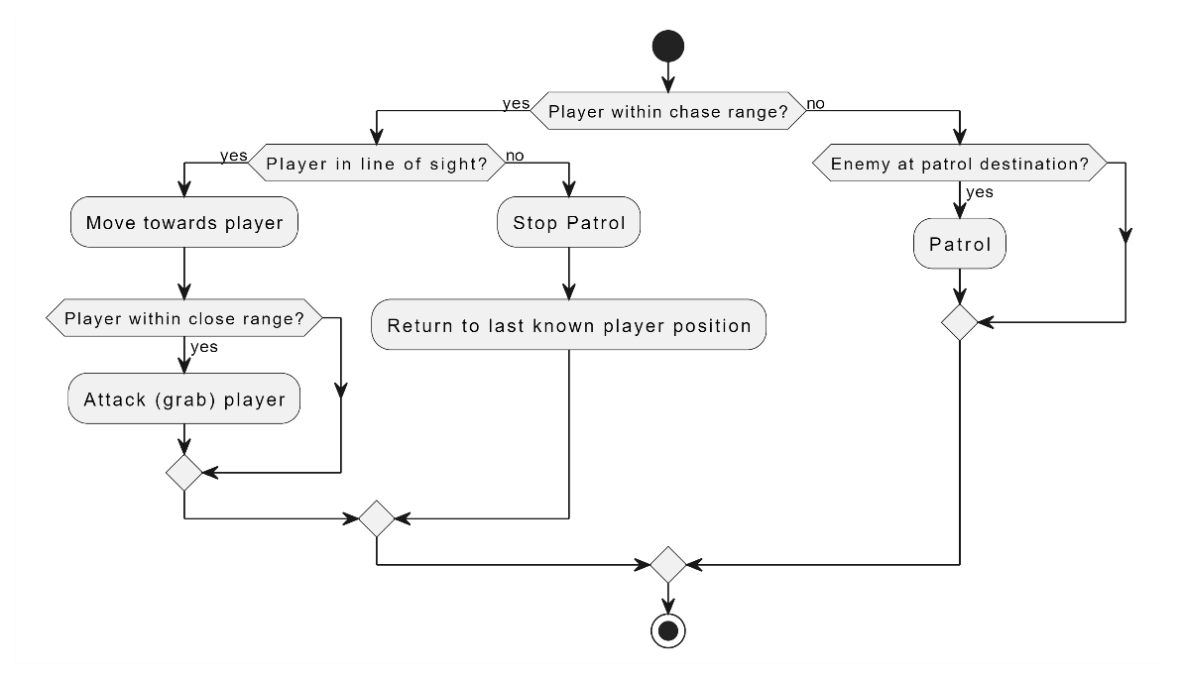

**Fig 4: Enemy AI Behaviour Flowchart**

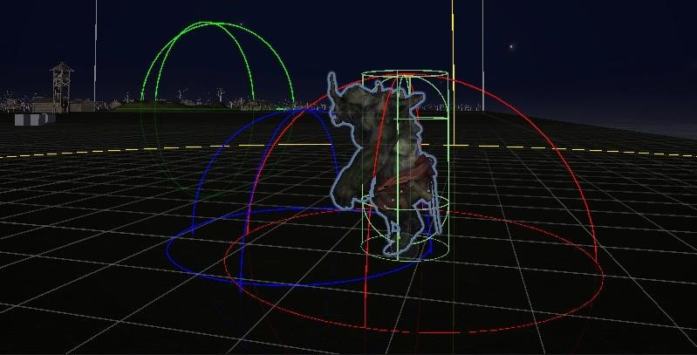

**Fig 5: Enemy Game Object in PATROL State**

5.3.4 GAME MAP:

Game maps play a crucial role in VR horror games as they provide players with a structured environment to navigate and explore. Well-designed maps not only guide players through the game but also prevent confusion and aimless wandering. In a VR horror game, the map is crafted with diverse topography, offering varied challenges and encounters. It includes strategically placed elements and eerie audio settings, creating an immersive atmosphere that enhances the overall gameplay experience.

5.4 ARCHITECTURE:

**Google Cardboard SDK**: Serves as a foundational tool for creating immersive experiences compatible with the Google Cardboard VR platform. This SDK provides developers with essential resources and libraries to build VR applications specifically tailored for the Cardboard headset. It includes features for rendering stereoscopic 3D graphics, handling head tracking and orientation, and managing user input through touch interactions. By integrating the Google Cardboard SDK into the game's architecture, developers can ensure seamless compatibility with Cardboard devices, allowing players to experience the horror game in immersive virtual reality using their smartphones.

**Gamepad Controller*:*** Serves as a key input device for players to interact with the virtual environment. While VR games typically emphasize motion controllers for immersive interactions, gamepads play a crucial role in providing traditional input methods and enhancing accessibility. Players use the gamepad's buttons and directional inputs to navigate the game world, control character movement, and execute actions such as interacting with objects or accessing menus.

**Rendering*:*** Plays a critical role in bringing the terrifying world to life, with Unity's rendering pipeline delivering high-quality graphics, lighting, and visual effects tailored for VR environments. From eerie shadows and atmospheric lighting to intricate textures and immersive environments, Unity's rendering capabilities enable developers to create chilling and visually captivating horror scenes.

**Audio*:*** Serves as the backbone of immersion, enhancing the atmosphere and tension of the VR horror experience. Unity's audio engine allows developers to integrate spatial audio, ambient sounds, and unsettling sound effects that dynamically respond to player actions and environmental cues. This spatial audio simulation ensures that sounds emanate realistically from specific directions, intensifying the sense of dread and suspense.

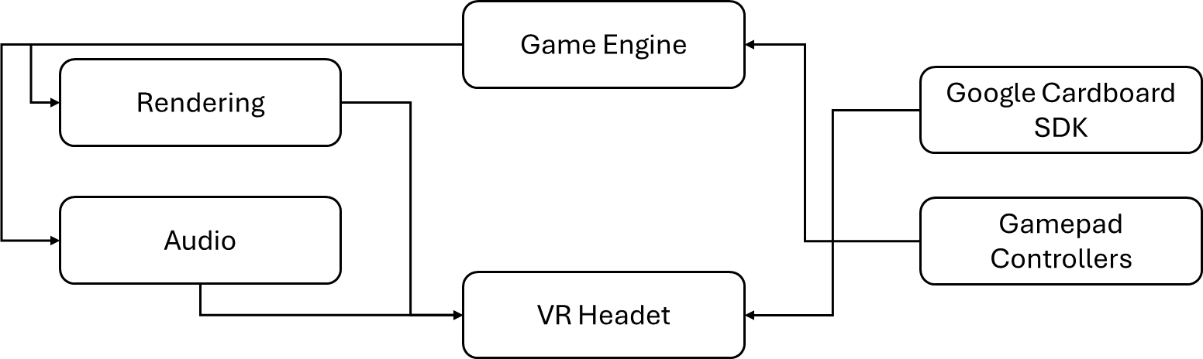

**Fig 6: Data Flow between Components**

5.5 USER FEEDBACK:

Throughout developments, various testing methods are being employed, including alpha and beta testing, alongside continuous testing among the development team. Initial feedback has positively highlighted the exceptional sound design, contributing significantly to the overall gameplay experience.

**6. CONCLUTION:**

Our VR horror game incorporates a holistic approach to gaming, seamlessly blending immersive environments with advanced technology while catering to the traditional enthusiasm for consuming horror stories. It represents a fusion of past, present, and future elements, presenting VR seamlessly into daily life experiences. Adhering to VR rules and integrating cohesive features, our game sets a new standard for immersive entertainment.

**7. ACKNOWLEDGMENTS**

We would like to express special thanks of gratitude to our guide & co-guide *Asst.* *Prof. Punam Bagul* as well as our Project Coordinator *Asst.Prof. Seema Bhuravane* who gave us the golden opportunity to do this wonderful project on the topic of *VIRTUAL REALITY HORROR GAME*, which also helped us in doing a lot of research and we came to know about so many new things. We are very grateful to our Head of the Department *Prof Amarja Adgaonkar* for extending her help directly and indirectly through various channels in our project work. We would also like to thank I/C *Principal Dr. Vilas N Nitnaware* for providing us the opportunity to implement our project. We are thankful to them.

**8. REFERENCES**

1. Ntokos, Konstantinos. *"Level of fear”*: Analysis of fear spectrum into a tool to support horror game design for immersion and fear." An International Journal (CGDEIJ) 1, no. 33-43 (2018).
2. Årnell, Tobias, and Nikola Stojanovic. "*Horror game design–what instills fear in the player?:* A study on the effects of horror game design theories and level design patterns on player behaviour in a horror environment." (2020).
3. Zhang, Ziwen. "Analysis of the design aesthetics and player emotions of horror games: Take ‘Little Nightmares’ as a case." (2022).
4. de Lima, Edirlei Soares, Bruno MC Silva, and Gabriel Teixeira Galam. "Adaptive virtual reality horror games based on Machine learning and player modeling." Entertainment Computing 43 (2022): 100515.
5. Lin, Jih-Hsuan Tammy, Dai-Yun Wu, and Chen-Chao Tao. "So scary, yet so fun: The role of self-efficacy in enjoyment of a virtual reality horror game." New Media & Society 20, no. 9 (2018): 3223-3242.
6. Lin, Tammy Jin-Hsuan. "Virtual Reality Horror Games and Fear in Gaming." In Oxford Research Encyclopedia of Communication. 2023.
7. Bian, Shijie. "Research on the Application of VR in Games." Highlights in Science, Engineering and Technology 39 (2023): 389-394.
8. Zhang, Ruiqi. "Research on the Progress of VR in Game." Highlights in Science, Engineering and Technology 39 (2023): 103-110.