Execution plan

**Project Title:** Vision2020

**Customer:** Individual Ophthalmologist’s Clinics

**Users:** Practicing Ophthalmologists and the staff at the clinic

**Development Team:** Mounika Reddy Jaladanki, Pavani Eupuri, Shruti Sankhe, Vimarsha Adyar

Software requirements elicitation is the practice of researching and discovering the requirements of a system from users, customers, and other stakeholders. Using this execution plan we are going to discover and organize requirements of the current stakeholders by conducting a survey with detailed feedback, brainstorming sessions with the development team and ophthalmologists, direct interviews probing about their practice and how they think any software can help them in automating their routine actions (taking X-Rays, uploading documents, acquiring consents), organizing, searching and reporting patient data, scheduling treatments and sending patients reminder emails, receiving patients’ feedback. We should also try to evaluate possible risks of operating such a software: loss of patient data, sub-optimal treatment plan recommendations, and incorrect claim calculations.

To start with our plan, we are dividing our target group into 3 categories which are:

1. Practicing ophthalmologists (Count 50)
2. Staff at the clinic (Count 50)
3. Development Team of Vision2020 (Count 4)

We will arrange 5 rounds of discussions with around 10 ophthalmologists for each round. Each round will consist of 1 survey, 120 minutes of brainstorming with a group of ophthalmologists and optional direct personal interview if ophthalmologists are willing to express personal detailed opinion and their personal vision of the project with our CTO. We need to verify that our current design matches user expectations. Our main communication tools will be Zoom conversations. We will also provide online forms for additional feedback to gather all possible suggestions for our project.

# Brainstorming sessions with target audience

Brainstorming is a group creativity technique available for eliciting requirements from stakeholders. It encourages participants to think more freely and suggest as many spontaneous new ideas to be included in the product we are developing.

Below are the sequence of activities the team has planned for successful brainstorming:

Step 1: Prepare the Group

* The team targets 5 events of 2 hours each with 10 participants in each brainstorming session
* Secondly, set up a comfortable meeting environment for the session, decide upon a time and invite the respective groups
* Upon gathering, everyone introduces themselves

Step 2: Present the Problem

* The team clearly defines the problem and the criteria they must meet, while making it clear that the meeting's objective is to generate as many ideas as possible.
* Give participants plenty of time at the start of the session to write down as many of their own ideas as they can. Then, ask them to share their ideas, while giving everyone a fair opportunity to contribute.

Step 3: Guide the Discussion

* Once everyone has shared their ideas, start a group discussion to develop other people's ideas, and use them to create new ideas
* As the group facilitator, ask the following questions
* What systems are you currently using?
* What are the challenges you are facing as an Ophthalmologist with your day to day operations?
* Are you facing any challenges with the current system?
* Is the current system easy to navigate and user friendly? Do you have any preferences?
* Is the current system accessible from all devices?
* Are there any specific suggestions you would like to put forward to have a better experience?

After the brainstorming activity is completed, the team will discuss and evaluate each idea raised during the event. This includes grouping similar ideas and prioritizing some vital ideas.

# End-User Survey

The below questionnaire is considered to send the end users to collect their feedback.

1. What issues can Vision 2020 software help you with?
   1. Check patient records for upcoming appointments, send notifications for schedules and feedback
   2. Retrieving historical health data
   3. Scheduling and rescheduling appointment times
   4. Suggestive treatments based on patients’ historical health data
   5. Your suggestions:



1. Any user interface challenges you want Vision 2020 to tackle?
2. Availability of patient’s data and prescription history
3. Minimum parameters or attributes for data retrieval
4. Data backup
5. Your suggestions:
6. Any security concerns about Vision 2020?
7. Patient data compromised
8. Data leaks via web access
9. Unsecured financial transactions
10. Your suggestions:



1. What is the main objective of storing patient data?
2. Easy data availability
3. Convenient data retrieval and exchange
4. Enabling historical analysis
5. Your suggestions:



# Individual Interview Questions for Experienced Ophthalmologists

For insightful information from our clients regarding market trends and funds, our interview procedure will comprise of questions mentioned below:

* Introduction of both the parties and purpose of visit
* Understand the practical scenarios and expectations from the project
* Listening to the detailed feedbacks

1. **What are the issues we are expected to resolve?**

We need a system to schedule/reschedule appointments, treatments, prescribe medicine, suggesting future treatments, analyze and research health history. A flexible system that incorporates ways of every ophthalmic surgeon and staff. A highly secured system strictly abiding to the laws and regulations related to the health data.

1. **What would be the ideal result of this project?**

To be used by every ophthalmology clinic and optician office.

1. **How to achieve these results?**

Effective and precise collection and prioritizing of requirements from ophthalmologists and staff. Formulation of a detailed project plan. Technical team with strong skills for successful implementation in arenas like backend, frontend, security and design.

1. **What are the critical factors for the project to be successful?**

Incorporating requirements of both the parties i.e. doctors and patients. Promising ease of access and increase in productivity. Get the required funding by presenting the statistical data to stakeholders by building confidence.

1. **What would be the hindrances on the path towards a successful outcome?**

Multiple scenarios can take the project downhill for example, hiring an inefficient team to handle the security. It can lead to loss of trust in the market. Insufficient funds may lead to building a team that lacks the required skill-set which may lead to project failure.

# System Prototype

A prototype is an early sample, model, or release of a product built to test a concept or process. Prototyping plays an important role in showing something concrete to users in the software elicitation process. It allows the development team and potential future customers to understand the product and plays a significant role in receiving feedback and improving the actual structure of the product.

The team will use the feedback gathered from previously created questionnaires and brainstorming sessions to create initial use cases to make an effective prototype for our system. Once there are enough use cases to build an initial version, the System architect will begin with the following steps:

* + - * Generate Data Models, ER diagrams and technical design specification
      * Create database schemas, class diagrams, sequence diagrams, object diagrams and component diagrams based on the use cases that were created in the previous step
      * Create an initial draft of the system architecture based on the use cases
      * Conduct another round of brainstorming and individual interview sessions with the stakeholders of the Vision 2020 app
      * Keep iterating these steps until there is a prototype that could be developed

Below is the draft version of use cases that have been created based on the initial brainstorming and survey sessions:

**Use Case Diagram**

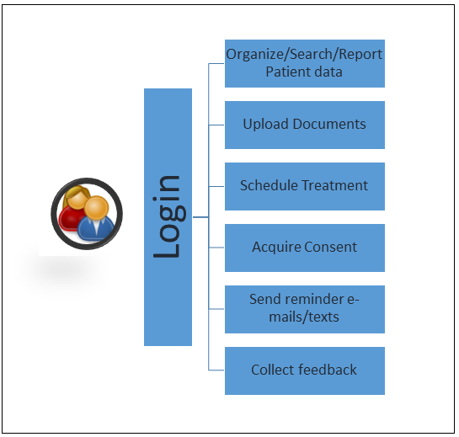

**Sequence Diagram for creating Patient record**

