International Technological University

SWE – 600: Advanced Software Engineering

Final Project Report - Vision2020

Mounika Reddy Jaladanki (94976), Pavani Eupuri (94850),

Shruti Sankhe (94964), Vimarsha Adyar (94703)

Supervisor: Prof. Qamar Asghar

Report submitted in complete fulfilment

of the requirements of the course

Advanced Software Engineering, Department of Software Engineering

**Project Glossary**

**Ophthalmologist** is an expert in diseases, functions and anatomy of the eye. They provide routine care such as vision testing as prescribe and fit eyeglasses or contact lenses and are also surgeons. They repair traumatic injuries to the eye and perform cataract and corneal surgery.

**Optometry** is the practice or profession of examining the eyes for visual defects and prescribing corrective lenses

**Insurance Claim** is a formal request by a policyholder to an insurance company for coverage or compensation for a covered loss or policy event. The insurance company validates the claim and, once approved, issues payment to the insured or an approved interested party on behalf of the insured.

**Micro services a**re smaller discrete set of services that are focused on 1 or 2 functions and the lines of division between them are very clear using APIs and the development teams are only focused on their area of responsibility.

Table of Contents

Project Concept 5

1.1 Introduction 6

1.2 Vision 6

1.3 Proposed Solution 6

Project Plan 7

2.1 Overview 8

2.2 Resource Estimates 8

2.3 Revision History 9

2.4 Meeting Minutes 9

Risk Management 12

3.1 Project Risks 13

3.2 Technical Risks 13

3.3 Business Risks 13

Requirements Overview 14

4.1 Functional Requirements 15

4.2 Non Functional Requirements 17

Software Architecture 21

Security Component 23

UML Diagrams 25

7.1 Use Case 26

7.2 Class Diagram 42

7.3 Sequence Diagram 43

7.4 Activity Diagram 45

7.5 Prototyping 46

Training Plan 54

Testing 56

8.1 Test plan 57

8.2 Test Strategy 57

8.3 Test Type 57

8.4 Risk and Issues 58

8.5 Test Logistics 58

8.6 Test Objectives 59

8.7 Test Criteria 59

8.8 Resource Planning 59

8.9 Test Environments 59

8.10 Schedule & Estimation 60

8.11 Test Deliverables 60

Conclusion 61

Resources and References 63

# Project Concept

## **Introduction**

Ophthalmology is a science of studying medical conditions associated with eyes. Vision 2020, a healthcare solution, which will cater to the operational business requirements of the ophthalmology clinics.

The Ophthalmologists have difficulties to manage their patients’ data and offer them the best time for the next appointments by using historical patients' data. Vision 2020 is a software system for Ophthalmologists and the clinic staff to manage their patients’ information and schedule appointments.

## **Vision**

Ophthalmologists today work an average of 47 hours per week. That’s more hours compared to dermatologists (45.5) and emergency medicine physicians (46). Our vision is to build a robust and reliable healthcare solutions that are precisely customized according to the needs and requirements of healthcare practitioners.

Considering the sensitivity of the information involved in healthcare domain, our system will be resilient and non-vulnerable.

We strive to offer better service to our clients and expand our customer base by surveys and collecting feedback.

## **Proposed Solution**

Our proposed solution aims to automate the routine actions taken by Ophthalmologists to save time in order to give better service to their patients. Our product will streamline maintaining reports, uploading documents, acquiring consents, organizing, searching and reporting patient data, printing ledgers, scheduling treatments and receiving patients’ feedback. We will also try to evaluate possible risks of operating a healthcare software, like data inconsistency, security, maintenance, extendibility of a system.

# Project Plan



## **Overview**

The development of Vision 2020 is planned to finish in four phases. The first phase will focus on identifying stakeholders, defining functional and non-functional requirements, designing system architecture and UML diagrams. Second phase will focus on building system prototypes, product development and code, risk management and software quality reports. Third phase will focus on project demo testing. Finally the fourth phase will aim to present prototype demo to end users.

|  |  |
| --- | --- |
| **Action Items** | **Deadline** |
| Project abstract | 01/26/2020 |
| Vision document | 02/10/2020 |
| Project plan and schedule | 02/18/2020 |
| Functional & Non-Functional requirements document | 02/29/2020 |
| UML diagrams | 03/16/2020 |
| Test and Quality plan | 03/19/2020 |
| Analyze risks and Risk management document | 03/20/2020 |
| Final project report | 04/02/2020 |

## **Resource Estimates**

|  |  |  |  |  |
| --- | --- | --- | --- | --- |
| **Resource** | **Count** | **Task** | **Duration** | **Priority** |
| Project Leader | 1 | Management | Entire Process | high |
| Front-end developer | 1 | Implement Design | Planning-Developing-Prototype-Testing | medium |
| Designer | 1 | UI design | Planning-Developing-Prototype-Testing | medium |
| Back-end developer | 1 | Design APIs | Planning-Developing-Prototype-Testing | high |
| Tester | 1 | Unit and Integration Testing | Prototype-Testing | medium |

## **Revision History**

|  |  |  |  |
| --- | --- | --- | --- |
| **Date** | **Description** | **Version** | **Name** |
| 03/10/2020 | Initial draft | 1.0 | All Team Members |
| 03/16/2020 | Modified project plan and schedule | 1.1 | Mounika |
| 03/18/2020 | Added UML Activity diagram | 1.2 | Shruti |
| 03/19/2020 | Changes made to Functional requirements | 1.3 | Pavani |
| 03/24/2020 | Added test and Quality plan | 1.4 | Mounika |
| 03/25/2020 | New risks added | 1.5 | Shruti |
| 03/25/2020 | Updated UML Sequence diagram | 1.6 | Vimarsha |
| 03/29/2020 | Updated Meeting Minutes | 1.7 | Pavani |
| 04/02/2020 | Formatted the document | 1.8 | Vimarsha |

## **Meeting Minutes**

|  |  |
| --- | --- |
| Meeting No. | Details |
| 1 | **Location:** ITU  Date: 01/26/2020  Time: 5pm  Attendees: All Team Members  **Agenda items:**   * Discussed on the project abstract * Finalized the project concept and scope  |  |  | | --- | --- | | **Action items** | **Deadline** | | Prepared project abstract | 01/26/2020 | |
| 2 | **Location:** Zoom  Date: 02/10/2020  Time: 8pm  Attendees: All Team Members  **Agenda items:**   * Reviewed project concept * Discussed on vision document  |  |  | | --- | --- | | **Action items** | **Deadline** | | Prepared vision document | 02/10/2020 | |
| 3 | **Location:** Zoom  Date: 02/16/2020  Time: 10pm  Attendees: All Team Members  **Agenda items:**   * Discussion about the Project plan and schedule  |  |  | | --- | --- | | **Action items** | **Deadline** | | Prepared project plan and schedule | 02/18/2020 | |
| 4 | **Location:** Zoom  Date: 02/24/2020  Time: 10pm  Attendees: All Team Members  **Agenda items:**   * Finalized the Functional and nonfunctional requirements  |  |  | | --- | --- | | **Action items** | **Deadline** | | Prepared requirements document | 02/29/2020 | |
| 5 | **Location:** Skype  Date: 03/10/2020  Time: 8pm  Attendees: All Team Members  **Agenda items:**   * Discussion on UML diagrams  |  |  | | --- | --- | | **Action items** | **Deadline** | | UML diagrams | 03/16/2020 | |
| 6 | **Location:** Skype  Date: 03/17/2020  Time: 9pm  Attendees: All Team Members  **Agenda items:**   * Discussion on Test and Quality plan  |  |  | | --- | --- | | **Action items** | **Deadline** | | Prepared Test and Quality plan | 03/19/2020 | |
| 7 | **Location:** Skype  Date: 03/20/2020  Time: 8pm  Attendees: All Team Members  **Agenda items:**   * Discussion on Risk Management      |  |  | | --- | --- | | **Action items** | **Deadline** | | Analyzed risks and prepared Risk management document | 03/20/2020 | |
| 8 | **Location:** Skype  Date: 03/29/2020  Time: 9pm  Attendees: All Team Members  **Agenda items:**   * Designed PPT presentation * Final project report preparation  |  |  | | --- | --- | | **Action items** | **Deadline** | | Submit final project report | 04/02/2020 | |

# Risk Management

Risk management refers to the practice of identifying potential risks in advance, analyzing them and taking precautionary steps to reduce the risk.

We have identified the following risk categories for Vision 2020:



## **Project Risks**

* Lack of knowledge sharing amongst the team may pose a risk if one of the team members is unavailable.
* Product not compliant with the auditing rules
* Ineffective management of time and budget
* Getting influenced by competitor products

## **Technical Risks**

* Database breach
* Data Integrity
* Data Loss
* Inability to maintain cross-browser and cross-device compatibility
* Unauthorized access.
* Endless changes of requirements for the software
* Existing technology required for the development is only in its initial stage with no advanced technology being available
* The project is too complex to implement
* Integration of modules turns out to be too much of a challenge within the project performance

## **Business Risks**

* Budget estimation is incorrect
* Cost overruns occur without realizing the need for reserved fund
* Arriving late in the market
* Client decides to discontinue with current contract and moves to a competitor
* Losing monetary fund
* Misuse of monetary funds

# Requirements Overview

Requirements engineering for health care solutions is a tough process as it is detail-oriented and involves multiple stakeholders like patients, surgeons, doctors, clinic professionals, auditing agencies, associations etc.

The purpose of this functional and business requirements section is to provide documentation to prospective ophthalmic healthcare solution providers to implement and operate Vision 2020 software.



## **Functional Requirements**

This Functional and Business Requirements Document will outline the Functional and Data requirements identified by the collaborative efforts of the Ophthalmologists and the development team as the proposed information system solution for ophthalmic healthcare solution.

Functional requirements are features of an application which must be implemented by a development team to enable the end users to accomplish their tasks. Hence, it’s important for the development teams and stakeholders to understand the requirements. Normally, the functional requirements focus on the system behavior under specific conditions.

* + 1. **Functionality**

The functionality of a system is measured by how well that system meets the functional requirements of the stakeholders. The functional requirements exhibit what the system should do without any regard on how they could be done. A list of functional requirements that are deemed to be necessary for ophthalmic healthcare solution system include:

|  |  |
| --- | --- |
| **Identifier** | **Requirement** |
| FR_001 | The system shall cater to both existing and new patients. |
| FR_002 | For existing patients, it shall retrieve their existing information. |
| FR_003 | The system shall allow the Ophthalmologist/Clinic staff to create new patient profiles. |
| FR_004 | The system shall allow the Ophthalmologist/Clinic staff to search/review the records of a specified patient |
| FR_005 | The system shall allow the Ophthalmologist/Clinic staff to update patient information, such as diagnosis, suggested medication, referrals, health conditions, treatments and prescriptions. |
| FR_006 | The system shall allow the Ophthalmologist/Clinic staff to schedule appointments for their patients. |
| FR_007 | The system shall allow the Ophthalmologist/Clinic staff to view all existing appointments for any selected date |
| FR_008 | The system shall allow the Ophthalmologist/Clinic staff to cancel/reschedule patient appointments. |
| FR_009 | The system shall allow the Ophthalmologist/Clinic staff to establish an eye care plan for a specified patient, which includes the identification of short-term and long-term goals based on a patient’s own specific conditions. |
| FR_010 | The system shall allow the Ophthalmologist/Clinic staff to upload applicable diagnosis reports or tests to the patient profile. |
| FR_011 | The system shall allow the Ophthalmologist to write prescriptions and forward them to the patient’s profile. |
| FR_012 | The system shall allow the Ophthalmologist to review the medical prescriptions and health history of a specified patient. |
| FR_013 | The system shall allow the patient to review their prescriptions and doctors’ instructions. |
| FR_014 | The system shall allow direct communication between multiple doctors in the clinic associated with the patient. |
| FR_015 | The system shall allow the Clinic staff to acquire consent for treatments/surgeries from patients before the scheduled treatments. |
| FR_016 | The system shall generate bills and forward them to the insurance company, government agency, and the patient. |
| FR_017 | The system shall send emails/text messages to patients’ as an upcoming appointment reminder. |
| FR_018 | The system shall collect feedback/survey from patients about the service and their experience at the clinic after every visit. |

* + 1. **Data**

Data Requirements refer to the type of data, its precision and accuracy, the persistence of data, and the data format. Below, we present some of the ophthalmic healthcare data prerequisites:

1. Fixed Data Fields: These fields include the standard attributes that all users share including name, date of birth, address, phone number, email address, sex, and ID.
2. Medical Data: This category includes diagnostic and treatment data using both medical codes and text.
3. Sensors Data: This data represents the readings from various sensors, such as temperature, blood pressure, and blood sugar level.
4. Image Data: Under this category, various images are stored, such as X-rays.
5. Accounting Data: This data provides all the fields needed for producing bills and invoices.
6. Service Data: Includes data needed for government agencies.

## **Non Functional Requirements**

Non-functional requirements are the properties or qualities that the system must have. They specify the system’s ‘quality characteristics’ or ‘quality attributes’. They are specific criteria that is used to judge the operation of a system, rather than specific behaviors of the system.

* + 1. **Availability**

|  |  |
| --- | --- |
| **NFR_001** | **Availability (System Downtime)** |
| Justification | * Frequent data backups * Upgrading and updating the system |
| Accepted Measurement | Downtime should not affect the regular business hours |
| Limitations | Synching downtime with multiple time-zones across the country |
| Action Plan | * System should be monitored for user activity * System maintenance should be carried out during least activity slots |

* + 1. **Data Consistency**

|  |  |
| --- | --- |
| **NFR_002** | **Consistency** |
| Justification | Ophthalmologists and clinic employees updating the system for any of their daily activities like booking appointments, treatment and diagnostic history, payments, insurance claims etc. |
| Accepted Measurement | Data should be consistent in every device and for every user |
| Limitations | * Maintaining multiple servers for better system performance and availability may lead to data inconsistency * Unverified and non-validated data will lead to data inconsistency |
| Action Plan | * The data should be verified and validated before the user performs submit action * The data consistency should be monitored across the servers by the experts |

* + 1. **Performance**

|  |  |
| --- | --- |
| **NFR_003** | **Performance** |
| Justification | Ophthalmologists and clinic employees using the system for any of their daily activities like booking appointments, treatment and diagnostic history, payments, insurance claims etc. |
| Accepted Measurement | System response time should be minimum |
| Limitations | Maintaining data consistency and availability simultaneously might affect the performance of the system |
| Action Plan | * Response time of the request should be less than 250 milli seconds * Implementing cache for faster results * Transactions and requests should be faster than requests for analytical data |

* + 1. **Security**

|  |  |
| --- | --- |
| **NFR_004** | **Security** |
| Justification | Data exchange and storage between the system and the users |
| Accepted Measurement | * Data accessibility should be based on the roles of the users * System involves sensitive patient information which should be shielded across the role hierarchy * Approved HIPAA evaluation of a compliance program |
| Limitations | Security requires minimizing the number of copies of the data (Availability), this reduces the chance of intruders accessing the data. Therefore, there is a fundamental architectural conflict between availability (replication, several copies) and security (specialization, minimal copies). |
| Action Plan | * HIPAA Privacy Rule to outline the right of the patient to access patient health information, a healthcare provider’s right to decline access of the PHI. * HIPAA Security Rule for secure handling, maintenance and transmission of the protected health information of the patients * Information in a system shall not be disclosed or made accessible to people or programs that are not authorized to have access to that information * When an application is created, developers must continually monitor, fix and prevent security vulnerabilities * Data requests and transfers should be encrypted |

* + 1. **Scalability**

|  |  |
| --- | --- |
| **NFR_005** | **Scalability** |
| Justification | Large number of system users |
| Accepted Measurement | System should be designed in a way that it can be scaled to accommodate the expanding user base in future |
| Limitations | * Complicated system architecture * Changes in the development team post product release * Resources involved to scale the system might not be compatible with the old system |
| Action Plan | * Systematic and simplified architecture * Well-communicated teams * Implementing microservice approach |

# Software Architecture

Our Ophthalmic healthcare system facilitates the delivery of services between the Ophthalmologist/Clinic staff and the patients. All the below systems are used by health care personnel to care for patients. Care is here defined as all work activities to deliver services to patients in response to their needs.

Integration within the Patient Care Information System is essential. The smooth running of this system is dependent on proper linkages between sub-systems/modules within it. It is desirable that they are already fully integrated at the time of procurement.

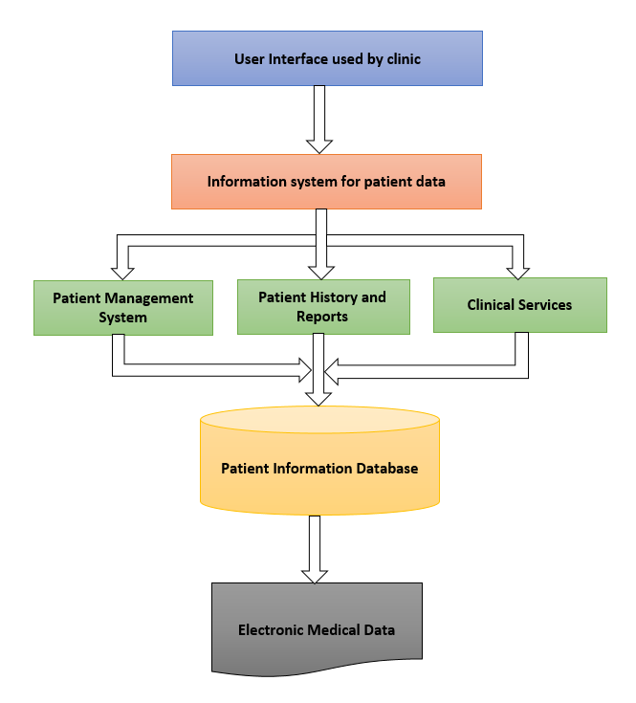

# Security Component

Security is an extremely important aspect of development of a healthcare system. Data like Patients history should be handled with added sense of security to counter data breach and similar vulnerabilities. In this case, Data accessibility should be based on the roles of the users. More importantly, the System holds sensitive patient information which should be shielded across the role hierarchy.

Implementing regulatory standards like HIPAA (Health Insurance Portability and Accountability Act of 1996) compliance to highlight lawful usage and disclosure of protected health information (PHI). HIPAA Privacy Rule outlines the right of the patient to access patient health information, a healthcare provider’s right to decline access of the PHI and monitoring details of disclosures and notices in the forms. HIPAA Security Rule ensures secure handling, maintenance and transmission of the protected health information of the patients. HIPAA compliance involves annual audits of a healthcare organization to evaluated administrative, physical and technical faults on the basis of HIPAA Privacy and Security standards. Federal auditors of HIPAA evaluated an organization’s compliance program on the basis of seven elements for its effectiveness. There are seven important elements are:

1. Implementation of written policies, procedures, and standards of conduct
2. Designated compliance officer and committee.
3. Conducting informative training and education.
4. Formulating appropriate lines of communication.
5. Steering internal monitoring and auditing.
6. Enforcement of standards through published penalizing guidelines.
7. Prompt responses to offenses identified and initiating corrective actions.

Enhanced Security requires minimizing the number of copies of the data (Availability), which results in reduction of possibility of intruders accessing the sensitive data. Therefore, there is a fundamental architectural conflict between availability (replication, several copies) and security (specialization, minimal copies).

Our plan of action to counter this is encryption of Data requests and transfers in the system. Also, Information in a system shall not be disclosed or made accessible to people or programs that are not authorized.

When an application is created, developers must continuously monitor, fix and prevent security vulnerabilities.

# 

# UML Diagrams

Unified Modeling Language (UML) is a general purpose modelling language. The main aim of UML is to define a standard way to visualize the way a system has been designed. It is quite similar to blueprints. A UML diagram is used to represent a system/structure along with its actors, roles, actions, classes, artifacts. A UML diagram is not only used to describe the object, information structures in an application, but also show the communication with its users.



## **Use Case**

A Use case is a list of steps that explain how a process will be carried out in a system. Use case Document helps us to walk through the steps the actor will take to achieve a goal. generally, use case is a methodology used in system analysis to identify, clarify and organize system requirements. These use cases are made up of a set of possible sequences of Interactions between system and users. Use cases are written by a business analyst or actor to write out the explicit steps in process.

There are 8 use cases in the Vision 2020 application. This document includes goals, scenario descriptions, and use case diagrams for all the below identified use cases:

|  |  |
| --- | --- |
| **Identifier** | **Use Case** |
| UC_001 | Clinic staff create new patient profiles |
| UC_002 | Clinic staff search/update patient profile data |
| UC_003 | Ophthalmologist/Clinic staff access/create/cancel/reschedule patients’ appointments |
| UC_004 | Ophthalmologist/Clinic staff upload documents |
| UC_005 | Clinic staff acquire patient consent for treatments |
| UC_006 | Clinic staff Validates Insurance Coverage and Generates Invoice |
| UC_007 | Clinic staff send emails/text to patients to remind them of upcoming appointments |
| UC_008 | Clinic staff collect feedback/survey from patient |

**UC_001 Clinic staff creates new patient profiles**

**Goal:** This scenario focuses on creation of profiles for new patients. This function is used by the ophthalmology clinic employees to create new patient data for the data records.

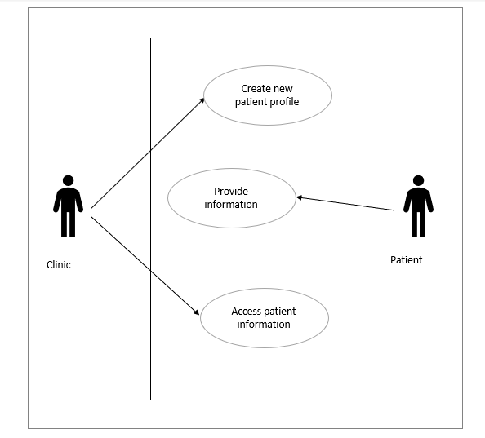

**Figure 1: UC_001**

|  |  |
| --- | --- |
| **Identifier** | **UC_001** |
| **Name** | Create new patient profile |
| **Trigger** | Creating profiles for patients visiting the clinic for the first time |
| **Preconditions** | Check for existing profiles for the patient.  Patient should have valid identification documents |
| **Postconditions** | A profile with the personal and contact details of the patient |
| **Primary actor** | Clinic staff/ Receptionist |
| **Participants (secondary actors)** | Patient |
| **Related use cases** | N/A |
| **Description of events** | 1. A clinic employee accesses new form to enter the patient’s data 2. They enter the data provided by the patient in the appropriate fields 3. The data is validated and verified by the system 4. The data is submitted and stored in the system 5. 5. A message is shown after successful submission of the data |

**UC_002 Clinic staff search/update patient profile data**

**Goal:** The clinic staff should be able to search the patient records and update patient information, such as diagnosis, suggested medication, referrals, health conditions, treatments and prescriptions.

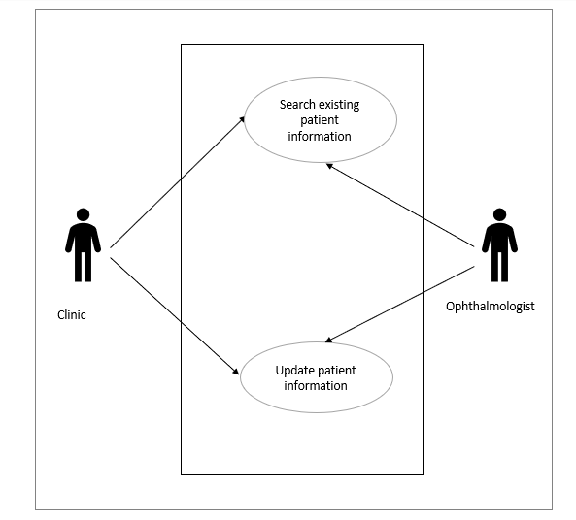

**Figure 2: UC_002**

|  |  |
| --- | --- |
| **Identifier** | **UC_002** |
| **Name** | Search/update profile data of the patient |
| **Trigger** | The staff searching for the existing profile of the patient  The staff updating the existing profile of the patient |
| **Preconditions** | Patients’ record must exist in the application |
| **Postconditions** | The search function must return the profile as a result for an existing patient.  The search function must return no result for a new patient.  The changes made to update a profile must be validated.  The changes made to the profile must be saved after the form submission. |
| **Primary actor** | Clinic staff, Ophthalmologists |
| **Participants (secondary actors)** | Patient |
| **Related use cases** | N/A |
| **Description of events** | 1. A clinic employee searches patient’s data 2. They find the patient profile associated with the search keywords 3. The data is validated and verified before updating by the system 4. The data is submitted and stored in the system 5. 5. A message is shown after successful submission of the data |

**UC_003 Ophthalmologist/Clinic staff access/create/cancel/reschedule patients’ appointments**

**Goal:** In this scenario, the Staff/Receptionist at the ophthalmology clinic shall be able to access the patient’s current appointments if any and book new appointments or cancel/reschedule existing appointments as per patient’s request. If there is an update to the appointment, automatic email and text message are triggered to inform the patients.A close up of text on a white background

**Figure 3: UC_003**

|  |  |
| --- | --- |
| **Identifier** | **UC_003** |
| **Name** | Access/create/cancel/reschedule patients’ appointments |
| **Trigger** | As per patient’s request, the Clinic staff/Receptionist want to access/create/cancel/reschedule their appointments |
| **Preconditions** | Patient record must exist on the application |
| **Postconditions** | Clinic staff/Receptionist can view the changes they have made to the appointments |
| **Primary actor** | Clinic staff/Receptionist |
| **Participants (secondary actors)** | Patient |
| **Related use cases** | UC_007 |
| **Description of events** | 1. A Clinic staff/Receptionist can find the patient’s existing appointment information in the system with date/time mentioned 2. Clinic Staff / Ophthalmologist Should be able to select an appointment from the list. 3. Clinic Staff / Ophthalmologist should be able to book an appointment for a particular date and time if there is no existing appointment 4. Clinic Staff / Ophthalmologist should be able to update an existing appointment information and cancel/reschedule to a different date. An update triggers an email/text message sent to the patients | |

**UC_004 Ophthalmologist/Clinic staff upload documents**

**Goal**: In this scenario, the Ophthalmologist/Clinic staff at the ophthalmology clinic shall be allowed to upload applicable diagnosis reports or tests to the patient profile.

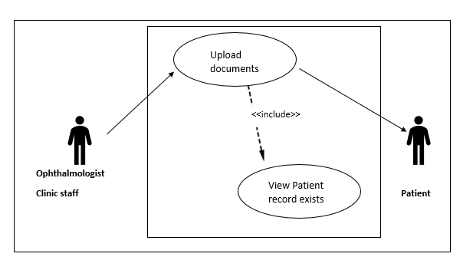

**Figure 4: UC_004**

|  |  |
| --- | --- |
| **Identifier** | **UC_004** |
| **Name** | Upload documents |
| **Trigger** | If there is any diagnosis reports or tests available, the Ophthalmologist/Clinic staff shall upload them to the patient profile for reference |
| **Preconditions** | Diagnosis reports or tests must be available |
| **Postconditions** | Ophthalmologist/Clinic staff are able to view the uploaded documents |
| **Primary actor** | Ophthalmologist/Clinic staff |
| **Participants (secondary actors)** | Patient |
| **Related use cases** | UC_002 |
| **Description of events** | 1. Patient undergoes applicable diagnosis 2. The reports get available and the Ophthalmologist/Clinic staff uploads them to the patient’s record 3. The reports shall be viewed in the patient’s record |

**UC_005 Clinic staff Acquire Patient Consent for Treatment/Surgery**

**Goal:** In this scenario, the Staff/Receptionist at the ophthalmology clinic takes a digital signature as a form of consent from the patient for the scheduled treatment/surgery.

This can be achieved in two ways:

1. Patient is physically present at the clinic and signs the consent form using the electronic signature panel.
2. Clinic staff/Receptionist emails the consent form to the patient to acquire consent in the form of digital signature.

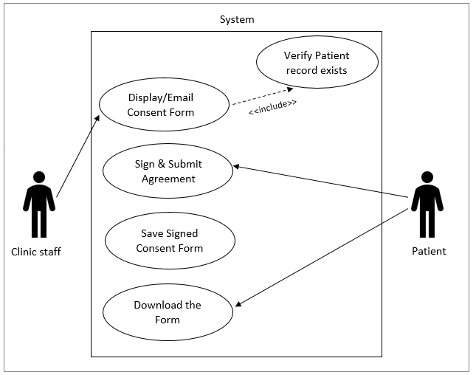

**Figure 5: UC_005**

|  |  |
| --- | --- |
| **Identifier** | **UC_005** |
| **Name** | Acquire Consent |
| **Trigger** | Clinic staff want to take consent from the patient before the treatment/surgery |
| **Preconditions** | Patient record must exist on the application |
| **Postconditions** | Patient shall sign and submit the form and be able to view it later |
| **Primary actor** | Clinic staff/ Receptionist |
| **Participants (secondary actors)** | Patient |
| **Related use cases** | UC_002 |
| **Description of events** | 1. System displays all the responsibilities and agreements between the patient and the doctor 2. Patient reads the agreement and signs it 3. System saves the form 4. Patient downloads the form |

**UC_006 Provider Validates Insurance Coverage and Generates Invoice**

**Goal:** In this scenario, the system looks up the patient’s medical insurance coverage, calculates the deductible to apply claims and generates an invoice for the balance amount to be paid by the patient.

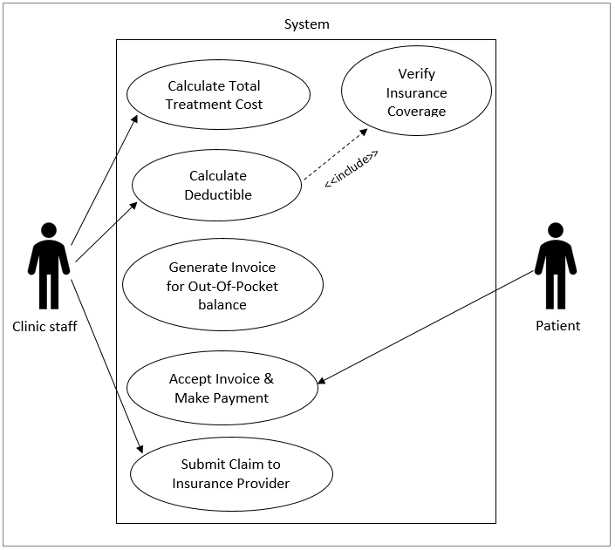

**Figure 6: UC_006**

|  |  |
| --- | --- |
| **Identifier** | **UC_006** |
| **Name** | Generate Invoice |
| **Trigger** | Ophthalmologist/Clinic staff want to generate invoice for patient’s treatment/surgery |
| **Preconditions** | Patient record must exist in the system |
| **Postconditions** | * Patient accepts invoice and makes payment * Clinic submits claim to the Insurance provider |
| **Primary actor** | Ophthalmologist/Clinic staff |
| **Participants (secondary actors)** | Patient, Insurance Provider |
| **Related use cases** | UC_002 |
| **Description of events** | 1. Clinic Staff initiates Bill Generation for Patient’s service using billing application 2. System validates Patient’s existing insurance details from its records 3. System determines services covered under insurance policy and calculates eligible deductibles to apply for claims to the insurance provider. 4. System generates invoices for out-of-pocket balance to be paid by the patient. 5. Patient accepts the invoice generated and the amount covered by the insurance policy. 6. Patient makes payment for an out-of-pocket balance amount. 7. Clinic System submits claim details to Insurance Providers. |

**UC_007 Clinic staff send emails/text to patients to remind them of upcoming appointments**

**Goal:** In this scenario, a Clinic Staff / Receptionist creates notifications for patients’ appointments. By creating notification via emails/texts, the Clinic staff can remind the patient about upcoming appointments before the appointment time.

Options are:  15 minutes before appointment, 30 mins, 45 mins, 1 hour, 2 hours, 4 hours, 12 hours, 24 hours, and 48 hours.

By setting notifications or reminders before appointments, clients can schedule their time and work for this appointment, if they can’t attend this meeting they can postpone or prepone according to their time/work.

**Figure 7: UC_007**

|  |  |
| --- | --- |
| **Identifier** | **Create UC-007** |
| **Name** | Send Notification/Reminder |
| **Trigger** | Clinic staff wants to create notifications via Email, SMS, Phone call to remind patients’ of their upcoming appointment |
| **Pre-condition** | There Should be an existing appointment. |
| **Post- Condition** | * Appointments are viewed. * An update may occur. * Update triggers email/ text messages |
| **Primary Actor** | Clinic staff/ Receptionist |
| **Participants (secondary actors)** | Patient |
| **Related use cases** | UC_003 |
| **Description of events** | * Clinic staff / Ophthalmologist should be able to reach patient’s account * Clinic Staff / Ophthalmologist should see available appointments with date/time mentioned by the client. * Clinic Staff / Ophthalmologist Should be able to select an appointment from the list. * Clinic Staff / Ophthalmologist should be able to book an appointment for a particular date & time. * Clinic Staff / Ophthalmologist should ask Patient that” Are they willing to set a Notification/ Reminder for their upcoming appointment” * Clinic Staff should be able to set a notification/ reminder for their upcoming appointment. * Patients should be able to respond back to notification with confirmation yes or No. * If yes, Clinic staff should be able to print schedules and share between Ophthalmologist and Patient. * If No, Clinic staff should be able to cancel or postpone appointments. |

**UC_008 Clinic staff/Ophthalmologist collect feedback/survey from patient**

**Goal**: In Ophthalmic practice the maintenance and restoration of visual function is the ultimate goal. General purpose of patient feedback surveys is information about how satisfied your patient are with different aspects of your service/product and about general experience they had with your clinic. This information can be collected in different kinds of surveys like promoted feedback. Unpromoted feedback-we can find opinions and reviews of clients post online by using internet monitoring tools.

In this scenario, a patient opinion is a resource for improvising patient experience and adjusting actions to patient needs.

A Clinic Staff / Ophthalmologist Conducts a feedback survey to assess the awareness of the existence of health-related quality of life (QOL), Thoughts, Opinions, and Feelings and for any suggestions. In this survey hospital-level characteristics, electronic health services, abstracted clinical information can be known

Collecting patient feedback shows you value their opinions

Patient feedback helps you create the best customer experience patient feedback helps to improve customer retention

Manually based paper survey

**Figure 8: UC_008-1**

Web based survey

**Figure 9: UC_008-2**

|  |  |
| --- | --- |
| **Identifier** | Create  **UC_008** |
| **Name** | Collect Patient Survey/Feedback |
| **Trigger** | Ophthalmologist/Clinic Staff want to collect patient opinion about how satisfied the patient was with different aspects of the service and their general experience at the clinic. |
| **Pre-condition** | Surveys should take place once a patient has his/her treatment or consultancy with clinic staff/Ophthalmologist. |
| **Post- Condition** | * Patient agreeing to take a survey is not compulsory. * An update may occur. * According to answers, service may change from next visit. |
| **Primary actor** | Clinic staff/ receptionist |
| **Participants (secondary actors)** | Patient |
| **Related Use case** | N/A |
| **Description Of events** | 1. Patients should create an appointment for treatment or consultancy. 2. Survey can happen in two ways 3. Manual paper based survey 4. Web system based survey 5. For improvising patient experience and adjusting actions to patient needs. 6. a Clinic Staff / Ophthalmologist conducts a feedback survey to assess the awareness of the existence of health-related quality of life. 7. Patient agrees and takes a few questions. 8. In this survey hospital-level characteristics, electronic health services abstracted clinical information can be known 9. patient feedback shows you value their opinions 10. patient feedback helps you create the best customer experience 11. patient feedback helps to improve customer retention |

## **Class Diagram**

A class diagram in the Unified Modeling Language is a type of static structure diagram that explains the structure of a system by showing the system’s classes, attributes, operations, methods and finally relationships among objects. The classes in a class diagram represent both the main elements, interactions in the application, and the classes to be programmed and executed.

**Figure 10: Class Diagram**

## **Sequence Diagram**

Sequence diagram shows objects interactions arranged in time sequence. It depicts the objects and classes involved in the scenario and the sequence of messages exchanged between the objects needed to carry out the functionality of the scenario. Sequence diagram are typically associated with use case realizations.

**Figure 11: Sequence Diagram for New Patient Creation and Searching Existing Patient Profile**

**Figure 12: Sequence Diagram showing interaction between Patient, Staff and Doctors**

## **Activity Diagram**

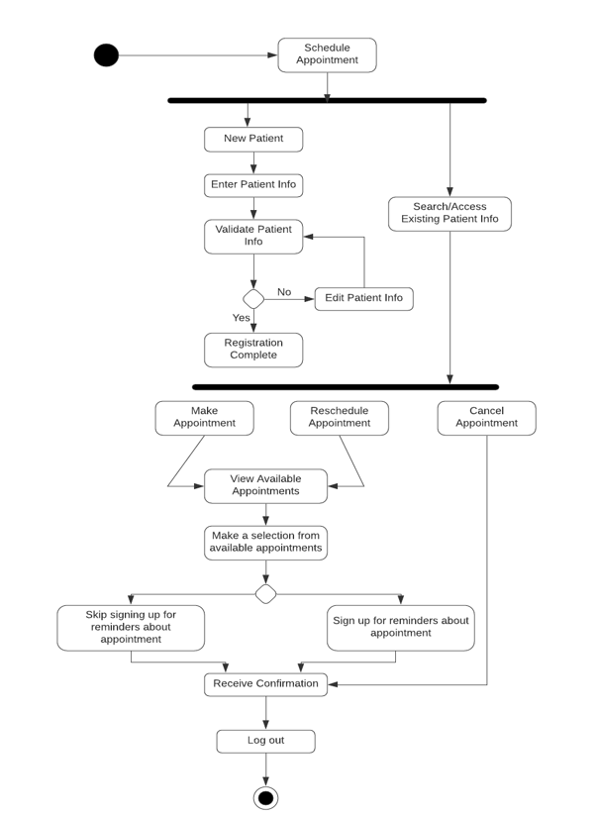

**Figure 13: Patient Appointment Activity Diagram**

## **Prototyping**

Prototyping is an activity of creating prototypes for our software system. A prototype is an early sample, model, or release of a product built to test a concept or process. Prototyping plays an important role in showing something concrete to users in the software elicitation process. It allows the development team and potential future customers to understand the product and plays a significant role in receiving feedback and improving the actual structure of the product.

Based on the feedback and ideas collected from other requirement elicitation techniques, an initial prototype is developed, which is tested by showing the initial version of prototype to the end users and collecting feedback from them. Based on received feedback, rework is made until an acceptable prototype is achieved.

This document includes the prototypes developed for Vision 2020 system.

**Vision 2020 Main Dashboard**

Main categories include:

* Patients
* Doctors
* Appointments
* Billing & Collections
* Reports

Quick Links tab on the right side of the screen will provide quick access to the most accessed functionalities.

**New Patient Creation Dashboard**

This dashboard is used to create new patient profiles for the ophthalmology clinic and can be navigated to upon clicking the ‘Patients’ category on the Main dashboard or the ‘New Patient’ link from the Quick Links tab. The clinical staff is responsible for collecting all the necessary information like Name, DOB, blood group, mobile no, email, allergic information, purpose of visit etc. from new patients and create the new Patient record using the below shown dashboard.

**View/Search Existing Patient Profile**

The below dashboard is a prototype of how an existing patient profile would appear on the system screen. This can be navigated to upon clicking the ‘Patients’ category on the Main dashboard. This dashboard will have all the information about the patient, history of visits, concerns/problems, medications, reports and test results.

**Doctor’s Profile View**

The below dashboard is a prototype of how an Ophthalmologist’s profile would appear on the system screen. This can be navigated to upon clicking the ‘Doctors’ category on the Main dashboard. This dashboard will contain information about the ophthalmologist’s mini biography, education, expertise, reviews and all of his/her scheduled appointments in the clinic.

**Appointments Dashboard**

The below prototype is a reflection of how the Appointment creation window would appear on the system. This window will appear upon clicking on the ‘New Appointment link from the Quick links tab or by selecting the Appointments category from the main dashboard. Other options include viewing all existing appointments, updating or cancelling an existing appointment.

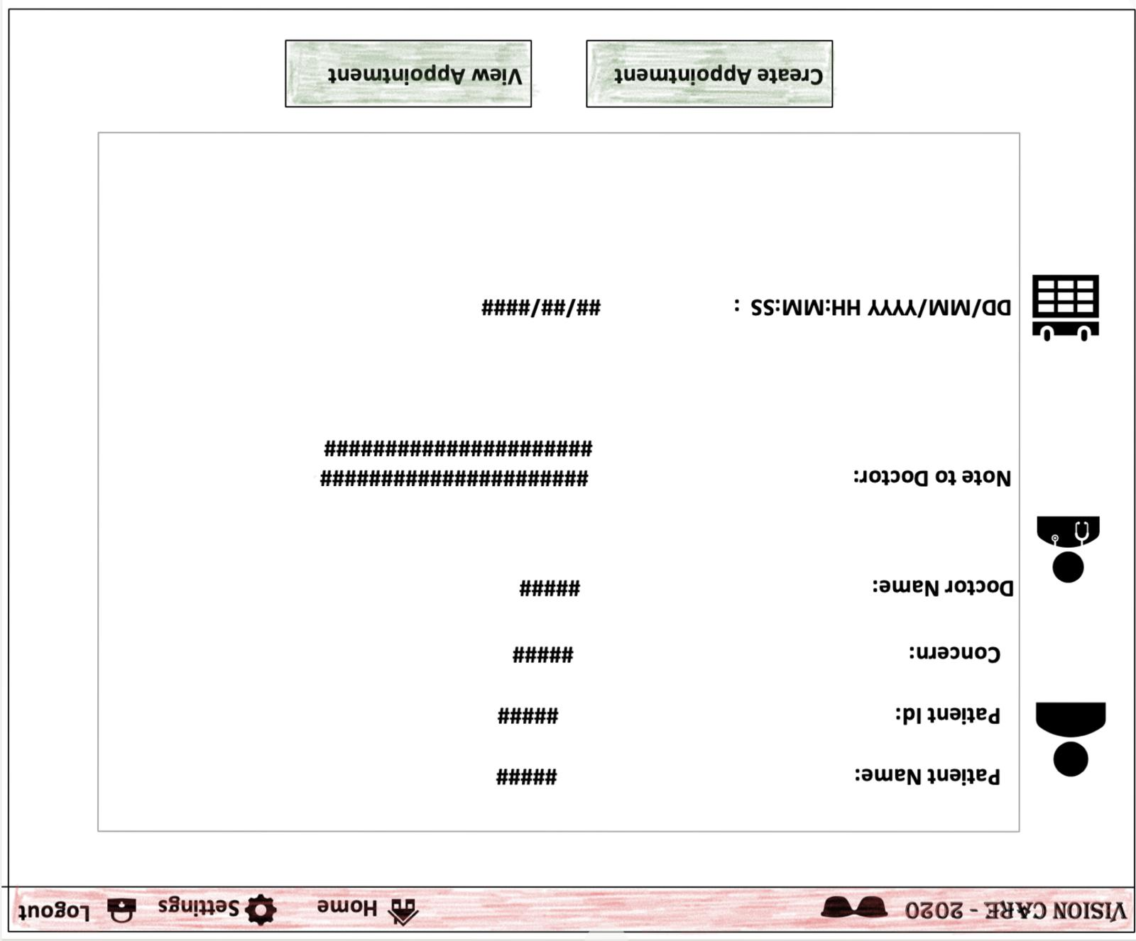

**Billing and Collections Dashboard**

All transactions between patient and the clinic and other third parties can be viewed on the Billings dashboard. This dashboard will also contain links to view Insurance claims and Invoices for the balance amount to be paid by the patients.

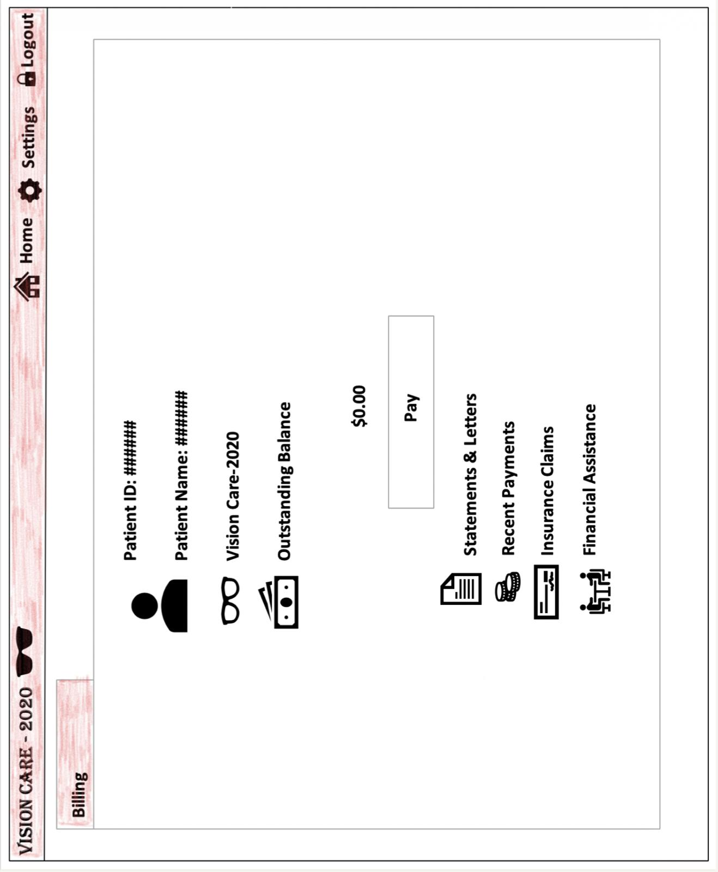

**Reports Dashboard**

All the applicable diagnosis reports and test results from in-house laboratories will be displayed on this dashboard. Each file can be downloaded and saved upon clicking on the file name.

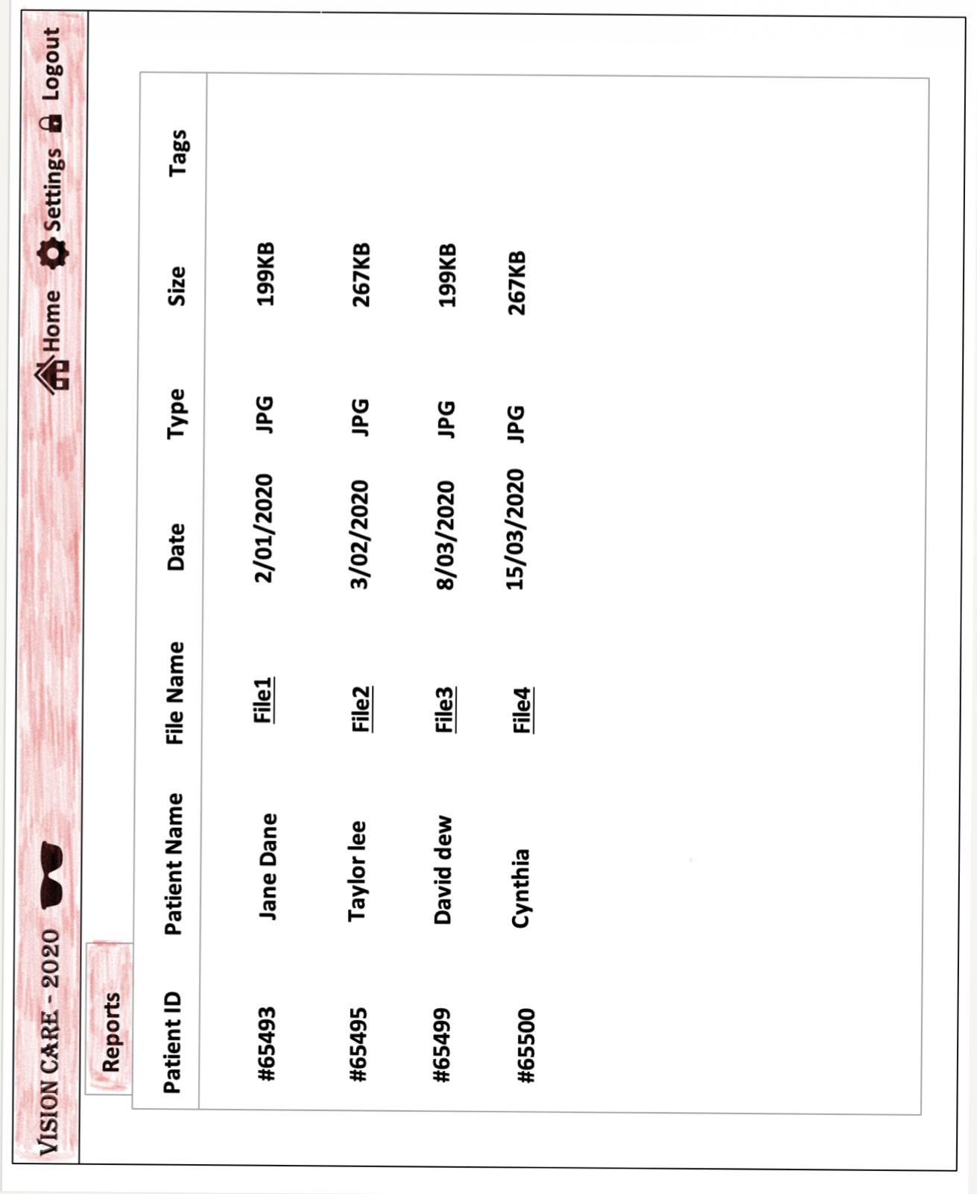

# Training Plan

Client satisfaction is a very important parameter for successful implementation of a project. It is very important to deliver the client requirements, but it is equally important to help the acquiring stakeholders get acquainted with the software system. Implementing a new system requires efficient training techniques in order to familiarize the acquiring stakeholders with the system and make them ready for the change. Trying to sign-up everyone for the appropriate training courses to start using the new system from day one is a far-fetched approach which guarantees nothing but failure. Complex training practices can make the users disinterested in the newly developed system which can directly and severely affect the market value of the product.

Identifying different type of acquirers is the first step towards portraying the system efficient enough to take care of their needs. It is important to deliver the project to people by clarifying the ways in which the new system will change their work. There are chances that the end-users of the system might need a certain level of computer proficiency to do their tasks on the new system. It is important to understand their past methods of action to highlight the newer ways of action.

Stakeholder interviews and surveys are very effective for deeper understanding of the requirements. They are also a means to make the stakeholders feel involved in the product development process. The data from stakeholder interviews and surveys should be used to demonstrate ways in which the new system is developed to take care of their requirements. The end-users must know that the features they demanded have been incorporated in the new system. Software products are essentially designed and developed to simplify and automate the redundant chores. Hence, they should know that their lives will be easier after this transition.

An elaborate demonstration of the features of the product according to the roles of the employees must be scheduled. They should be assured a 24/7 technical support for all their queries during the initial months of the product launch.

Building a strong stakeholder group is essential for a reliable market portfolio. A strong stakeholder group is also the driving force for rolling out efficient and reliable products in the future.

# Testing



## **Test plan**

A TEST PLAN is used to describe the scope, approach, resources, and schedule of all testing activities of the project Vision2020. The test plan serves as a blueprint to conduct software testing activities.

The plan identifies the items to be tested, the features to be tested, the types of testing to be performed, the personnel responsible for testing, the resources and schedule required to complete testing, and the risks associated with the plan.

## **Test Strategy**

* + 1. **Scope of Testing**

**Feature to be tested**

All the features of Vision2020 which were defined in the Functional Requirements section above are to be tested.

**Feature not to be tested**

Features like User Interfaces, Hardware Interfaces, Software Interfaces, Database logical, Security and Performance need not be tested.

## **Test Type**

In Vision2020 project, we have the following levels of testing:

* + 1. **Unit testing:**

The individual units/components of a software are tested. The purpose is to validate that each unit of the software product performs as expected.

* + 1. **Integration testing:**

Here, the individual units/components are combined and tested as a group. The purpose of this level of testing is to expose faults in the interaction between integrated components.

* + 1. **System Testing:**

This testing level validates the complete and fully integrated software product. The purpose of a system test is to evaluate the end-to-end system specifications. It is also necessary to test the non-functional aspect of the system which include tests to check performance, data security, usability/user friendliness, volume, and load/stress.

## **Risk and Issues**

|  |  |
| --- | --- |
| **Risk** | **Mitigation** |
| Team member lack the required skills for application testing | Plan training course to skill up the team members |
| The project schedule is too tight | Set Test Priority for each of the test activity |
| Test Manager has poor management skill | Plan leadership training for manager |
| Lack of proper budget estimate and cost overruns | Establish the scope before beginning work, pay a lot of attention to project planning and constantly track and measure the progress |

## **Test Logistics**

* + 1. **Who will test?**

The project identifies the following members for carrying out the testing:

1. Vimarsha Adyar (Developer/Tester)
2. Mounika Reddy Jaladanki (Developer/Tester)
   * 1. **When will test occur?**

The tester will start the test execution when all the following inputs are ready:

1. Software is available for testing
2. Test Specification is created
3. Test Environment is built

## **Test Objectives**

Test Objective is the overall goal and achievement of the test execution. The objective of the testing is finding as many software defects as possible and to ensure that the software under test is bug free before release and works as expected in real business environment.

## **Test Criteria**

* + 1. **Suspension Criteria**

If the testing team reports that there are **40%** of test cases **failed**, suspend the testing until the development team fixes all the failed cases.

* + 1. **Exit Criteria**

Specifies the criteria that denote a **successful** completion of a test phase

1. Run rate of test cases is mandatory to be 100%

2. Pass rate of 80% is mandatory

## **Resource Planning**

* + 1. **System Resource**

1. Server **–** MySQL, Apache server

2. Test tool - Develop a Test tool which can auto generate the test result and automated test execution

3. Network - Setup a LAN Gigabit and internet line

4. Computer - At least 4 computer run Windows 7, Ram 2GB, CPU 3.4GHZ

* + 1. **Human Resource**

1. Test Manager - Manage the whole project and defines project directions

2. Testers - Identifying and describing appropriate test techniques/tools/automation architecture, verify and assess the Test Approach, execute the tests, log results and report the defects

## **Test Environments**

1. QA environment - Exhaustive testing would take place and majority of bugs would be captured
2. UAT environment - This is performed by our Vision2020 end users where fewer bugs are expected to be captured

## **Schedule & Estimation**

|  |  |
| --- | --- |
| **Task** | **Estimate effort** |
| **Create the test specification** | 170 man-hours |
| **Perform Test Execution** | 80 man-hours |
| **Test Report** | 10 man-hours |

## **Test Deliverables**

Test deliverables are provided as below

* + 1. **Before testing phase**

- Test cases documents

- Test Design specifications

* + 1. **During the testing**

- Test Tool

- Simulators

- Test Data

- Test Trace-ability Matrix

- Error logs and execution logs

* + 1. **After the testing cycles is over**

- Test Results/reports

- Defect Report

- Installation/ Test procedures guidelines

- Release notes

# Conclusion

On a conclusive note, The Vision2020 software system is expected to be released within 6 months. Our vision2020 journey will continue with the advancements we plan to introduce in our future releases.

We are designing and developing this system to seamlessly scale with the features we have planned.

We are planning to add a feature that recommends medical plans to the patients under the expert guidance of doctors.

Secondly, we are introducing a module that can group the optometry clinics in the vicinity associated with the parent ophthalmology clinics.

We also plan to implement At-home vision care solutions for people who are unable to visit the clinics.

An additional feature to verify and flag incorrect claims will streamline the billing process.

# Resources and References

1. Software Engineering 10th edition by Ian Somerville

<https://dinus.ac.id/repository/docs/ajar/Sommerville-Software-Engineering-10ed.pdf>

1. Software Requirements 3rd edition by Karl Wiegers and Joy Beatty

<https://ptgmedia.pearsoncmg.com/images/9780735679665/samplepages/9780735679665.pdf>

1. Stakeholder Identification and Categorization

<https://www.pmi.org/learning/library/secure-360-stakeholder-buy-in-9306>

1. The Unified Modeling Language Reference Manual

<http://www.temida.si/~bojan/IPIT_2014/literatura/UML_Reference_Manual.pdf>

1. Trello Project Management

<https://trello.com/b/3VDJUQgy/advanced-software-engineering-2020-vision-care>