    



Session: 2021-2022

# MINI PROJECT REPORT

**On**

**“SENDING MAIL USING PYTHON”**

**BACHELOR OF TECHNOLOGY IN COMPUTER SCIENCE AND ENGINEERING**

**Submitted to-**

**VIJAY KUMAR SHARMA**

**(Department of Computer Science & Engineering)**

**Submitted by-**

### Aarif Ansari Roll No.1900680100006

### Himanshu Pratap Singh Roll No.1900680100130

### Karan Singh Roll No. 1900680110027

**5RD SEMESTER DEPARTMENT OF COMPUTER**

**SCIENCE AND ENGINEERING/IT/EC/EE/BT/ME**

**MEERUT INSTITUTE OF ENGINEERING AND TECHNOLOGY, MEERUT**

**DECLARATION**

We hereby declare that the project entitled -“Sending mails using python”, which is being submitted as Mini Project in department of Computer Science and engineering to Meerut Institute of Engineering and Technology, Meerut (U.P.) is an authentic record of our genuine work done under the guidance of Vijay Kumar Sharma of Computer Science and Engineering, Meerut Institute of Engineering and Technology, Meerut.

Date: 23 Dec 2021 Aarif Ansari (1900680100006)

Place: Meerut Institute of Engineering and Technology Himanshu Pratap(1900680100130)

Karan Singh (1900680110027)

**CERTIFICATE**

This is to certify that mini project report entitled – “Sending mails using python” submitted by Aarif Ansari, Karan Singh and Himanshu Pratap Singh has been carried out under the guidance of Vijay Kumar Sharma of Computer Science and Engineering, Meerut Institute of Engineering and Technology, Meerut. This project report is approved for Mini Project (KCS 554) in 5th semester in “CSE department” from Meerut Institute of Engineering and Technology, Meerut.

### Internal Examiner Date:

.

## ACKNOWLEDGEMENT

I express my sincere indebtedness towards our guide Prof., Vijay Kumar Sharma of Computer Science and Engineering, Meerut Institute of Engineering and Technology, Meerut for his valuable suggestion, guidance and supervision throughout the work. Without his king patronage and guidance, the project would not have taken shape. I would also like to express my gratitude and sincere regards for his kind approval of the project. Time to time counseling and advises.

I would also like to thank to our HoD Dr. (Prof.) M.I.H Ansari, Department of Computer Science and engineering, Meerut Institute of Engineering and Technology, Meerut for his expert advice and counseling from time to time.

I owe sincere thanks to all the faculty members in the department of Computer Science and engineering for their kind guidance and encouragement time to time.

Date: 23 Dec 2020 Aarif Ansari

Karan Singh

Himanshu Pratap Singh

**Table of contents**

### Description page no.

**Declaration i**

**Certificate ii**

**Acknowledgement iii**

**Chapter 1 Introduction v**

### Chapter 2 Technology Bucket vii

Description of Python

**Chapter 3 Output screens xiii**

**Appendices** Implementation code

### References

**Chapter 1**

### Introduction

### Sending mails using Python is an interactive way to know about python libraries. This project helped me in learning how to use smtp library and function in python. The main motive of this project is to use send mails automatically by code. The project is developed with help of Python and smtp.

### Objective: Send mails using python

### Description: This project sends mail without log in to mail. Its code automatically logs you in and sends mail. So, this feature can be used in several other projects.

**Chapter 3**

### Technology Bucket

## 3. Description of Python

Python is an interpreted, object-oriented, high-level programming language with dynamic semantics developed by Guido van Rossum. It was originally released in 1991. Designed to be easy as well as fun, the name "Python" is a nod to the British comedy group Monty Python. Python has a reputation as a beginner-friendly language, replacing Java as the most widely used introductory language because it handles much of the complexity for the user, allowing beginners to focus on fully grasping programming concepts rather than minute details.

Python is used for server-side web development, software development, mathematics, and system scripting, and is popular for Rapid Application Development and as a scripting or glue language to tie existing components because of its high-level, built-in data structures, dynamic typing, and dynamic binding. Program maintenance costs are reduced with Python due to the easily learned syntax and emphasis on readability. Additionally, Python's support of modules and packages facilitates modular programs and reuse of code. Python is an open source community language, so numerous independent programmers are continually building libraries and functionality for it.

**Python Use Cases**

* Creating web applications on a server
* Building workflows that can be used in conjunction with software
* Connecting to database systems
* Reading and modifying files
* Performing complex mathematics
* Processing Big Data
* Fast prototyping
* Developing production-ready software

Professionally, Python is great for backend web development, data analysis, artificial intelligence, and scientific computing. Developers also use Python to build productivity tools, games, and desktop apps.

**Features and Benefits of Python**

* Compatible with a variety of platforms including Windows, Mac, Linux, Raspberry Pi, and others
* Uses a simple syntax comparable to the English language that lets developers use fewer lines than other programming languages
* Operates on an interpreter system that allows code to be executed immediately, fast-tracking prototyping
* Can be handled in a procedural, object-orientated, or functional way.

**Python Syntax**

* Somewhat like the English language, with a mathematical influence, Python is built for readability
* Unlike other languages that use semicolons and/or parentheses to complete a command, Python uses new lines for the same function
* Defines scope (i.e., loops, functions, classes) by relying indentation, using whitespace, rather than braces (aka curly brackets).

**Python Flexibility**

Python, a dynamically typed language, is especially flexible, eliminating hard rules for building features and offering more problem-solving flexibility with a variety of methods. It also allows uses to compile and run programs right up to a problematic area because it uses run-time type checking rather than compile-time checking.

**Chapter 4**

**Output screens**

1. **Received Mail**

**Fig. 1**

1. **Sent mail**

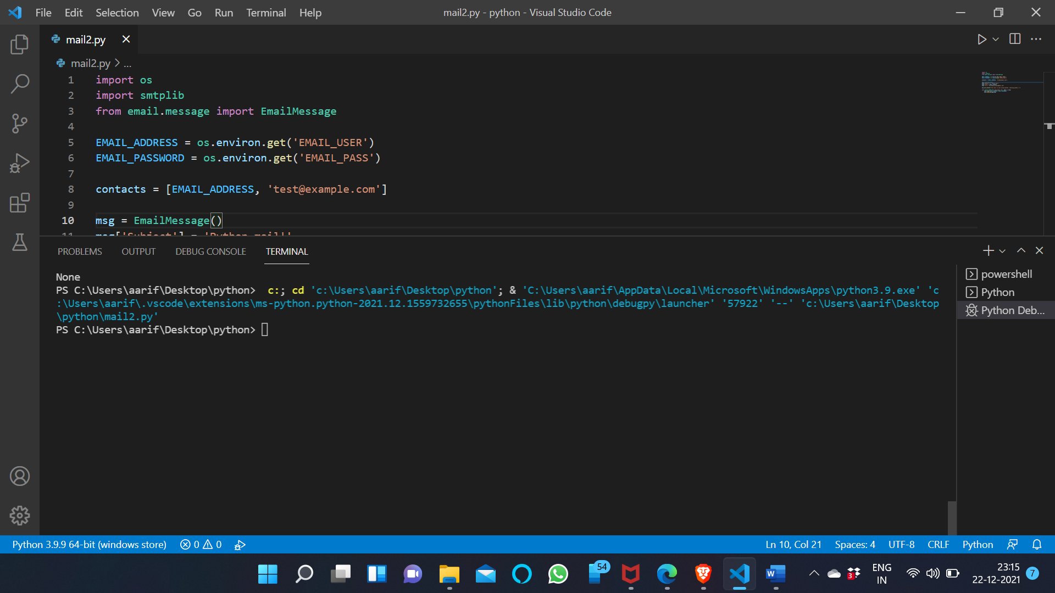

**Fig. 2**

**Appendices**

Implementation Code

import os

import smtplib

from email.message import EmailMessage

EMAIL_ADDRESS = os.environ.get('EMAIL_USER')

EMAIL_PASSWORD = os.environ.get('EMAIL_PASS')

contacts = [EMAIL_ADDRESS, 'test@example.com']

msg = EmailMessage()

msg['Subject'] = 'Python mail!'

msg['From'] = EMAIL_ADDRESS

msg['To'] = 'akashpanwarhumai@gmail.com'

msg.set_content('This mail is sent unsing python. Learning python :)')

with smtplib.SMTP_SSL('smtp.gmail.com', 465) as smtp:

    smtp.login(EMAIL_ADDRESS, EMAIL_PASSWORD)

    smtp.send_message(msg)

**References**

1. YouTube