Lab Objective
In this lab, you will learn how to use Liquibase to manage database schema changes. By the end of this exercise, you will be able to:
- Install Liquibase Community Edition.
- Connect Liquibase to a PostgreSQL database.
- Create and organize database migration files.
- Apply database changes using Liquibase.
- Track applied changes using the DATABASECHANGELOG table.
- Roll back changes safely using rollback commands.
Estimated Duration: 45–60 minutes

Learning Outcomes
After completing this lab, you will be able to:
- Explain the purpose of Liquibase.
- Create a database migration (changeset).
- Understand the role of a Master Changelog.
- Apply database changes using the Liquibase CLI.
- Roll back a database to a previous version.
- Explain why executed changesets should never be modified.

Prerequisites
Before starting this lab, ensure the following software is installed.

Software | Version | Purpose
Java | 17 or later | Required to run Liquibase
PostgreSQL | Latest | Database server
VS Code | Latest | Code editor
Liquibase Community | Latest | Database migration tool
Internet Connection | Required | Download Liquibase

Lab Scenario
You have joined a development team working on an online banking application.
The database currently contains no tables.
Your task is to create and manage the database structure using Liquibase instead of writing SQL scripts manually.

Part 1 – Install Liquibase
Step 1 – Download Liquibase
Download Liquibase Community Edition from:
https://www.liquibase.com/download
Choose the Windows ZIP package.

Step 2 – Extract
Extract the ZIP file to
C:\Liquibase
Your folder should look similar to:
C:\Liquibase
│
├── liquibase.bat
├── liquibase.jar
├── internal
└── lib

Step 3 – Configure Environment Variables
Add the following folder to the Windows PATH environment variable.
C:\Liquibase
Restart Command Prompt.

Step 4 – Verify Installation
Open Command Prompt.Execute
liquibase --version
Expected Output
Liquibase Community
Version 5.x.x

Part 2 – Create the Database
Open PostgreSQL (pgAdmin or psql).
Create a database named
CREATE DATABASE liquibase_demo;
Verify
\l
or
SELECT datname FROM pg_database;
Expected database
liquibase_demo

Part 3 – Create the Project
Create the following project.
liquibase-demo
│
├── changelog-master.xml
├── liquibase.properties
└── changes
└── 001-create-customers.xml
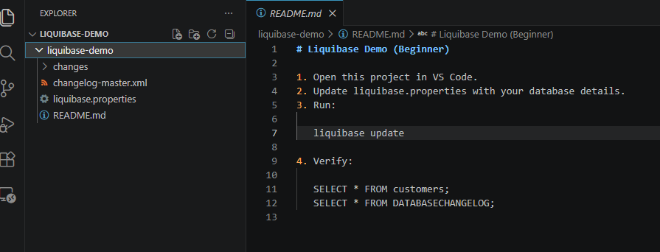
Part 4 – Configure Liquibase
Open
liquibase.properties
Add
changeLogFile=changelog-master.xml

url=jdbc:postgresql://localhost:5432/liquibase_demo

username=postgres

password=postgres

driver=org.postgresql.Driver

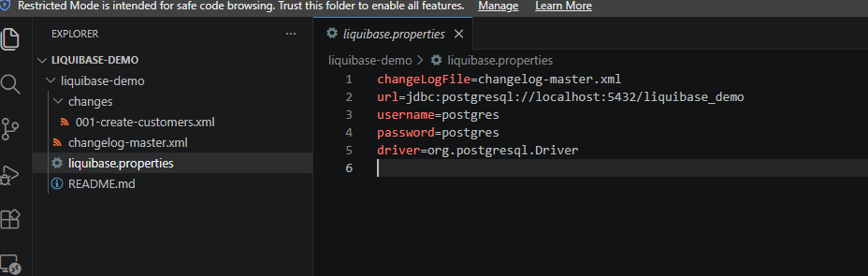
Explanation
Property | Purpose
changeLogFile | Starting point for Liquibase
url | PostgreSQL connection string
username | Database user
password | Database password
driver | PostgreSQL JDBC Driver

Part 5 – Create the Master Changelog
Open
changelog-master.xml
Add
<?xml version="1.0" encoding="UTF-8"?>

<databaseChangeLog
xmlns="http://www.liquibase.org/xml/ns/dbchangelog"
xmlns:xsi="http://www.w3.org/2001/XMLSchema-instance"
xsi:schemaLocation="
http://www.liquibase.org/xml/ns/dbchangelog
http://www.liquibase.org/xml/ns/dbchangelog/dbchangelog-latest.xsd">

<include file="changes/001-create-customers.xml"/>

</databaseChangeLog>

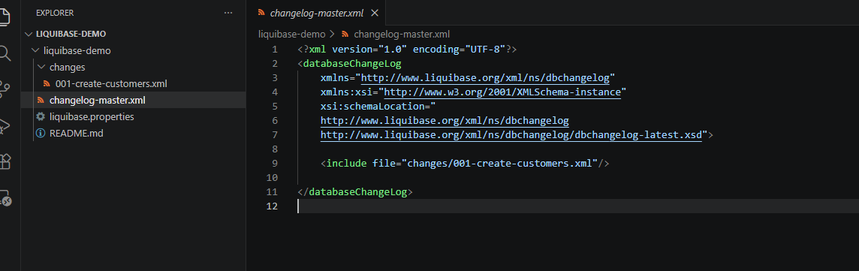
Why?
The Master Changelog is similar to the Table of Contents in a book.
Liquibase starts here and executes every included changeset in order.

Part 6 – Create Your First Changeset
Create
changes/001-create-customers.xml
Create a table named
customers
with the following columns.
Column | Type | Constraint
customer_id | BIGINT | Primary Key
name | VARCHAR(100) | NOT NULL
email | VARCHAR(100) | Optional

Part 7 – Run the Migration
Execute
liquibase update
What happens?
Liquibase will
- Read liquibase.properties
- Open changelog-master.xml
- Execute 001-create-customers.xml
- Create the customers table
- Record the changeset in DATABASECHANGELOG

Part 8 – Verify the Results
Verify the new table.
SELECT * FROM customers;
Expected
customer_id
name
email
Verify Liquibase history.
SELECT * FROM DATABASECHANGELOG;
You should see one executed changeset.

Part 9 – Version 1.1
Create a new file.
changes/002-add-phone-column.xml
Add a new column
phone_number
Update
changelog-master.xml
Include the new file.
Run
liquibase update
Verify
SELECT * FROM customers;
Expected columns
customer_id

name

email

phone_number

Part 10 – Rollback Demonstration
Add the following rollback to the second changeset.
<rollback>
<dropColumn
tableName="customers"
columnName="phone_number"/>
</rollback>
Create a database tag.
liquibase tag version1.0
Rollback
liquibase rollback version1.0
Verify
SELECT * FROM customers;
The phone_number column should no longer exist.

Lab Summary
At the end of this lab, you should have successfully:
- Installed Liquibase.
- Connected Liquibase to PostgreSQL.
- Created a Master Changelog.
- Created your first database migration.
- Applied the migration.
- Verified migration history.
- Added a second migration.
- Rolled the database back to a previous version.

Student Challenge
Complete the following tasks independently.
Task 1
Create an orders table containing:
- order_id
- customer_id
- amount
- order_date

Task 2
Create a migration that adds an address column to the customers table.

Task 3
Write a rollback section that removes the address column.

Task 4
Explain the purpose of the DATABASECHANGELOG table.

Task 5
Why is it considered a bad practice to modify a changeset that has already been executed in another environment?

Reflection Questions
- What problem does Liquibase solve?
- What is a changeset?
- What is the purpose of the Master Changelog?
- Why does Liquibase maintain the DATABASECHANGELOG table?
- What is the difference between update, tag, and rollback?
- When should a rollback be used?
- Why should applied changesets remain unchanged?

