TalentSignal AI
Architecture Diagram and Scoring Logic
By: Shruti Vinod Nair

1. Product Overview
TalentSignal AI is an AI-powered recruiting assistant that helps a recruiter move from a job description to an actionable shortlist. It parses the role, scans a candidate pool, explains each candidate match, simulates outreach conversations, estimates candidate interest, and ranks candidates using both fit and engagement signals.

2. Architecture Diagram
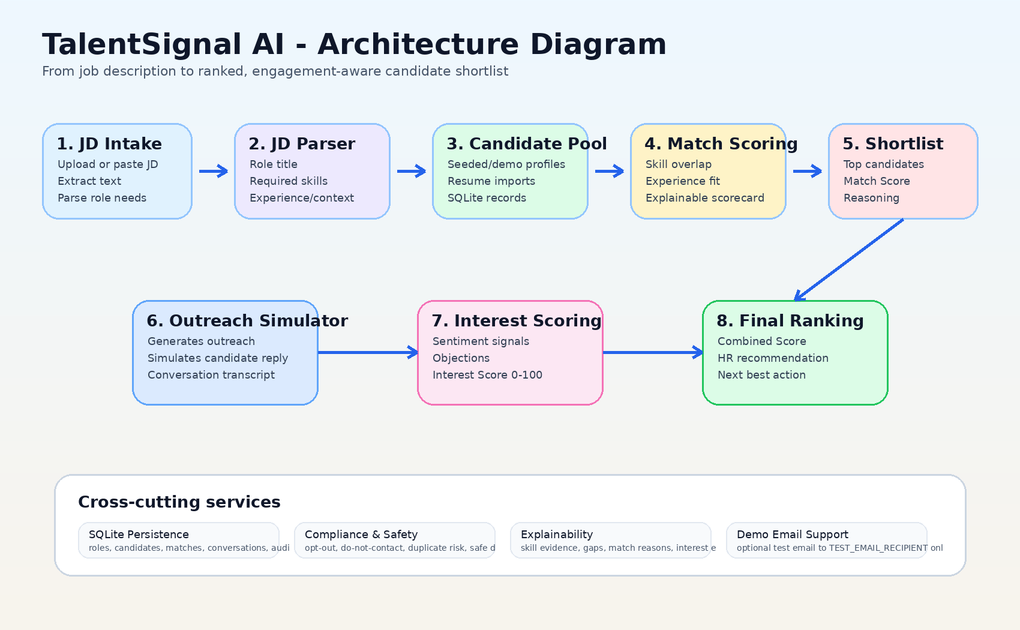
Figure 1. TalentSignal AI end-to-end architecture from JD intake to HR-ready ranked shortlist.

3. Component Description
JD Intake and Parsing | The recruiter uploads or pastes a job description. The app extracts the role title, required skills, nice-to-have skills, experience level, location/work mode, and other role context.
Candidate Discovery | The system scans the local candidate pool and resume-imported profiles. For the demo, this is intentionally deterministic and fast, so the app does not depend on external APIs.
Match Scoring Engine | Each candidate is scored against the parsed JD. The system produces a Match Score and a plain-English explanation showing matched skills, gaps, experience fit, and work-mode alignment.
Outreach Simulator | The agent generates a recruiter-style outreach message and simulates a candidate reply. This satisfies the conversational engagement requirement without requiring real inbox replies during the demo.
Interest Scoring Engine | The simulated reply is analyzed for sentiment, intent, scheduling signals, objections, and enthusiasm. These signals produce an Interest Score between 0 and 100.
Final Ranking and HR Summary | Candidates are ranked using Match Score plus Interest Score. The dashboard then gives HR a clear next action such as schedule recruiter screen, send details, recruiter review, keep warm, or do not contact.

4. Scoring and Ranking Logic
TalentSignal AI uses two primary scores so recruiters can see both fit and willingness to engage.

A. Match Score
The Match Score estimates how well a candidate fits the job description. It is based on:
- Required skill overlap, such as React, TypeScript, GraphQL, Python, or PostgreSQL.
- Nice-to-have skill overlap and domain relevance.
- Experience and seniority alignment with the JD.
- Location, work mode, and compensation fit where available.
- Risk and compliance signals such as duplicate risk or do-not-contact status.

B. Interest Score
The Interest Score estimates how interested the candidate appears after the simulated outreach conversation. It considers:
- Positive intent, such as “sounds interesting”, “open to chat”, or “available this week”.
- Neutral curiosity, such as asking for more role details, salary range, or remote policy.
- Negative intent, such as “not interested”, “pass”, or opt-out style language.
- Scheduling signals, which strongly increase the score because they show readiness to move forward.
- Objections, such as compensation or remote-work concerns, which are surfaced for HR follow-up.

C. Combined Score
Final ranking formula: Combined Score = 0.65 x Match Score + 0.35 x Interest Score
This weighting keeps role fit as the strongest signal while still rewarding candidates who show clear interest during the conversation.

5. Example Recommendation Logic
High Match + High Interest | Recommend: Schedule recruiter screen. The candidate fits the role and showed strong engagement.
High Match + Medium Interest | Recommend: Send role details or answer the candidate’s objection, such as compensation or work mode.
Medium Match + High Interest | Recommend: Recruiter review. The candidate is interested, but the role fit needs human judgment.
Low Interest | Recommend: Keep warm or deprioritize. The candidate may be a fit but is unlikely to move now.
Compliance Blocked | Recommend: Do not contact. Safety and consent rules override ranking.

6. How This Meets the Project Requirement
- Takes a Job Description as input through upload or pasted text.
- Discovers and evaluates candidates from a candidate pool.
- Produces explainable Match Scores instead of black-box rankings.
- Engages candidates conversationally through simulated outreach and replies.
- Calculates Interest Scores from the engagement response.
- Outputs a ranked shortlist with Match Score, Interest Score, Combined Score, and HR next action.
In short: TalentSignal AI gives recruiters an immediately actionable shortlist by combining candidate fit with engagement intelligence, while keeping the demo deterministic, explainable, and safe.

