# Introduction of the Project

**The project starts with –**

ENTER 1---->FOR NEW ITEM

ENTER 2---->FOR WOMEN SECTION

ENTER 3---->FOR MEN SECTION

ENTER 4---->FOR KID SECTION

ENTER 5---->FOR MODIFY ITEM

ENTER 6---->FOR SEARCH ITEM

ENTER 7---->FOR SHOW ALL INVENTORY ITEM WISE

ENTER 8---->FOR REMOVE ITEM

ENTER 9---->LIST ALL BILLS

ENTER 10--->GENERATE CUSTOMER BILL

ENTER 11--->EXIT

# System Requirements of the Project

**Recommended System Requirements**

Processors: Intel® Core™ i3 processor 4300M at 2.60 GHz.

Disk space: 2 to 4 GB.

Operating systems: Windows® 10, MACOS, and UBUNTU.

Python Versions: 3.X.X or Higher.

**Minimum System Requirements**

Processors: Intel Atom® processor or Intel® Core™ i3 processor.

Disk space: 1 GB.

Operating systems: Windows 7 or later, MACOS, and UBUNTU.

Python Versions: 2.7.X, 3.6.X.

**Prerequisites before installing MySQL Connector Python**

You need root or administrator privileges to perform the installation process.

Python must be installed on your machine.

Note: – MySQL Connector Python requires python to be in the system’s PATH. Installation fails if it doesn’t find Python.

On Windows, If Python doesn’t exist in the system’s PATH, please manually add the directory containing python.exe yourself.

# Python Coding

#***************JUET GUNA ******************

#***************WELCOME TO THE MALL***************

#*******Designed and Maintained By:

#*******SHRUTI BHARGAVA - 1st YEAR - ENRL NO - 221B374

#*******SHOURAY SONI - 1st YEAR - ENRL NO - 221A021

import mysql.connector

# GLOBAL VARIABLES DECLARATION

myConnnection =""

cursor="" userName="" password =""

pcode=""

#MODULE TO CHECK MYSQL CONNECTIVITY def MYSQLconnectionCheck ():

global myConnection global userName

global password

userName = input("\n ENTER MYSQL SERVER'S USERNAME : ") password = input("\n ENTER MYSQL SERVER'S PASSWORD : ")

myConnection=mysql.connector.connect(host="localhost",user=userN ame,passwd=password , auth_plugin='mysql_native_password' ) if myConnection:

print("\n CONGRATULATIONS ! YOUR MYSQL CONNECTION HAS BEEN ESTABLISHED !")

cursor=myConnection.cursor()

cursor.execute("CREATE DATABASE IF NOT EXISTS MALL")

cursor.execute("COMMIT")

cursor.close() return myConnection else:

print("\nERROR ESTABLISHING MYSQL CONNECTION CHECK

USERNAME AND PASSWORD !")

#MODULE TO ESTABLISHED MYSQL CONNECTION def MYSQLconnection ():

global userName global password global myConnection

global cid

global pcode

myConnection=mysql.connector.connect(host="localhost",user=userN ame,passwd=password , database="MALL" ,

auth_plugin='mysql_native_password' ) if myConnection:

return myConnection else:

print("\nERROR ESTABLISHING MYSQL CONNECTION !") myConnection.close()

#MODULE FOR MEN'S SECTION def menSection():

global pcode if myConnection:

cursor=myConnection.cursor()

print("ITEMS UNDER THE MENS SECTION ARE : ") sql="SELECT * FROM PRODUCT WHERE PRODUCT_CATEGORY=%s"

cursor.execute(sql,("Men",)) data=cursor.fetchall() if data:

print(data)

while True: print("""

ENTER 1 TO BUY

ENTER 0 TO RETURN TO MAIN MENU

""")

choice = int(input("Please Enter Your Choice : ")) if choice == 1 : item = searchItem() if item:

cursor=myConnection.cursor()

createTable ="""

CREATE TABLE IF NOT EXISTS

BILL(BILL_CODE VARCHAR(10) PRIMARY KEY ,PRODUCT_CODE

VARCHAR(10),CID VARCHAR(10),

CNAME VARCHAR(30), PRICE INT

,QUANTITY INT , DISCOUNT INT ,TOTAL INT );

"""

cursor.execute(createTable)

bnumber=input("\n Enter BILL Number : ") cid=input("\n Enter Customer Identification No. : ") cname=input("\n Enter Customer Name : ") price=int(input("\n Enter Price : ")) quantity=int(input("\n Enter Quantity : ")) discount=int(input("\n Enter Discount Amount, If any) : "))

total = (price * quantity) - discount

sql= "INSERT INTO BILL

VALUES(%s,%s,%s,%s,%s,%s,%s,%s)"

values=

(bnumber,cid,pcode,cname,price,quantity,discount,total) cursor.execute(sql,values) cursor.execute("COMMIT")

print("\n ITEM ADDEDD SUCCESSSFULLY IN YOUR CART !")

cursor.close()

elif choice == 0:

break; else: print("Sorry ,May Be You Are Giving Me Wrong Input, Please Try Again !!! ") else:

print("\nSomthing Went Wrong ,Please Try Again !")

#MODULE FOR WOMEN'S SECTION def womenSection():

global pcode if myConnection:

cursor=myConnection.cursor()

print("ITEMS UNDER THE WOMEN SECTION ARE : ")

sql="SELECT * FROM PRODUCT WHERE PRODUCT_CATEGORY=%s"

cursor.execute(sql,("Women",)) data=cursor.fetchall() if data:

print(data) while True: print("""

ENTER 1 TO BUY

ENTER 0 TO RETURN TO MAIN MENU

""")

choice = int(input("Please Enter Your Choice : ")) if choice == 1 : item = searchItem() if item:

cursor=myConnection.cursor()

createTable ="""

CREATE TABLE IF NOT EXISTS

BILL(BILL_CODE VARCHAR(10) PRIMARY KEY ,PRODUCT_CODE

VARCHAR(10),CID VARCHAR(10),

CNAME VARCHAR(30), PRICE INT

,QUANTITY INT , DISCOUNT INT ,TOTAL INT );

"""

cursor.execute(createTable)

bnumber=input("\n Enter BILL Number : ") cid=input("\n Enter Customer Identification No. : ") cname=input("\n Enter Customer Name : ") price=int(input("\n Enter Price : ")) quantity=int(input("\n Enter Quantity : ")) discount=int(input("\n Enter Discount Amount, If any) : "))

total = (price * quantity) - discount

sql= "INSERT INTO BILL

VALUES(%s,%s,%s,%s,%s,%s,%s,%s)"

values=

(bnumber,cid,pcode,cname,price,quantity,discount,total) cursor.execute(sql,values) cursor.execute("COMMIT")

print("\n ITEM ADDEDD SUCCESSSFULLY IN YOUR CART !")

cursor.close()

elif choice == 0:

break; else:

print("Sorry ,May Be You Are Giving Me Wrong Input,

Please Try Again !!! ")

else:

print("\nSomthing Went Wrong ,Please Try Again !")

#MODULE FOR KIDS'S SECTION def kidsSection():

global pcode if myConnection:

cursor=myConnection.cursor()

print("ITEMS UNDER THE KIDS SECTION ARE : ")

sql="SELECT * FROM PRODUCT WHERE PRODUCT_CATEGORY=%s"

cursor.execute(sql,("Kids",)) data=cursor.fetchall() if data:

print(data) while True: print("""

ENTER 1 TO BUY

ENTER 0 TO RETURN TO MAIN MENU

""")

choice = int(input("Please Enter Your Choice : ")) if choice == 1 : item = searchItem() if item:

cursor=myConnection.cursor()

createTable ="""

CREATE TABLE IF NOT EXISTS

BILL(BILL_CODE VARCHAR(10) PRIMARY KEY ,PRODUCT_CODE

VARCHAR(10),CID VARCHAR(10),

CNAME VARCHAR(30), PRICE INT

,QUANTITY INT , DISCOUNT INT ,TOTAL INT );

"""

cursor.execute(createTable)

bnumber=input("\n Enter BILL Number : ") cid=input("\n Enter Customer Identification No. : ") cname=input("\n Enter Customer Name : ") price=int(input("\n Enter Price : ")) quantity=int(input("\n Enter Quantity : ")) discount=int(input("\n Enter Discount Amount, If any) : "))

total = (price * quantity) - discount

sql= "INSERT INTO BILL

VALUES(%s,%s,%s,%s,%s,%s,%s,%s)"

values=

(bnumber,cid,pcode,cname,price,quantity,discount,total) cursor.execute(sql,values) cursor.execute("COMMIT")

print("\n ITEM ADDEDD SUCCESSSFULLY IN YOUR CART !")

cursor.close()

elif choice == 0:

break; else:

print("Sorry ,May Be You Are Giving Me Wrong Input,

Please Try Again !!! ")

else: print("\nSomthing Went Wrong ,Please Try Again !")

#MODULE FOR ADDING NEW ITEM def addItem(): global pcode if myConnection: cursor=myConnection.cursor()

createTable ="""

CREATE TABLE IF NOT EXISTS

PRODUCT(PRODUCT_CODE VARCHAR(10) PRIMARY KEY,

PRODUCT_CATEGORY VARCHAR(20),

PRODUCT_BRAND VARCHAR(30) ,PRODUCT_NAME VARCHAR(30))"""

cursor.execute(createTable)

pcode=input("\nEnter Product Code : ")

pcategory=input("\nEnter Product Category [ MEN/WOMEN/KIDS ] : ")

pbrand=input("\nEnter Brand Name : ")

pname=input("\nEnter Product Name : ")

sql= "INSERT INTO PRODUCT VALUES(%s,%s,%s,%s)"

values= (pcode,pcategory,pbrand,pname)

cursor.execute(sql,values) cursor.execute("COMMIT")

print("\nNEW ITEM ADDEDD SUCCESSSFULLY !") cursor.close()

else:

print("\nERROR ESTABLISHING MYSQL CONNECTION !")

#MODULE FOR SEARCH AN ITEM def searchItem(): global pcode if myConnection:

cursor=myConnection.cursor()

pcode=input("PLEASE ENTER PRODUCT CODE : ") sql="SELECT * FROM PRODUCT WHERE PRODUCT_CODE=

%s"

cursor.execute(sql,(pcode,)) data=cursor.fetchall()

if data:

print(data) return True else:

return False cursor.close() else:

print("\nSomthing Went Wrong ,Please Try Again !")

#MODULE FOR e AN ITEM def modifyItem(): global pcode item = searchItem() if item: if myConnection:

cursor=myConnection.cursor() print("PRESS 1 FOR PRODUCT NAME : ") print("PRESS 2 FOR PRODUCT CATEGORY : ")

print("PRESS 3 FOR PRODUCT BRAND : ")

choice=int(input("Enter Your Choice : ")) if choice==1:

name=input("ENTER NEW PRODUCT NAME : ")

sql="UPDATE PRODUCT SET PRODUCT_NAME= %s WHERE PRODUCT_CODE = %s"

cursor.execute(sql,(name,pcode))

cursor.execute("COMMIT")

print("PRODUCT NAME UPDATED SUCCESSFULLY ")

elif choice == 2:

category=input("ENTER NEW CATEGORY :")

sql="UPDATE PRODUCT SET PRODUCT_CATEGORY= %s WHERE PRODUCT_CODE= %s"

cursor.execute(sql,(category,pcode)) cursor.execute("COMMIT")

print("PRODUCT CATEGORY UPDATED SUCCESSFULLY ")

elif choice==3:

brand=input("ENTER NEW BRAND NAME :")

sql="UPDATE PRODUCT SET PRODUCT_BRAND= %s WHERE PRODUCT_CODE = %s"

cursor.execute(sql,(brand,pcode)) cursor.execute("COMMIT") print("BARND UPDATED SUCCESSFULLY ") else:

print("Sorry ,May Be You Are Giving Me Wrong Input,

Please Try Again !!! ")

else:

print("\nSomthing Went Wrong ,Please Try Again !") else:

print("Item Record Not Found , Please Try Again !")

#MODULE FOR DISPLAY INVENTORY def showInventory():

if myConnection:

cursor=myConnection.cursor()

sql="SELECT * FROM PRODUCT GROUP BY PRODUCT_CATEGORY" cursor.execute(sql) data=cursor.fetchall() if data:

print(data) return True else:

return False cursor.close() else:

print("\nSomthing Went Wrong ,Please Try Again !")

#MODULE TO REMOVE AN ITEM def removeItem () : global pcode item = searchItem() if item : if myConnection: cursor=myConnection.cursor()

sql="SELECT * FROM PRODUCT WHERE PRODUCT_CODE=

%s"

cursor.execute(sql,(pcode,)) data=cursor.fetchall() if data:

print("\n**** Item Removed Successfully !!! *****")

sql="DELETE FROM PRODUCT WHERE PRODUCT_CODE=%s" cursor.execute(sql,(pcode,)) cursor.execute("COMMIT")

cursor.close() else: print("\nSomthing Went Wrong ,Please Try Again !") else:

print("Record Not Found , Please Try Again !")

#MODULE TO LIST ALL BILLS def allBills():

if myConnection:

cursor=myConnection.cursor() sql="SELECT * FROM BILL GROUP BY CID" cursor.execute(sql) data=cursor.fetchall() if data: for bill in data:

print(bill) return True else:

return False cursor.close() else:

print("\nSomthing Went Wrong ,Please Try Again !")

#MODULE TO GENERATE PARTICULAR CUSTOMER'S BILL def generateBill(): global pcode if myConnection:

cursor=myConnection.cursor()

cid=input("\nEnter Customer Identification No. : ")

sql="SELECT CNAME , SUM(TOTAL) AS 'TOTAL AMOUNT' FROM BILL GROUP BY %s"

cursor.execute(sql,(cid,)) data=cursor.fetchall() if data:

print("###################################")

print("NAME AMOUNT")

print(data) return True else:

print("\nCustomer Not Found !")

cursor.close() else:

print("\nSomthing Went Wrong ,Please Try Again !")

#MAIN SCREEN OF THE SOFTWARE

print("#***************JUET Guna*******")

print("#***************WELCOME TO THE MALL****") print("#*******Designed and Maintained By:")

print("#*******SHRUTI BHARGAVA - 1st YEAR -ENRL NO - 221B374 ")

print("#*******SHOURAY SONI - 1st YEAR - ENRL NO – 221A021")

# MYSQL CONNECTION CHECK myConnection = MYSQLconnectionCheck () if myConnection: MYSQLconnection () while(True):

print("""

1---->FOR NEW ITEM

2---->FOR WOMEN SECTION

3---->FOR MEN SECTION

4---->FOR KID SECTION

5---->FOR MODIFY ITEM

6---->FOR SEARCH ITEM

7---->FOR SHOW ALL INVENTORY ITEM WISE

8---->FOR REMOVE ITEM

9---->LIST ALL BILLS

10--->GENERATE CUSTOMER BILL

11--->EXIT

""")

choice = int(input("Please Enter Your Choice : ")) if choice == 1: addItem()

elif choice ==2: womenSection() elif choice ==3: menSection() elif choice ==4: kidsSection() elif choice ==5: modifyItem() elif choice ==6:

item=searchItem() if item: print("*******Record Found !!!*******") else:

print("Record Not Found , Please Try Again !") elif choice ==7: showInventory() elif choice ==8: removeItem() elif choice ==9: allBills() elif choice == 10: generateBill() elif choice == 11:

print("Thanks for visiting\n

****We are eagerly waititng for your next visit !!! ***") break; else:

print("Sorry ,May Be You Are Giving Me Wrong Input, Please Try Again !!! ") else:

print("\nERROR ESTABLISHING MYSQL CONNECTION !")

# END OF THE PROJECT

**MYSQL DATABASE AND TABLES USED IN THIS PROJECTS**

## DATABASE AND TABLES

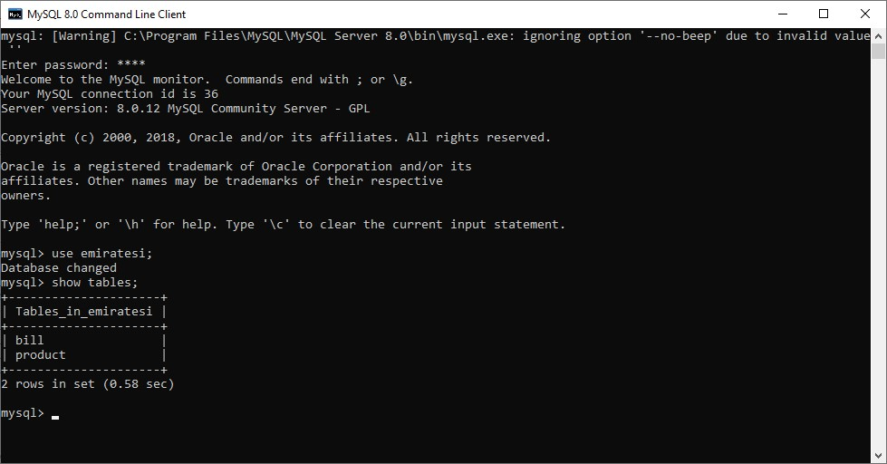



## TABLE STRUCTURE

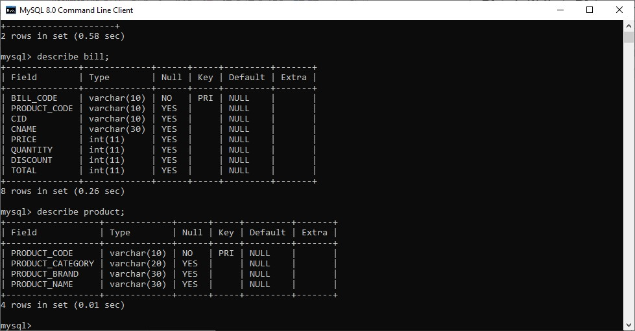

## BACKEND DATA GENERATED THROUGH SOFTWARE

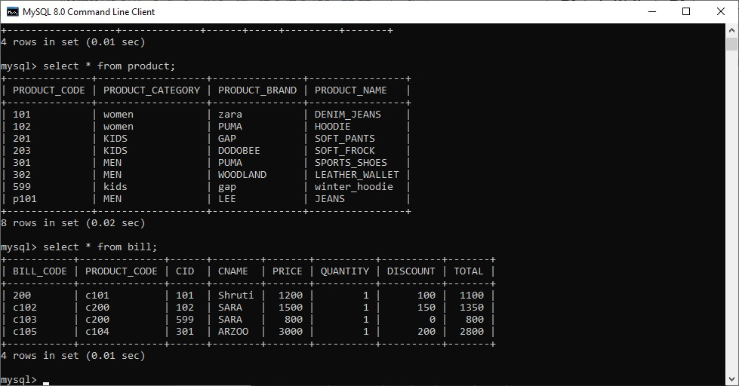

# References

1. python.org
2. Code Academy
3. tutorialsPoint.com
4. PythonChallenge.com
5. Google’s Python Class
6. LearnPython.org
7. layak.in