**Pyramid of Pain Overview**

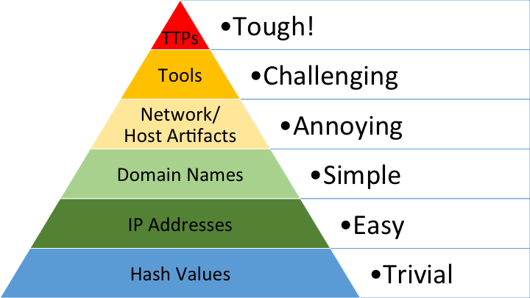

**Concept**: Describes the difficulty for attackers to adapt to defensive measures.

* **Color Coding**:
  + **Green**: IP Addresses (easiest for attackers to change)
  + **Teal**: Domain Names (more challenging but still manageable)
  + **Yellow**: Host Artifacts (requires more effort and resources to alter)

**1. Hashing Algorithms**

* **Definition**: A hashing algorithm converts input data into a fixed-length string of characters (a hash or digest), acting like a digital fingerprint.
* **Purpose**:
  + **Data Integrity**: Ensures data remains unchanged.
  + **Security**: Protects sensitive information like passwords.
* **Common Hashing Algorithms**:
  + **MD5**: 128-bit hash (not secure for sensitive data)
  + **SHA-1**: 160-bit hash (considered insecure)
  + **SHA-256**: 256-bit hash (secure and widely used)
* **Analogy**: Hashing is like blending ingredients; a slight change results in a completely different smoothie (hash).

**2. IP Addresses**

* **Definition**: A unique identifier for devices on the internet, enabling communication.
* **Blocking IP Addresses**:
  + Can slow down attacks but attackers can quickly switch to new IPs.
  + **Fast Flux**: A technique where attackers change IP addresses frequently, complicating defense efforts.

**3. Domain Names**

* **Definition**: Readable addresses for websites (e.g., evilcorp.com).
* **Importance**: Attackers use deceptive domain names for malicious activities, including Command and Control (C2) infrastructure.
* **Punycode Attacks**: Convert non-ASCII characters into a web-accessible format to mislead users.
* **Detection Techniques**:
  + Analyze logs for suspicious activity.
  + Beware of URL shorteners hiding malicious links.

**4. Host Artifacts**

* **Definition**: Traces left by attackers on a system, indicating malicious activity.
* **Common Artifacts**:
  + **Registry Values**: Changes in the Windows registry by malware.
  + **Suspicious Processes**: Unusual processes indicating potential malware.
  + **Indicators of Compromise (IOCs)**: Signs of an attack, such as specific file alterations.
  + **Dropped Files**: Files installed or modified by malware.

**5. Tools for Analysis**

**VirusTotal**: Analyzes files and URLs for malicious content.

**Any.run**: A sandbox tool that allows for the analysis of malware behavior, including network connections and DNS requests.

**Example Scenario**

**Fast Flux Attack**: An attacker uses a network of infected computers to frequently change the IP addresses associated with a malicious domain, complicating detection and blocking efforts.

**Using Any.run**: By analyzing network behavior, security professionals can identify and block potential threats.

**Conclusion**

Understanding these components is essential for effective cybersecurity measures. While blocking IP addresses and analyzing domain names can provide some defense, attackers continually adapt, making it crucial to employ multiple strategies, including monitoring host artifacts and using advanced tools for analysis.