PROJECT 2: VISUALISATIONS

Crime data - South Australia

# **Data source**

* <https://data.gov.au/dataset/ds-sa-860126f7-eeb5-4fbc-be44-069aa0467d11/details?q=crime>

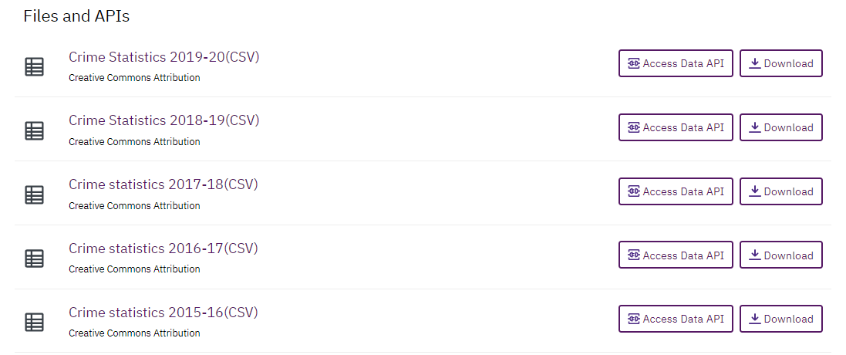

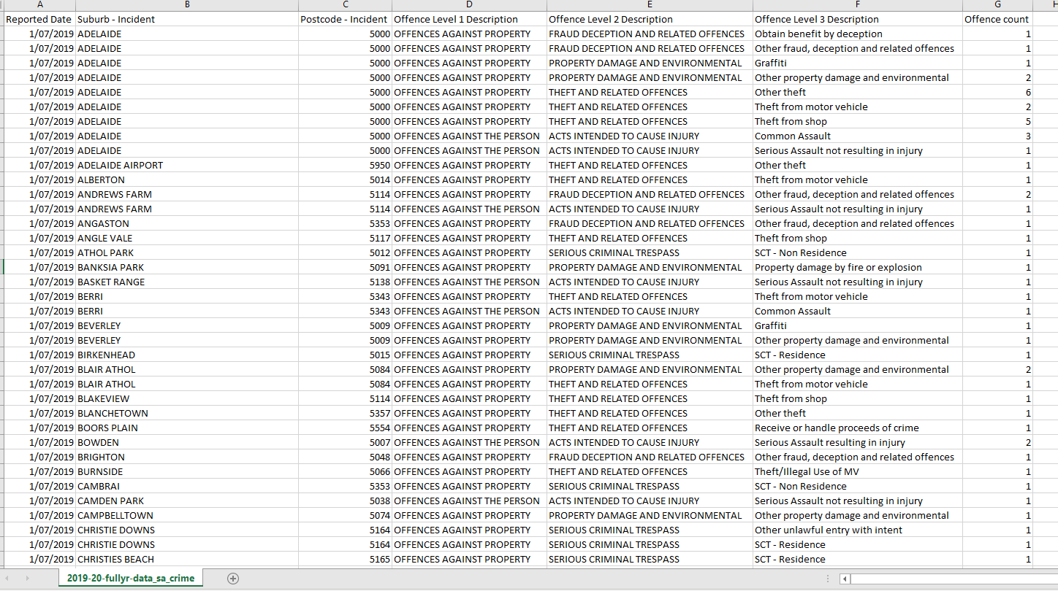

# **Rationale**

On data.gov.au we found interesting data on South Australia crime. We chose to compare crime data available between 2015 and 2020. We chose South Australia because data.gov.au contains very consistent and clean data provided by South Australia Police for consecutive years.

We will seek to find out what types of crimes are most frequent, what suburbs are mostly affected and how these trends present over the 5 years of data.

We will seek to match Suburbs for each incident with geolocations found in the following website: https://www.matthewproctor.com/australian_postcodes

# **‘Inspiring’ visualisations**

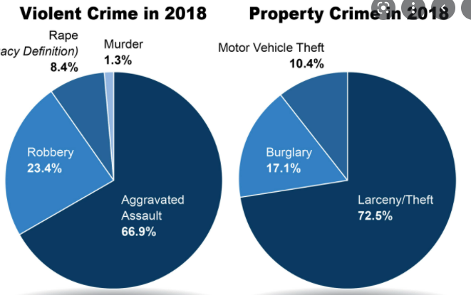

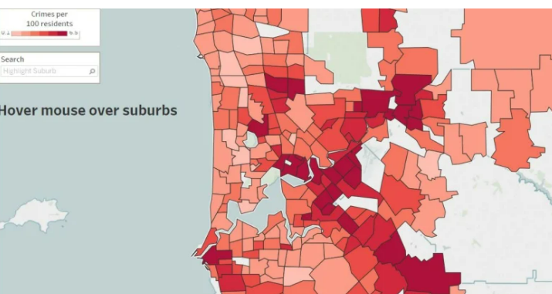

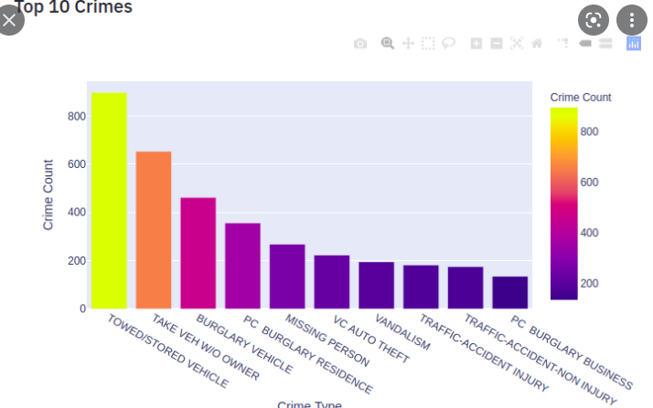

# **Design Sketch**

Navbar

HOME Data API Link to source data

Rationale for website (brief website description)

Filters

**Pie Chart SA CRIME** (Property or Person)

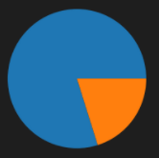

Filters

**Bar Chart** (Crime Lev 2)

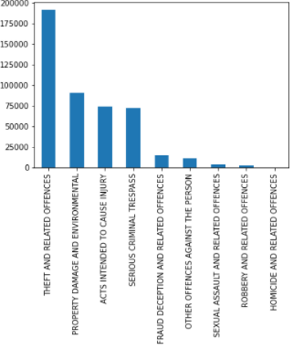

Filters

**Bar Chart** (Crime Lev 3)

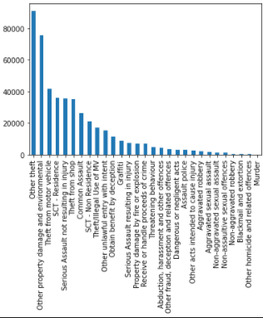

Filters

**Map Viz**

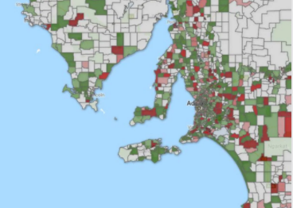

Filters

**Line chart** (dates)

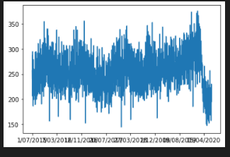

# **Primary GitHub repo**

https://github.com/Shrutihindocha/Project-2-Visualisations